HOW TO SOLVE THE PUZZLE ON THE LAST PAGE of FISHHEAD.
(It’s probably just as well I didn’t have the energy to do some sort of Kit Williams’ Masquerade.)

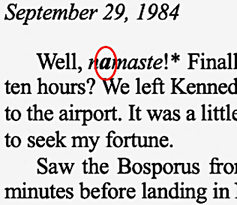
1) Copy out each bolded letter from the text. Look carefully: The bolded letters begin in my first journal entry (notice how the first one is also slightly enlarged) and are found only in my journal entries (not in letters I wrote home). There’s only one bolded letter per journal entry, and it’s the first occurrence of that letter. There is a total of 35 bolded letters—characters; the last two are numbers.*
Disregard case. There are no spaces.

The first three bolded letters are:
a l i…

*The last five (of the 35) do not need to be sorted in Step 2, below. They are a process clue, used in Step 3 below, which is why I placed their numbers FIRST (plus a colon) as a hint to their importance, in the number list at the back of the book.

2) Align the bolded letters in a column respective to a column of the Nepali numerals from the book’s last page. Sort the table ascending on the column of Nepali numerals. If it doesn’t sort correctly on the Nepali characters, add a third column with the translated Arabic numeral equivalents for the sort.

This example uses just the first three bolded letters in the book, i.e., bold Letter 2 occurs later in the text.

a | ५ | 5
L | ३ | 3
I | १ | 1

3) After sorting, add a fourth column and Rot13 the first column into the fourth column.

i | १ | 1 | v
l | ३ | 3 | y
a | ५ | 5 | n

The letters in the fourth column form the solution. Note: I’m not providing the answer; you’ll have to work through it. However, some reading Fishhead will already know what it’s about.

# # #

If you need this explained:
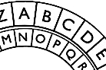
Rot13 is a function meaning “rotate by 13”: Arrange two sets of the 26 letters of the alphabet in concentric circles, then rotate one circle halfway around, i.e., by 13 letters. The rotated letter next to the given letter is the Rot13 equivalent.

The UNIX command line below also will Rot13 the left-column letters:

tr 'A-Za-z' 'N-ZA-Mn-za-m' <<< "ila"

NOT-EVEN-HALF-BAKED KIT WILLIAMS VERSON:

From the mammal eye of the Greatest Of All Time, sequence the letters by the color names of the simplest digital color schema to point to the first letters by the angle in radians of the respective sine, cosine, and tangent of the page number in that month number of that year number; but it’s a full moon, then find the Bikram-Sambat calendar year and…
