DSA 210 Project Report

Name & Surname: Emir Kerem Subaşı

Number: 34422

Do NBA Player Salaries Reflect Their On-Court Performance?

Introduction:

Professional Basketball leagues are on the rise in the 21’s century, especially with National Basketball Association’s (NBA) lead. NBA is one of the biggest sports industries with a multi-billion dollars of budget, where the players are the center of entertainment. Due to the attention on them, these star players are also earning millions of dollars annually throughout their career, and we always assume that they earn their salaries. But is it actually true? We sometimes see some players earning way more than others and do not perform too well, but we still acknowledge them because of their fame. Is it like this for all players? This study will focus on this question and try to answer it.

Motivation:

I got this idea to work on my project because I’m a big fan of basketball, both playing and watching. I may not be doing so fine playing it, but I watch it and follow NBA a lot. This question always wondered in my mind, and I always thought about the players I thought were not actually earning their salaries, and some were performing much above them with less payment. So, this was the perfect idea for my study.

Data Collection:

For this study, I collected my data mainly from two sources.

- Basketball Reference: Player statistics and their certain variables, which will be mentioned furthermore.
- Kaggle: For player salaries.

Both of these datasets were obtained for the 2024-2025 season to not create a mass amount of data, and the findings of the study will be just for this certain period. This study does not give an insight for any other seasons or the present.

Data Preprocessing:

The dataset I’ve got from Basketball Reference had all the special characters in player names (like “Alperen Şengün”, where the letters ‘ş’ and ‘ü’ are present) but the data from Kaggle did not have them. To prevent further errors, I changed every single special letter to their Latin counterparts in the Basketball Reference dataset.

I also cleaned the datasets in which case a player would exist in a dataset and in the other was not, or if any of their salary or statistics datasets were missing. To address these, the rows with unmatched names and variables were removed. This ensured that we have complete statistics for each player.

The variables used are (per 36 minutes):

- Points Per Game
- Assists
- Rebounds
- Turnovers
- Minutes Played
- Salary (in USD)
- Team
- Position

Features that were redundant, highly correlated with others, or not directly related to performance were excluded to reduce noise. For example, players who played under a certain number of minutes which does not really show any real observation are removed from the study.

I have also created two variables on my own, CPI (Composite Performance Index) and VPD (Value Per Dollar) which I will be using. It must be noted that these parameters are created by me and explained further in my Explanatory Data Analysis part and may or may not be truly reliable. The results we will be getting in this study are only centered around them.

Key Findings:

- The Salary Distribution is Highly Skewed: The distribution of salaries is highly skewed to the right, meaning most of the players are earning average salaries while a small number of players are earning a lot more, making us distinguish between the two. This also indicates that the salary distribution is uneven, with only a small number of players having a top-tier contract.

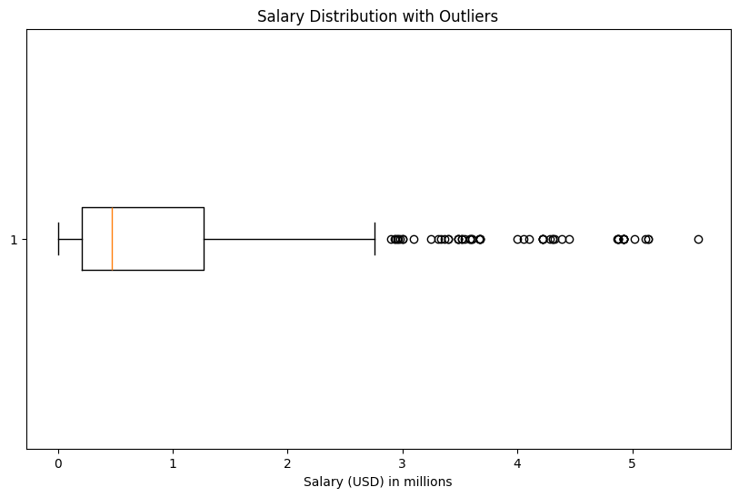

- Performance Metrics Mostly Correlate with Salary: The variable’s I’ve created such as CPI or usual performance metrics such as points, assists etc. usually match with player salaries, but still fail to form a strong linear relationship all by themselves.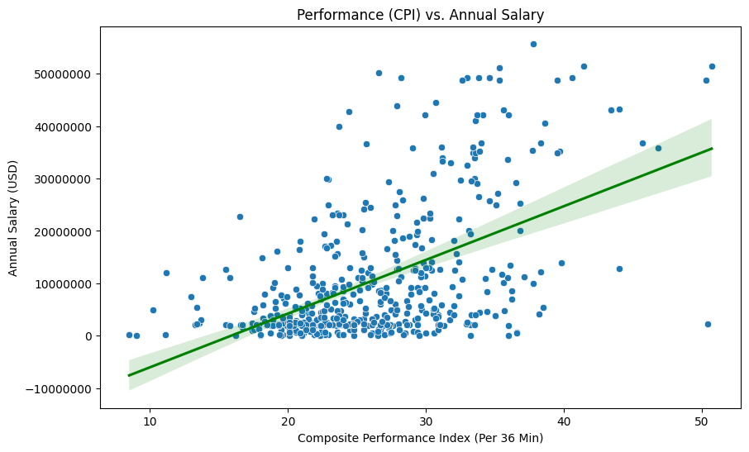
- The Metrics of Different Positions: I also studied and found out the correlation between CPI x Positions and VPI x Positions to get a broader look at the data and decide whether different positions actually influenced the salaries. I merged two Guard and Forward positions into one to have a smoother image.

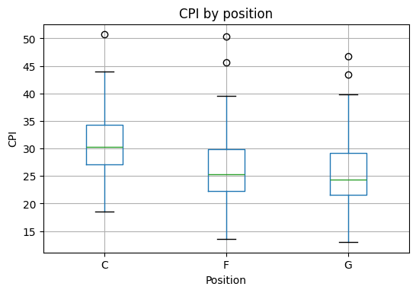

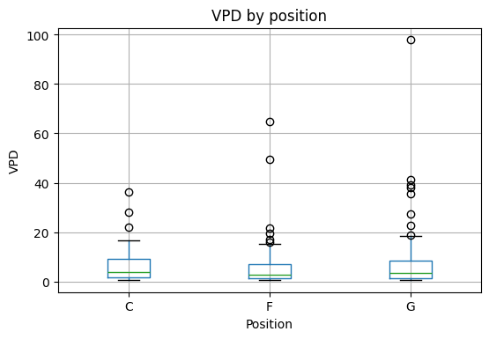
Hypothesis Tests:

The following hypothesis tests are implemented to further enhance our understanding, and to see if some of the points we’ve made were true or not:

Hypothesis Test 1: VPD differs by position
- H₀: Mean VPD is the same for guards, forwards and centers.
- H₁: At least one position has a different mean VPD.
Result: Fail to reject H₀: No significant difference found.

Hypothesis Test 2: Top VPD players are underpaid vs others
- H₀: There is no significant difference in average salary between high-value players and overpaid players.
- H₁: There is a significant salary difference between high-value players and overpaid players.
Result: Reject H₀: There is a significant difference in average salary between high-value players and overpaid players.

Hypothesis Test 3: The correlation between CPI and Salary
- H₀: There is no correlation between CPI and Salary.
- H₁: There is a significant correlation between CPI and Salary.
Result: Reject H₀: There is a strong correlation.

A significance level of a = 0.05 was applied to all the tests above.
As we can see, the result indicate that some metrics actually do indicate positive correlation with player salary. We both got our null hypothesis rejected and not, therefore we are on the right track of researching.

But still, our hypthesis tests show that the performance metrics are significant to figure out the salary determination. Therefore we must employ supervised machine learning methods to figure out the relationships between performance and salary more.

Machine Learning Methods:
After validating the statistical relationship between player performance metrics and salary through hypothesis testing, supervised machine learning methods were applied to model and predict NBA player salaries. The objective of this phase was to quantify how well each player’s earned wage can be estimated based on measurable on-court performance indicators.

The task was formulated as a regression problem, where the goal is to predict a continuous target variable using multiple performance-related features.
The input features included:
- Points per game
- Assists per game
- Rebounds per game
- Turnovers per game
- Minutes played per game
The target variable was:
- Player Salary (USD)
We first did a test split to use some data on training set to fit he models, and the others were used for performance eevaluation.
We used two models here to see our predicted salaries vs actual ones, namely;
Linear Regression: To be used as a baseline model for a simpler interpretation. It shows a linear relationship between the performance metrics and salaries, and also allows us to inspect coefficients.
Decision Tree Regressor: Is used to detect potential non-linear relationships. Decision trees are flexible but may cause other problems if the data is more linear than not.

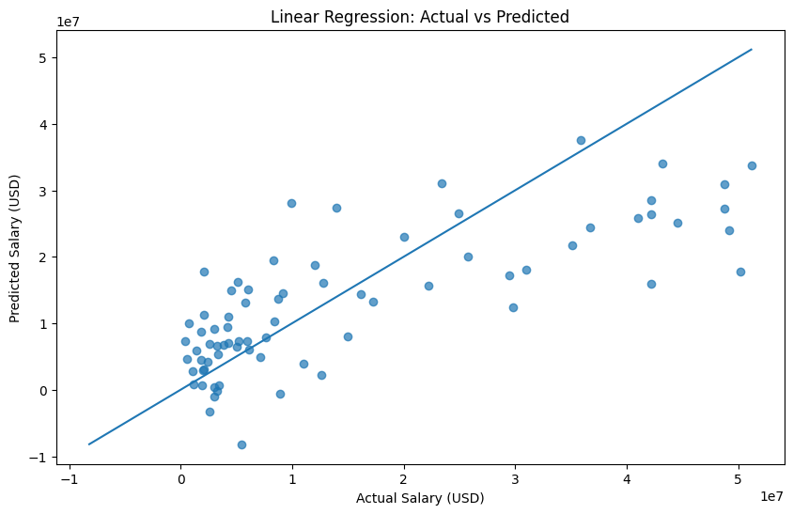

RMSE: 10478673.543863138
R^2 : 0.5588046876185153

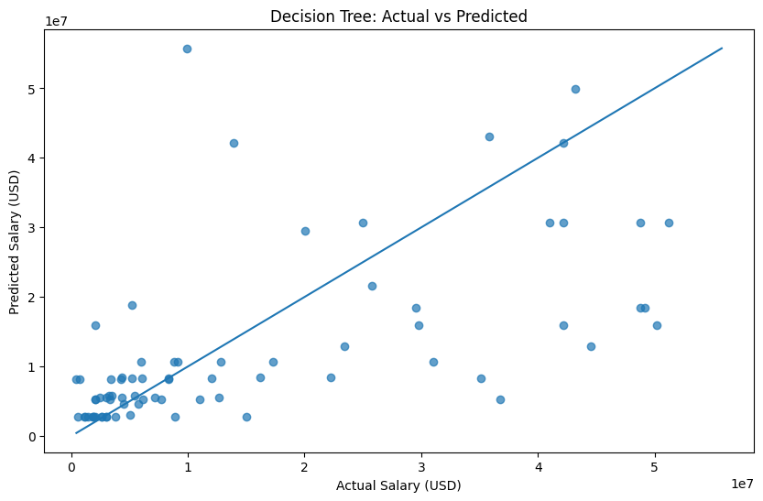

RMSE: 13081634.275825888
R^2 : 0.3123898553840455

Model performance was assessed using the following evaluation metrics:
- Root Mean Squared Error (RMSE): Measures the average magnitude of prediction errors in the same unit as salary.
- R-squared (R²): Represents the proportion of variance in salary explained by the model.
RMSE was prioritized for interpretation, as it directly reflects prediction error in monetary terms. And looking at both R^2 and RMSE results, we came to the conclusion that Linear Regression was the better model to use. It was more transparent and simple.

Afterwards we compared the underpaid and overpaid players using our new residual analysis:
For each player in the dataset, a predicted salary was computed using the trained regression model. The difference between the actual salary and the predicted salary was then calculated as:
Salary Difference = Actual Salary − Predicted Salary
- A positive difference indicates that the player earns more than the model predicts (potentially overpaid).
- A negative difference indicates that the player earns less than the model predicts (potentially underpaid).
This approach allows for a performance-based valuation independent of contract history or reputation.

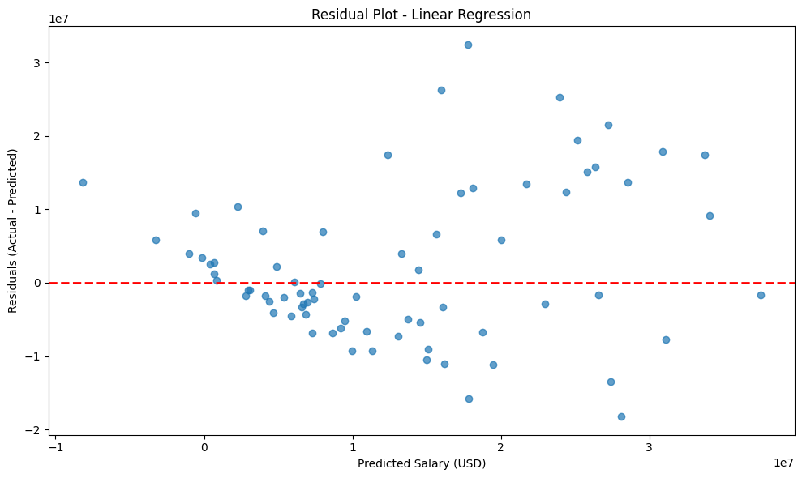

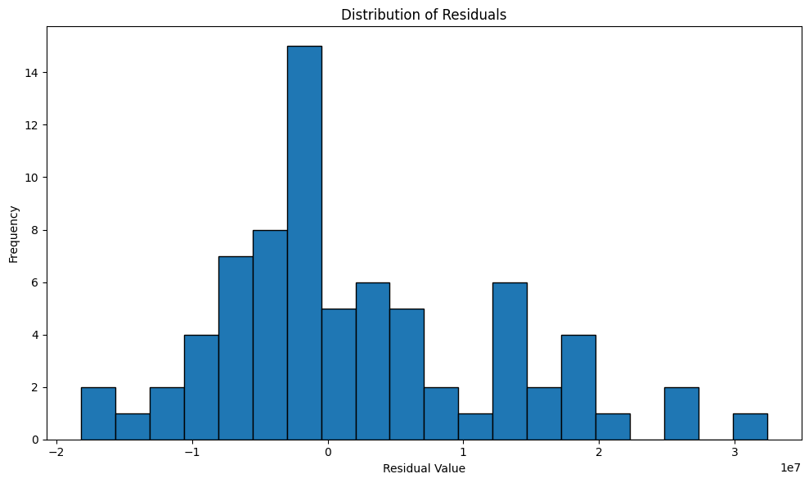

Therefore, we come to the conclusion that the balance between players earning less and more are somewhat balanced, although players earning less are more clustered compared to those earning more.

It is important to emphasize that this analysis does not imply incorrect contract decisions or mismanagement by teams. NBA contracts are influenced by numerous factors beyond measurable on-court performance, including:
- Team-specific salary cap constraints
- Contract duration and timing
- Player popularity and market value
- Injury risk and veteran experience
That is why the result I got is solely for performance metrics of 2024-2025 season, leaving other factors.
And finally, we used K-Means to group players into certain tiers to have a better understanding:
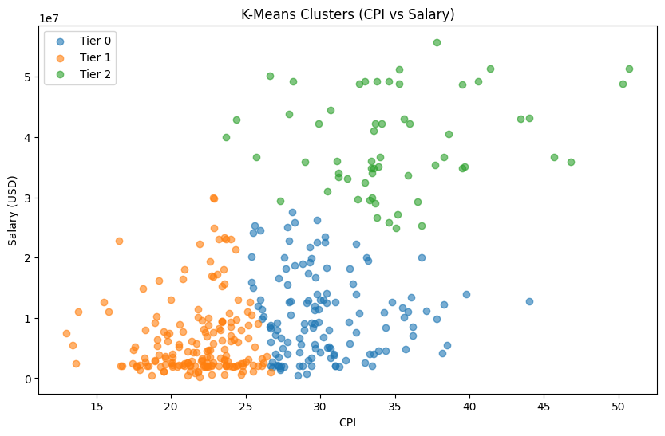
Limitations:
Like previously mentioned, this study has some limitations. It only shows a b roader understanding of performance versus salaries, not counting some other metrics like:
- Salary Cap Constraints
- Agencies
- Age of Players
- Injury Prone Players
- Missed Games
- Actual Mismanagements
- Single Season Measurement
As a result of these, some players may seem overpaid or underpaid. This must be taken in consideration.
For future work, one could take into consideration of these metrics as well, creating a more accurate dataset and model structure. Advanced efficiency and defensive metrics could be incorporated. Salary cap limitations, expanding into multiple seasons, exploring more machine learning models, it could all be implemented.

Conclusion:
This project examined the relationship between NBA player’s performance with their annual salary in the season 2024-2025. The aim was to understand whether their performance on-court reflected their salaries. By integrating several data of each player, this study applied the salary data, the explatory data analysis, hypothesis tests and machine learning methods to evaluate performance metrics of the basketball players.
The explatory analysis part determined that higher performance metrics usually were associated with high salaries, but some expections were present. Our hypothesis tests proved the significant comparison between salaries and performance metrics were present, but some players still earned more than they are supposed to.
Machine learning methods demonstrated that player salaries could actually be predicted in relation to their performance data. We used Linear Regression, Decision Tree Regression and other impliances to get a broader understanding, and to prove our point.
Overall, this study achieved its aim on coming up with the truth to our first question. Are some players in NBA actually overpaid. Answer is, yes. According to my custom variables and data, some players indeed earn more than they are supposed to. But the limitations still exist, and a more accurate analysis could only be performed if we eliminated those issues. But as it is, the study achieved what it was supposed to achieve.

