1. Write a query to pivot order data, returning the count of orders that were placed by customers. Show statistics for the 2006 and 2007 years:

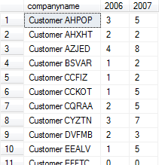

1. Create a Stored Procedure to pivot order data, returning the count of orders that were placed by customers for the specified years. The list of years should be sent to the procedure by the VARCHAR parameter.

The procedure execution will look like: EXEC dbo.PivotOrdersByYear @YearsList = '2006,2007,2008'

*Note: To achieve this you may want to apply dynamic SQL in the procedure.*

1. “Unpivot” the order details to have the list of productid, unitprice and qty values in rows:

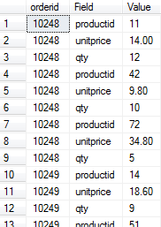

1. Show the list of distinct customers who placed orders with each employee. Create two queries one for SQL Server 2017 version and another for older version of SQL Server:

