- Return orders placed in June 2007.
Tables involved: Sales.Orders table.
Output columns: orderid, orderdate, custid, empid

- Return employees with last name containing the letter 'a' twice or more
Tables involved: HR.Employees table
Output columns: empid, firstname, lastname

- Return orders with total value(qty*unitprice) greater than 10000 sorted by total value
Tables involved: Sales.OrderDetails table
Output columns: orderid, totalvalue

- Return the three ship countries with the highest average freight in 2007.
Tables involved: Sales.Orders table
Output columns: shipcountry, avgfreight

- Calculate row numbers per each customer based on order date ordering.
Tables involved: Sales.Orders table
Output columns: custid, orderdate, rownum
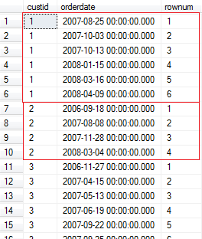
- Figure out and return for each employee the gender based on the title of courtesy. Ms. and Mrs. are Female; Mr. is Male; Dr. is Unknown.
Tables involved: HR.Employees table
Output columns: empid, firstname, lastname, titleofcourtesy, gender
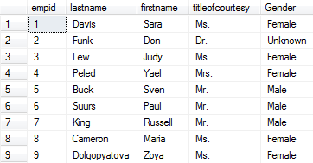

- Return customers and regions. Sort the rows in the output by region having NULLs sort last (after non-NULL values)
Tables involved: Sales.Customers table
Output columns: custid, region
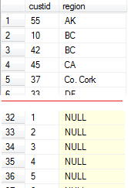

- Return the list of employees sorted by their hire date. Show only 5 employees, skipping first two records.
Tables involved: HR.Employees table
Output columns: empid, lastname, firstname, hiredate
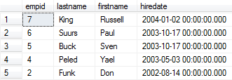

- Return customers that have more than 20 orders.
Tables: Sales.Orders
Output:
