- Return supplier locations (Country, region, city and postalcode) excluding locations that are both employee and customer locations. In other words, if the location exists in all three tables, do not show it.
Tables: Production.Suppliers, HR.Employees, Sales.Customers
Output columns: country, region, city, postalcode

- Return locations that are both supplier locations and customer locations but not employee locations.
Tables: Production.Suppliers, HR.Employees, Sales.Customers
Output columns: country, region, city, postalcode

- Calculate the number of distinct locations that are either employee or customer locations in each country
Tables: HR.Employees, Sales.Customers
Output columns: country, DistinctLocationsCount
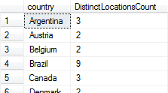

- Return two the most recent orders for employees with employee ID of 3 or 5
Tables: Sales.Orders
Output columns: empid, orderid, orderdate

- Write a query that generates an output of 10 numbers in the range 1 through 10 without using a looping construct. You do not need to guarantee any order of the rows in the output of your solution.
Output:
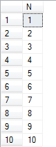

- Write a query that returns customer and employee pairs that had order activity in January 2008 but not in February 2008.
Tables: Sales.Orders
Output columns: custid, empid

- Write a query that returns customer and employee pairs that had order activity in both January 2008 and February 2008 but not in 2007 year.
Output columns: custid, empid

