- Return information about the order with the maximum order ID.
Tables involved: Sales.Orders
Output columns: orderid, orderdate, empid, custid
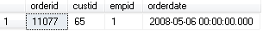

- Return order IDs of orders placed by employees with a last name starting with D.
Tables involved: Sales.Orders, HR.Employees
Output columns: orderid

- Write a query that returns orders placed by customers from the United States.
Tables involved: Sales.Orders, Sales.Customers
Output columns: custid, orderid, orderdate, empid

- For each customer return order with the maximum order ID.
Tables involved: Sales.Orders
Output columns: custid, orderid, orderdate, empid

- Return customers from Spain who did not place orders.
Tables involved: Sales.Orders, Sales.Customers
Output columns: custid, companyname

- For each customer return orders information. Also show the previous order ID.
Tables involved: Sales.Orders
Output:
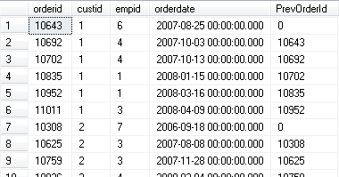

- Calculate the cumulative sum over the years using Sales.OrderTotalsByYear view. In other words, for each year, return the sum of quantity up to that year. So for the earliest year recorded in the view (2006), the running total is equal to that year's quantity. For the second year (2007), the running total is the sum of the first plus second years, and so on.
Involved view Sales.OrderTotalsByYear
Output:
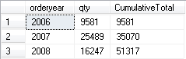

- Write a query that returns employees who did not place orders on or after May 1, 2008.
Tables involved: Sales.Orders, HR.Employees
Output columns: empid, FirstName, lastname

- Write a query that returns the list of countries where there are customers exist but not employees
Tables involved: Sales.Customers, HR.Employees
Output columns: country

- Write a query that returns customers who placed orders in 2007 but not in 2008.
Tables involved: Sales.Orders, Sales.Customers
Output columns: custid, companyname

