- Write a query that returns a row for each employee and day in the range June 12, 2009 – June 16 2009.
Desired output
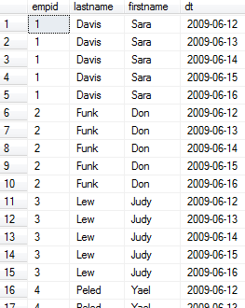

- Return customers and their orders including customers who placed no orders
Desired output
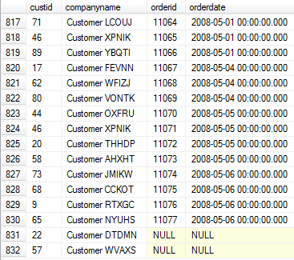

- Write a query to produce all possible combinations of pairs of employees.
Desired output:
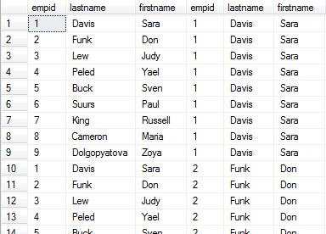

- Write a query that produces a sequence of integers in the range 1 through 1,000
using table Digits below:

USE tempdb;
IF OBJECT_ID('dbo.Digits', 'U') IS NOT NULL
DROP TABLE dbo.Digits;
CREATE TABLE dbo.Digits(digit INT NOT NULL PRIMARY KEY);

INSERT INTO dbo.Digits(digit)
SELECT 0 UNION ALL SELECT 1 UNION ALL SELECT 2 UNION ALL SELECT 3 UNION ALL SELECT 4 UNION ALL SELECT 5 UNION ALL SELECT 6 UNION ALL SELECT 7 UNION ALL SELECT 8 UNION ALL SELECT 9

- Write a query to produce unique pairs of employees
Desired output:
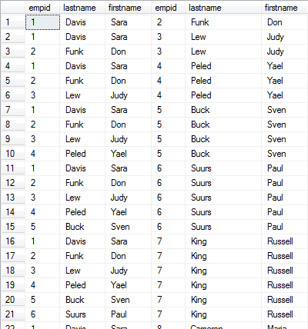

- Write a query to match customers with their orders and orders with their order lines
Output:
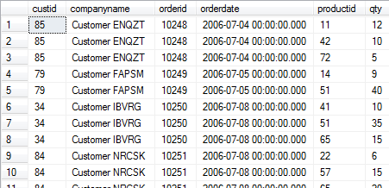

- Write a query to return customers who did not place any orders
Desired output:
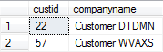

- Write a query that calculates a total quantity for each customer and month (monthly qty) and running total for monthly qty
Output:
