- Write a query against the Sales.Orders table and return the number of distinct customers handled in each order year
Output:
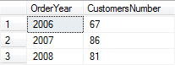

- Return order years and the number of customers handled in each year only for years in which more than 70 customers were handled
Output:
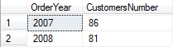

- Calculate the difference between the number of customers handled in the current and previous years.
Output
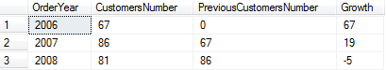

- Return information about an employee (Don Funk, employee ID 2) and all of the employee's subordinates in all levels (direct or indirect):
Output:
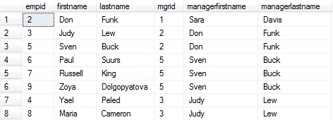

- Write a solution using a recursive CTE that returns the management chain leading to Zoya Dolgopyatova (employee ID 9).
Output:
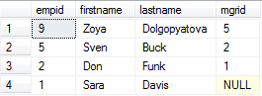

- Write a query that returns orders with the maximum order date for each employee.
Output:
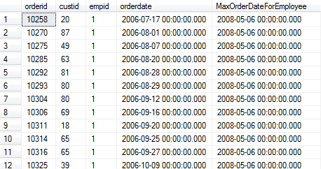

- Return two most expensive products per each supplier
Output:
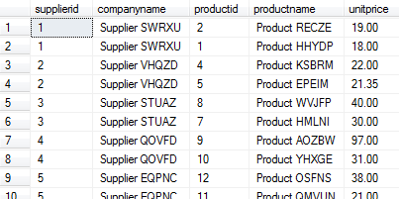

- Create an inline table-valued function. Input should be a supplier ID (@supid AS INT) and a requested number of products (@n AS INT). The function should return @n products with the highest unit price that are supplied by the given supplier ID. When issuing the following query::
Output:
SELECT * FROM Production.fn_TopProducts(5, 2)
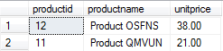

- Using the function you have created in previous exercise, return two most expensive products per each supplier
Output:
