**What is software? What is software engineering?**

Software: It is a collection of computer program

that helps us to perform a task.

Software engineering is a systematic engineering approach to software development. A software engineer is a person who applies the principles of software engineering to design, develop, maintain, test, and evaluate computer software.

**Explain types of software.**

Software types:

There are 3 types of software

1. System software

2. Programming software

3. Application software

**System software**: It is software designed to provide a platform for other software. **Examples** of system software include operating systems like Mac OS, Linux, Android and Microsoft Windows, computational science software, game engines, search engines, industrial automation, and software as a service applications.

**E.g.:** device drivers, OS, server, utilities.

**Programming**: It a tool or software development tool is a computer program that software developers use to create, debug, maintain, or otherwise support other programs and applications.

**E.g**.: Complier, interpreter, Debugger.

**Application software:** Application Software is a type of computer program that performs specific functions. These functions, performed by application software, can be personal, business as well as educational. Thus, application Software is also known as end-user software or productivity software.

**E.g.:** Web application, mobile application, and desktop application

**What is SDLC? Explain each phase of SDLC.**

**SDLC** is mainly called software development life cycle. This specifies the task to perform at different stages by software developer or engineer. Which include requirement planning (gathering), Analysis, Design, Coding, Testing and Maintenance.

**Requirement plannin**g includes- what are the requirements needed to develop the product like software tools/hardware, requirement of peoples, product to complete (life span), cost, which methodology required etc.

**Analysis** includes- here we analyzing the by documentation called SRS.

**Design**- what we have gathered and make a documented will perform in designing phase like blue print.

**Coding**- here the actual work is started, we do coding here on the basis of information we gather and make a blueprint. Here developer’s work is started.

**Testing**- In this phase the actual work of tester is started. The work done so far is tested here and if defect is formed then further send to the developing term.

**Maintenance**- This is the last phase of any project here the product or application is maintained and get the feedback of the product/application and re-leased the product/application.

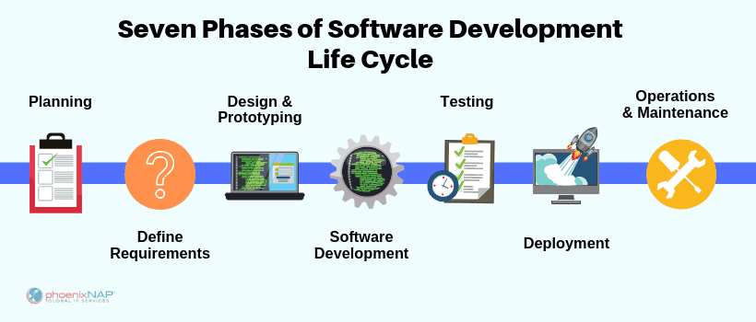

**What is Use case Diagram? Create a use-case on bill payment on Paytm.**

A **use case diagram** is a graphical depiction of a user's possible interactions with a system.

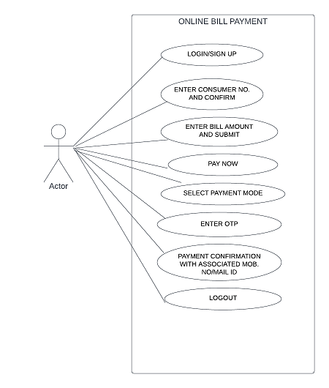

**What is DFD? Create a DFD diagram on Flipkart.**

A data-flow diagram is a way of representing a flow of data through a process or a system. The DFD also provides information about the outputs and inputs of each entity and the process itself.

DFD of flipkart 0 level:

Customer management

**FLIPKART**

Login management

Product management

Sales management

System/

Admin

Shipment management

**What is Flow chart? Create a flowchart to make addition of two numbers.**

PRINT SUM

SUM = NUM1 +NUM2

INPUT NUM1 AND NUM2