Atma Ram Sanatan Dharma College University of Delhi



Database Management Systems

Practical File for Paper Code 323xxxxx

Submitted By Sudipto Ghosh

College Roll No. 19/78003 BSc (Hons) Computer Science

Submitted To Ms Manisha Bagri

Department of Computer Science

# INDEX

|  |  |  |  |
| --- | --- | --- | --- |
| S No. | Objective | Date | Sign |
| **1** | Query to display Employee Name, Job, Hire Date, Employee Number; for each employee with the Employee Number appearing first. |  |  |
| **2** | Query to display unique jobs from the Employee Table. |  |  |
| **3** | Query to display the Employee Name concatenated by a Job separated by a comma. |  |  |
| **4** | Query to display all the data from the Employee Table. Separate each Column by a comma and name the said column as THE_OUTPUT. |  |  |
| **5** | Query to display the Employee Name and Salary of all the employees earning more than $2850. |  |  |
| **6** | Query to display Employee Name and Department Number for the Employee No = 79. |  |  |
| **7** | Query to display Employee Name and Salary for all employees whose salary is not in the range of $1500 and  $2850. |  |  |
| **8** | Query to display Employee Name and Department No. of all the employees in Dept 10 and Dept 30 in the alphabetical order by name. |  |  |
| **9** | Query to display Name and Hire Date of every Employee who was hired in 1981. |  |  |
| **10** | Query to display Name and Job of all employees who have not been assigned a supervisor. |  |  |
| **11** | Query to display the Name, Salary and Commission for all the employees who earn commission. |  |  |

|  |  |
| --- | --- |
| **12** | Sort the data in descending order of Salary and Commission. |
| **13** | Query to display Name of all the employees where the  third letter of their name is ‘A’. |
| **14** | Query to display Name of all employees either have two ‘R’s or have two ‘A’s in their name and are either in Dept No = 30 or their Manger’s Employee No = ‘778’. |
| **16** | Query to display the Current Date along with the day name. |
| **17** | Query to display Name, Hire Date and Salary Review Date which is the 1st Monday after six months of employment. |
| **18** | Query to display Name and calculate the number of months between today and the date on which employee was hired of department ‘Purchase’. |
| **19** | Query to display the following for each employee <E- Name> earns < Salary> monthly but wants < 3 * Current Salary >. Label the Column as Dream Salary. |
| **20** | Query to display Name with the 1st letter capitalized and all other letter lower case and length of their name of all the employees whose name starts with ‘J’, ’A’ and ‘M’. |

DATABASE SCHEMA

RELATION: EMPLOYEE

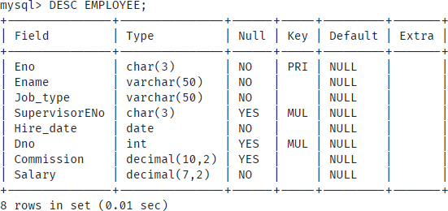

RELATION: DEPARTMENT

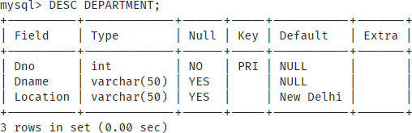

# DDL

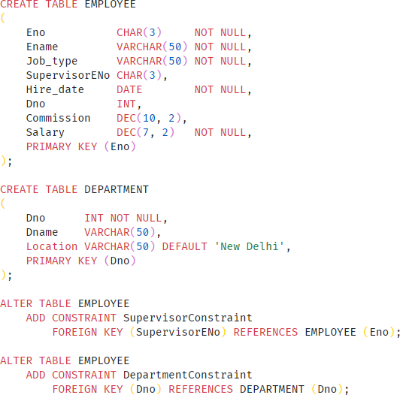

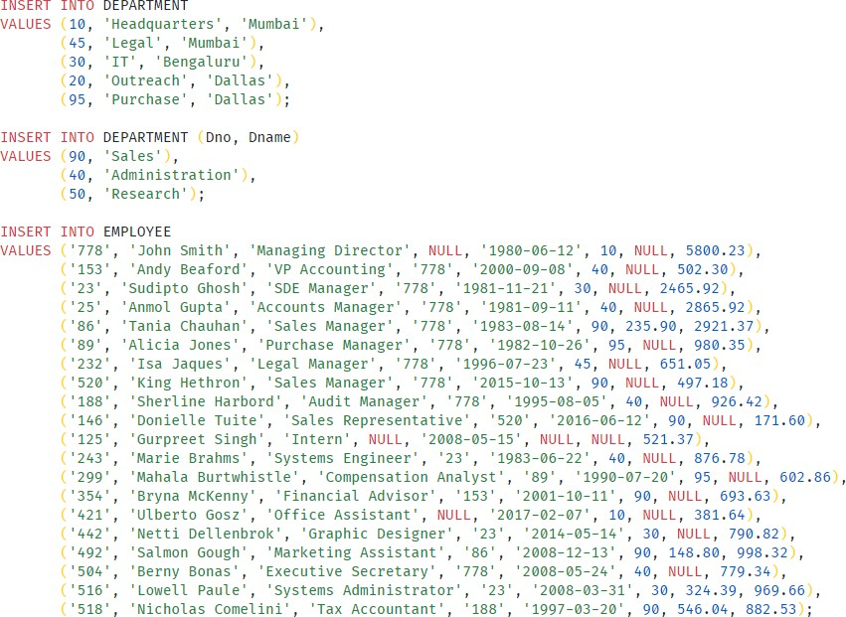

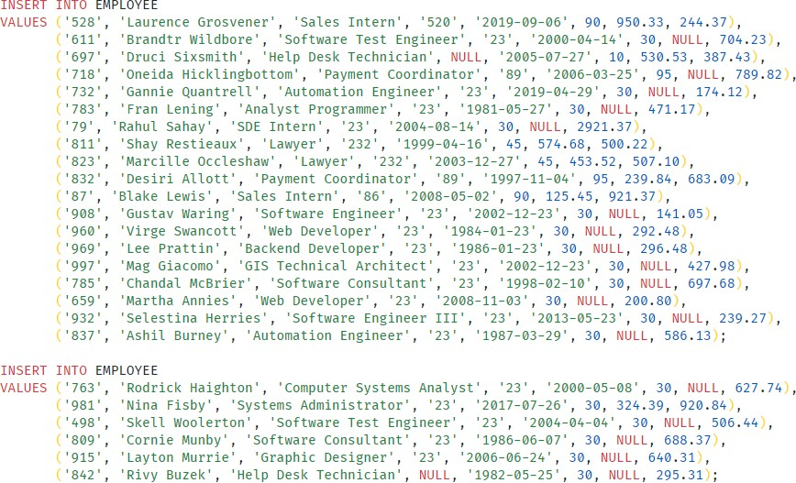

Query to display Employee Name, Job, Hire Date, Employee Number for each employee with the Employee Number appearing first.

Query

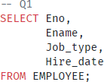

Results

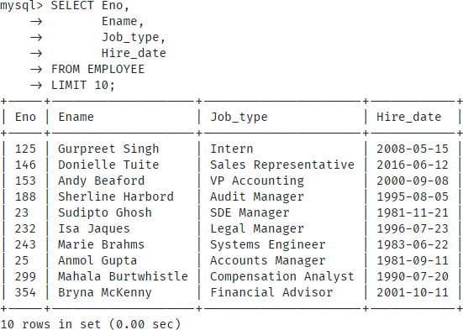

Query to display unique jobs from the Employee Table.

Query

Results

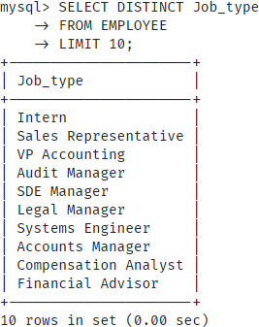

Query to display the Employee Name concatenated by a Job separated by a comma.

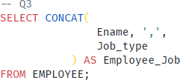Query

Results

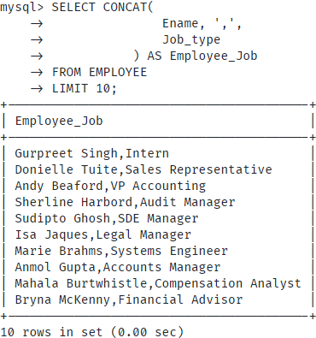

Query to display all the data from the Employee Table. Separate each Column by a comma and name the said column as THE_OUTPUT.

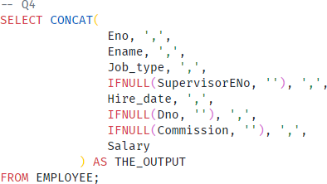Query

Results

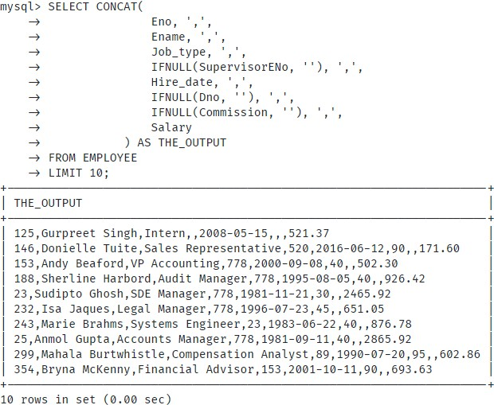

Query to display the Employee Name and Salary of all the employees earning more than $2850.

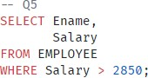Query

Results

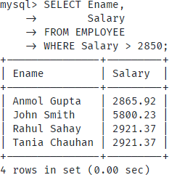

Description

# QUERY 6

Query to display Employee Name and Department Number for the Employee No = 79.

Query

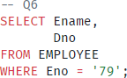

Results

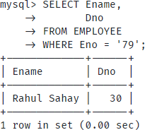

Query to display Employee Name and Salary for all employees whose salary is not in the range of

$1500 and $2850.

Query

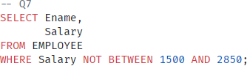

Results

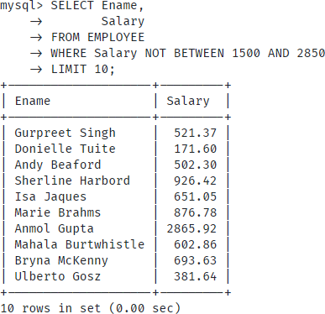

Query to display Employee Name and Department No. of all the employees in Dept 10 and Dept 30 in the alphabetical order by name.

Query

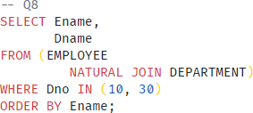

Results

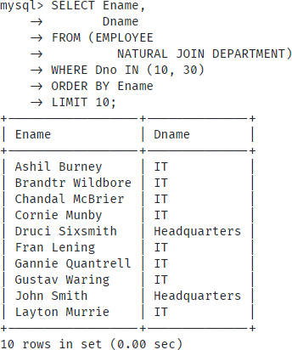

Query to display Name and Hire Date of every Employee who was hired in 1981.

Query

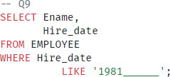

Results

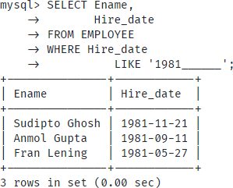

Query to display Name and Job of all employees who have not been assigned a supervisor.

Query

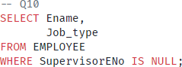

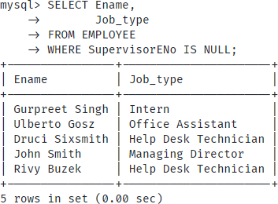Results

Query to display the Name, Salary and Commission for all the employees who earn commission.

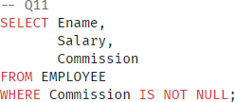Query

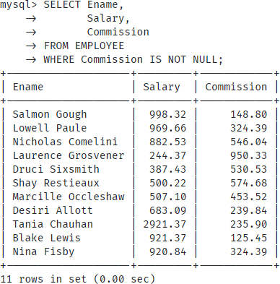Results

Sort the data in descending order of Salary and Commission.

Query

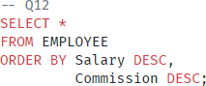

Results

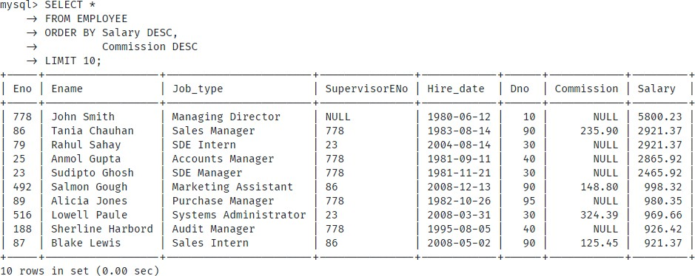

Query to display Name of all the employees where the third letter of their name is ‘A’.

Query

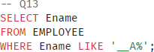

Results

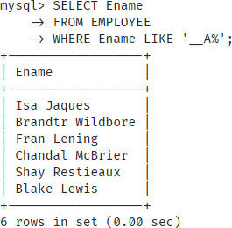

Query to display Name of all employees either have two ‘R’s or have two ‘A’s in their name and are either in Dept No = 30 or their Manger’s Employee No = ‘778’.

Query

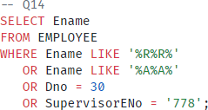

Results

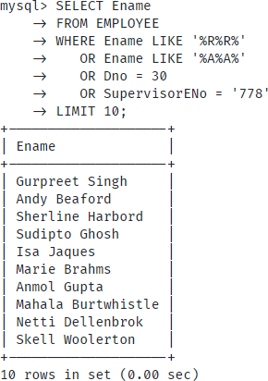

Query to display the Current Date along with the day name.

Query



Results

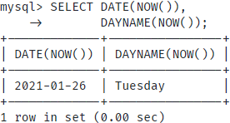

Query to display Name, Hire Date and Salary Review Date which is the 1st Monday after six months of employment.

Query

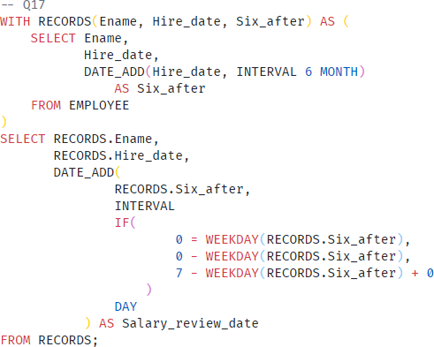

Results

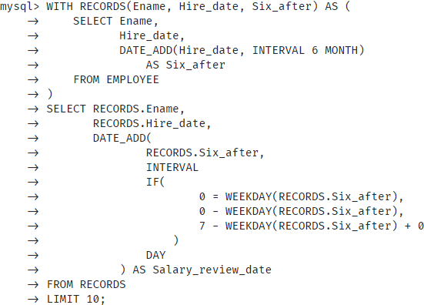

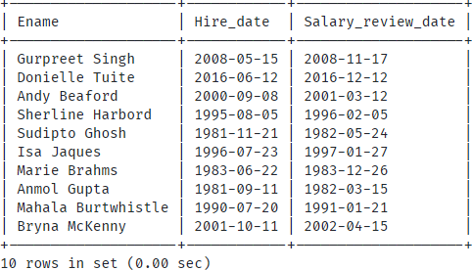

Description

# QUERY 18

Query to display Name and calculate the number of months between today and the date on which

employee was hired of department ‘Purchase’.

Query

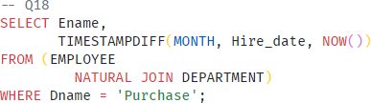

Results

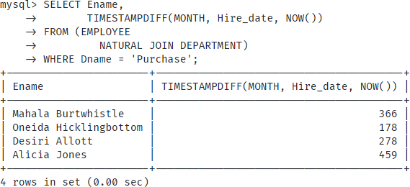

Description

# QUERY 19

Query to display the following for each employee <EName> earns < Salary> monthly but wants < 3 * Current Salary >. Label the Column as Dream Salary.

Query

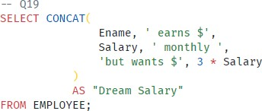

Results

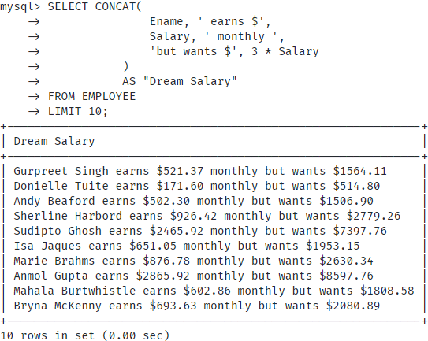

Description

# QUERY 20

Query to display Name with the 1st letter capitalized and all other letter lower case and length of their name of all the employees whose name starts with ‘J’, ’A’ and ‘M’.

Query

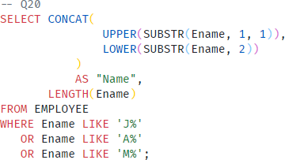

Results

