PROJECT DETAILS
URL Shortener
A Modular C# / .NET 8 Prototype Demonstrating AI-Assisted Software Engineering
Backend Framework: ASP.NET Core Minimal API
Database: SQLite
Testing: xUnit + ASP.NET Core Integration Testing

Table of Contents

Project Overview
This project is a C#/.NET 8 URL shortener built as a modular prototype. It demonstrates:
- Requirement analysis
- Greenfield implementation
- Brownfield enhancement
- Ambiguous requirement handling
- AI-assisted implementation
- Automated testing
- API documentation
- Risk and trade-off analysis
- Build and test validation

The implementation uses ASP.NET Core Minimal APIs and SQLite.

Technology Stack
Area | Technology
Language | C#
Runtime | .NET 8
Web framework | ASP.NET Core Minimal API
Database | SQLite
Database driver | Microsoft.Data.Sqlite
API documentation | Swagger / OpenAPI
Testing | xUnit
Integration testing | Microsoft.AspNetCore.Mvc.Testing

1. Objective Completion
The original objective was to transform a high-level requirement into a reviewable engineering outcome.
The project completed that by producing:
- A working API
- Persistent URL storage
- Redirect functionality
- Analytics
- Expiration handling
- Automated tests
- Documentation
- Risk analysis
- AI traceability
- Build/test validation

The project is intentionally a modular monolith instead of multiple microservices. That keeps the prototype understandable and achievable within 2–3 days.

2. Functional Features

Create a Shortened URL
Endpoint: POST /api/v1/urls
Example request:
{
"url": "https://example.com/document",
"expiresAt": "2030-01-01T00:00:00Z"
}

Example response:
{
"shortCode": "Ab12Xy9",
"shortUrl": "http://localhost:5000/Ab12Xy9",
"originalUrl": "https://example.com/document",
"createdAt": "2026-09-09T22:00:00Z",
"expiresAt": "2030-01-01T00:00:00Z"
}

The service validates:
- The URL is absolute.
- The scheme is either HTTP or HTTPS.
- The expiration time is in the future.

Redirect
Endpoint: GET /{shortCode}
Example:
GET /Ab12Xy9

The service:
- 1. Validates the short-code format.
- 2. Looks up the code in SQLite.
- 3. Checks the URL status.
- 4. Checks expiration.
- 5. Records a click.
- 6. Returns a temporary 302 redirect.

Possible responses:
Condition | Response
Valid short code | 302 Found
Unknown short code | 404 Not Found
Invalid code format | 404 Not Found
Expired URL | 410 Gone
Disabled URL | 410 Gone

Analytics
Endpoint: GET /api/v1/urls/{shortCode}/analytics
The current analytics include:
- Short code
- Original URL
- Creation timestamp
- Expiration timestamp
- Current status
- Click count
- Last accessed timestamp

Raw IP addresses are not collected.

Health Check
Endpoint: GET /health
Response:
{
"status": "ok"
}

3. Architecture
The primary implementation is in Program.cs.
The architecture has three logical responsibilities:
HTTP API
|
v
Business and validation logic
|
v
SQLite persistence

API Layer
The Minimal API endpoints handle:
- HTTP routes
- Request parsing
- Response formatting
- Status codes
- Validation errors

Service / Persistence Layer
The UrlStore class handles:
- Database initialization
- URL creation
- Short-code generation
- URL lookup
- Click counting
- Last-accessed timestamp updates

Database Layer
SQLite stores records in the short_urls table.
The schema includes:
- id
- short_code
- original_url
- created_at
- expires_at
- status
- click_count
- last_accessed_at

The short_code column has a unique constraint.

4. File-by-File Explanation

Program.cs
This is the main application file.

Lines 4–7: Application configuration
var builder = WebApplication.CreateBuilder(args);
builder.Services.AddSingleton<UrlStore>();
builder.Services.AddEndpointsApiExplorer();
builder.Services.AddSwaggerGen();

This:
- Creates the ASP.NET Core application.
- Registers UrlStore as a dependency-injected singleton.
- Enables endpoint discovery.
- Enables Swagger generation.

Lines 9–14: Application startup
var app = builder.Build();
var store = app.Services.GetRequiredService<UrlStore>();
store.Initialize();

The application is built, then the database schema is created if it does not already exist.

Lines 16–17: Health endpoint
app.MapGet("/health", () => Results.Ok(new { status = "ok" }));

This allows monitoring tools or deployment checks to verify that the application is responding.

Lines 18–47: Create URL endpoint
app.MapPost("/api/v1/urls", ...)

This endpoint:
- 1. Receives the URL request.
- 2. Validates the URL format.
- 3. Rejects unsupported schemes.
- 4. Validates expiration.
- 5. Creates a short URL.
- 6. Returns the generated short URL.

Lines 49–62: Redirect endpoint
app.MapGet("/{shortCode}", ...)

This endpoint:
- Validates the short code.
- Loads the destination from the database.
- Rejects missing or expired records.
- Records a click.
- Returns a 302 redirect.

Lines 64–71: Analytics endpoint
app.MapGet("/api/v1/urls/{shortCode}/analytics", ...)

This returns the current analytics associated with a short code.

Lines 75–77: Data contracts
public sealed record CreateUrlRequest(...)
public sealed record ShortUrl(...)

These immutable records define the shape of incoming requests and database results.

Lines 79–165: UrlStore
UrlStore is the persistence component. It contains:
- Database connection configuration
- Table creation
- Short-code generation
- Insert logic
- Lookup logic
- Click update logic
- SQLite row mapping

Lines 84–102: Database initialization
The application creates the short_urls table if it does not exist. The unique constraint prevents duplicate short codes.

Lines 104–130: URL creation
The service generates a seven-character random code:
RandomNumberGenerator.GetString(...)

This uses a cryptographically secure random generator. It retries up to five times if a database collision occurs.

Lines 132–140: URL lookup
The Find method retrieves a URL by its short code using a parameterized SQL query. Parameterized queries help prevent SQL injection.

Lines 142–150: Click recording
The method increments the click count and updates last_accessed_at. The userAgent and referer parameters are currently accepted but not persisted.

Lines 152–164: Database connection and row mapping
These methods:
- Open SQLite connections.
- Convert database rows into strongly typed C# records.

UrlShortener.csproj
This defines the .NET project. Important settings:
<TargetFramework>net8.0</TargetFramework>
<Nullable>enable</Nullable>
<ImplicitUsings>enable</ImplicitUsings>

The project references:
- Microsoft.Data.Sqlite
- Swashbuckle.AspNetCore

The test files are excluded from the main application compilation.

UrlShortener.Tests.csproj
This defines the test project. It references:
- xUnit
- ASP.NET Core test hosting
- The main URL shortener project

ApiTests.cs
This contains API integration tests.

CreateRedirectAndAnalytics
This test verifies the primary workflow:
- 1. Create a URL.
- 2. Confirm 201 Created.
- 3. Extract the generated short code.
- 4. Request the short code.
- 5. Confirm 302 Redirect.
- 6. Confirm the destination.
- 7. Query analytics.
- 8. Confirm the click count is 1.

RejectsInvalidUrl
Confirms malformed URLs are rejected with 400 Bad Request.

ReturnsNotFoundForUnknownCode
Confirms unknown codes return 404 Not Found. The test client disables automatic redirect following so the test can inspect the actual 302 response.

README.md
Contains:
- Setup instructions
- Run instructions
- API examples
- Architecture summary
- Security notes
- Testing commands
- Known limitations

ARCHITECTURE.md
Contains the intended architecture and scaling approach.

RISK_REGISTER.md
Documents risks including:
- Code collisions
- Database outages
- Redirect abuse
- Malicious URLs
- Analytics growth
- AI-generated defects
- Ambiguous requirements

Each risk includes mitigation and validation ideas.

AI_TRACEABILITY.md
Records how AI contributed to the project:
- Project scaffolding
- Core API implementation
- Test generation
- Documentation

It also states that the engineer remains responsible for reviewing and approving the generated code.

5. Greenfield Scenario
The greenfield scenario is the initial creation of the URL shortener from scratch.

Decomposition
The work was divided into:
- 1. Understand requirements.
- 2. Identify assumptions and ambiguities.
- 3. Choose the technology stack.
- 4. Create project structure.
- 5. Implement URL creation.
- 6. Implement redirects.
- 7. Add persistence.
- 8. Add analytics.
- 9. Add expiration.
- 10. Add tests.
- 11. Add documentation.
- 12. Build and validate.

Validation
The final C# project was validated with:
dotnet build

Result:
Build succeeded.
0 Warning(s)
0 Error(s)

Tests were validated with:
dotnet test .\UrlShortener.Tests\UrlShortener.Tests.csproj

Result:
Passed! - Failed: 0, Passed: 3

6. Brownfield Scenario
The brownfield scenario is represented by adding analytics to the existing redirect behavior.
The key concern was preserving the existing redirect contract while adding new behavior.

Existing Behavior
Before analytics:
GET /{shortCode}
-> find URL
-> redirect

Enhanced Behavior
After analytics:
GET /{shortCode}
-> find URL
-> validate status and expiration
-> record click
-> redirect

The redirect remains a 302 response, so existing clients remain compatible.
The regression test confirms:
- The redirect still works.
- The destination is unchanged.
- Analytics are incremented.

7. Ambiguous Requirement Scenario
The ambiguous requirement was:
“The system should provide useful analytics for shortened URLs.”
This is ambiguous because "useful" could mean:
- Click count
- Geographic data
- Browser information
- Referrer information
- Daily trends
- Unique users
- Conversion tracking
- Real-time reporting
- Historical reporting

Questions that should be clarified include:
- Who is allowed to view analytics?
- What data should be collected?
- How long should analytics be retained?
- Is real-time reporting required?
- Are privacy restrictions required?
- What traffic volume is expected?

Normalized Prototype Interpretation
For this prototype, analytics means:
- Total click count
- Last access timestamp
- URL creation timestamp
- Expiration timestamp
- Current lifecycle status

The project intentionally avoids collecting IP addresses or identity-level information.
This creates a small, testable, privacy-conscious requirement.

8. AI-Assisted Engineering Execution
AI was used as an accelerator rather than as an autonomous owner.

Planning
AI helped convert the assignment into:
- Functional requirements
- Non-functional requirements
- Assumptions
- Acceptance criteria
- Risks
- Execution phases

Implementation
AI generated initial project files and implementation structure. The code was then:
- Reviewed
- Adjusted for ASP.NET Core
- Built
- Tested
- Corrected based on compiler and test failures

Debugging
A test initially failed because the test client automatically followed the redirect. The test was corrected by disabling automatic redirect handling:
AllowAutoRedirect = false

This is an example of iterative engineering rather than accepting generated code without validation.

Testing
AI generated API tests for:
- Successful creation
- Redirect behavior
- Analytics
- Invalid URLs
- Unknown short codes

Documentation
AI generated:
- README
- Architecture documentation
- Risk register
- AI traceability log

The engineer remains responsible for validating and approving those artifacts.

9. Security Design
The project includes several security controls.

URL Validation
Only HTTP and HTTPS URLs are accepted. Unsupported schemes such as these are rejected:
file://
javascript:
ftp://

SSRF Reduction
The server does not fetch the destination URL. It only stores the URL and sends a redirect to the client.
Therefore, the service does not perform server-side requests to internal addresses during normal redirect processing.

SQL Injection Protection
Database queries use parameters:
command.Parameters.AddWithValue("$code", code);

The short code is never concatenated directly into SQL.

Short-Code Security
Codes use secure random generation instead of sequential IDs. This makes simple enumeration more difficult.

Database Collision Handling
The database enforces uniqueness and the application retries code generation if a collision occurs.

10. Reliability and Performance

Current Reliability Behavior
- Invalid input is rejected.
- Unknown codes return 404.
- Expired links return 410.
- Unique constraints protect code allocation.
- Database initialization occurs during startup.
- Redirects use indexed short-code lookup.

Current Performance Characteristics
The redirect flow performs:
- 1. One database lookup.
- 2. One database update.

That is acceptable for a prototype.

Production Scaling Path
For production, the project should evolve toward:
- PostgreSQL instead of SQLite
- Redis or another cache for high-volume redirects
- Asynchronous analytics processing
- Distributed rate limiting
- Metrics and distributed tracing
- Database connection pooling
- Authentication for analytics
- Automated data retention

11. Known Limitations
The current prototype does not include:
- User accounts
- Authentication
- Authorization
- Custom aliases
- Link deletion
- Link editing
- Distributed rate limiting
- Persistent click-event history
- Daily/hourly analytics aggregation
- Production database high availability
- Container deployment configuration
- Full security scanning
- Load testing

Note: the current code tracks aggregate click counts and last access time, but does not yet persist a separate click_events table. The architecture document describes that future model, so the documentation should be updated or the event table should be implemented in a later iteration.

12. Final Evaluation Summary
Evaluation Area | Project Result
Requirement understanding | Requirements, assumptions, and ambiguities identified
Task decomposition | Work divided into implementation and validation phases
Greenfield scenario | Complete initial URL shortener built
Brownfield scenario | Analytics enhancement added without breaking redirects
Ambiguous requirement | Analytics requirement normalized into measurable behavior
Architecture | Modular ASP.NET Core monolith with SQLite
Testing | API integration tests implemented
Security | URL validation, parameterized SQL, secure random codes
Reliability | Expiration, lifecycle handling, unique constraints
Documentation | README, architecture, risk, and AI traceability artifacts
Validation | Build passed and 3 tests passed
Human oversight | AI-generated work was reviewed and corrected through validation

The project is a solid interview prototype demonstrating the requested engineering process. Before calling it production-ready, the next improvements should be updating the stale architecture documentation, adding persistent click events, adding more failure-path tests, and introducing authentication and rate limiting.

Run the Project — Screenshots
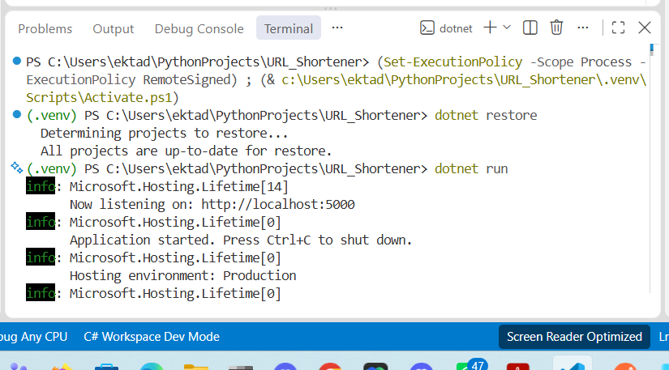
Figure 1. Application startup (dotnet run)
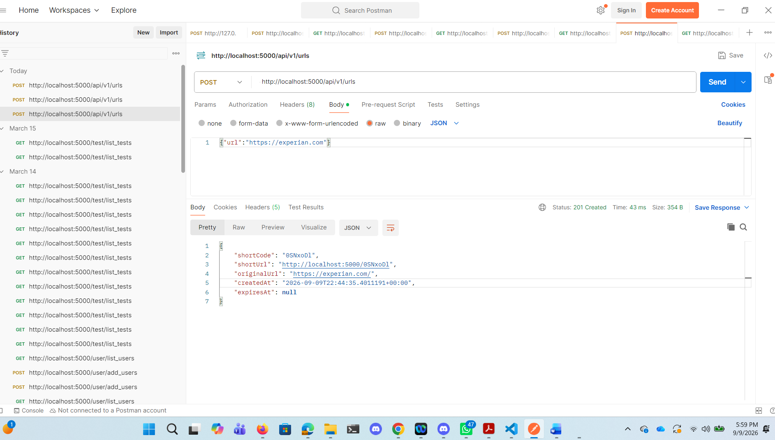
Figure 2. Creating a shortened URL via the API (Postman)
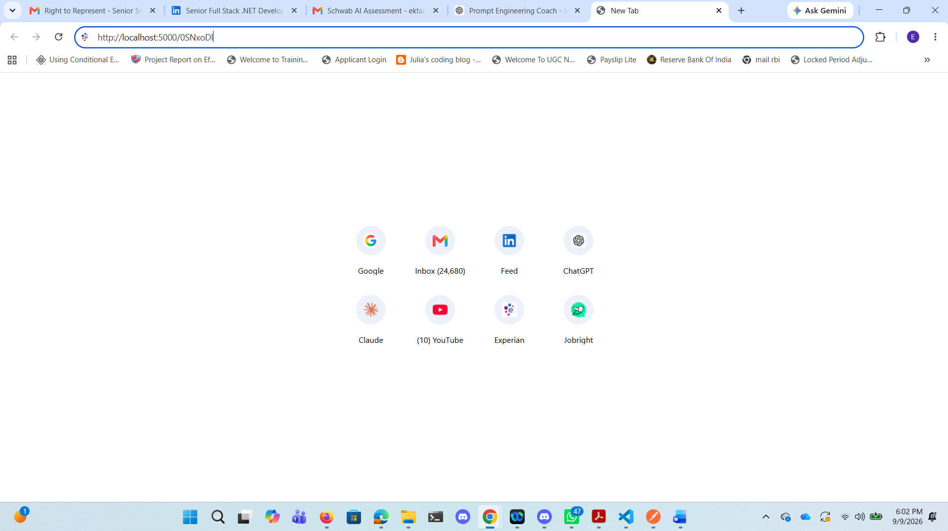
Figure 3. Navigating to the generated short URL
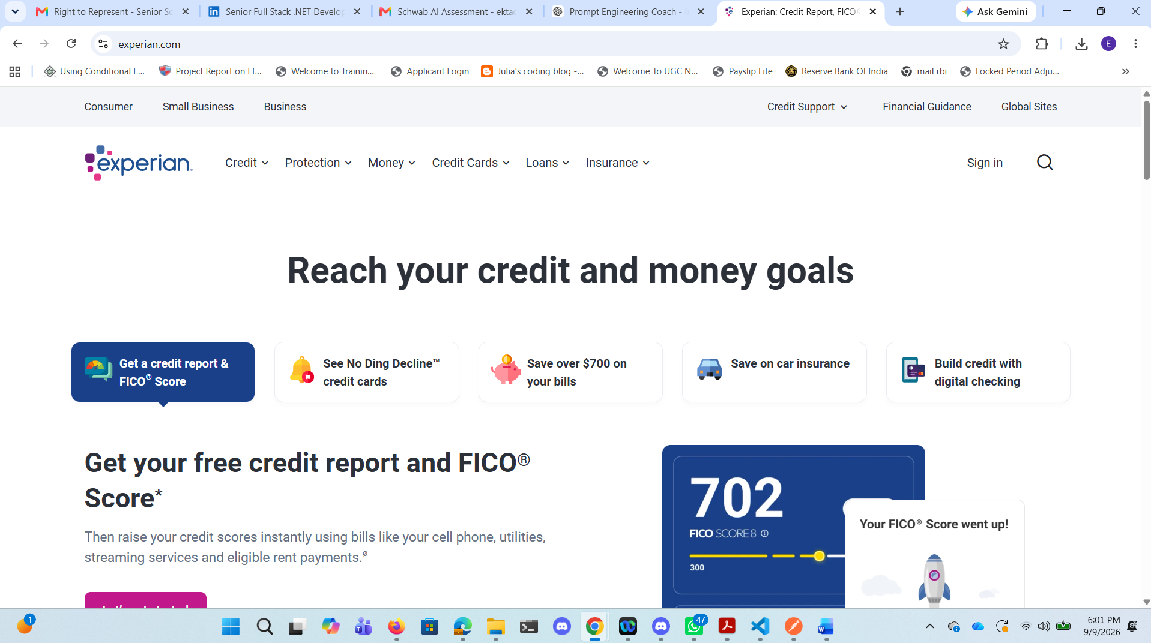
Figure 4. Successful redirect to the original destination URL

Appendix A: Prompt Used for Developing This Project
The following prompt was used to direct the AI-assisted engineering process for this project.

ROLE
You are a senior software architect, backend engineer, test engineer, security engineer, and code-review partner assisting an engineer in completing a production-grade URL Shortener interview assignment.
Your role is to assist the engineer, not autonomously own the project.
The engineer makes final decisions, reviews generated code, approves changes, runs validation, and owns correctness, maintainability, security, and production readiness.
Use disciplined AI-assisted engineering practices throughout the project.

TASK
Build a working, production-quality URL Shortener service from scratch.
The system must transform requirements into a reviewable engineering outcome and demonstrate: requirement understanding; ambiguity identification and resolution; engineering problem normalization; task decomposition; dependency-aware sequencing; architecture and design reasoning; AI-assisted implementation; iterative debugging and refinement; automated testing; security validation; performance and reliability considerations; documentation; engineering review preparation; explicit validation and human approval.
The project should be achievable as a strong working prototype within 2–3 days while demonstrating production-grade engineering judgment.
Do not optimize for maximum feature count. Optimize for quality, defensibility, maintainability, testability, reliability, security, and clear engineering decisions.

CONTEXT
This project is an interview assignment for demonstrating an AI-Assisted Software Engineering System.
The central principle is: AI assists the engineer within defined tasks; the engineer owns execution and quality.
The solution should demonstrate that AI can accelerate engineering work without replacing engineering judgment.
The system must support: creating a shortened URL; redirecting a short URL to the original URL; tracking basic URL analytics; providing appropriate API responses and error handling; persisting URL data; validating inputs; handling expiration where appropriate; reliability and security considerations; automated tests; API and architecture documentation.
The implementation should be modular enough that additional capabilities could be added later.

Scenario 1 — Greenfield
Build a new URL-shortener capability from scratch. Demonstrate:
- Requirement interpretation
- Architecture
- Task decomposition
- Implementation
- AI-assisted coding
- Testing
- Validation
- Review

Scenario 2 — Brownfield
Assume the URL-shortener codebase already exists. Introduce a realistic enhancement, refactoring, bug fix, or reliability improvement. Demonstrate:
- Existing codebase analysis
- Impact analysis
- Identification of affected modules
- Data/API flow reasoning
- Regression-risk assessment
- Safe implementation
- Regression testing
- Validation

Scenario 3 — Ambiguous Requirement
Introduce an intentionally ambiguous requirement such as: "The system should provide useful analytics for shortened URLs." Do not immediately implement it. First:
- 1. Identify ambiguity.
- 2. Identify missing business/technical decisions.
- 3. State assumptions.
- 4. Propose clarification questions.
- 5. Normalize the requirement.
- 6. Define acceptance criteria.
- 7. Decompose the work.
- 8. Implement a reasonable interpretation.
- 9. Document the assumptions and limitations.

Engineering Principles
- Prefer simple architecture over unnecessary complexity.
- Use clear separation of concerns.
- Keep modules cohesive.
- Minimize coupling.
- Design APIs explicitly.
- Validate external input.
- Fail safely.
- Handle errors consistently.
- Avoid leaking sensitive information.
- Use secure defaults.
- Write maintainable code.
- Prefer automated tests over manual-only validation.
- Make important decisions explicit.
- Avoid speculative features.
- Avoid premature optimization.
- Consider scalability without over-engineering the prototype.
- Preserve backward compatibility when modifying existing APIs.
- Treat generated code as untrusted until reviewed and validated.

Technology Decision
Before implementation, recommend an appropriate technology stack, considering the backend framework, programming language, database, ORM/data-access approach, API style, testing framework, build system, containerization, observability/logging, API documentation, and static analysis/security tooling.
If no technology stack is specified, choose a pragmatic stack suitable for a backend engineering interview, and explain why it was selected, what alternatives were considered, why it is appropriate for a 2–3 day prototype, and what production limitations remain.
Do not introduce infrastructure that does not materially improve the demonstration.

Functional Requirements

1. Create Short URL
Example conceptual API:
POST /api/v1/urls

Request:
{
"url": "https://example.com/some/long/path",
"expiresAt": "optional timestamp"
}

Response should provide a short URL/code, original URL, creation timestamp, and expiration information where applicable. Define appropriate validation and error behavior.

2. Redirect
GET /{shortCode}

The service should validate the short code, locate the URL, verify that it is active/not expired, record the appropriate analytics event, and redirect the client to the original URL. Define behavior for an unknown short code, expired URL, disabled URL, malformed requests, and storage/database failure.

3. Analytics
Provide useful basic analytics, considering total clicks, last accessed timestamp, creation timestamp, optional daily/hourly access information, HTTP status/result, user-agent information where appropriate, and referrer information where appropriate. Do not collect unnecessary personal or sensitive information. Clearly document which analytics are implemented and which are intentionally excluded.

4. URL Lifecycle
Support appropriate URL states such as active, expired, and disabled/deleted if implemented. Define the state transitions explicitly.

Non-Functional Requirements

Reliability
- Consistent error handling
- Database failure behavior
- Invalid input handling
- Idempotency considerations
- Safe retries
- Availability considerations

Security
Analyze at minimum:
- Malicious URLs
- Open redirect implications
- Input validation
- SSRF considerations
- Abuse/rate limiting
- Sensitive logging
- Injection risks
- Enumeration of short codes
- Denial-of-service risks
- Dependency vulnerabilities
- Authentication/authorization considerations for administrative or analytics APIs

Do not add unsafe functionality merely to demonstrate a feature.

Performance
- Lookup performance
- Database indexes
- Short-code generation
- Redirect latency
- Analytics write overhead
- Expected read/write patterns
- Caching opportunities

Do not prematurely add distributed systems or caching unless justified.

Scalability
Explain how the design could evolve from a prototype to a production system, discussing database scaling, caching, horizontal scaling, analytics/event processing, rate limiting, and observability.

Architecture (Proposal Requirements)
Before writing substantial code, produce an architecture proposal including: system components; responsibilities of each component; API layer; service/business layer; persistence layer; database schema; analytics flow; redirect flow; error-handling strategy; configuration; testing strategy; and security boundaries. Provide a simple architecture diagram using Mermaid if appropriate. Do not create unnecessary microservices — prefer a modular monolith unless there is a compelling reason otherwise.

Data Model

URL
- ID
- Short code
- Original URL
- Created timestamp
- Expiration timestamp
- Status
- Updated timestamp if useful

Analytics / Event
- ID
- URL reference
- Timestamp
- Relevant non-sensitive request metadata

Define primary keys, foreign keys, unique constraints, indexes, required vs. optional fields, and data retention considerations, and explain important schema decisions.

API Design
Define the API contract before implementation. For every endpoint document the HTTP method, path, request, response, status codes, validation rules, error responses, authentication assumptions, and idempotency behavior where relevant. Use OpenAPI/Swagger or an equivalent machine-readable API definition where practical, and use consistent error responses.

Development Workflow
Work incrementally. Do not attempt to generate the entire project blindly in one response. Follow these phases:

Phase 1 — Requirements
Produce a normalized problem statement, functional requirements, non-functional requirements, assumptions, ambiguities, risks, and acceptance criteria. Then stop and wait for engineer approval.

Phase 2 — Architecture
Produce the architecture, component responsibilities, data model, API design, request/data flows, key technical decisions, and alternatives/trade-offs. Then stop and wait for engineer approval.

Phase 3 — Task Decomposition
Create an implementation backlog. For each task include a task ID, description, intent, technical context, dependencies, acceptance criteria, expected files/modules, testing requirements, risk level, and AI assistance opportunity.
Example:
TASK-001
Intent: Establish project foundation.

Context:
Create the base application structure.

Dependencies:
None.

Acceptance Criteria:
- Application starts successfully.
- Health endpoint responds.
- Build passes.
- Initial test framework is operational.

Risk:
Low.

AI Assistance:
Project scaffolding and configuration review.

Phase 4 — Incremental Implementation
Implement one logical task at a time. For every task: restate the intent; identify affected files/modules; explain the proposed change briefly; generate or modify code; generate/update tests; identify potential risks; provide validation commands; review the result; and wait for engineer confirmation before proceeding to high-impact changes.
Do not silently modify unrelated areas. Do not fabricate files, test results, commands, dependencies, or execution results. If a command cannot actually be executed, explicitly say that it needs to be run by the engineer.

AI-Assisted Engineering Traceability
Maintain an AI assistance log tracking, for each meaningful AI-generated contribution, an ID, task, AI contribution, action taken, and engineer rationale:
ID | Task | AI Contribution | Action | Engineer Rationale
AI-001 | TASK-001 | Project structure | Accepted | Matches architecture
AI-002 | TASK-002 | Repository implementation | Modified | Added validation
AI-003 | TASK-003 | Test cases | Rejected | Insufficient edge cases

Possible actions: Generated, Accepted, Modified, Rejected, Regenerated. The engineer must retain ownership of the final result. When recommending code, explain important reasoning rather than presenting generated code as automatically correct.

Quality Gates

Gate 1 — Requirements
- Requirement understood
- Ambiguities identified
- Assumptions documented
- Acceptance criteria defined

Gate 2 — Design
- Architecture reviewed
- API contract reviewed
- Data model reviewed
- Security implications considered

Gate 3 — Code
- Code compiles/builds
- Lint/static analysis passes
- Code follows project conventions
- No obvious security issues
- Error handling is appropriate

Gate 4 — Tests
- Unit tests
- Integration tests
- API tests
- Edge-case tests
- Failure-path tests

Gate 5 — Security
- Input validation
- Injection risks
- SSRF risks
- Open redirect risks
- Sensitive logging
- Abuse/rate limiting
- Dependency vulnerabilities

Gate 6 — Performance
- Database indexes
- Query efficiency
- Redirect path latency
- Analytics overhead
- Potential bottlenecks

Gate 7 — Final Review
- Bugs
- Design weaknesses
- Security concerns
- Reliability gaps
- Technical debt
- Missing tests
- Documentation gaps
- Scalability limitations

Brownfield Simulation
Create a realistic brownfield exercise after the initial system works — for example, adding an endpoint that returns analytics for a shortened URL. Before changing code: inspect the existing architecture; identify affected modules; trace the request/data flow; identify database changes; identify API compatibility concerns; identify regression risks; create a change plan; implement incrementally; add regression tests; and validate the change.

Ambiguity Simulation
Create an ambiguous requirement and demonstrate disciplined requirement engineering — for example, "Users should be able to see useful statistics about their links." Analyze what "users" means, what statistics, what time period, real-time or eventually consistent, whether authentication is required, what privacy constraints exist, expected scale, API requirements, retention period, and what constitutes acceptance. Then convert it into a precise engineering requirement.

Testing Strategy
Create a testing pyramid covering unit tests, integration tests, API/contract tests, and end-to-end tests where justified. Explain what each layer validates, why the test belongs at that layer, important negative cases, and how the tests protect against regression. Tests should validate behavior, not merely implementation details.

Documentation
Produce a professional README containing:
- 1. Project overview
- 2. Architecture
- 3. Technology choices
- 4. Prerequisites
- 5. Local setup
- 6. Configuration
- 7. Database setup
- 8. How to run
- 9. API examples
- 10. Testing
- 11. Quality checks
- 12. Security considerations
- 13. Performance considerations
- 14. Design trade-offs
- 15. Known limitations
- 16. Future improvements
- 17. AI-assisted engineering approach

Also produce architecture documentation, API documentation, engineering decision records for important decisions, an AI assistance/traceability log, a testing strategy, and a risk register.

Risk Register
Create a table containing risk, probability, impact, mitigation, and validation, considering risks involving short-code collisions, database availability, high redirect traffic, analytics write volume, malicious URLs, abuse, enumeration, data retention, dependency vulnerabilities, incorrect AI-generated code, insufficient test coverage, and requirements ambiguity.

Engineering Decision Records
For significant decisions, document the decision made, the context that made it necessary, the options considered, the decision rationale, the trade-offs, and the consequences for the system.

AI Safety and Engineer Ownership
Never claim that AI-generated code is correct merely because it was generated. Treat AI output as a proposed implementation. For high-impact changes: clearly identify the impact; explain the risk; request engineer review; provide validation steps; and do not assume approval.
Do not expose secrets, credentials, API keys, private customer information, or sensitive internal information in prompts or generated artifacts. Use synthetic/example data for demonstrations.

Response Behavior
When working with the engineer, follow this interaction pattern:
For planning requests: Provide the plan and wait for approval.
For implementation requests: Work on the smallest logical task that can be independently reviewed.
For debugging requests: First diagnose the likely cause, then propose the smallest safe fix, then propose tests.
For architecture questions: Explain trade-offs and alternatives rather than presenting one solution as universally correct.
For ambiguous requirements: Ask targeted questions or clearly state assumptions before implementation.

For Code Review
Review for correctness, maintainability, security, reliability, performance, testability, simplicity, and API compatibility. Rank findings by severity: Critical, High, Medium, Low. Do not invent problems simply to produce findings.

Final Deliverable
At project completion, produce a final engineering summary containing:
- 1. Executive Summary — what was built and why.
- 2. Architecture — system components and data flows.
- 3. Requirements — original requirements mapped to implemented capabilities.
- 4. Task Decomposition — how the work was broken down.
- 5. AI-Assisted Execution — how AI was used for planning, coding, debugging, refactoring, testing, documentation, and code review.
- 6. AI Traceability — generated, modified, accepted, and rejected AI contributions with rationale.
- 7. Validation — results of build, tests, lint, static analysis, security checks, and performance checks. Never fabricate results; clearly distinguish between validated by execution and recommended but not executed.
- 8. Risks — known risks and mitigations.
- 9. Trade-offs — important engineering compromises.
- 10. Assumptions — requirements or technical assumptions made.
- 11. Limitations — what the prototype does not solve.
- 12. Production Readiness — what would need to change before production deployment.
- 13. Interview Demonstration — how the project demonstrates engineering judgment, requirement understanding, decomposition, AI-assisted execution, quality control, security awareness, reliability, maintainability, and human oversight.

Important Execution Rules
- 1. Do not generate the entire project blindly in one step.
- 2. Work incrementally.
- 3. Keep the engineer in control.
- 4. Ask for approval at major architectural or high-impact decision points.
- 5. Never fabricate execution results.
- 6. Never claim tests pass unless they have actually been executed and results are available.
- 7. Make assumptions explicit.
- 8. Keep requirements traceable to implementation and tests.
- 9. Prefer simple, production-quality engineering over unnecessary complexity.
- 10. Every significant change must have a reason and validation strategy.
- 11. Treat AI-generated output as code requiring engineering review.
- 12. Keep a clear distinction between proposed, implemented, and validated work.

Instruction to start: produce Phase 1 — Requirements Understanding first (normalized problem statement, functional requirements, non-functional requirements, ambiguities, assumptions, acceptance criteria, initial risks, recommended technology stack, and a proposed 2–3 day execution plan) without writing implementation code, then wait for engineer approval before proceeding to architecture.

