

**Dharmsinh Desai University, Nadiad**

**Faculty of Technology**

**Department of Computer Engineering**

B.Tech. CE Semester – VI

Subject: System Design Practice

Project Title: Employee Payroll Management System

By: Hemnani Ekta Prakash

CE042

18CEUOD021

Guided By: Prof. Sheetal Shah.



**Dharmsinh Desai University, Nadiad**

**Faculty of Technology**

**Department of Computer Engineering**

**CERTIFICATE**

This is to certify that the Project entitled “**Employee Payroll Management System”** carried out in subject of System Design Practice is the bonafide work of

**1) Ekta Hemnani (18CEUOD021)**

Of B.Tech, Semester VI in the branch of Computer Engineering during academic year 2019 - 2020.

|  |  |  |
| --- | --- | --- |
|  |  |  |
| **Guide** |  | **HOD** |
| **Prof. Sheetal Shah**  Assistant. Professor,  Computer Engineering Department,  Dharmsinh Desai University, Nadiad |  | **Dr. C. K. Bhensdadia**  Head,  Computer Engineering Department,  Dharmsinh Desai University, Nadiad |
|  |  |  |
|  |  |  |

Contents:

1. Introduction.
2. Software Requirement Specification.
3. Design
4. Implementation Detail.
5. Screenshots.
6. Conclusion.
7. Limitation and Future Extension.
8. Bibliography.

**Abstract**

Till now the details of all the employees of the company were recorded manually so the employee record management was becoming difficult to manage. Employee details such as personal details, Monthly Attendance and Salary information used to be added and updated frequently so management of data became difficult day by day.

The purpose of the Employee Payroll Management System is to automate existing manual system by the help of computerized equipment and full-fledged computer software, fulfilling the requirements.

The Employee has to register himself to get a username and password. Then employee can always login using that username and password. Employee can view his attendance and income information in his account. Adding Monthly Attendance of each employee and updating Salary details is done by Admin.

**Introduction**

Employee Payroll Management system is platform which provides facility to record Every Detail of employee in the system.

The project of creating Web Application on Payroll Management System is created using PHP. For the development of frontend pages, HTML, CSS and Bootstrap is used. To Store User Data and manage the backend, MySQL is used.

**Software Requirement Specification**

Users:

1. Admin

2. Employee

Functional Requirements:

R1- Manage Login

Description: Verify User login credentials and proceed

Input: Login Credentials.

Output: Home Page

Exception: If user login details are not valid, error message is displayed.

R2 - Manage Employee

R2.1: Display details.

Description: Display employee details like personal information, Attendance, Income.

Input: User Selection.

Output: User Data.

R3 - Manage Admin

R3.1: Manage Employee

Description: Admin can add new employee, add monthly attendance of the employee, and update the basic salary of the employee. Admin can also view employee data, update employee personal details, and delete the employee record.

R3.3.1: Add New Employee.

Description: If a new employee is joining, register him.

Input: Employee details.

Output: Confirmation message.

R3.3.2: Display Employee.

Description: Display employee details like personal information, Attendance, Income.

Input: User Selection.

Output: User Data.

R3.3.3: Update Employee details

Description: Display employee details like personal information, Attendance, Income and allow to modify it.

Input: User Selection and Data to modify.

Output: Confirmation message with Modified User Data.

R3.3.4: Delete Employee Record.

Description: Display employee and allow to delete

Input: User Selection.

Output: Confirmation message.

R3.3.5: Add Monthly Attendance

Description: Add Monthly Attendance of employee.

Input: Employee Monthly Attendance.

Output: Modified Attendance Record.

R3.3.6: Update Employee Salary

Description: Display employee Income details and modify it.

Input: User Selection and data to modify.

Output: Modified Salary Data.

**Design**

Use Case Diagram

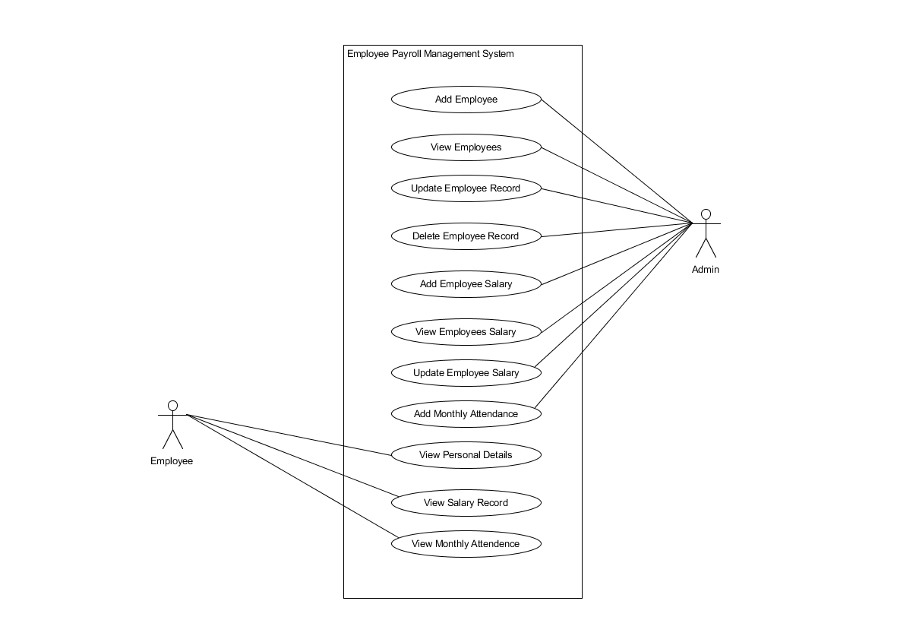

Class Diagram:

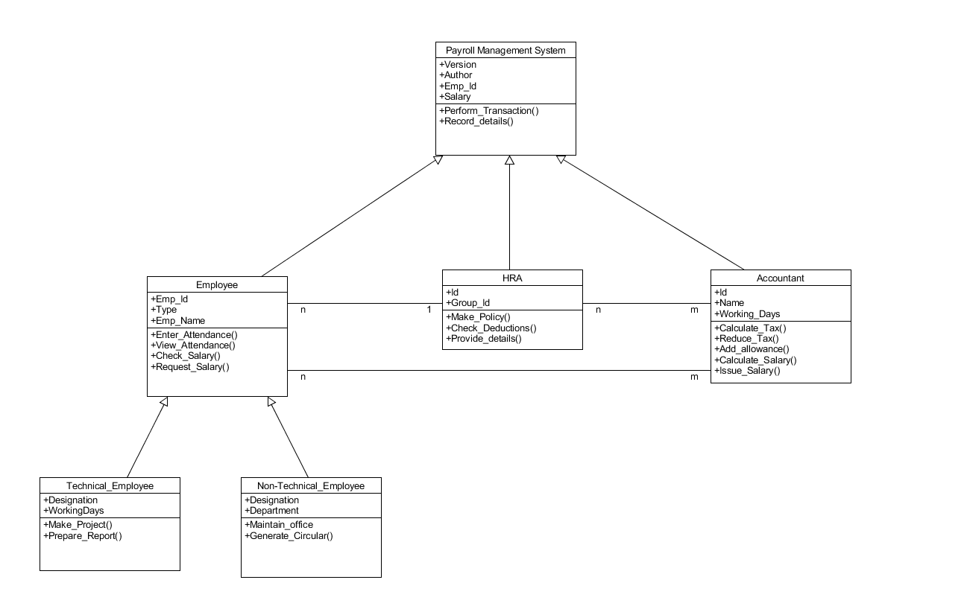

ER Diagram:

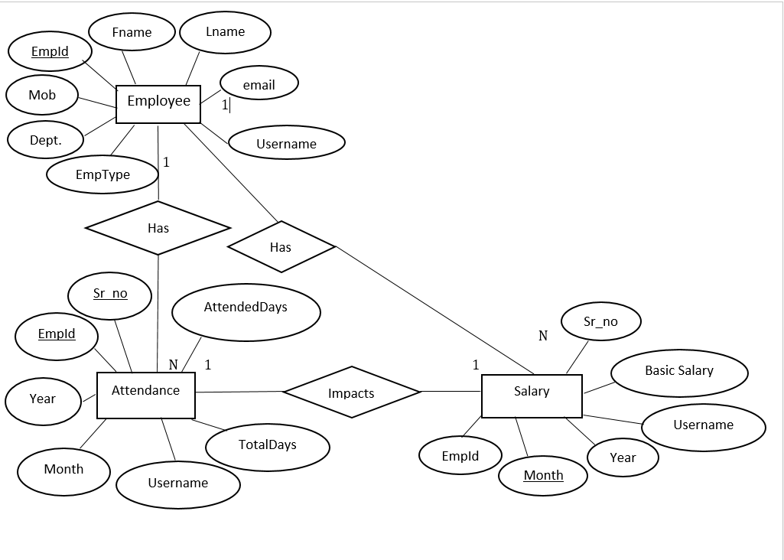

Data Dictionary:

|  |  |  |  |  |  |  |  |  |
| --- | --- | --- | --- | --- | --- | --- | --- | --- |
| Personal_Details | | | | | | | | |
| Sr.  No. | Field  Name | Data  Type | Width | Required | Unique | PK/FK | Referenced  Table | Description |
| 1 | EmpId | Number | 10 | Yes | Yes | Yes (auto-Increment) |  |  |
| 2 | FirstName | Varchar2 | 15 | Yes | No |  |  |  |
| 3 | LastName | Varchar2 | 15 | Yes | No |  |  |  |
| 4 | MobNo | Varchar2 | 10 | Yes | Yes |  |  |  |
| 5 | Email | Varchar2 | 40 | Yes | Yes |  |  |  |
| 6 | EmpType | Varchar2 | 10 | Yes | No |  |  |  |
| 7 | Department | Varchar2 | 20 | Yes | No |  |  |  |
| 8 | Username | Varchar2 | 20 | Yes | Yes |  |  |  |
| 9 | Password | Varchar2 | 64 | Yes | No |  |  |  |

|  |  |  |  |  |  |  |  |  |
| --- | --- | --- | --- | --- | --- | --- | --- | --- |
| Attendance | | | | | | | | |
| Sr.  No. | Field  Name | Data  Type | Width | Required | Unique | PK/FK | Referenced  Table | Description |
| 1 | Sr_no | Number |  | Yes | Yes | PK |  |  |
| 2 | EmpId | Number | 10 | Yes | Yes | FK | Personal_Details |  |
| 3 | Username | Varchar2 | 20 | Yes | Yes |  |  |  |
| 4 | Attended Days | Number |  | Yes | No |  |  |  |
| 5 | Total Days | Number |  | Yes | No |  |  |  |

|  |  |  |  |  |  |  |  |  |
| --- | --- | --- | --- | --- | --- | --- | --- | --- |
| Salary | | | | | | | | |
| Sr.  No. | Field  Name | Data  Type | Width | Required | Unique | PK/FK | Referenced  Table | Description |
| 1 | Sr_No | Number | 10 | Yes | Yes | PK |  |  |
| 2 | EmpId | Number | 10 | Yes | Yes | FK | Personal_Details |  |
| 3 | Username | Varchar2 | 20 | Yes | Yes |  |  |  |
| 4 | Basic Salary | Varchar2 | 10 | Yes | No |  |  |  |
| 5 | Month | Varchar2 | 12 | Yes | No |  |  |  |
| 6 | Year | Varchar2 | 12 | Yes | No |  |  |  |
| 7 | Gross Salary | Varchar2 | 10 | Yes | No |  |  |  |
| 8 | Net Salary | Varchar2 | 10 | Yes | No |  |  |  |

**Implementation Detail**

1. Modules Created.

Add Data: The Module that inserts user data into the database.

View Data: This module retrieves data from the database.

Edit Data: This modules retrieves the user data and allows to modify it.

Delete Data: This module deletes data from database.

1. Function Prototype.

The function to calculate the salary takes basic salary of employee as input and calculates all the earnings and deductions on basic salary. This function returns gross salary and net salary.

**Screenshots**

1. Login

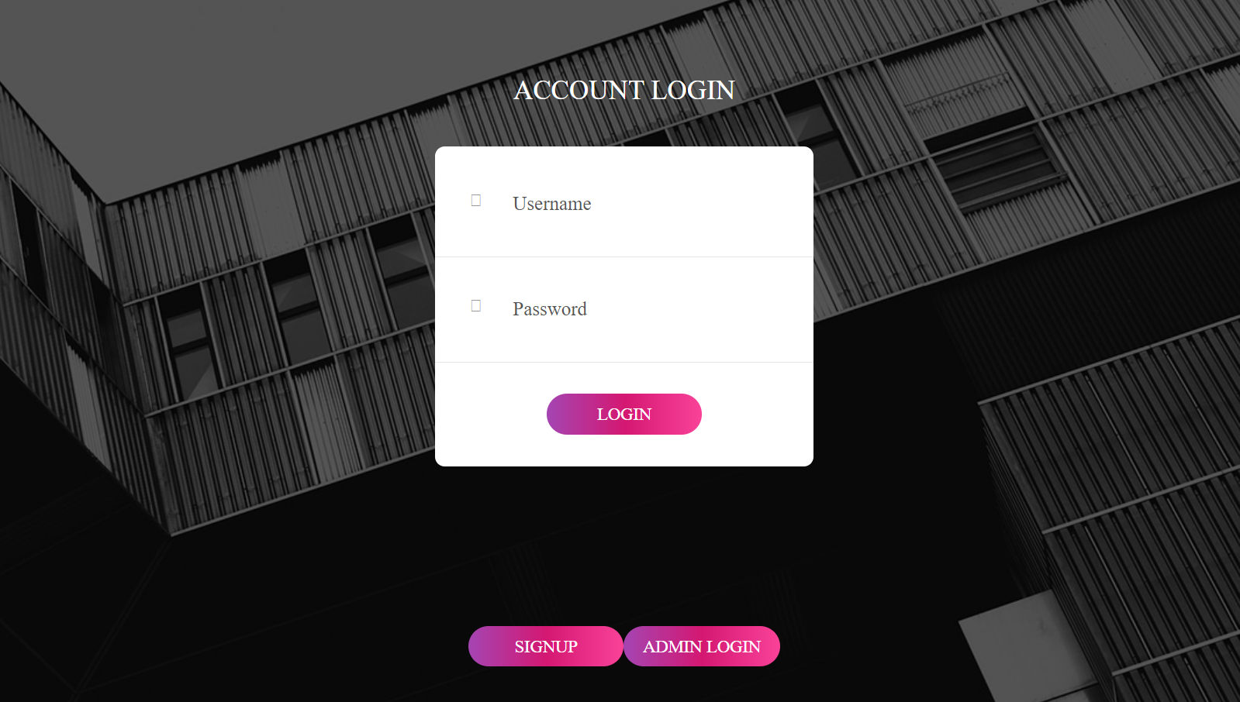

1. View Employee List

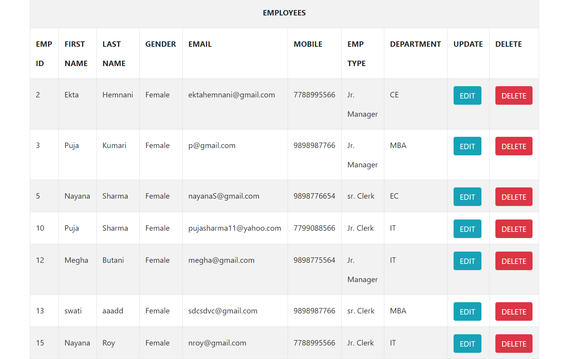

1. View Employee Attendance List.

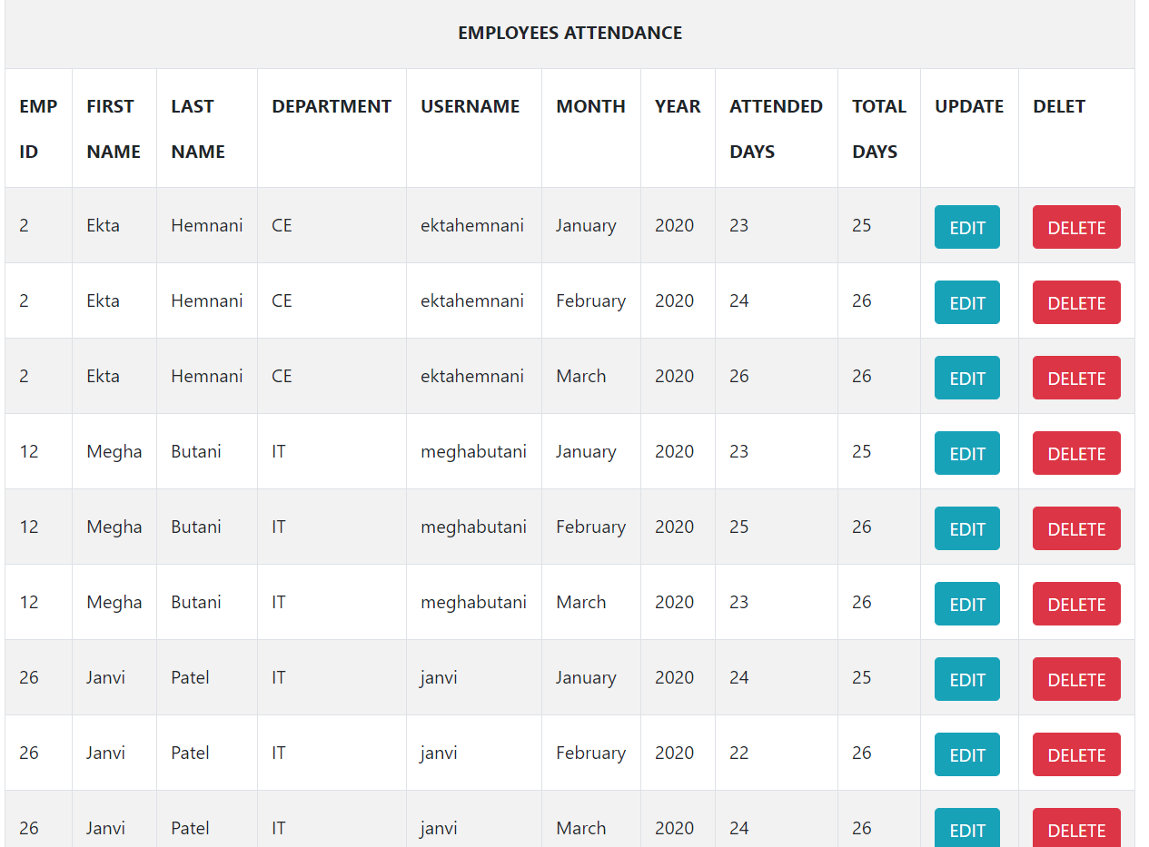

1. Update Employee Salary

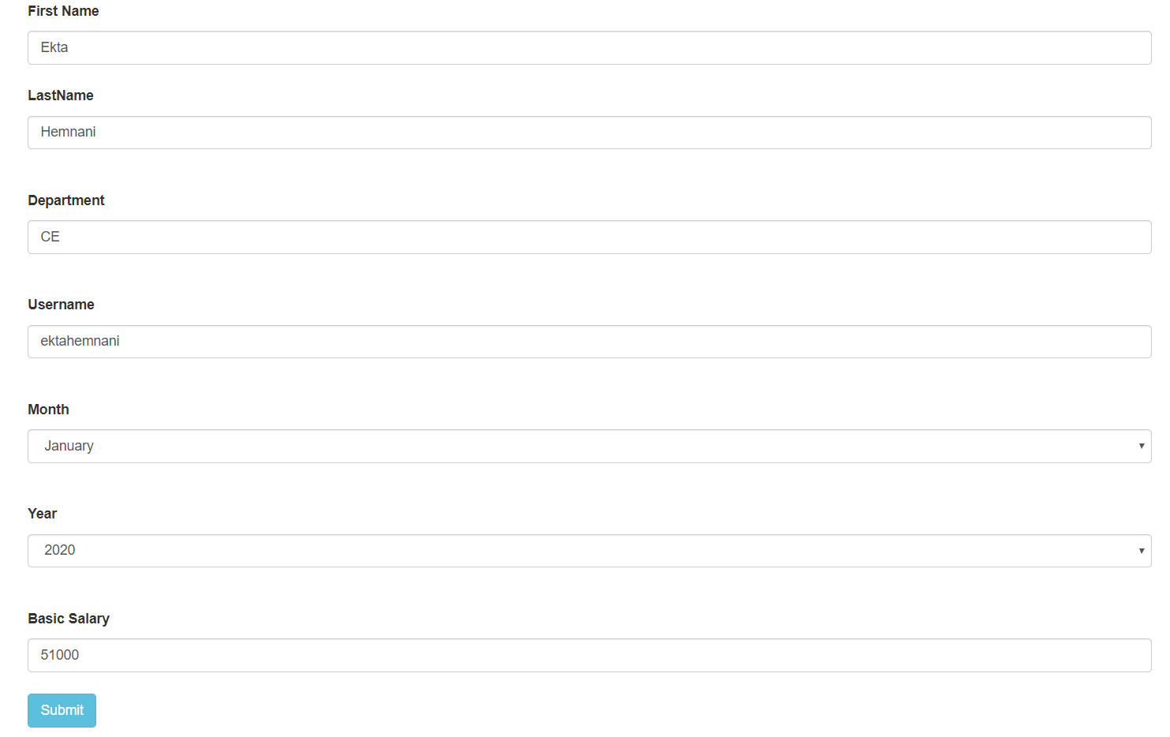

1. View Employee Salary.

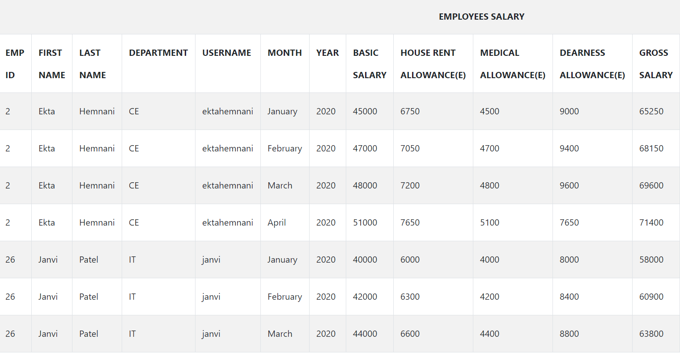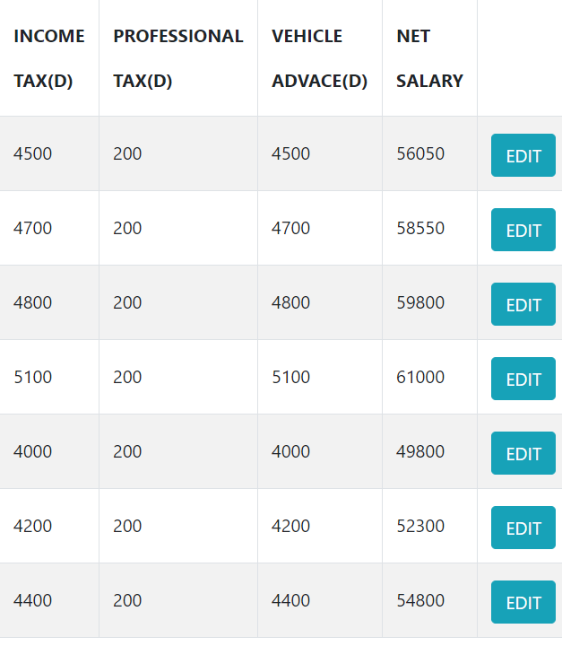

1. Employee Profile.

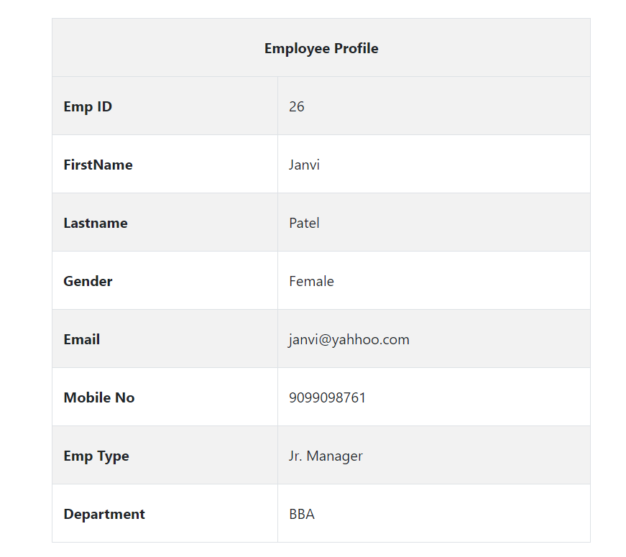

1. Month Wise Attendance

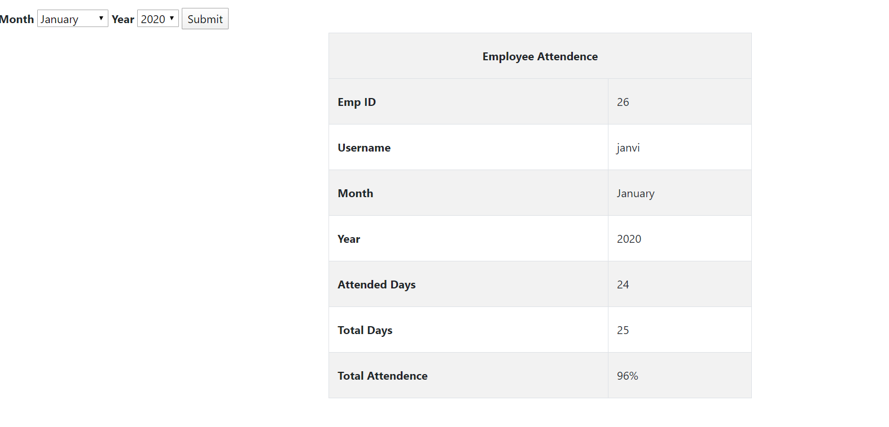

1. Month Wise Income Record.

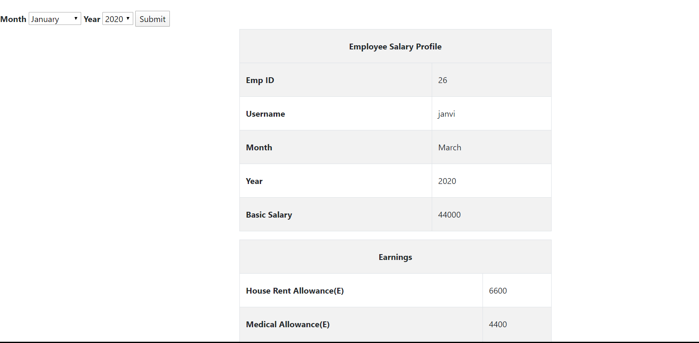

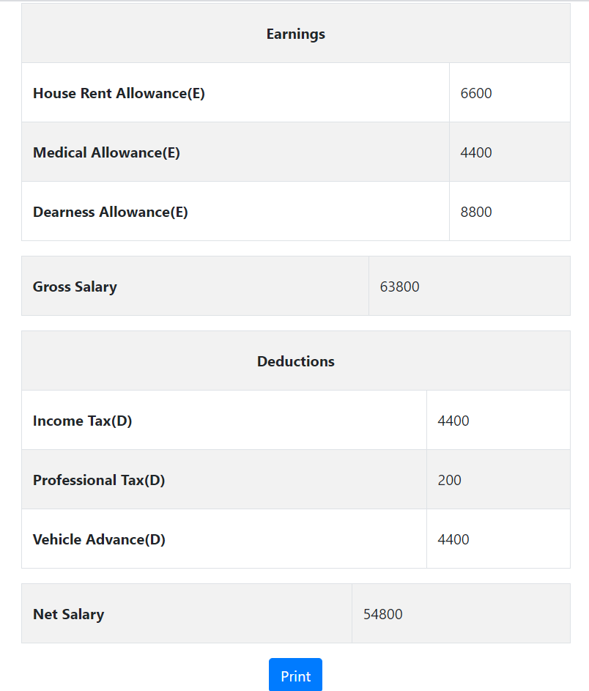

**Conclusion**

1. The Employee record is being managed by the System. The Employee record includes employee’s personal details, attendance and salary information.
2. The Admin can manage the record of all the employees.
3. Employee can view his month wise salary and also print it.
4. Employee can view his month wise attendance.

**Limitation and Future Extension**

Employee don’t have an option to view his yearly income statement.

**Bibliography**

1. <https://www.w3schools.com>
2. <https://stackoverflow.com>
3. <https://www.codeproject.com>