**Important Info.**

1. Install WAMP server.
2. For that download two files, File name: vcredist_x64.exe and Wampserver2.4-x64.exe
   1. Note: If you are running wamp of XP machine running 32 bit then you need to select appropriate 32 bit files.
3. Installation of WAMP server required VC++ files. File name: vcredist_x64.exe
   1. Install vcredist_x64.exe
   2. Select all default and click next.
   3. Click Finish.
   4. Now double click Wampserver2.4-x64.exe

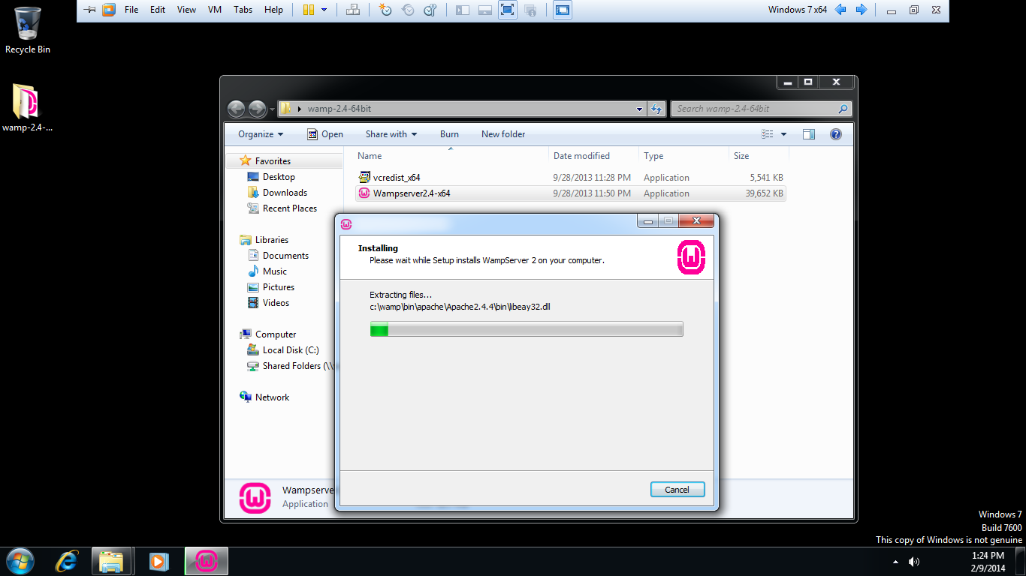

* 1. Click all options with default.
  2. At the end wamp server will start automatically.
  3. Unzip the file test.rar into C:/wamp/www/ directory

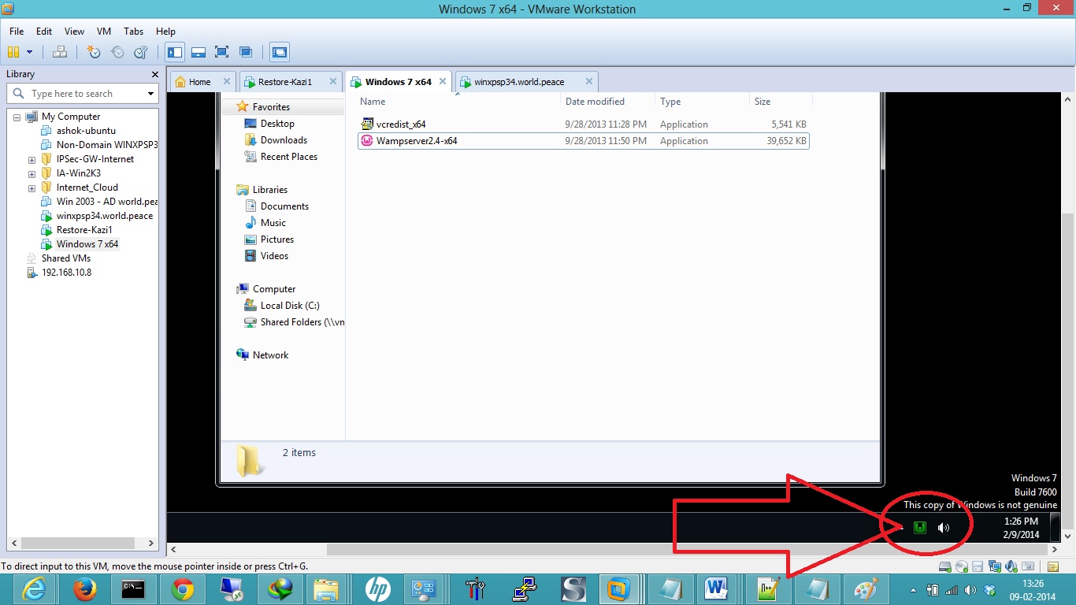

1. One phpmyadmin on webserver by accessing :
   1. <http://localhost>
   2. Click on phpmyadmin

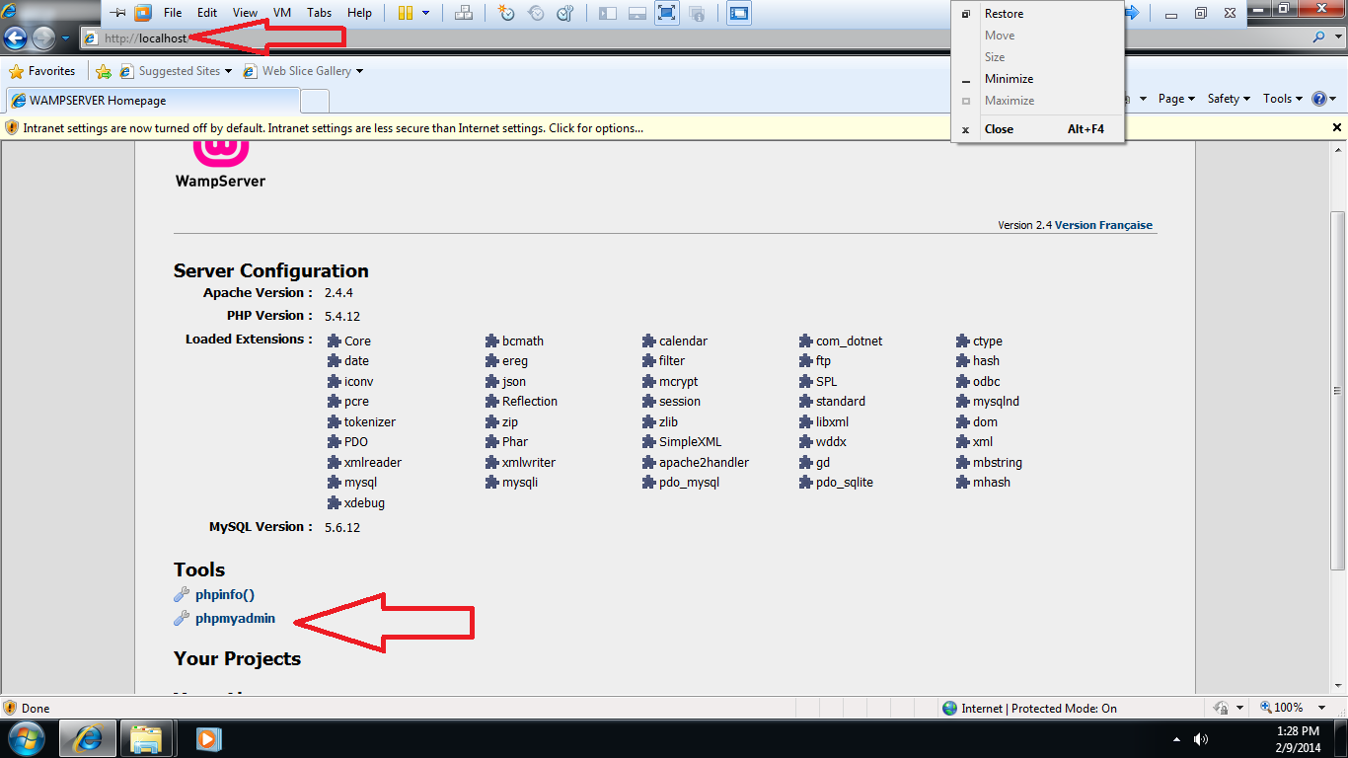

* 1. By default there is no password. Default username is : root

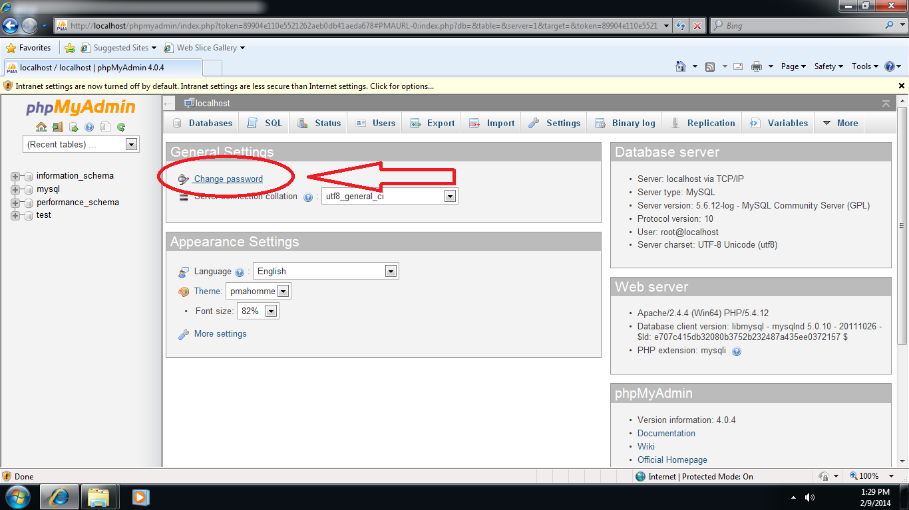

* 1. Click on change password and change the password to = q1w2e3

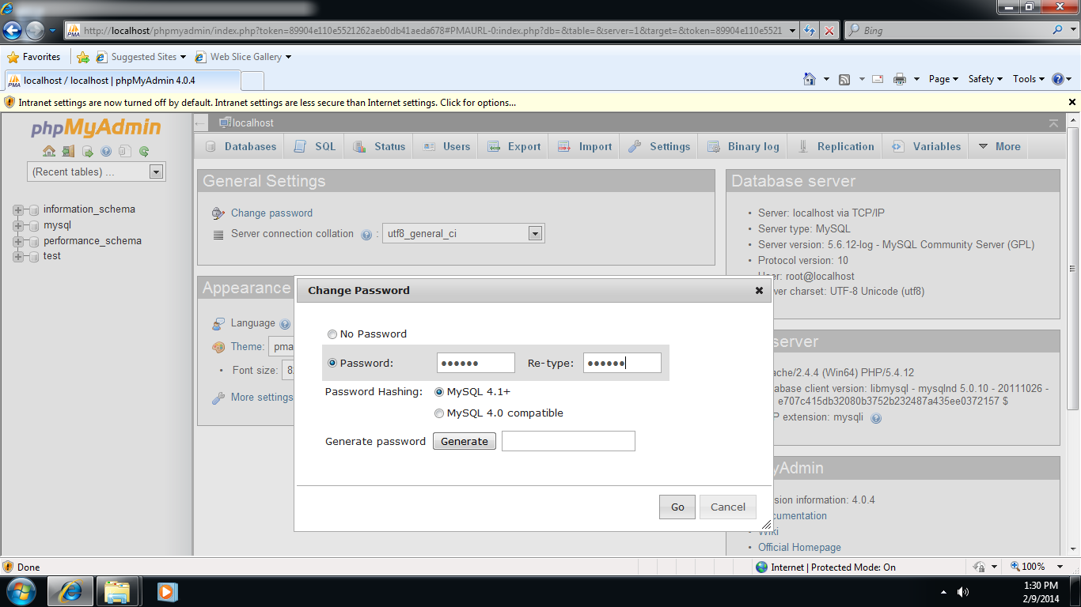

* 1. Click Go.

1. At this step you will only be able to access your website locally. By typing following URL in browser.

<http://localhost/test/index.php>

1. Open conect.php file it will look like this.

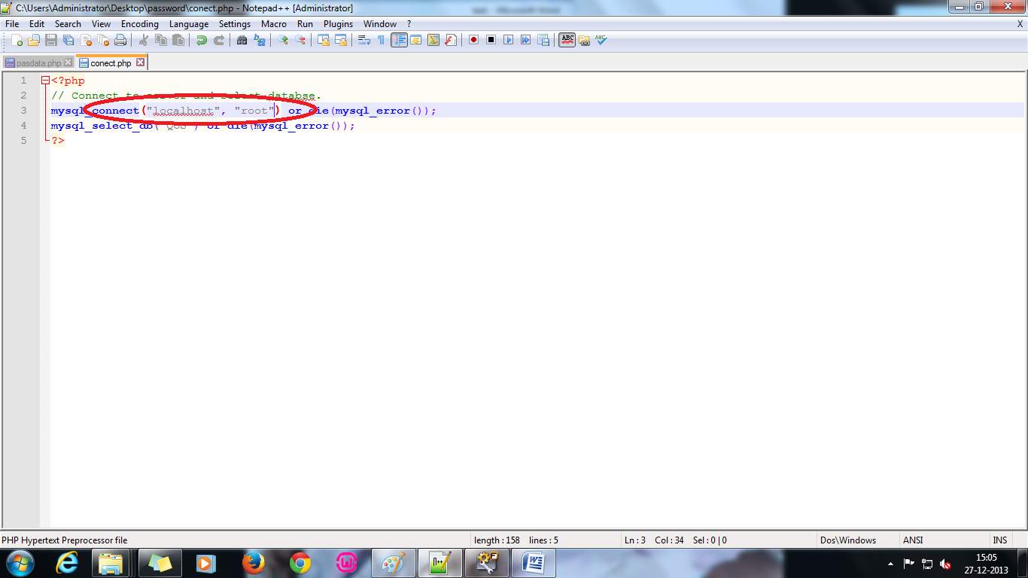

1. Change the file by adding your password in the field like shown in below fig.

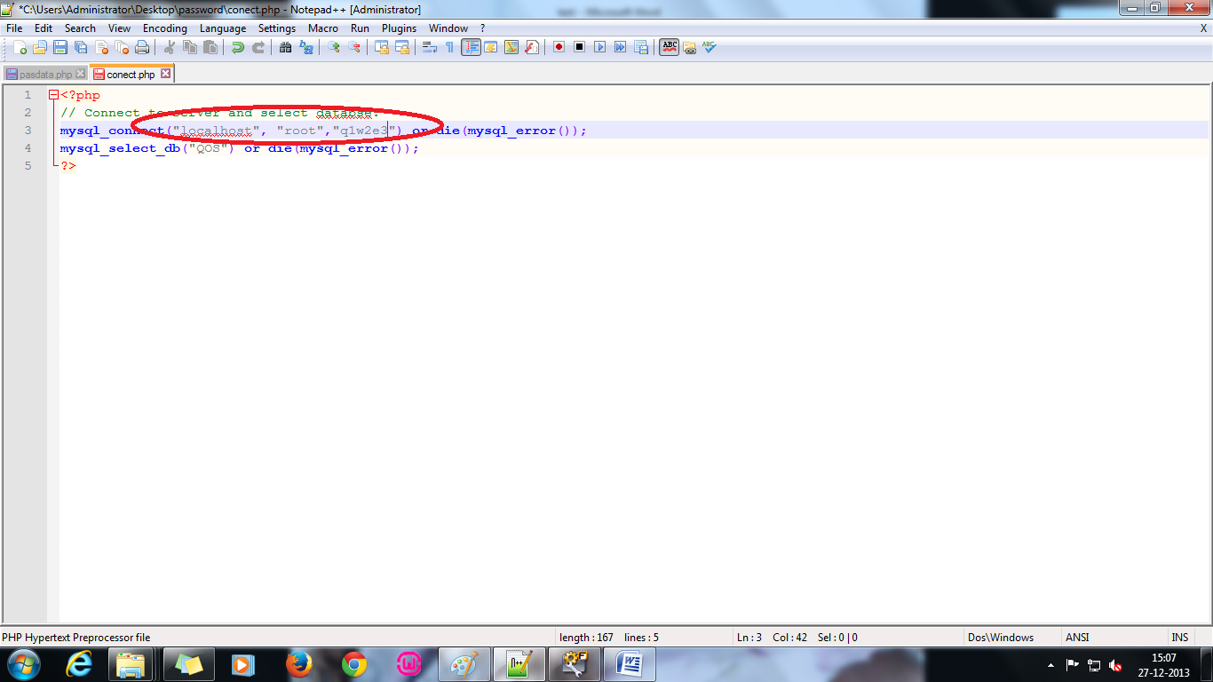

1. Create Database. By running following link

[http:localhost//test/database.php](http://test/database.php)

* 1. Your database name will be “QOS”.
  2. Following will be the success message.

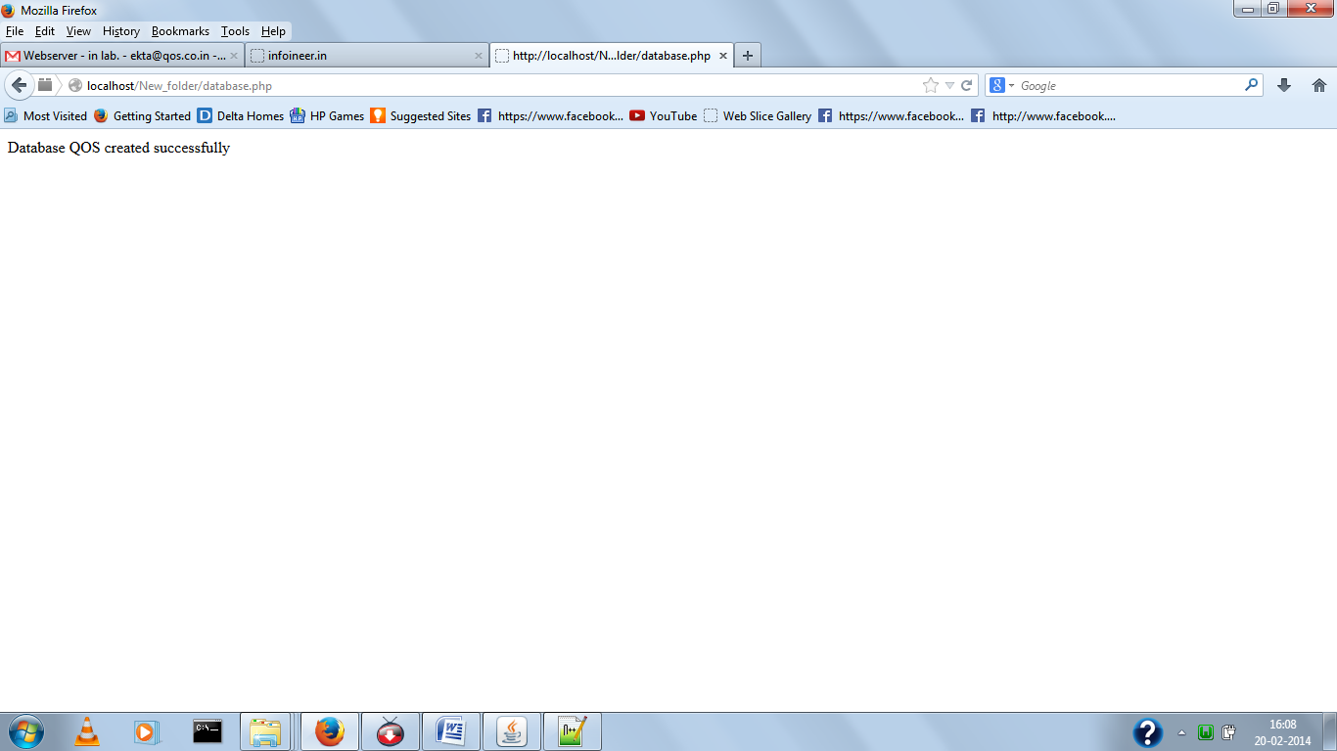

1. Create 4 tables with name users , answers , questions and quiz_takers by running following link

<http://localhost/test/install.php>



1. Add qusetions with answers using this link:

<http://localhost/test/addQuestions.php>

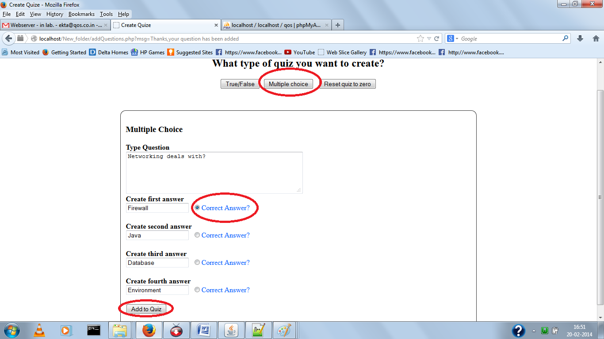

1. You can add multiple choice questions and true/false questions or both. You can reset the questions also.
2. Confirmation page looks like.

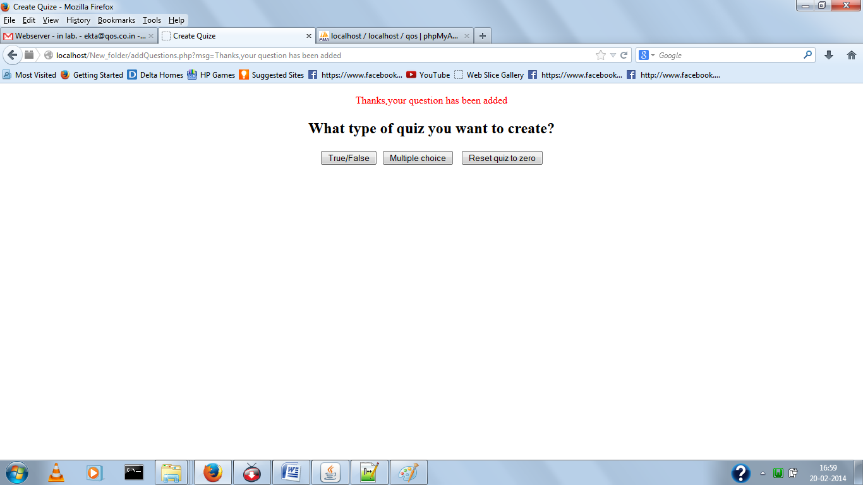

1. Now you are ready to work with test website.

http://localhost/test/index.php

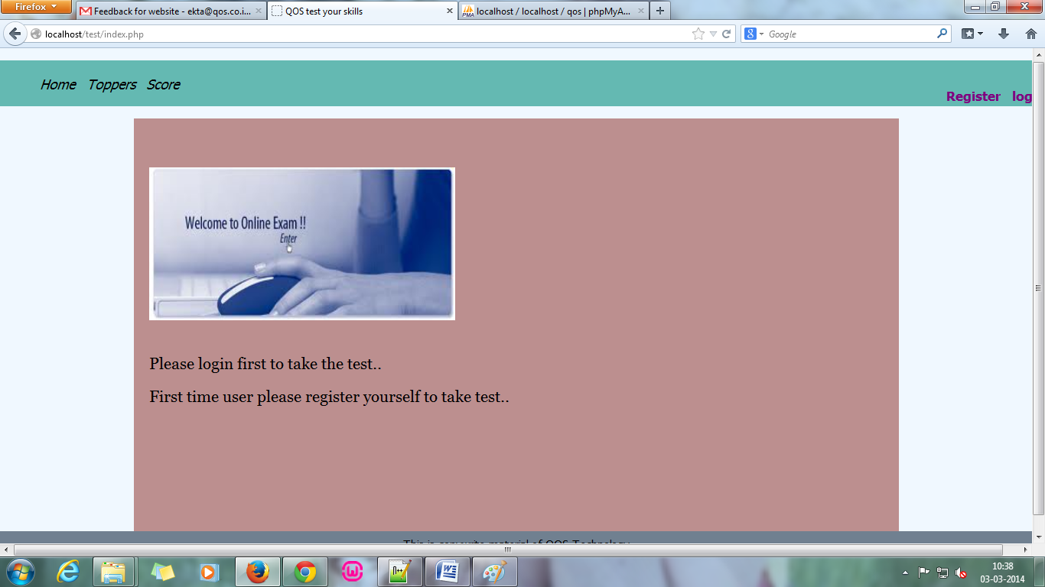

1. Now register yourself from register link and login to see the questions.

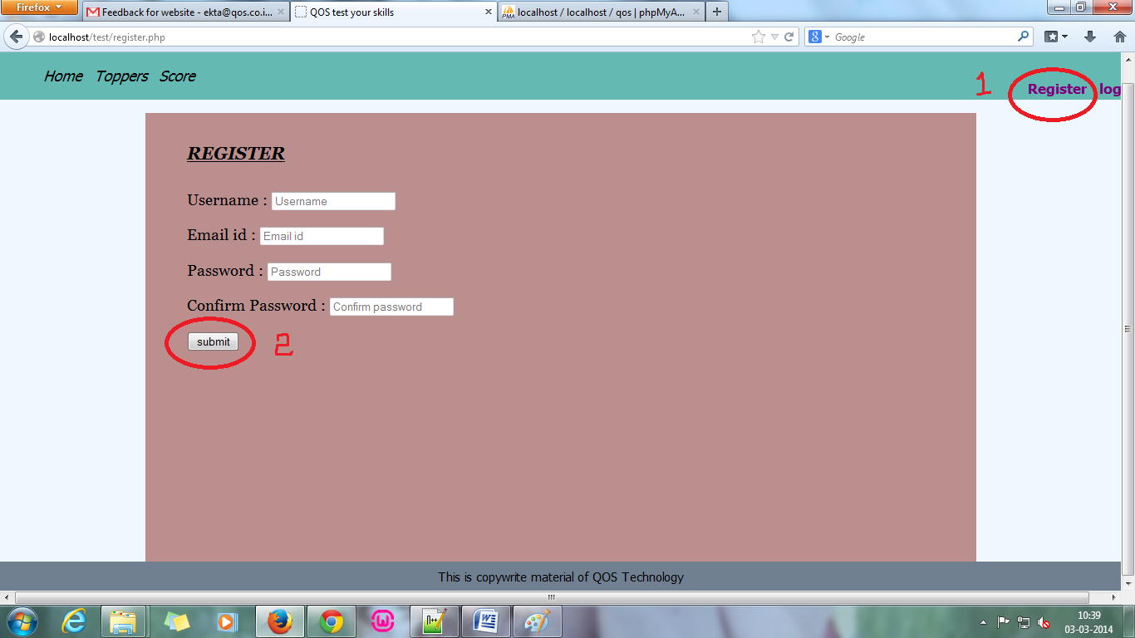

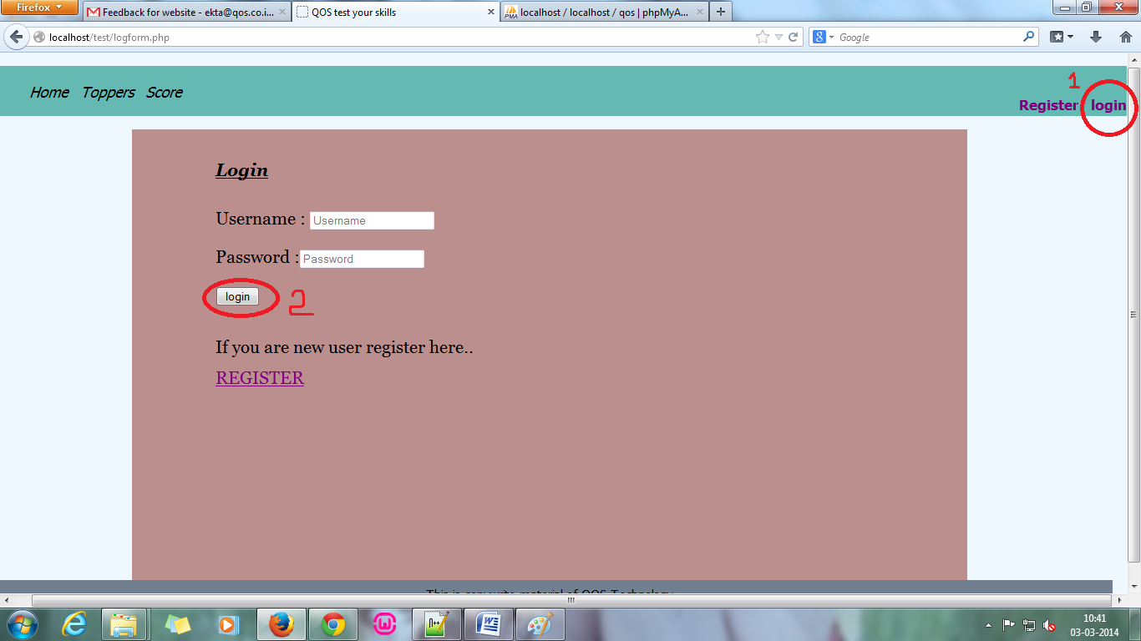

1. You can check your score and attempt history by clicking on score link.

