Project Title
Clothing Store - Online Fashion Website
Figma Prototype - https://www.figma.com/proto/FPPAGdDDRNQnvuVcMrzyeB/Project-1?node-id=2-2&p=f&t=fzdriByA1MOlzD8g-1&scaling=min-zoom&content-scaling=fixed&page-id=0%3A1&starting-point-node-id=2%3A2

1. Project Brief
The goal of this project is to design and develop a static online clothing store website that highlights traditional Nepali fashion while also offering modern casual clothing. The website aims to introduce elements of Nepali culture into a contemporary Canadian context by blending cultural garments with everyday fashion.
The design focuses on creating a clean, visually appealing, and user-friendly platform where users can easily browse products, explore categories, and view product details. The website emphasizes both cultural representation and modern usability, making it accessible and engaging for a wide audience.

2. Main Goal
To create a visually appealing and user-friendly clothing store website where users can easily:
- Browse products
- Explore categories
- View product details

3. Sub Goals
The following objectives were included in the project:
- Organize clothing into categories (Men, Women, Kids)
- Display products using images, names, and prices
- Create clear and simple navigation between pages
- Ensure responsiveness across desktop and mobile devices
- Maintain a consistent visual style throughout the website

4. Project Description
The Clothing Store website is designed to showcase a mix of traditional Nepali clothing and modern casual fashion. The main goal is to bring aspects of Nepali culture into a modern Canadian environment through fashion and design.
The website presents clothing items using images and simple product cards, allowing users to easily browse and understand available products. Traditional designs are combined with contemporary styles to create a unique shopping experience that reflects both cultural identity and modern trends.
The project is developed using HTML and CSS, focusing on layout design, visual presentation, and user-friendly navigation rather than full e-commerce functionality.

5. Planned Website Pages
Home Page
Introduces the brand and displays featured and trending products. Includes navigation to all other pages.
Shop Page
Displays all products in a grid layout with filtering options and categories.
Product Page
Provides detailed information about a selected product, including image, description, price, and selection options.
Cart Page
Displays selected items, quantities, and total price in a structured layout.
Thank You Page
Appears after checkout to confirm the user’s action and guide them forward.
Help Page
Provides useful information such as shipping details, size guides, and return policies.
About / Contact Page
Includes information about the brand and contact details.
Login Page
Allows users to input login details (static design).

6. Project Timeline
Date / Week | Task
March 10 | Finalize project idea and write project brief
Week 10 | Plan layout and create paper wireframes
Week 10–11 | Develop HTML structure and CSS styling
Week 12 | Final adjustments and project submission

7. Paper Prototypes
Initial paper sketches were created to plan the layout of key pages such as the Home page, Product page, and Cart page. These sketches helped visualize the structure and layout before moving into digital design using Figma.
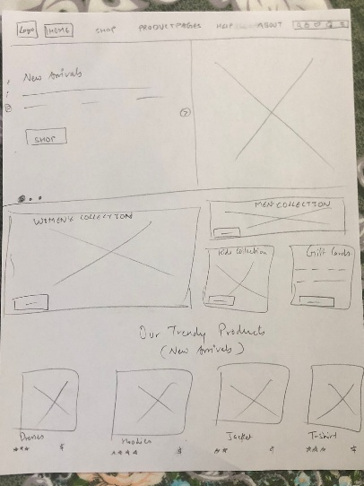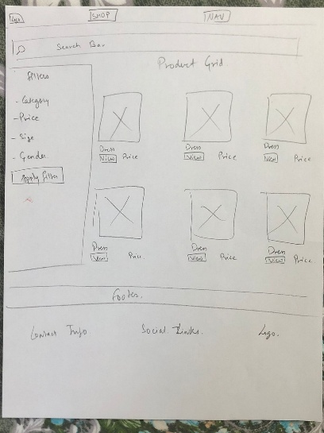
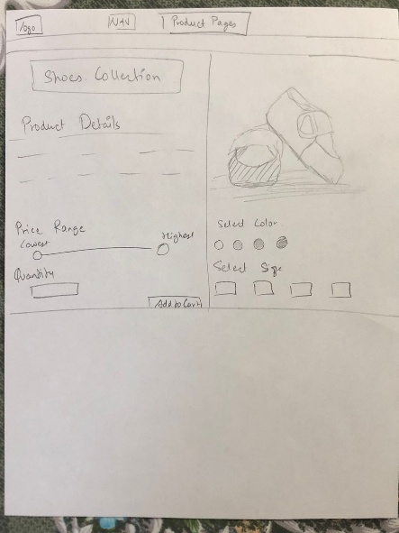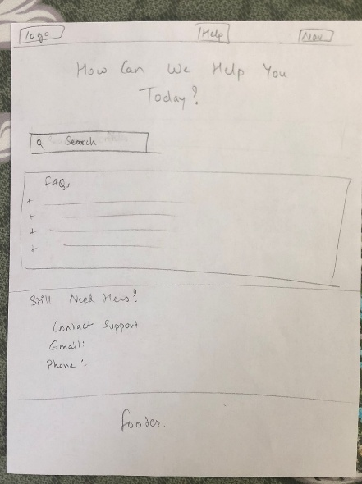

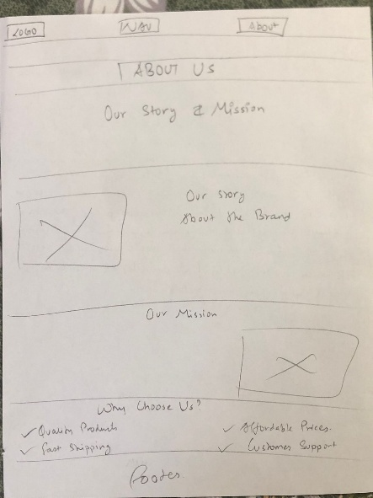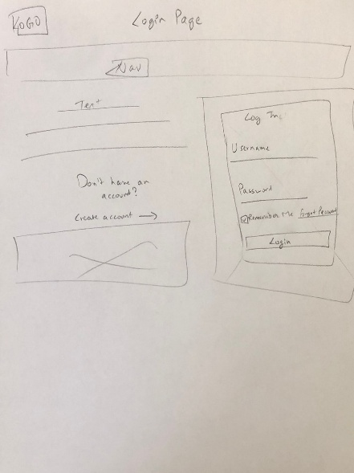

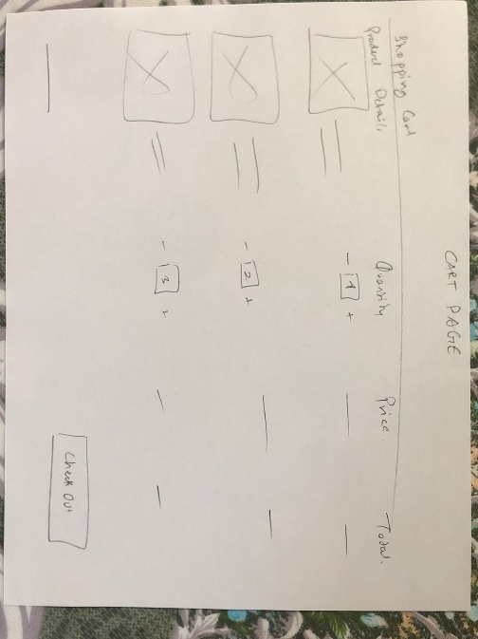
8. Design Process
The design process started with sketching basic layouts to determine structure and content placement. These ideas were then translated into digital wireframes using Figma.
During development, HTML was used to build the structure of each page, while CSS was used to style the layout, apply typography, and ensure visual consistency.
Responsive design techniques such as media queries were used to ensure the website works across different screen sizes.

9. Challenges & Solutions
Layout:
Some sections required adjustments to alignment and spacing. This was solved using CSS Grid and Flexbox.
Responsive:
Ensuring the website worked on mobile and tablet screens required additional media queries and layout adjustments.
Navigation:
Creating logical links between pages helped avoid dead ends and improved user experience.

10. Reflection
One of the key ideas behind this project was to represent Nepali culture through fashion while adapting it to a modern Canadian audience. By combining traditional clothing elements with casual modern styles, the website creates a unique identity that reflects both cultural heritage and contemporary fashion.
During the development process, I made several adjustments to my original design while working with HTML and CSS. Some layout and styling approaches did not work as expected or caused issues with responsiveness, so I revised parts of the structure and styling to improve functionality and visual consistency. These changes helped me better understand how to troubleshoot design problems and adapt my approach when something was not working.
This process improved my skills in layout design, responsive development, and debugging CSS issues. It also taught me the importance of flexibility and iteration when building a website.
Overall, this project strengthened my ability to create a complete static website from planning to final implementation while maintaining a clear design concept and user-friendly experience.
11.

Bibliography
W3School. (n.d.). Retrieved from W3School.
https://fonts.google.com/
https://developer.mozilla.org/en-US/docs/Web/HTML
https://www.w3schools.com/css/
https://www.w3schools.com/howto/howto_js_rangeslider.asp

