SIADS 699 Capstone Project Report
Team 27 - Predicting Film Financial Success

Peter Sklamberg, Benjamin Wilson, Evgeny Kuzmin

Introduction
Film success is inherently uncertain, with outcomes influenced by a combination of factors such as budget, genre, cast, and creative direction. While individual movies can be unpredictable, broader patterns may emerge when analyzing financial performance, audience reception, and production scale at an aggregate level.
Our project investigates whether movie success can be predicted using pre-release characteristics. Specifically, we aim to determine how features such as genre, production budget, and actor and director “star power” relate to the likelihood that a film achieves financial success.
We started by conducting exploratory data analysis (EDA) to identify relationships between key variables, including how genres, actors, and directors influence financial performance and audience reception over time. Second, we developed a classification model to predict whether a film is financially successful based on pre-release features.
To support this analysis, we constructed a merged dataset from IMDb and TMDB, combining movie metadata, ratings, and financial information. We then engineered features capturing historical performance of actors, directors, and genres, and applied clustering techniques to identify actor and movie archetypes, some of which are incorporated as additional model features.
Our findings indicate that movie success is multi-dimensional. Financial efficiency, production scale, and audience reception are driven by distinct factors and are not fully aligned. While large budgets and franchise participation increase scale and visibility, financial success is often achieved through cost-efficient production models, and audience reception is more closely tied to narrative-driven content.

Exploratory Data Analysis
The analysis focuses on three key dimensions of movie success: financial performance (Return on Investment, ROI), audience reception (IMDb ratings), and production scale (budget). The goal is to identify structural relationships between these dimensions and understand how factors such as genre, actors, and directors influence outcomes, both overall and over time. These insights are subsequently used to inform feature engineering decisions and modeling design.
Genre-Level Analysis
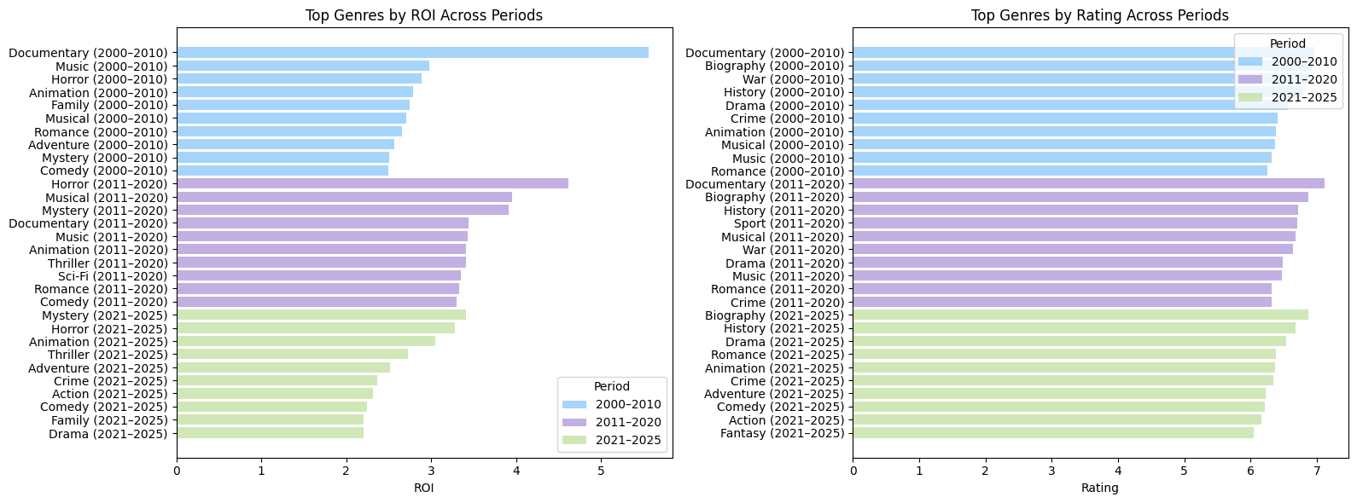
Analyzing genres reveals a clear divergence between financial efficiency and audience reception. From a financial perspective, Documentary and Horror films consistently achieve the highest ROI. Documentary films exceed ROI values of 5.5 in earlier periods despite very low budgets (~$2–6M), while Horror, Mystery, and Musical films reach ROI levels of approximately 3.5–4.6 with modest production costs. These genres follow a low-cost, high-return model where profitability is driven by efficiency rather than scale.
In contrast, high-budget genres such as Animation and Sci-Fi also generate strong returns but with lower efficiency (ROI ~3.3–3.4), indicating diminishing returns at higher production scales. From an audience perspective, Biography, War, and History films consistently achieve the highest ratings (~6.7–6.9), but with lower ROI, suggesting that narrative-driven genres prioritize critical reception over financial efficiency.
At the genre combination level, financial performance is concentrated within a narrow group, particularly Horror–Mystery–Thriller, which consistently delivers the highest ROI across all periods (peaking around 9.3). In contrast, top-rated combinations remain concentrated in Drama-based categories such as Biography–Drama–History and Crime–Drama, with minimal variation over time.
Examining trends over time shows that financial leadership shifts moderately—from Documentary in early periods to Horror and Mystery in later years—but remains within cost-efficient genres. In contrast, rating leaders remain highly stable, indicating that audience preferences for narrative-driven content do not change significantly over time.
These findings suggest that historical ROI varies significantly across genres and over time, indicating that genre-based features—particularly historical ROI—are likely to carry meaningful predictive signals. However, the divergence between ROI and ratings highlights that financial success is multi-dimensional and cannot be explained by genre alone. Additionally, the observed temporal shifts support the use of a time-based train/validation/test split, as relationships between features and outcomes evolve over time.

Actor-Level Analysis
Initial results show that actors with the highest ROI are often less recognized and associated with lower-budget films. This indicates that high ROI is primarily driven by cost-efficient production models rather than star power. To ensure meaningful comparisons, the analysis is restricted to actors with sufficient experience and audience exposure. Within this filtered group, three distinct patterns emerge. High-budget actors (e.g., Gal Gadot, Tom Holland) are strongly associated with large-scale franchise productions (~$130M–$170M budgets), achieving stable but moderate ROI (~2.5–4.5) and consistent ratings. High-ROI actors (e.g., Tobin Bell) operate in lower to mid-budget films and achieve strong financial efficiency (ROI ~8+), often in genre-driven productions such as horror. High-rating actors (e.g., Timothée Chalamet) deliver strong audience reception (>7.2) with moderate ROI, reflecting a focus on critically successful films. Elberse investigates in a 2007 study on The Role of Star Power in Movie Success whether well-known actors significantly influence box office outcomes. The findings suggest that star power alone does not guarantee financial success, emphasizing that broader production and market factors play a critical role. This insight aligns with our analysis of actor and director “star power,” where we observe that financial efficiency, production scale, and audience reception are driven by different underlying factors.

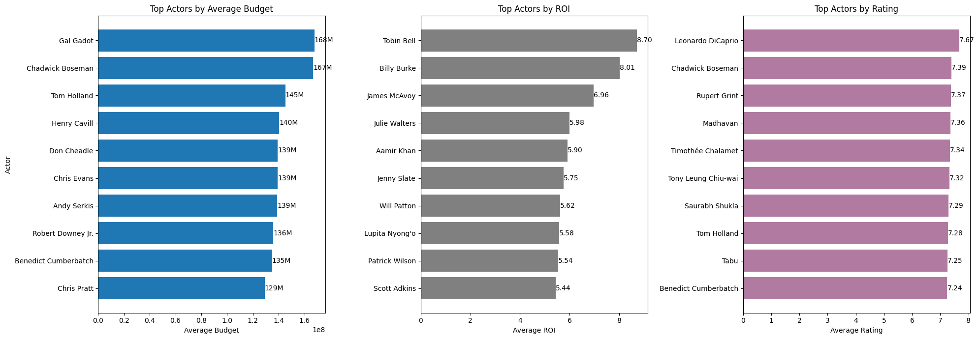
Over time, actor performance evolves from strong alignment in the early 2000s—driven by a small number of dominant franchises—to increasing separation across dimensions. In recent years, a clear structure emerges: budget is driven by franchise actors, ROI by cost-efficient productions, and ratings by critically strong or hybrid mainstream actors. This reflects increasing specialization of actor roles within the industry.
These results highlight that actor performance cannot be captured by simple features or sparse combinations such as actor–genre pairs. Under a temporal split, many such combinations are not observed in the training data, requiring imputation and leading to unstable model performance. Instead, aggregated “star power” features based on historical averages (e.g., ROI, rating, budget, experience, popularity) provide a more robust representation of actor influence. This approach reduces sparsity, avoids excessive imputation, and improves generalization.

Director-Level Analysis
Directors exhibit a similar structural separation across performance dimensions. High-budget directors such as J. J. Abrams and David Yates are strongly associated with large-scale franchise productions, maintaining stable ROI (~3–4.5) and strong ratings (~7+). High-ROI directors such as James Wan operate within lower-budget, genre-driven films, achieving very high efficiency (ROI 8–10+). In contrast, top-rated directors such as Christopher Nolan and Quentin Tarantino produce critically acclaimed films with moderate ROI.
Over time, director performance follows a similar evolution as actors, moving from early alignment to increasing segmentation. Budget becomes more strongly tied to franchise ecosystems, ROI to cost-efficient genre strategies, and ratings to directorial vision and storytelling.
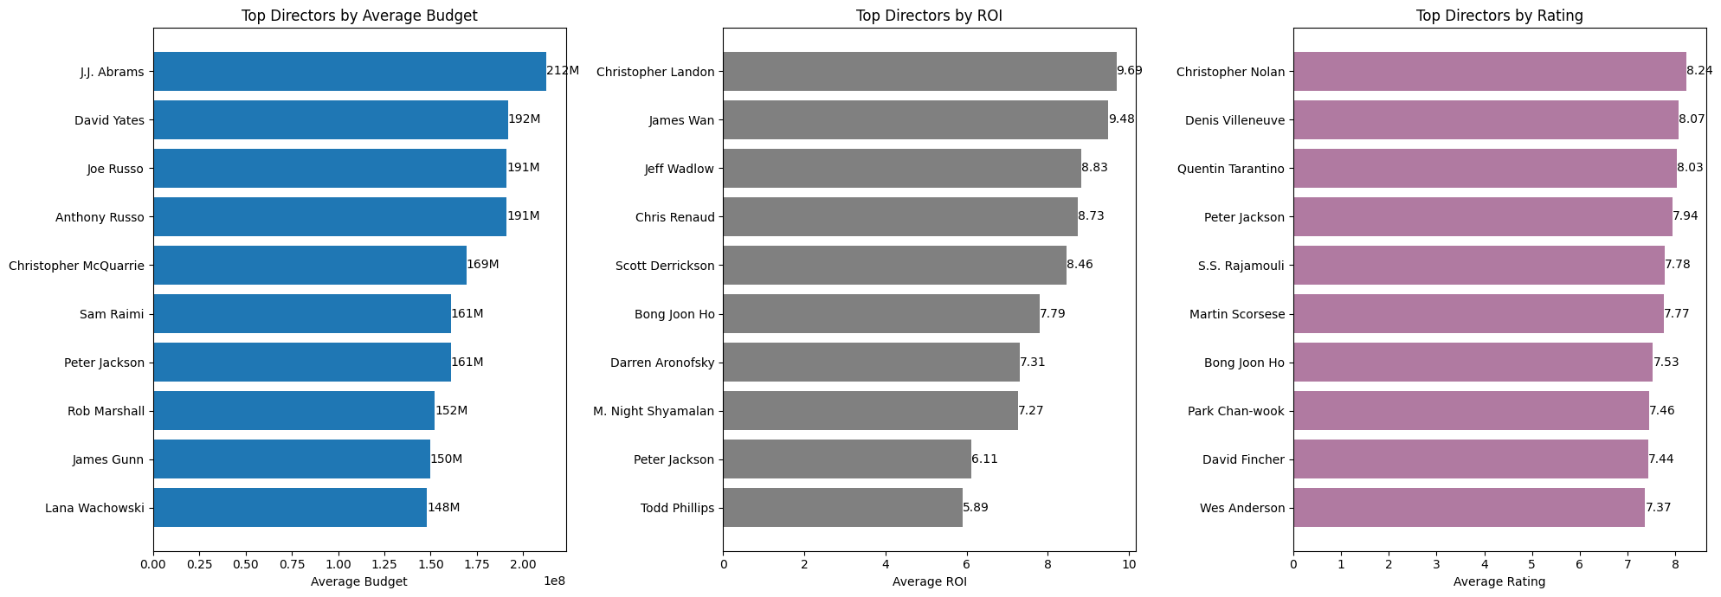
Director-level effects reinforce the need for aggregated historical features rather than single metrics. While directors contribute additional predictive signal, their impact is secondary to structural drivers such as budget and genre.

Clustering Analysis: Actor and Movie Archetypes
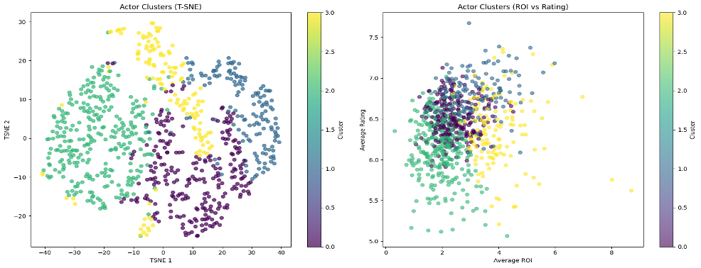
To capture the multi-dimensional nature of performance, we apply K-Means clustering to both actors and movies using features such as ROI, ratings, budget, and popularity. The number ofclusters is selected using the Elbow Method and Silhouette Score, balancing statistical fit with interpretability.
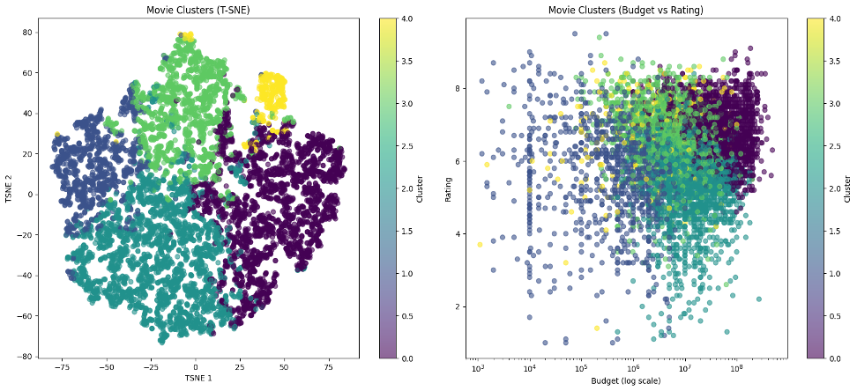
Clustering reveals that both actor “star power” (above) and movie performance (below) consist of multiple independent dimensions. For actors, scale (budget and exposure), audience perception (ratings and popularity), and ROI form distinct archetypes. For movies, performance reflects trade-offs between budget, ROI, ratings, and popularity, confirming that high budgets do not guarantee success and the most efficient films are often not the largest. Clustering provides a structured way to summarize complex interactions into a smaller set of interpretable features. Cluster assignments serve as higher-level representations that reduce dimensionality and avoid sparsity issues, making them suitable for inclusion in classification models.
EDA Synthesis
Across genres, actors, and directors, the analysis shows that financial success is driven by a combination of production scale, efficiency, and audience reception, rather than any single factor. ROI patterns vary across segments and over time, while budget remains a dominant structural driver.
These findings directly informed our modeling approach. We prioritized historical ROI-based features, avoided sparse interaction terms (such as actor–genre combinations), and constructed aggregated features such as star power and clustering-based representations. Additionally, observed temporal shifts in performance justified the use of a time-based train/validation/test split to better reflect real-world prediction settings.
Overall, the analysis highlights that movie success is inherently multi-dimensional and only partially predictable using structured pre-release data, motivating the use of predictive models to quantify these relationships.

Predictive Modeling, Feature Engineering, and Scenario Simulation
Data Structure, Problem Framing, and Temporal Design

The primary objective of the modeling phase was to predict whether a movie would achieve commercial success using information available prior to release. Within this project, a movie was classified as financially successful if its box office revenue was greater than or equal to two times its production budget.
To better simulate real-world forecasting conditions and reduce temporal leakage, the dataset was divided chronologically rather than randomly. Movies released before 2016 were used for training, movies released between 2016 and 2020 were used for validation and model selection, and movies released during and after 2021 were reserved for final testing. Movies released in 2020 were excluded because of major disruptions to theatrical performance caused by the COVID-19 pandemic.
This temporal structure ensured that historical information was always used to predict future movie releases, creating a more realistic evaluation framework for predictive modeling.

Historical Feature Engineering and Star Power Representation
A major component of the modeling process involved constructing historical actor and director performance features using only information available from the training dataset.
Actor-level historical metrics were aggregated using variables such as average budget, average revenue, average return-on-investment (ROI), average rating, historical success rate, and total movie appearances. To reduce dimensionality and capture broader performance patterns, K-Means clustering was applied to actor historical profiles. The resulting clusters were converted into ordered star power categories representing broader commercial performance archetypes rather than subjective celebrity reputation.


These actor-level features were then aggregated into movie-level variables including average actor star power, maximum actor star power, and cast size.
Similar historical features were engineered for directors using training-period movie outcomes. Director variables included historical average revenue, historical success rate, average ROI, average rating, and directing experience measured by the number of prior movies.

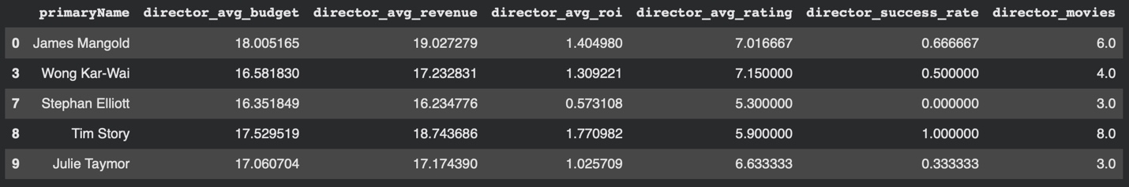
Importantly, all historical actor and director variables were constructed exclusively from training-period data to prevent information leakage into validation and test datasets.

Feature Preparation and Correlation Analysis
The final modeling dataset combined production-related variables, genre indicators, historical actor variables, and historical director variables.
Several additional preprocessing steps were applied before modeling. Production budgets were log-transformed to reduce skewness and improve model stability. Correlation analysis was also performed to identify highly collinear director-related variables. Highly correlated features such as director average budget, director average ROI, and director average rating were removed to reduce redundancy and improve interpretability.
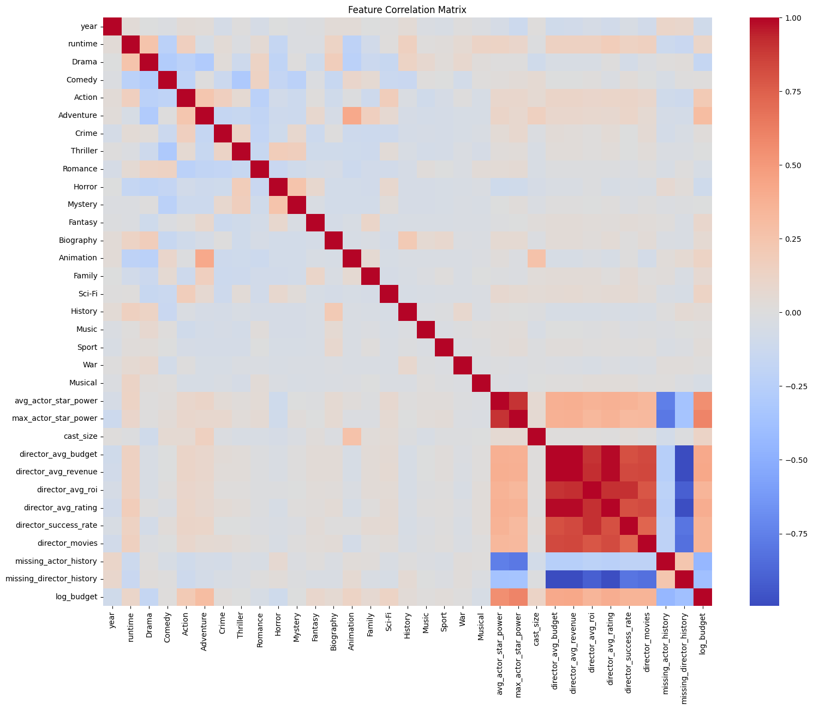

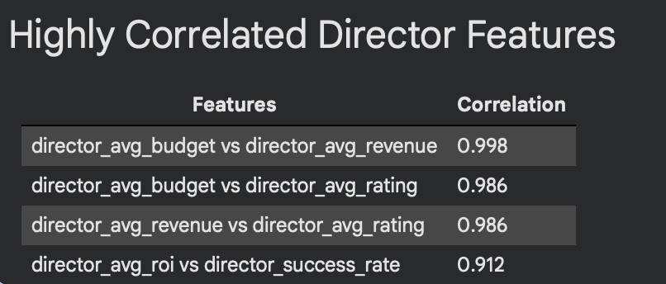

Missing historical information for actors and directors was handled using missing-history indicator variables together with zero-value imputation. This allowed the models to distinguish between genuinely low historical performance and previously unseen industry participants.

Baseline Model Development and Validation
Several supervised machine learning algorithms were evaluated throughout the project, including Logistic Regression, Random Forest, Gradient Boosting, and XGBoost classifiers.
The baseline Logistic Regression model achieved moderate validation performance with a ROC-AUC score of 0.646 and demonstrated relatively strong recall and F1-score values. However, ensemble-based tree models consistently produced stronger ranking performance, suggesting that nonlinear feature interactions played an important role in predicting movie success.
Among the baseline approaches, XGBoost achieved the highest validation ROC-AUC score of 0.676 and the highest validation accuracy. Random Forest produced similarly competitive results while maintaining stronger recall stability across validation experiments.

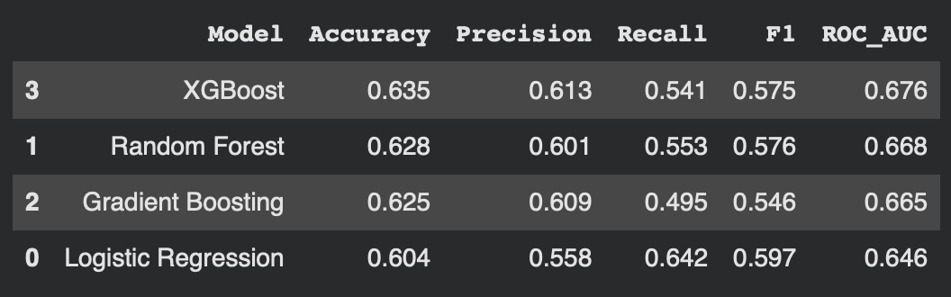
Overall, the validation results demonstrated that engineered historical variables — including actor star power, director success history, genre indicators, runtime, and budget-related variables — contained meaningful predictive information related to movie success.

Feature Importance and Sensitivity Analysis
After establishing baseline model performance, feature importance analysis was performed using the XGBoost classifier in order to evaluate the contribution of individual predictors.
The strongest features included director success rate, average actor star power, maximum actor star power, historical director revenue, runtime, and production budget. Several genre-related variables also contributed meaningful predictive value.

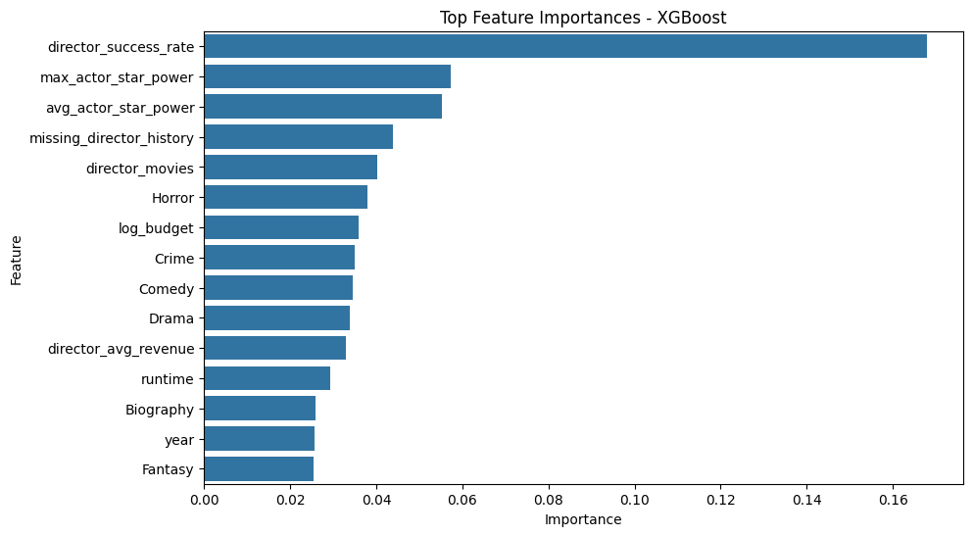
A sensitivity analysis was then conducted by progressively removing lower-importance features and retraining the XGBoost model. The results demonstrated that small amounts of feature reduction had minimal impact on validation performance, while aggressive feature elimination substantially reduced ROC-AUC scores.

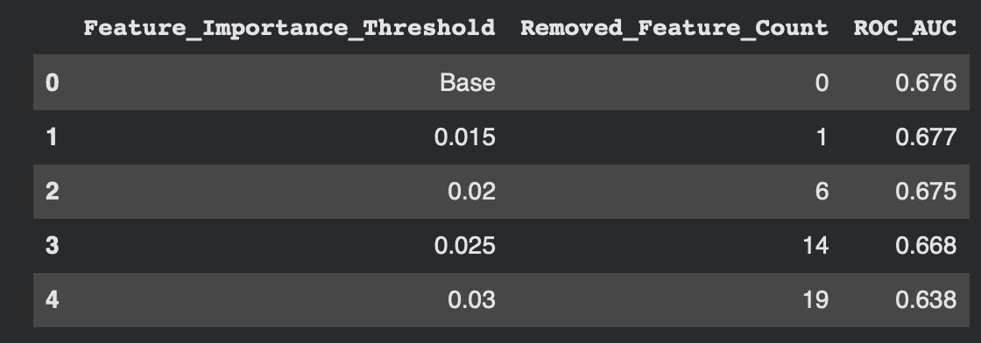
These findings suggest that movie success prediction benefits from combining multiple complementary variables rather than relying on only a few dominant predictors.

Hyperparameter Tuning and Ensemble Modeling
After evaluating the baseline models, hyperparameter tuning and ensemble learning techniques were explored to improve predictive performance.
Grid Search was applied to optimize the Random Forest classifier, while Randomized Search was used for XGBoost parameter tuning. A stacking ensemble model combining Logistic Regression, Random Forest, and XGBoost was also evaluated.
The tuned Random Forest model achieved the strongest overall validation performance and demonstrated the most stable generalization behavior across evaluation metrics. Although the tuned XGBoost and stacking ensemble approaches remained competitive, neither produced meaningful improvements over the tuned Random Forest classifier.


The final tuned Random Forest model was therefore selected as the best-performing model and evaluated on the held-out test dataset.

Final Model Performance and Interpretation
On the unseen test dataset, the final tuned Random Forest model achieved a ROC-AUC score of 0.648 and an accuracy of 0.624, demonstrating moderate but stable predictive performance.
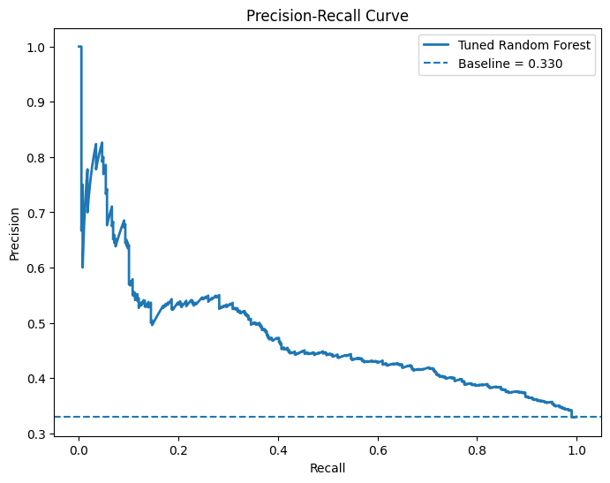
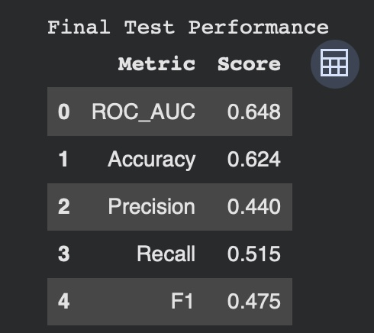
Feature importance analysis showed that director success history, actor star power, production budget, runtime, and genre-related variables were among the most influential predictors. Director-related historical variables in particular demonstrated strong predictive contribution, indicating that prior directing performance played a significant role in the model’s estimation of commercial success probability.
Precision-recall analysis, confusion matrices, calibration curves, and ROC visualizations further demonstrated that the model consistently outperformed random classification while maintaining relatively stable probability estimates across different prediction thresholds.
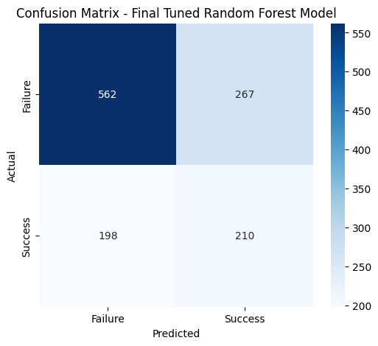
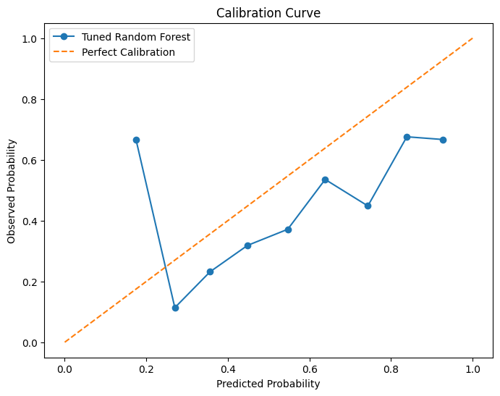
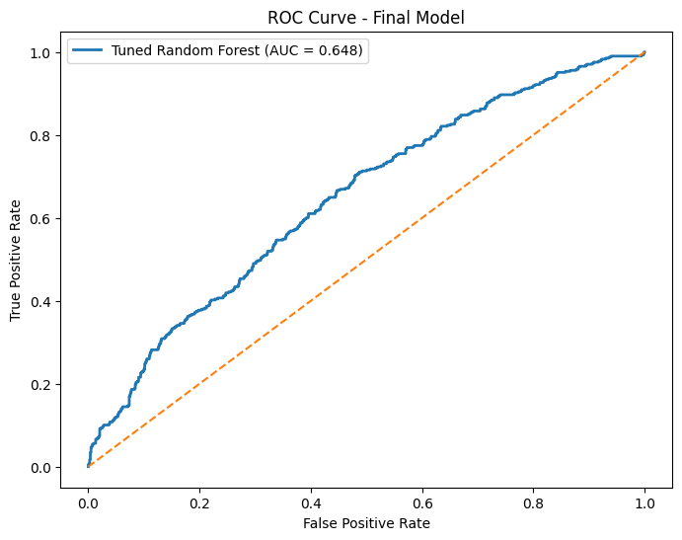
At the same time, the moderate overall predictive performance highlights the inherent uncertainty associated with movie success prediction. Financial outcomes are influenced by many difficult-to-measure external factors not directly captured in the dataset, including marketing effectiveness, release timing, streaming competition, audience preferences, critical reception, social media influence, and broader economic conditions.

Scenario Simulation and Decision-Support Analysis
Beyond traditional classification modeling, the project was extended into a scenario simulation and decision-support framework.
Reusable historical lookup tables were created for both actors and directors using aggregated training-period information. These tables stored historical performance profiles including star power indicators, historical revenue performance, ratings, success rates, and production scale metrics.
Using these lookup tables, hypothetical movie projects could be dynamically constructed by selecting alternative actors, directors, budgets, runtimes, and genre combinations. The trained machine learning model could then estimate predicted success probabilities for each hypothetical scenario.



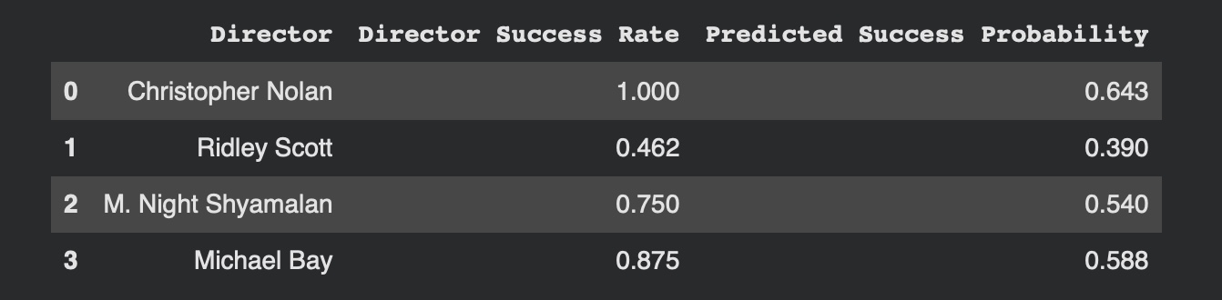

This framework allowed alternative production strategies to be compared while holding other movie characteristics constant. For example, the analysis demonstrated how replacing directors or modifying actor combinations could substantially influence the model’s predicted probability of commercial success.
The scenario simulation framework transformed the project from a static historical classification task into a reusable analytics system capable of supporting preliminary production planning, investment evaluation, casting analysis, and commercial risk assessment

Overall Synthesis
Overall, the modeling results demonstrate that movie success is partially predictable using structured pre-release information, particularly when incorporating historical actor, director, and genre performance variables. While predictive performance remains inherently limited by the complexity and uncertainty of the entertainment industry, the models consistently identified meaningful patterns associated with commercial outcomes.
More importantly, the project demonstrates how machine learning, clustering techniques, historical aggregation, ensemble modeling, and scenario simulation can be combined into a practical analytics framework capable of supporting strategic decision-making within film production environments.
Statement of Work
Evgeny Kuzmin was responsible for data acquisition, preprocessing, and dataset construction, including integration of IMDb and TMDB data, data cleaning, filtering, and preparation of the final modeling dataset. He also conducted EDA to uncover trends across genres, actors, and directors, as well as temporal analysis of these features.

Peter Sklamberg led the model development and evaluation, including feature engineering, implementation of classification models (Logistic Regression, Decision Tree, Random Forest, Gradient Boosting), hyperparameter tuning, and performance evaluation using validation and test sets.

Benjamin Wilson contributed to feature engineering and modeling, including the design and implementation of historical performance features (actor and genre-based), leakage prevention strategies, and support in model evaluation and interpretation.

References
Hossein, N., and D. W. Miller. “Predicting Motion Picture Box Office Performance Using Temporal Tweet Patterns.” International Journal of Intelligent Computing and Cybernetics, vol. 11, no. 1, 2018, pp. 64–80.

Elberse, Anita. Do Star Actors Drive the Success of Movies? Harvard Business School, 2007.

Wang, Siyi. An Empirical Analysis of Determinants Driving Hollywood Box Office Success. Proceedings of the 2025 10th International Conference on Financial Innovation and Economic Development (ICFIED 2025), Atlantis Press, 2025.

