FINAL PROJECT | INDIVIDUAL SUBMISSION | 11 NOVEMBER 2026

Distributed Multi-Model Analytics
for E-commerce Data
TECHNICAL REPORT • MongoDB / Apache HBase / Apache Spark
Institution: Adventist University of Central Africa (AUCA) | Student name / ID: [Complete before submission]

Executive summary
This project demonstrates how three complementary big-data technologies can be combined to analyze a synthetic e-commerce platform. The objective was to model transactional and browsing information, implement suitable NoSQL storage structures, process large datasets using Spark, and answer one cross-system business question: which products attract browsing interest, and how does that compare with their transaction performance?
We began with the lecturer-provided Python generator, producing 10,000 users, 5,000 products, 25 categories, 500,000 transactions and 2,000,000 sessions over a 90-day activity window. MongoDB stored all 2,515,025 generated documents. A Docker-hosted HBase instance stored 5,000 selected sessions and 16,804 product-date metric rows. PySpark cleaned 500,000 transactions, executed SQL summaries and a registration-cohort activity analysis, then joined HBase browsing metrics with MongoDB product and transaction metrics using product_id.
The integrated output retained all 5,000 products. The most-viewed product in the HBase subset was prod_01411 (13 views); the product with the largest completed transaction quantity in MongoDB was prod_01951 (403 units). Four charts were prepared to explain these patterns. Results demonstrate a working multi-model analytical pipeline; they are not claims about real customers or a validated conversion rate.

Research objective and implemented approach
Design and assess a reproducible proof of concept that uses MongoDB for nested business records, HBase for time-ordered browsing metrics, and Spark for batch analytics and cross-source integration. The architecture below summarizes the implemented flow.
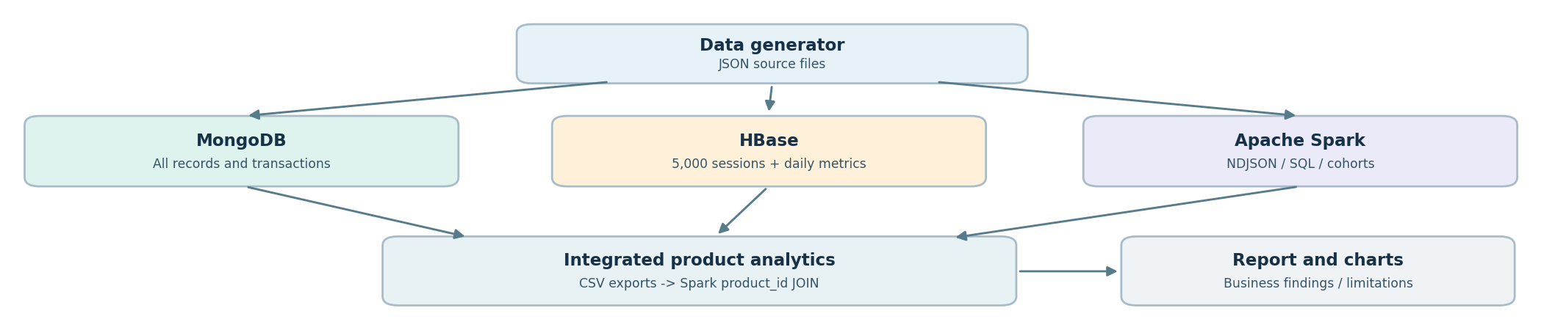
Figure 1. Implemented architecture. CSV exports were used as a practical bridge between MongoDB/HBase and a local Spark session; they were not live connectors.

1. Data generation and preparation
The supplied dataset_generator.py was used to create interconnected JSON datasets. The generator models customers navigating an online shop, viewing products, adding items to carts and creating transactions. It uses Faker for synthetic information, controlled random choices for user journeys, and inventory updates to reflect purchases.
Entity | Generated count | Main fields / analytical role
Users | 10,000 | user_id, geo_data, registration_date; customer grouping
Products | 5,000 | product_id, category_id, price_history, stock; product identity
Categories | 25 | category_id and embedded subcategories; taxonomy
Transactions | 500,000 | transaction_id, user_id, session_id, items[], status, total
Sessions | 2,000,000 | session_id, page_views[], cart_contents, device, referrer

1.1 How the synthetic customer journey works
Each session begins at a home, search or category page, then follows weighted transitions to product-detail, cart, checkout or confirmation pages. A product-detail page may add an item to the cart (programmed probability 0.30). Transactions linked to a session require relevant cart/checkout activity, followed by a programmed conditional completion probability of 0.70. The generator also adds some transactions outside the direct session link. Thus, not every transaction can be joined to a browsing session by session_id.
The inventory manager checks available stock; transaction items store product_id, quantity, unit_price and subtotal. An optional transaction discount has a programmed probability of 0.20, with rates selected from 5%, 10%, 15% and 20%. These are generation parameters, not measured business rates.

1.2 Dataset relationships and quality controls
Relationship | Join key | Why it matters
Users → sessions / transactions | user_id | Customer history and registration cohorts
Sessions → transactions (where present) | session_id | Journey-to-purchase investigation
Products → transaction items | product_id | Product-level transaction quantities
Products → browsing metrics | product_id | Cross-system comparison of interest and outcomes

The output comprised users.json, products.json, categories.json, transactions.json and 20 session chunks (sessions_0.json through sessions_19.json, 100,000 sessions per file). The large JSON arrays were validated with streaming parsing before loading. Spark later read an NDJSON conversion of transactions.json to simplify parallel row-oriented processing.

1.3 Methodological choices
We retained the lecturer’s generator logic rather than replacing it with a smaller custom dataset; we separated complete MongoDB storage from the smaller HBase demonstration subset; and we documented the file-to-file and source-to-source joins. These decisions make the workflow understandable and auditable, while acknowledging that local storage and memory constrain scale.

2. Part 1 — MongoDB document modeling and analytics
MongoDB was selected for variable and nested e-commerce records. The ecommerce_db database held five collections: users (10,000), products (5,000), categories (25), sessions (2,000,000) and transactions (500,000), totaling 2,515,025 documents. The local MongoDB server was verified at localhost:27017 after data ingestion.

2.1 Document schema and why it was appropriate
Collection | Design decision | Analytical benefit
users | One document per user; embedded geo_data | Fast retrieval of user details
products | Product details with embedded price_history | Historical prices available with product
categories | Subcategory array embedded in parent category | Natural hierarchy representation
sessions | Page-view array and cart_contents in a session | Full browsing journey in one document
transactions | Line-item array embedded with status and totals | Group / unwind purchases without separate item table

Example observed transaction: transaction_id txn_3ad156b0bb6b has two line items, a subtotal of 1,125.22, a discount of 168.78 and a total of 956.44. Its status is completed. MongoDB Decimal128 preserves monetary precision, rather than relying on binary floating-point rounding.

2.2 Aggregation strategy
The MongoDB analytical work was organized around non-trivial pipelines. A product-performance pipeline filters or groups transaction documents, unwinds the embedded items[] array, groups by item.product_id, sums quantities or item subtotals, and sorts the resulting products. A behavior-oriented pipeline groups sessions by attributes such as device type or referrer and counts session outcomes. Both use the document structure rather than manually flattening every nested record first.
REPRESENTATIVE QUERY LOGIC FOR REPRODUCIBILITY
Pipeline A — product performance | Pipeline B — browsing segments
$match(status) → $unwind(items) → $group(product_id, quantity) → $sort → $limit | $group(device_profile.type, session_count, converted_count) → $project(activity rate)

These concise pipeline plans describe the analytical methods, not a claim that their exact command text or a particular conversion-rate result was independently reproduced for this report. The independently verified MongoDB evidence is the collection count, document counts and product-level export results.

2.3 Verified product export
The integration/export_mongodb.py step read 5,000 product records and processed 500,000 transactions one by one. It identified 4,766 products appearing in transaction items. The other 234 products did not appear in the scanned transaction items; this does not establish that they received zero views. The export separated all-status item quantities from quantities in status=completed transactions, and retained item subtotals before transaction-level discounts.

3. Part 1 — HBase wide-column modeling and access
Apache HBase was used to model time-series browsing activity with explicit row-key access patterns. It ran inside Docker (harisekhon/hbase image) using the working hbase-recovery container. HBase was deliberately used for a manageable subset, rather than incorrectly claiming that all two million sessions had been loaded.

3.1 Two implemented tables
HBase table | Row key | Column families and content
fp_user_sessions | user_id#reverse_time#session_id | info: session metadata; pv: page views; cart: cart contents
fp_product_metrics | product_id#YYYYMMDD | m:views and m:cart_quantity

The reverse-time component was constructed as 9,999,999,999 minus the session Unix timestamp; it places a user’s newer sessions earlier within that user_id prefix. Daily product rows group activity for a product on a given date. For example, prod_00000#20260925 stores m:views=1 and m:cart_quantity=3 in the observed scan.

3.2 Loading process and verification
The HBase loader used ijson to stream session records from sessions_0.json and generated HBase Shell put commands. We first checked a small test of 20 sessions, expanded the sample to 1,000, and finally loaded the first 5,000 sessions. The resulting tables contained 5,000 user-session rows and 16,804 product-date rows. Specific-user access was supported by the user_id prefix in the session row key.
Verified metric | Observed result | Evidence in the workflow
Session rows loaded | 5,000 | HBase count after staged ingestion
Product-date rows | 16,804 | HBase count and full scan export
HBase scan sample | 3 rows returned | prod_00000 dates: 20260830, 20260925, 20261019
CSV conversion | 16,804 complete rows | 0 incomplete metric rows

3.3 Browse-to-cart measurement
For each product_detail page, the loader increments m:views. For each product remaining in the session’s final cart, it adds the recorded quantity to m:cart_quantity. Consequently, cart_quantity measures units in carts, not items purchased; views count page-detail events, not necessarily unique shoppers.

3.4 Design and infrastructure trade-offs
The first HBase container encountered a Thrift startup problem; a recovery container reused the existing volume with the problematic Thrift startup disabled. The master and RegionServer then supported HBase Shell scans. For scalability, a real cluster would distribute regions across RegionServers and avoid row-key hotspots. The selected 5,000 sessions were the first records of a chunk, so they are a deterministic demonstration subset—not a statistically random representative sample.

4. Part 2 — Spark processing, SQL and cohort analysis
Apache Spark performed batch transformation and analytics on the 500,000 transaction records. The original transactions.json was converted with ijson into approximately 203 MB of newline-delimited JSON (transactions.ndjson), then loaded with a local PySpark session (local[2], 2 GB driver memory). Removing a conflicting SPARK_HOME setting resolved an earlier Spark-version startup error.

4.1 Cleaning and storage
The script converted monetary values from strings to decimal(18,2), parsed transaction timestamps, normalized status/payment_method text, checked required IDs/timestamps/non-negative totals, removed duplicate transaction IDs, and wrote transactions_clean.parquet. The checks returned 500,000 original transactions, 0 invalid transactions under the defined checks, 0 duplicates and 500,000 cleaned transactions. Nested item monetary fields remained strings in this particular cleaned schema; product-level monetary exports were handled separately.

4.2 Verified Spark SQL results
Transaction status | Number | Transaction value
completed | 317,055 | 264,428,273.18
delivered | 61,226 | 67,830,723.08
processing | 60,933 | 67,191,918.13
shipped | 60,786 | 67,125,249.06
TOTAL | 500,000 | 466,576,163.45

Activity month | Transactions | Unique customers | Transaction value
2026-08 | 169,268 | 10,000 | 157,886,330.43
2026-09 | 166,157 | 10,000 | 154,991,898.17
2026-10 | 164,575 | 10,000 | 153,697,934.85

The reported amount is a sum of transaction totals across different statuses, not verified cash received or accounting revenue. Transaction activity fell modestly across August–October in the synthetic dataset. A third SQL query joined transactions with user profiles on user_id and summarized activity by customer registration month (February–August 2026).

4.3 Registration-cohort activity
A cohort was defined by the registration month of each user. The analysis joined user profiles with transactions, counted distinct active users by cohort and transaction month, then divided by the total users in each cohort. All observed cohort-month pairs for August–October produced an activity rate of 100%. This reflects the generated dataset and the selected observation window. It is not valid evidence of 100% real-world retention, nor a fully observed month-zero purchase retention curve.

5. Part 3 — Integrated analytics across data stores
Business question: Which products attract customer browsing interest, and how does this relate to their transaction performance? The implemented workflow brought together MongoDB product and transaction data, HBase browsing records, and a Spark join. Source data was read from the real databases, exported to CSV for a reliable local hand-off, and then integrated in Spark.

5.1 Data integration workflow
Step | Source / script | Output / validated scope
1 | HBase Shell scan of fp_product_metrics | 16,804 product-date rows
2 | convert_hbase_to_csv.py | 16,804 complete rows: id/date/views/cart
3 | export_mongodb.py | 5,000 product rows, 4,766 product-sales rows
4 | spark_integrated_analysis.py | Aggregate HBase by product_id; left join both MongoDB exports
5 | Spark CSV writer | 5,000 integrated product records

Spark grouped HBase day-level values by product_id and summed views and cart_quantity. A LEFT JOIN starting from the 5,000-product catalog preserved products with no observed activity in one or both exports. Missing counts were filled with zero; monetary values were cast to decimal(18,2). The result enabled ranking by browsing interest and completed-transaction item quantities.

5.2 Two independently verified findings
Criterion | Leading product | Observed metric
Most product-detail views (HBase subset) | prod_01411 | 13 views; 12 cart units; 276 completed units in MongoDB
Most units in completed transactions | prod_01951 | 403 completed units; 9 HBase views; 11 cart units

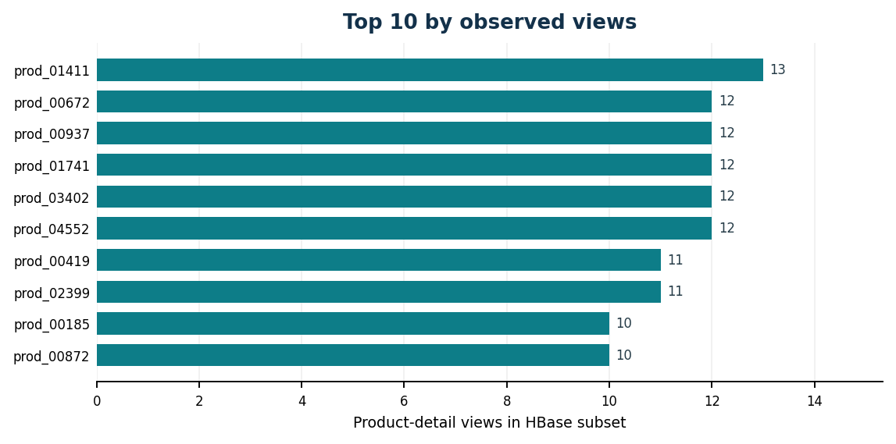 | 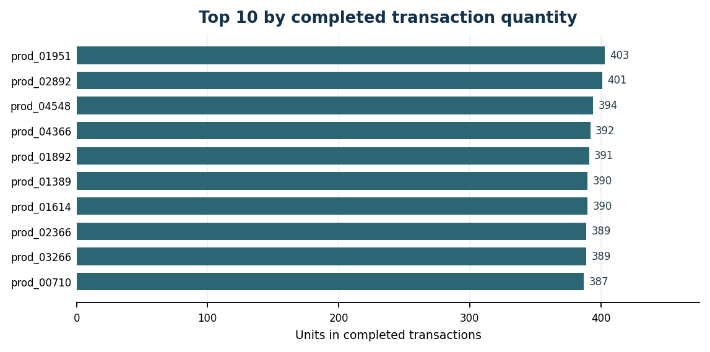
Figures 2–3. Rankings reproduced from verified Spark integrated-analysis output. Views use HBase subset; completed quantities use the full MongoDB transaction export.
Interpretation: the product with the highest observed views was not the leader by completed quantity. Because views came from 5,000 selected sessions and quantities from 500,000 transactions, this is a descriptive comparison—not a matched product conversion rate, correlation test, or causal result.

6. Part 4 — Visualisation and interpretation
The project produced four static PNG visualisations. The report presents the actual observed rankings and the user-verified scatter plot, with annotations that make the evidence scope explicit. The assignment required no interactive dashboard.

6.1 Browsing and cart interest
The ten highest-viewed products in the HBase subset received between 10 and 13 product-detail views each. Their cart quantities varied more: among those same ten products, prod_02399 recorded 17 cart units from 11 detail views. Cart units may exceed views because one cart may contain several units; it is therefore inappropriate to treat this ratio as conversion.
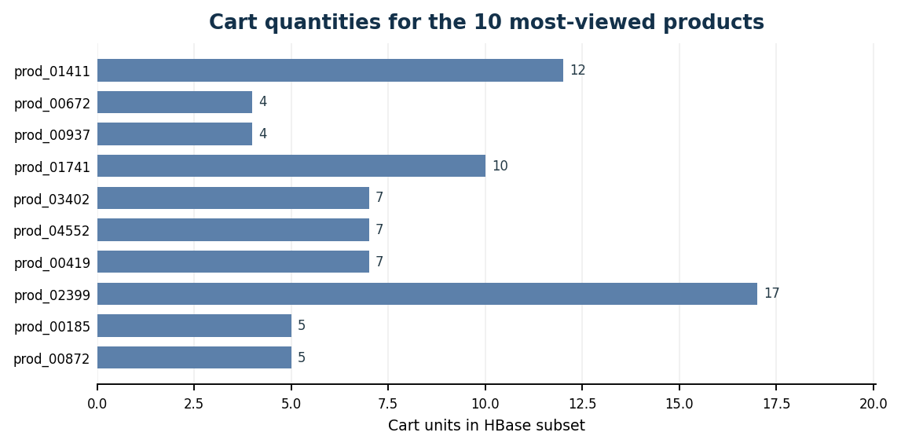
Figure 4. Cart quantities for the ten most-viewed products, using confirmed HBase metrics. This is NOT a ranking of the ten largest cart quantities across all products.

6.2 Browsing views versus completed quantities
The scatter plot places the HBase subset’s view count on the horizontal axis and completed-item quantities from MongoDB transactions on the vertical axis. Vertical columns appear because views are integer counts and many products share the same number of observed views. Completed quantities vary considerably within those columns.
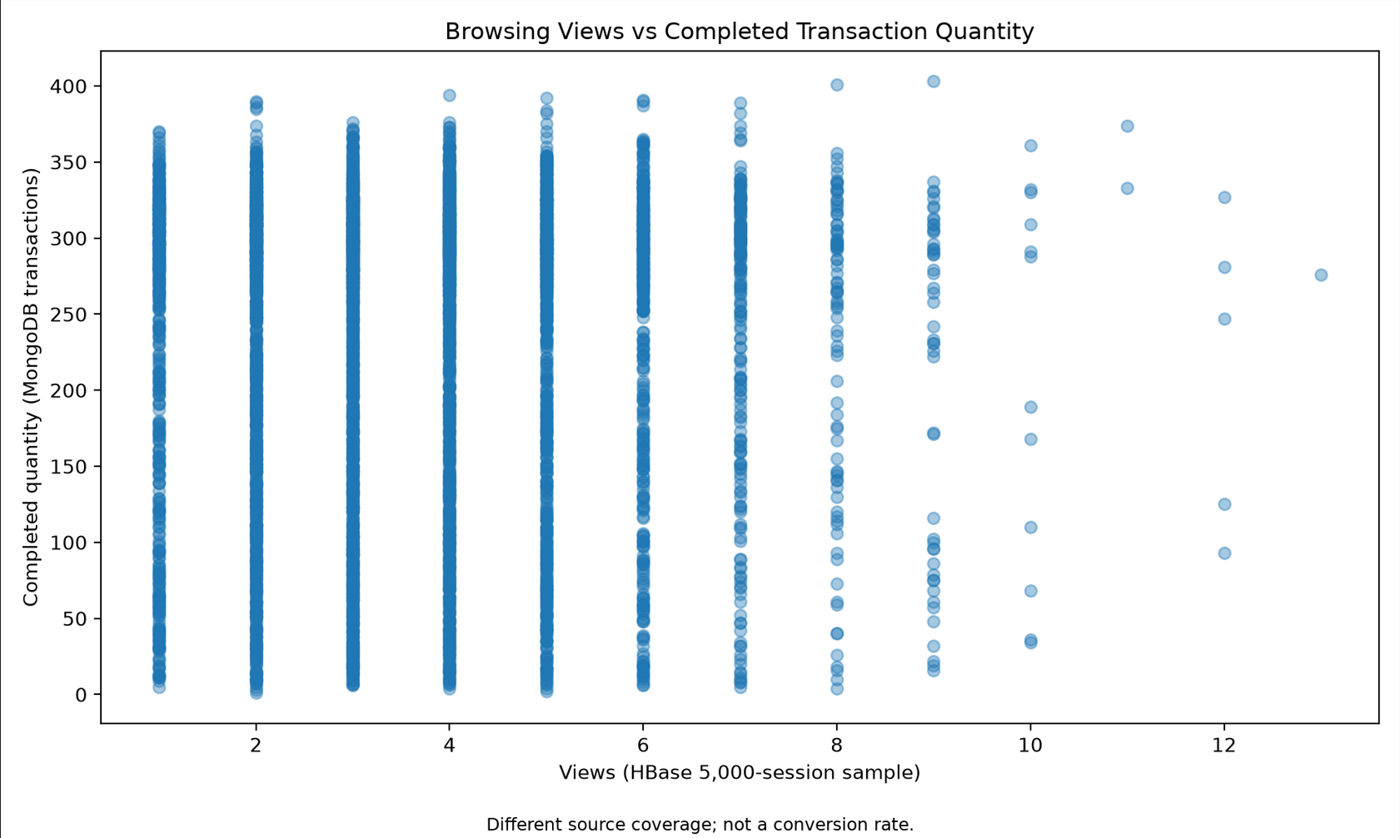
Figure 5. Actual scatter plot screenshot from the verified project visualization; source scope is explicitly different between axes. It cannot be used to estimate a product purchase-conversion rate.

7. Discussion, limitations and conclusion

7.1 Technology choices and scalability
Technology | Why selected | Scale-up consideration (not benchmarked)
MongoDB | Nested documents and flexible product/session records | Indexes, partitioning/sharding and query review
HBase | User-prefix time series and sparse product-day metrics | More RegionServers; balanced row keys; bulk ingestion
Spark | Repeatable batch transformations, SQL and joins | Multi-node cluster; pruning, caching, tuned partitions
CSV exchange | Practical and transparent integration on one PC | Replace shell exports with supported connectors/jobs

7.2 Evidence-based limitations
- Data are synthetic; generated behavior should not be generalized to actual online shoppers.
- HBase used the first 5,000 sessions from one chunk, not a random sample of the full 2,000,000.
- The integrated views/cart metrics and transaction quantities have different populations and coverage; no true purchase conversion rate or causal relationship was estimated.
- Spark cohort analysis counts any transaction status as activity in August–October; 100% observed activity is not proof of durable retention.
- The prototype ran Spark locally (local[2]) and HBase in one Docker environment. Distributed throughput or failover was not benchmarked.
- MongoDB item subtotals are before transaction-level discount. Reported status-group transaction totals should not be called realized revenue.

7.3 Reproducibility and final verification
Key reproducible files include dataset_generator.py; hbase/schema.hbase, load_hbase.py and queries.hbase; spark/prepare_transactions.py, spark_clean.py, spark_sql_queries.py and spark_cohort.py; integration/convert_hbase_to_csv.py, export_mongodb.py and spark_integrated_analysis.py; plus visualization scripts and four chart PNGs. The final GitHub repository should contain the actual MongoDB loader/aggregation source code, dependency details, run order and screenshots. It must not include raw database volumes, secrets, or unreasonably large generated datasets.
Before submission: confirm the PDF is 6–8 pages; include the current report, architecture and charts; correct any schema comment implying HBase stores purchases (the implemented metrics were views/cart quantities); verify MongoDB aggregation scripts and source-code availability; supply the student’s official identification and a functioning README.

7.4 Conclusion
The project achieved a working end-to-end multi-model analytics demonstration. MongoDB handled 2.5 million nested documents, HBase stored and queried time-series browsing activity, and Spark cleaned, summarized, and integrated the exported data. The resulting 5,000-product analytical table and visualizations answer a concrete comparative business question while acknowledging sampling and synthetic-data constraints. The exercise illustrates not only tool operation, but why schema design, join-key integrity, staged validation, and cautious interpretation matter in big-data analytics.
PRIMARY SOURCES AND EVIDENCE
AUCA, “Big Data Analytics Final Project: Distributed Multi-Model Analytics for E-commerce Data” (28 October 2026); lecturer-provided dataset_generator.py; confirmed PowerShell, MongoDB, HBase and Spark outputs from the project working sessions (2 November 2026).

