About the document
This documentation is intended to explain a developer how to build an windows installer for a Wb based application which is developed using Java, MySQL and Tomcat.

Prerequisites
Before proceeding with this installer build up procedure, you should have below mentioned files and steps covered.
- A .war file of a web application for which you will be building a web installer.
- An extracted Tomcat File which can be downloaded from the tomcat website
that’s https://tomcat.apache.org/download-70.cgi
- JRE of the specific version using which the web application is developed.
- MySQL of specific version which is being used in the web application.
- Put all of these into one folder.
- Download Innosetup compiler from https://jrsoftware.org/isdl.php and install the same.
- Once the it is installed, we are ready to go.

Create a Basic script(.iss) file

- Once the Innosetup is installed open the software.
- This will open a screen like the image given below. Choose on the Create a new script file using setup wizard and click next.

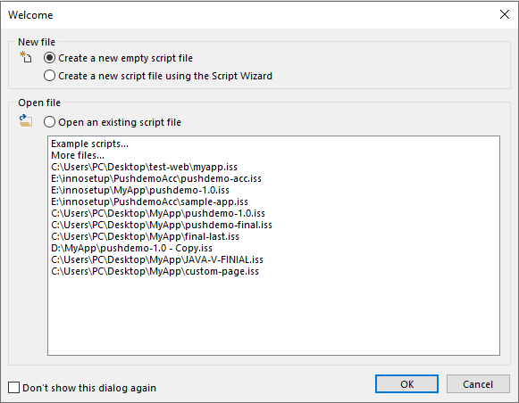
- Click Next

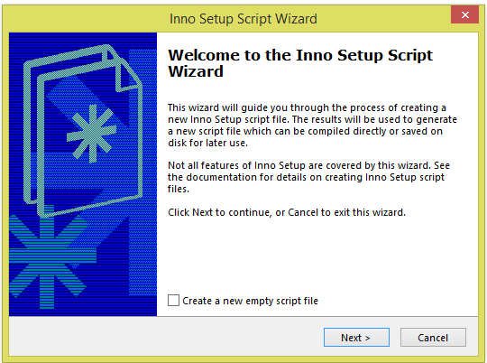

- Provide the application name, version, Publisher and website of company and Click Next.

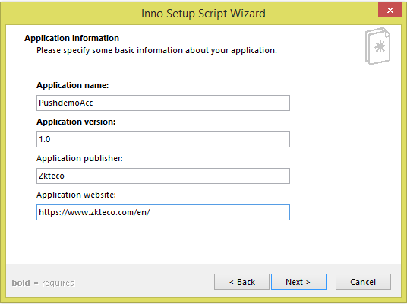

- Choose the base folder and folder name when the application and will be installed where it will install. Let allow user to change the application folder checked. Click Next.

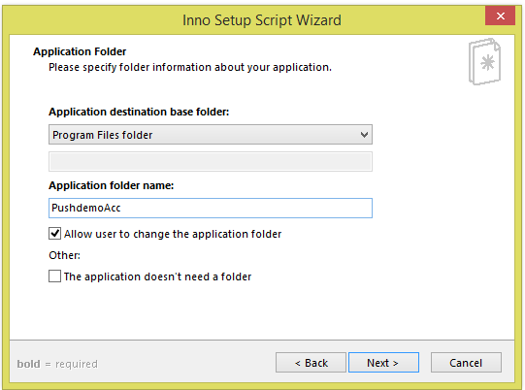

- Let the Default be there and click on the add files to add the dependency files for the software. In this case JRE, MYSQL, Tomcat Folder.

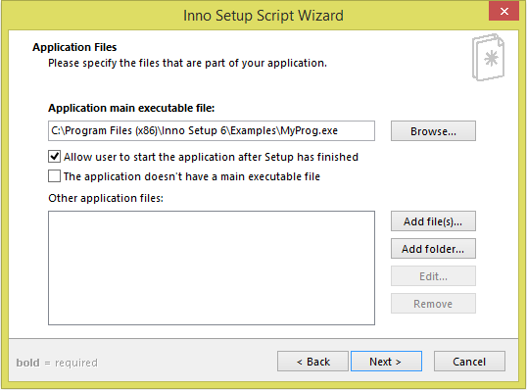
- After choosing all the dependent files and folder Click Next.

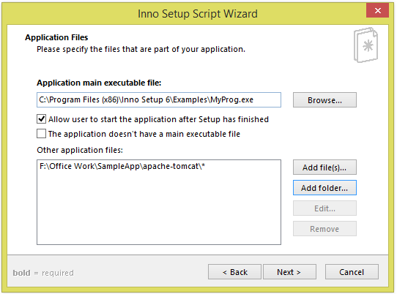
Here it will list all the selected files and folders.

- Select the required check boxes and click Next.

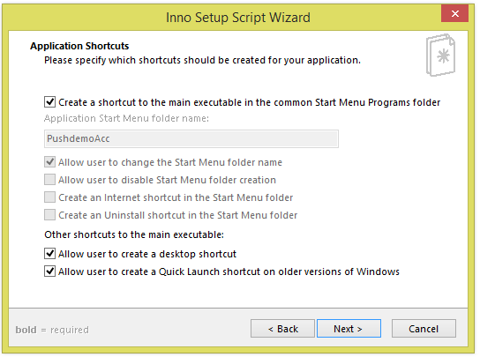

- Choose the license file if any required and fill the boxes if any required and click Next.

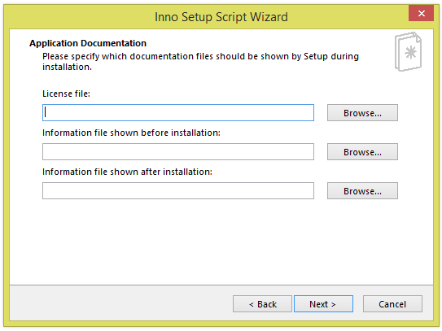

- Choose Administrative install mode as we need admin permission to install and click Next.

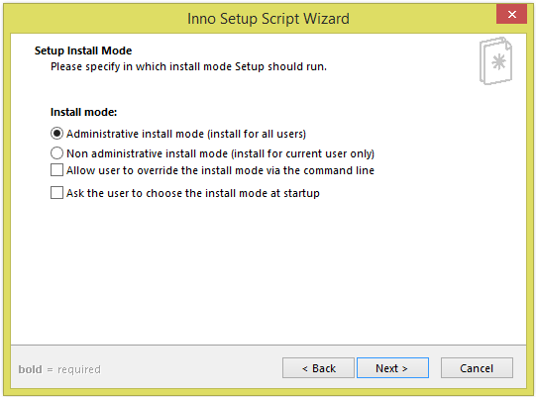
If we choose this option, we no need to run our software as administrator every time
- Choose language as English and click Next.

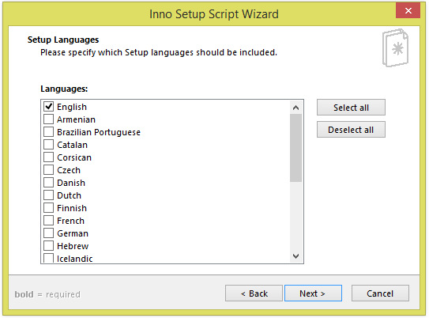
You can choose any number of languages

- Choose the specifics mentioned and click Next.

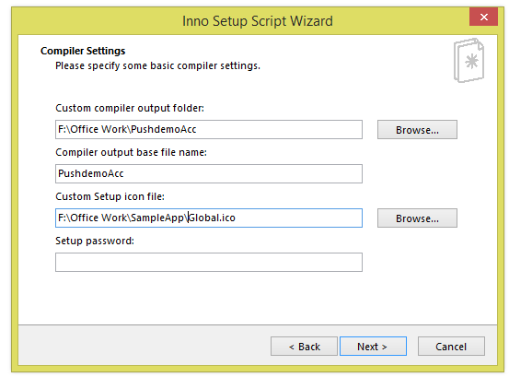
where the exe file will be stored
The exe file name
The icon file for the software

- Choose Yes and click on Next.

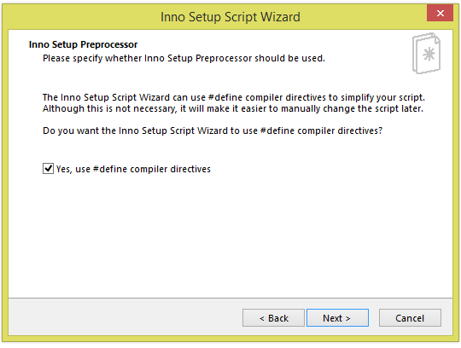

- Click Finish. This will create a script file.

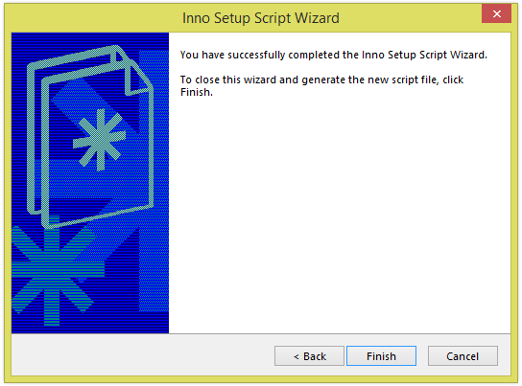

- As soon as you click Finish it will show the below screen with a basic script file. Click on Yes

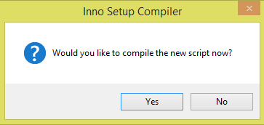

- Click Yes and save the .iss file into the same folder where all the prerequisite files are there.

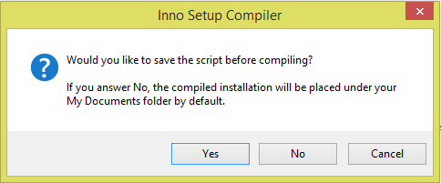

- Now the base file is ready to be edited. We can now modify it according to our requirement. Below some of the code snippet is given. For a good understanding of the code first go through the documentation which is given in https://jrsoftware.org/ishelp/ .

Edit the script according to the requirement

The image below shows the [Setup] section which explains about the basic details of the application which is going to be created. The ArchitecturesInstallIn64BitMode=x64 is given if the software is installed in 32bit system also the files will defaultly be stored in Programfiles.

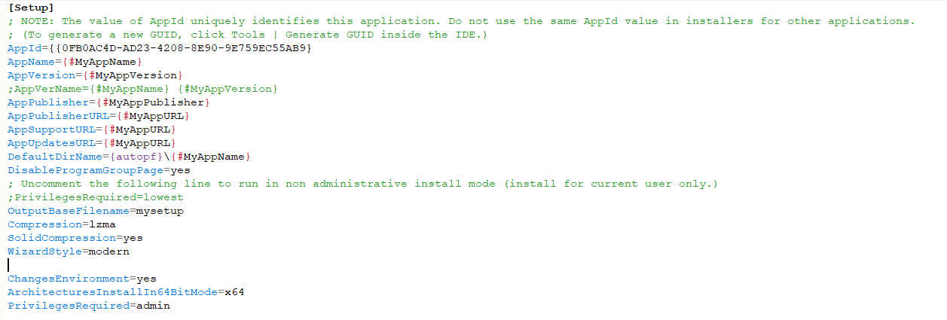

The [Files] section will copy the specified files to the installation directory in the host system. Like in this software we have dependency on Java, Tomcat and MySQL, so we are copying it to host pc. But after installation which files we don’t required anymore we should delete it.
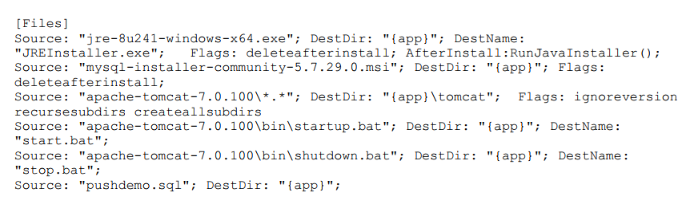

The [Registry] section is to specify some files in to host pc registry or to change environment variables or add it. In this section the JAVA_HOME and CATALINA_HOME is set.
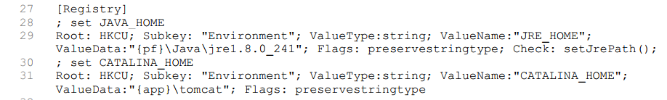

The [Run] section is used to run the files which we have copied in the file section to the host pc. In this if some command line arguments are required also can be passed. There is a lot of parameters passed here which can be referred from the https://jrsoftware.org/ishelp/ [Inno Setup Documentation].
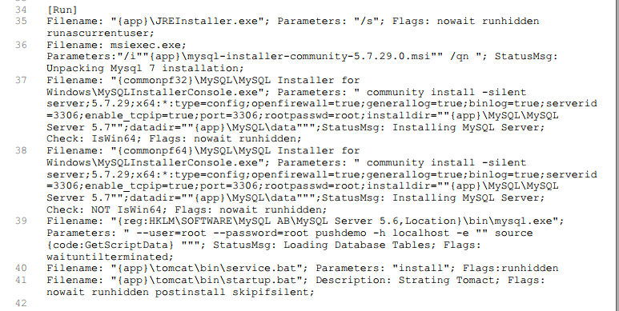

The [Code] section shows that if any utility code has to be written it can be written here i.e. In this case the code is written to decide which version of java is installed in the host system or its installed or not.
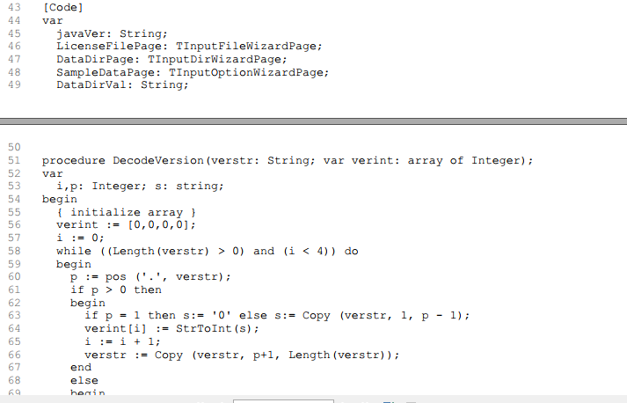

After the code written save the file into the folder where all the files like java, mysql.msi and tomcat is present.

Once saved click on the Compile icon which will generate the desired .exe file into the specified folder in the [Setup] section.
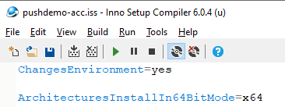

Run the executable in any windows.

Once the executable file is generated, we are ready to install the file in any windows system.

