Introduction
Paul Gordijn
Felicity Elliot
Shannon Rushworth
Andy Blackmore
Craig Mulqueeny
Ian Rushworth
Adrian Armstrong
Clinton Carbutt
Brent Coverdale
Debbie Jewitt
Skhumuzo Khubeka
Abstract
The KwaZulu‑Natal terrestrial conservation plan is closely integrated with neighbouring conservation initiatives and seeks to connect multiple realms of biodiversity, from the marine to the terrestrial environment. Its overarching aim is to secure sufficient space for conservation while minimising constraints and maximising available opportunities. The following section outlines the conservation planning process and the rationale that underpins it.
Download Word (docx)

The KwaZulu-Natal systematic conservation plan

Plan aim & stages
This terrestrial conservation plan aims to solve the problem of: how to ensure sufficient space for biodiversity conservation, in the KwaZulu-Natal terrestrial realm, whilst simultaneously minimising constraints and maximising opportunities (see Note 2). This is also known as the minimum set of protected areas’ solution (i.e., the ‘min set’) (Margules and Pressey 2000; Hanson et al. 2025). There are four broad stages that need to be addressed for resolution of this conservation problem (Escott et al. 2016; SANBI and UNEP-WCMC 2024) (Figure 1).
 Note 1: Costs & decision support
Constraints and opportunities are referred as costs in conservation planning. These costs are more than the monetary value of acquiring protected areas for conservation efforts. In conservation planning ‘costing’ involves how complex socio-ecological factors are quantified and tradeoffs made. The balancing of these tradeoffs is the ‘decision support’ mechanism that helps optimise the conservation planning solution with other human land use activities (Escott et al. 2016; SANBI and UNEP-WCMC 2024).

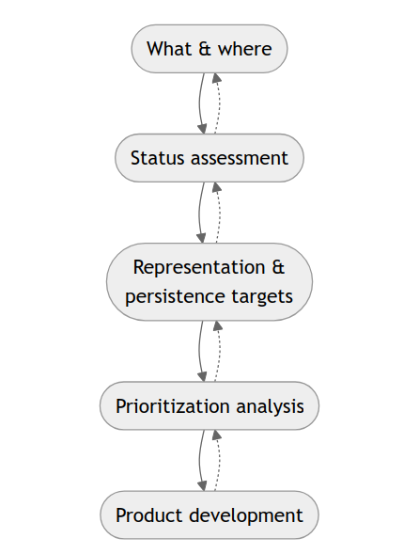
Figure 1: The iterative stages, from gathering data, target setting, to prioritisation analyses, in conservation planning (c.f. SANBI and UNEP-WCMC (2024)). (1) The first stage addresses the what and where of biodiversity-related landscape features. (2) The second speaks to goal setting for the space biodiversity needs. (3) The third stage deals with setting up decision-making criteria that helps balance tradeoffs between the ‘costs’ of conservation efforts and socio-ecological factors (see Note 2). (4) Finally, the forth involves a robust and transparent analysis that solves the problem of the where and how should conservation efforts be prioritised at minimum ‘cost’.
The what and where of biodiversity-related features requires a collation and modelling of biodiversity occurrence data in order to provide the best possible spatial representation of biodiversity. This helps guarantee that conservation efforts are directed to the most appropriate locations. Other important what and where features for biodiversity include key habitat features for breeding, or safe zones (refugia).
The second stage concerns determination of meaningful representation and persistence targets. In other words, how much of which ecosystems and ecological features need to be represented, in the conservation plan, to secure the persistence of biodiversity. Setting up decision-support mechanisms helps us ensure that conservation efforts are focused on optimal locations. For this, other land uses and socio-ecological dynamics have to be considered (Margules and Pressey 2000; Hanson et al. 2025). Once this data is gathered the final stage involves the prioritisation analysis. Multiple analyses are run showing different scenarios in a transparent process to demonstrate how the plan attempts to optimise conservation while supporting critical socio-ecological dynamics (Escott et al. 2016; SANBI and UNEP-WCMC 2024).

Integrating biodiversity realms
Integrating the terrestrial conservation plan with the marine, estuarine, and freshwater biodiversity realms is critical for an overall land- to sea-scape approach. This integration ensures that critical marine realms are supported by important estuaries. These estuaries are supported by a freshwater plan, and conservation in linked terrestrial environs is prioritised to promote this overall land–ocean ‘scape’ ― a multi-realm ‘ecoscape’ (Wedding et al. 2025).
 Note 2: Terrestrial and freshwater overlap
Wetlands provide an interesting case of overlap in the terrestrial and freshwater realms. Many species directly use both of ‘realms’. The terrestrial plan accounts for this overlap through its incorporation freshwater features, that is, ‘freshwater’ associated species, and freshwater bodies (Escott et al. 2016; Lötter 2015). The terrestrial plan is however specifically engineered to address terrestrial-focused conservation problems necessitating a separate exercise to address freshwater conservation planning.

The above linking from marine, estuary, freshwater to terrestrial, describes the hierarchical approach recommended for integrating biodiversity plans (Escott et al. 2016; Lötter 2015). This ‘linking’ is done from the most dependant, that is, most affected by other adjacent realms, to the least-dependent realm. In conservation planning, the terrestrial realm is considered the least dependent, compared with the marine and estuarine realms, in KwaZulu-Natal (Escott et al. 2016; Desmet and Hawley 2019).
Overlap between realms has to be dealt with systematically. For conservation planning in KwaZulu-Natal, the rugged topography with incised valleys and associated catchment systems is best addressed through a catchment management approach (Escott et al. 2016; Desmet and Hawley 2019). This catchment management system neatly ties the terrestrial to the estuarine, coastal and marine realms.
Desmet, Philip, and Greer Hawley. 2019. Eastern Cape Biodiversity Plan 2019: Technical Notes. Technical Report Project No 2005-012. Department of Water Affairs; Forestry.
Escott, B., F. Elliot, and T.-C. Livingstone. 2016. Draft KwaZulu-Natal Biodiversiy Spatial Planning Terms and Processes. Version 3.3. Technical report. Ezemvelo KwaZulu-Natal Wildlife.
Hanson, Jeffrey O, Richard Schuster, Matthew Strimas-Mackey, et al. 2025. “Systematic Conservation Prioritization with the Prioritizr r Package.” Conservation Biology 39 (1): e14376. https://doi.org/10.1111/cobi.14376.
Lötter, Mervyn. 2015. Techinical Report for the Mpumalanga Biodiversity Sector Plan – MBSP. Technical report. Mpumalanga Tourism; Parks Agency.
Margules, Christopher Robert, and Robert L Pressey. 2000. “Systematic Conservation Planning.” Nature 405 (6783): 243–53.
SANBI, and UNEP-WCMC. 2024. Mapping Biodiversity Priorities: A Practical Approach to Spatial Biodiversity Assessment and Priortisation to Inform National Policy, Planning, Decisions and Action. 2nd ed. South African National Biodiversity Institute. Pretoria, ZA.
Wedding, LM, T Agardy, S Green, et al. 2025. “Bridging Land and Seascape Restoration for Ecoscape Recovery.” Npj | Ocean Sustainability 4 (1): 31.

