Technical introduction
Paul Gordijn
Felicity Elliot
Shannon Rushworth
Andy Blackmore
Craig Mulqueeny
Ian Rushworth
Adrian Armstrong
Clinton Carbutt
Brent Coverdale
Debbie Jewitt
Skhumuzo Khubeka
Abstract
The three principal questions that guide the Ezemvelo KZN Wildlife Systematic Conservation Plan, are; 1) What biodiversity does the province contain and where is it, 2) what is the status of this biodiversity, and 3) addressed by a prioritisation analysis — where and how should conservation efforts be prioritized. This technical introduction elaborates on each of these questions that are expanded into five stages, each critical for a detailed understanding of the conservation plan’s associated products.
Download Word (docx)

The KwaZulu-Natal Systematic Conservation Plan
The Systematic Conservation Plan (SCP) around these key questions (SANBI and UNEP-WCMC 2024; Jung et al. 2025):
- What biodiversity and where is it?
- What is the state of this biodiversity?
- Where and how should conservation efforts be prioritised?
These questions form the basis for the structure of this conservation plan. The first key question involves collation and modelling of data in order to obtain the best available spatial representation of biodiversity. The second is largely concerned with the conservation or risk status of biodiversity that will guide the mapping of biodiversity, and the prioritisation analyses in point three.

Conservation plan stages
The main stages of the conservation plan are depicted in Figure 1 below.
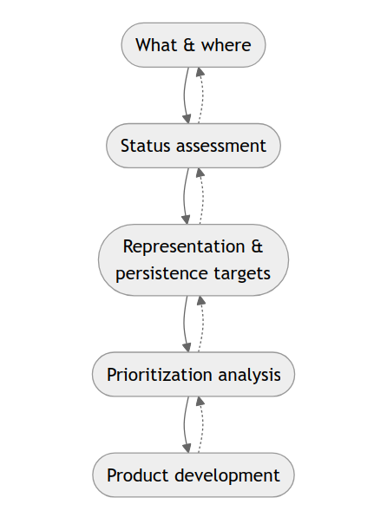
Figure 1: Flowchart depicting the iterative stages of gathering data, analyses, and outputs of the systematic conservation plan (c.f. SANBI and UNEP-WCMC (2024)).
The stages of this SCP are as follows:
- The what and where of biodiversity — representation data (see ATsec-eco-state):
  - Develop a baseline‑ecosystem layer that broadly represents the spatial distribution of biotic communities (i.e., coarse‑filter features).
  - Determine the state of ecosystems and their biodiversity:
    - Ascertain the distribution of protected and conserved areas.
    - Refine the baseline‑ecosystems layer to represent the current state of biodiversity.
  - Bolster the representation of all species.
  - Represent ecosystem function and change — collection of additional spatial datasets.
    - Ecosystem processes
    - Ecosystem infrastructure
    - Ecosystem services
    - Ecological condition
    - Climate change information
    - Socio‑economic data
- Determine the current state of ecosystems and their biodiversity:
  - Evaluate the risk and protection status of ecosystems.
  - Align and compare provincial (and where appropriate trans‑regional) ecosystem risk status.
  - Evaluate the risk and protection status of species.
- Set representation and persistence targets:
  - Representation and persistence of ecosystems, including alignment with the Global Biodiversity Framework (Convention on Biological Diversity 2022).
  - Representation and persistence of species.
- Spatial prioritisation:
  - Spatial framework of evaluation — planning units.
  - Compilation of cost (decision‑support) layers.
  - Systematic spatial prioritisation analyses and scenario modelling.
  - Sensitivity analysis.
- Product development.

What & where
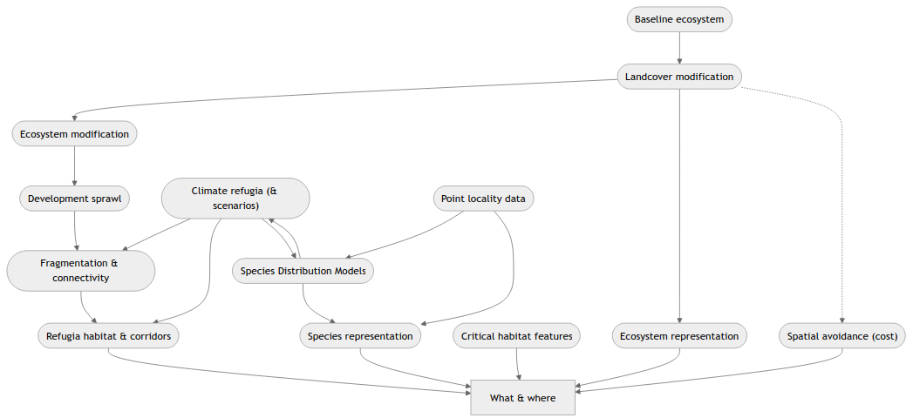
Figure 2: Inputs to determining the what and where of biodiversity.

The what and where of biodiversity
For robust representation of biodiversity and associated ecosystem infrastructure and services into the future, the what and where of biodiversity needs to consider change drivers. The functions of biodiversity, and associated ecosystems, also need to be considered for accurate representation when attempting to ensure conservation of these features.
In order to maximise representation of biodiversity in a landscape, the SCP process adopts a two-pronged approach, specifically:
- a wide-ranging (or coarse-filter): “Ecosystem representation” approach (see Section 3.1), and
- a targeted (or fine-filter): “Species representation” approach (see Section 3.1.2) (SANBI and UNEP-WCMC 2024).
Representation of the ecosystem types in the area-of-interest largely fulfils the wide-ranging component, that is, if the SCP incorporates the full diversity of ecosystems, it is likely to represent their constituent taxa. The complementary approach, that is, the targeted approach, caters for specific, threatened taxa, or those not operating within the parameters of represented ecosystems (Margules and Pressey 2000).

Ecosystem representation
Incorporating ecosystem types in the SCP process serves to broadly capture the spatial distribution of distinct-biological communities, and thereby the full suite of species—i.e., gamma diversity (Whittaker 1960)—across the region of interest (Mucina 2024). Following the previous terrestrial SCP for KwaZulu-Natal (Escott 2010), a vegetation-type map formed a robust surrogate for ecosystem types. Vegetation types commonly serve as surrogates for ecosystem types because they largely capture differences in biodiversity patterns across the landscape (SANBI and UNEP-WCMC 2024).
For an up-to-date representation of ecosystem extent, the provincial-vegetation map (i.e., coverage) had to be adjusted. The provincial-vegetation coverage serves as a representation of “natural” vegetation communities prior to GC pressures ca. 1750 (Mucina et al. 2018). Therefore, the coverage had to be adjusted to reflect the current state of ecosystems using the best available data.

Ecosystem and biodiversity state datasets

Protected and conserved ecosystems

Ecosystem protection and conservation

Species representation

Species selection criteria

Criteria for the selection of species

Introduction
The broad-ranging approach for representation of biodiversity in the SCP was complemented by a targeted approach (see Section 3.1.2). The targeted approach required a systematic selection of species (SANBI and UNEP-WCMC 2024). Ezemvelo KZN Wildlife scientists and a broad range of stakeholders at an SCP inaugural workshop (Elliot 2023), developed the criteria for the inclusion of species in a workshop session with external stakeholders. For the KwaZulu-Natal SCP, these criteria were applied to each grouping of taxa as shown below.

Criteria for inclusion
Table 1: Criteria for inclusion of species in the targeted approach.
ID | Criteria | Rules
1 | Endemic to KwaZulu-Natal. | Feature must be triggered by ≥1 criterion; criteria equal weighting; may include uncertain data but removed if insufficient; consider age and accuracy of data.
2 | Near Endemic to KwaZulu-Natal (50–99% of taxon distribution falls within KwaZulu-Natal).
3 | Threat status (CR, EN, Rare, VU, NT). Global or Regional. Highest threat status taken.
4 | International obligation.
5 | Umbrella species.
6 | Isolated from core known range with genetic differences.
7 | Edge of range species (may be well protected in KZN but globally/regionally threatened).
8 | Life‑history stage essential for protection of species.
9 | Species conservation plan or biodiversity management plan.
10 | Other (specify).
11 | Resource use threat.
12 | Specific populations (e.g., Tembe elephants, berg eland).

Taxon‑specific species selection
Following the criteria in Table 1, species were selected for groupings of taxa: amphibians, aquatic species, birds, invertebrates, mammals, and plants.

Amphibians (championed by A. Armstrong)
All endemic, near-endemic, and threatened (CR, EN, VU) species were included.

Aquatic species (championed by S. Khubheka)

Birds (championed by B. Coverdale)

Invertebrates (championed by A. Armstrong)
All endemic, near-endemic and threatened (CR, EN, VU) taxa are included. Only taxa in the Biodiversity Database are included in the analysis.

Mammals (championed by B. Coverdale)

Plants (championed by C. Carbutt)
The targeted plant species list for the updated KZN SCP revision was developed as follows:
- An extract of the plant list used for the previous SCP by Escott (2010) was made.
- The extract was evaluated by the plant group (Ezemvelo KZN Wildlife + SANBI) at the C‑Plan workshop at Didima, Jan 2025.
- The list was further refined and checked.
- Species names were updated for taxonomic changes.
- Red List status updated to SANBI RL version 2024.
- The list was tabled at the July 2025 C‑Plan Steering Committee meeting.
- Approved pending minor revision.
- Fully revised in Aug 2025 per Steering Committee directives.
- ~23 taxa were the focus: extinct or widespread non‑endemic taxa removed; endemic/near‑endemic or declining taxa retained.
- Final revised list (Aug 2025) was uploaded to MS Teams as directed.

Reptiles (championed by A. Armstrong)
All endemic, near-endemic and threatened (CR, EN, VU) species are included.

Status assessment

Representation & persistence targets

Prioritisation analysis

Product development
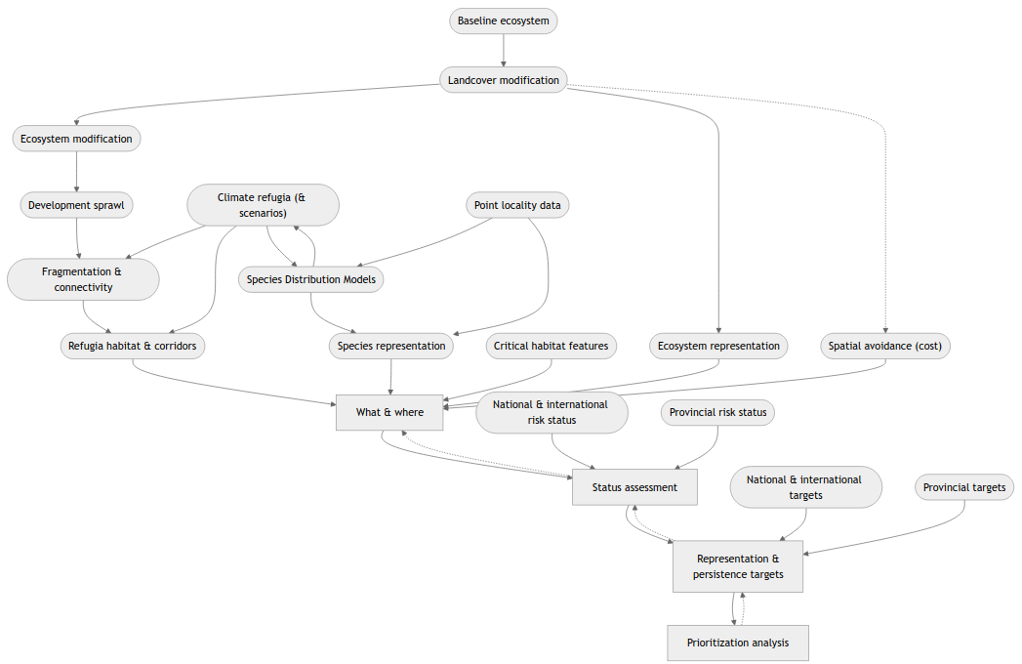
Figure 3
Convention on Biological Diversity. 2022. Kunming–Montreal Global Biodiversity Framework. Secretariat of the Convention on Biological Diversity; CBD/COP/DEC/15/4. https://www.cbd.int/doc/decisions/cop-15/cop-15-dec-04-en.pdf.
Elliot, Felicity. 2023. Biodiversity Conservation Plan Background Document: Workshop for Steps, Gaps and Specialist Information to Be Presented. Technical report. Ezemvelo KZN Wildlife.
Escott, Boyd. 2010. Conservation Plan Work Notes. Technical Report No. 2. Ezemvelo KZN Wildlife.
Jung, Martin, Vanessa M Adams, Diogo Alagador, et al. 2025. “An Interoperable and Standardized Protocol for Reporting Systematic Conservation Planning Projects.” Conservation Science and Practice, e70097.
Margules, Christopher Robert, and Robert L Pressey. 2000. “Systematic Conservation Planning.” Nature 405 (6783): 243–53.
Mucina, Ladislav. 2024. “Ecological Versus Biogeographical Regionalization: Colliding or Colluding?” Journal of Biogeography 51 (9): 1795–800.
Mucina, L., M. C. Rutherford, and L. W. Powrie. 2018. The Vegetation Map of South Africa, Lesotho and Swaziland. Edited by South African National Biodiversity Institute. South African National Biodiversity Institute. bgis.sanbi.org/Projects/Detail/186.
SANBI, and UNEP-WCMC. 2024. Mapping Biodiversity Priorities: A Practical Approach to Spatial Biodiversity Assessment and Priortisation to Inform National Policy, Planning, Decisions and Action. 2nd ed. South African National Biodiversity Institute. Pretoria, ZA.
Whittaker, Robert Harding. 1960. “Vegetation of the Siskiyou Mountains, Oregon and California.” Ecological Monographs 30 (3): 279–338.

These translate to the plan’s objectives
We use “species” in the broad sense, referring to any distinct taxonomic unit (e.g., subspecies) unless otherwise indicated.
If available, these data can be considered for inclusion in prioritisation analysis and assessment.

