* For avgCOVID_IgG
  + Bottom two are outliers:
  + 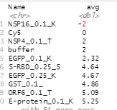
* For avgControl_IgG
  + Bottom three are outliers:

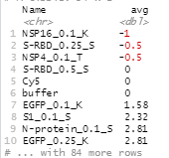

* + Top two are outliers:

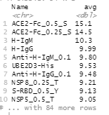

* For avgCOVID_IgM
  + Bottom two are outliers:

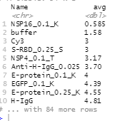

* For avgControl_IgM
  + Bottom one is outlier:

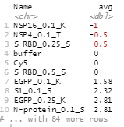

* + Top one is outlier:

