Project 6

Bracken Adams
Computer of Science
Speed School of Engineering
University of Louisville, USA
NameID@louisville.edu

- Introduction (What did you do in this project and why?)
In this project, I implemented a hybrid Genetic Algorithm and Wisdom of the Crowds algorithm on a Partition problem (https://en.wikipedia.org/wiki/Partition_problem).

A Partition problem consists of a set of numbers and is split into two partitions where the sum of each can be added up and equal each other.

I did not verify that there was a solution to the number sets provided, but instead gave them to the algorithm to see how close they could get to a perfect solution. I provided 5 different number sets. Sets with number counts of:
100
200
300
400
500

The numbers in the sets were generated randomly from https://www.calculatorsoup.com/calculators/statistics/number-generator.php.

I allowed the Genetic Algorithms to run through the numbers with different mating methods and different mutation rates. I then gave the outputs to the Wisdom of the Crowds algorithm which took the most common place of each number through the provided partition sets and put the number there.

After the algorithms were ran, I print out everything onto a webpage, showing the Wisdom of the Crowd algorithm first, followed by the 9 results that were fed into the algorithm. Each result shows the name of the results ({Name of the file} – {Algorithm used to generate result}), the total difference between the partitions, the time taken to run the algorithm, and then each partition. Each partition shows the values of all of the numbers included, and then shows the set of numbers.

- Approach (Describe algorithm you are using for this project)
The Genetic Algorithm that was used in this project generated 6 random sets of partitions to be used as ancestors. It took those sets and ran them through 500 generations of mating and mutation.

The mating methods I used were:

- Best set mates with the second, third, and fourth best set on both sides while the two worst sets are ditched.
- Top 4 sets mate together randomly while the two worst sets are ditched.
- Best set mates randomly with the next 4 best sets while the worst set is ditched.

Mating tried to take every other number from each parent’s first partition and put that into the child first partition and took the remaining numbers and put them in the second partition.

The mutation rates I used were:

- 2%
- 5%
- 10%

The mutation method loops over each number in each partition of each child. If the small mutation chance hits, the number is moved to the other partition.

For each file, there are 9 populations the above is ran for. One for each combination of mutation rate and mating method. Once the 9 solutions come back, they’re passed into a Wisdom of the Crowds method. This method looks for the most common partition of each number through the 9 solutions and places the number in that partition.

- Results (How well did the algorithm perform?)
The algorithm performed very well for the genetic algorithm portion in regards to how close each population was to creating a perfect solution. It would almost always be within 100 of the solution, and often times would get down to a difference of less than 10.

The portion that used the Wisdom of the Crowds algorithm however did not do as well. I think this is because the solution to a Partition Problem doesn’t take into account each piece. It only takes the final count of everything. In the TSP problem for example, the Wisdom of the Crowds algorithm grabs sections of the path. Grabbing a better section of the path directly affects the solution. In an example where people are trying to name each of the Presidents, the solutions grabbed by Wisdom of the Crowds influence the accuracy of the overall solution. In the Partition Problem, grabbing a number and not taking into account the overall value doesn’t make a whole lot of sense.

  - Data (Describe the data you used.)
I touched on it briefly above, but I generated number sets from: https://www.calculatorsoup.com/calculators/statistics/number-generator.php. I took the values that were generated here and put them into the tool here: https://www.browserling.com/tools/spaces-to-newlines. This tool broke out each number into its own line. I used this to make the file easier to read. I then pasted all of that into a text file and placed that in the project.

I used 5 different files with counts of 100, 200, 300, 500, and 1000. I wanted to see how the algorithms performed with different number sets and if the mutation rate or mating method had a different effect on the smaller sets of numbers as opposed to the larger sets.

For each of the files, I ran a mutation/mating method similar to what I had done in project 5. I ran through 9 different combinations of variables:
 | Mutation Rate A: 2% | Mutation Rate B: 5% | Mutation Rate B: 10%
Mating Method A | Mutation A & Mating A | Mutation B & Mating A | Mutation C & Mating A
Mating Method B | Mutation A & Mating B | Mutation B & Mating B | Mutation C & Mating B
Mating Method C | Mutation A & Mating C | Mutation B & Mating C | Mutation C & Mating C

The mutation rate is applied to each number in each partition.

Fitness of parents is calculated by calculating the difference in the total value of Partition 1 and Partition 2 in each set. The lower the difference is, the more fit the parent is.

Mating Method A:
- Take the most fit parent and mate it with the second, third, and fourth most fit parents twice. Ends up being mating between:
  - Most fit and second most fit
  - Most fit and third most fit
  - Most fit and fourth most fit
  - Second most fit and most fit
  - Third most fit and most fit
  - Fourth most fit and most fit
Mating Method B:
- Takes random of the top 4 most fit parents and mates them together randomly. Ends up being mating between:
  - Random 1st - 4th and random 1st - 4th most fit
  - Random 1st - 4th and random 1st - 4th most fit
  - Random 1st - 4th and random 1st - 4th most fit
  - Random 1st - 4th and random 1st - 4th most fit
  - Random 1st - 4th and random 1st - 4th most fit
  - Random 1st - 4th and random 1st - 4th most fit
Mating Method C:
- Takes most fit parent and mates it with the second, third, fourth, and fifth most fit parents randomly. Ends up being mating between:
  - Most fit and random 1st - 5th most fit
  - Most fit and random 1st - 5th most fit
  - Most fit and random 1st - 5th most fit
  - Random 1st - 5th and most fit
  - Random 1st - 5th and most fit
  - Random 1st - 5th and most fit

  - Results (Numerical results and any figures or tables.)
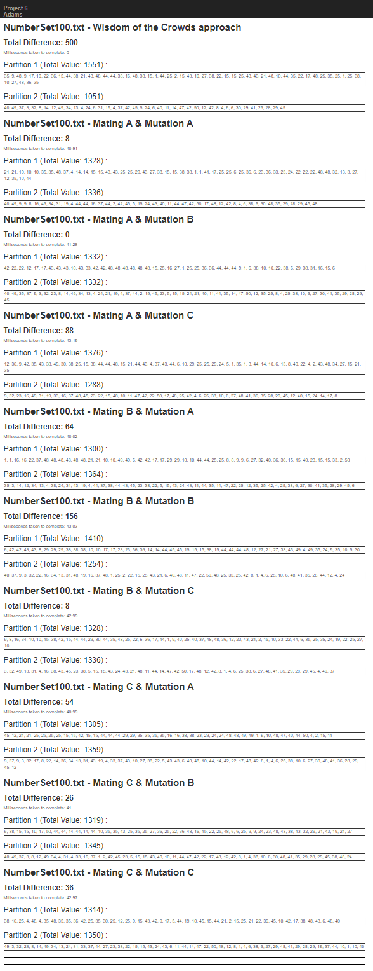
The total difference between partitions is listed under the name of each section. The first one (Wisdom of the Crowds result), has a total difference of 500, while the next 9 has an outlier who is at 156, with everything else under 100.

Even in one result using the smallest data set, it becomes pretty obvious that the Wisdom of the Crowds algorithm does not shine here. It looks ever worse when looking at the largest data set:
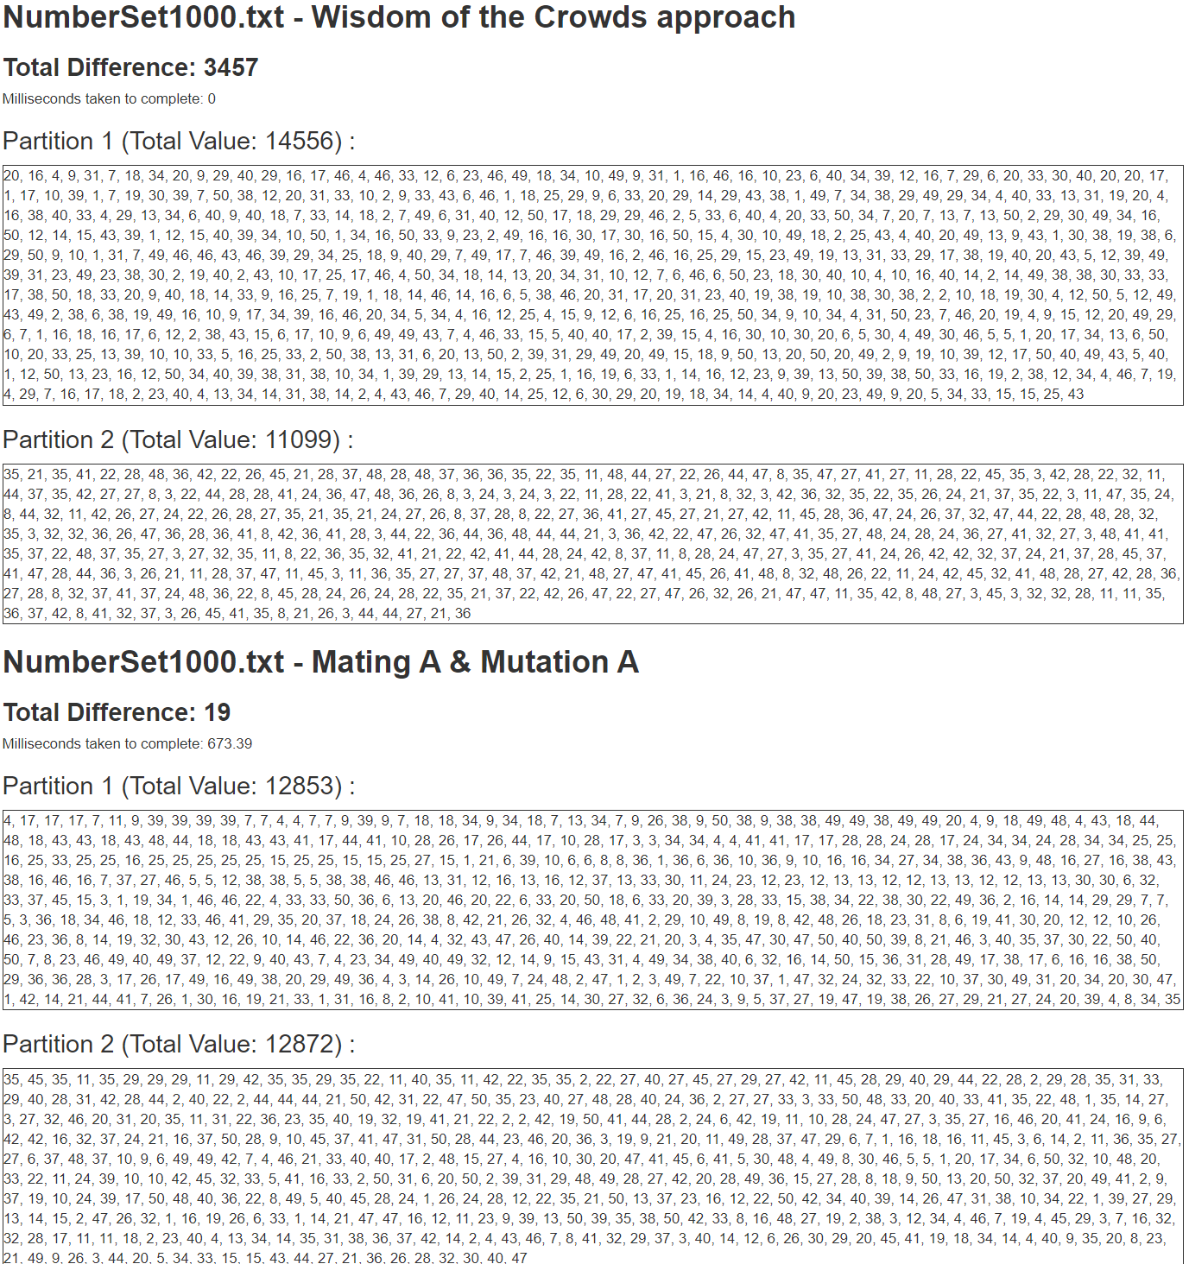
When listing the results of all of the files through 6 runs, you can see just how much the pure Genetic Algorithm shines:

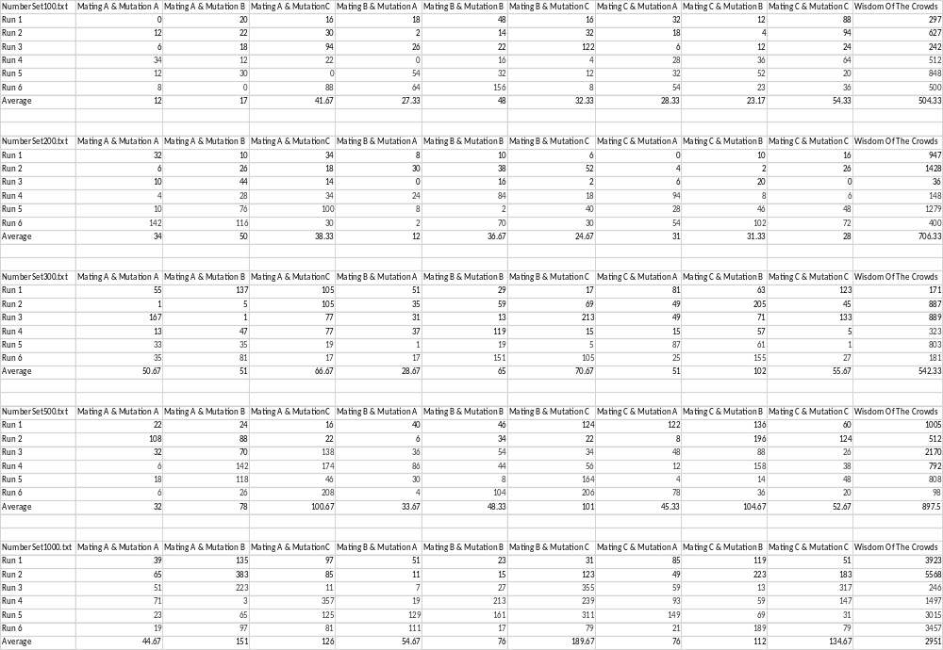

- Discussion (Talk about the results you got and answer any specific questions mentioned in the assignment.)

Averaging out the other 9 differences between partitions from each of the number set files:
NumberSet100.txt
- 31.57
- Compared to 504.33 from Wisdom of the Crowds (1597% worse)

NumberSet200.txt
- 31.78
- Compared to 706.33 from Wisdom of the Crowds (2223% worse)

NumberSet300.txt
- 60.15
- Compared to 542.33 from Wisdom of the Crowds (902% worse)

NumberSet500.txt
- 66.26
- Compared to 897.5 from Wisdom of the Crowds (1355% worse)

NumberSet1000.txt
- 107.19
- Compared to 2951 from Wisdom of the Crowds (2753% worse)

It is hard to tell if the Wisdom of the Crowds algorithm is worse for the smaller or the larger sets of numbers. Overall, there is no reason to use it for this type of problem because the Genetic Algorithm provides MUCH better solutions.

The speed of each population running through the Genetic algorithm was also very negligible. I am not sure if this means I should have used bigger datasets, or if this is just because the data is simpler so it can run through more data easier than the TSP. The largest population could be run in less than a second, so it was much easier to collect results for this.

Overall, I am very happy with the results of the Genetic Algorithm. I expected once the number sets got larger, that the difference between partitions would widen exponentially. Instead, they still widened, but only by an average of 75 from 100 numbers to 1000 numbers.

- References (If you used any sources in addition to lectures please include them here.)

