Project 3

Bracken Adams
Computer of Science
Speed School of Engineering
University of Louisville, USA
NameID@louisville.edu

- Introduction (What did you do in this project and why?)
In this project, I implemented the Closest Edge Insertion Heuristic algorithm against the Traveling Sales Person problem. The TSP coordinate lists provided for this project were 30 & 40 coordinates, so the previous brute force algorithm would never work.

I implemented this algorithm in C# in a .net Core environment using the MVC architecture. I used .net Core with MVC because it is the architecture I am most familiar with in order to show something in a UI.

- Approach (Describe algorithm you are using for this project)
The Closest Edge Insertion Heuristic algorithm works one node at a time. It takes the closest not included node to any of the included nodes and finds out where it can be added to the path, adding the least amount of distance. It continues doing this until all of the nodes are included.

- Results (How well did the algorithm perform?)
The algorithm seemed to perform very well. Using the brute force on this, it can do 11 points at most and that takes a few seconds, so it would never be able to complete all 40 points. But using this algorithm, it can do 40 points in the matter of milliseconds.

  - Data (Describe the data you used.)
I used the data provided in .TSP file. The file gives a description through the first 7 lines and then each new line following is a city Id and a set of coordinates.

  - Results (Numerical results and any figures or tables.)
The results were printed out to an HTML canvas for both .TSP files using a red dot to represent each city and a black line to represent the paths taken between each city

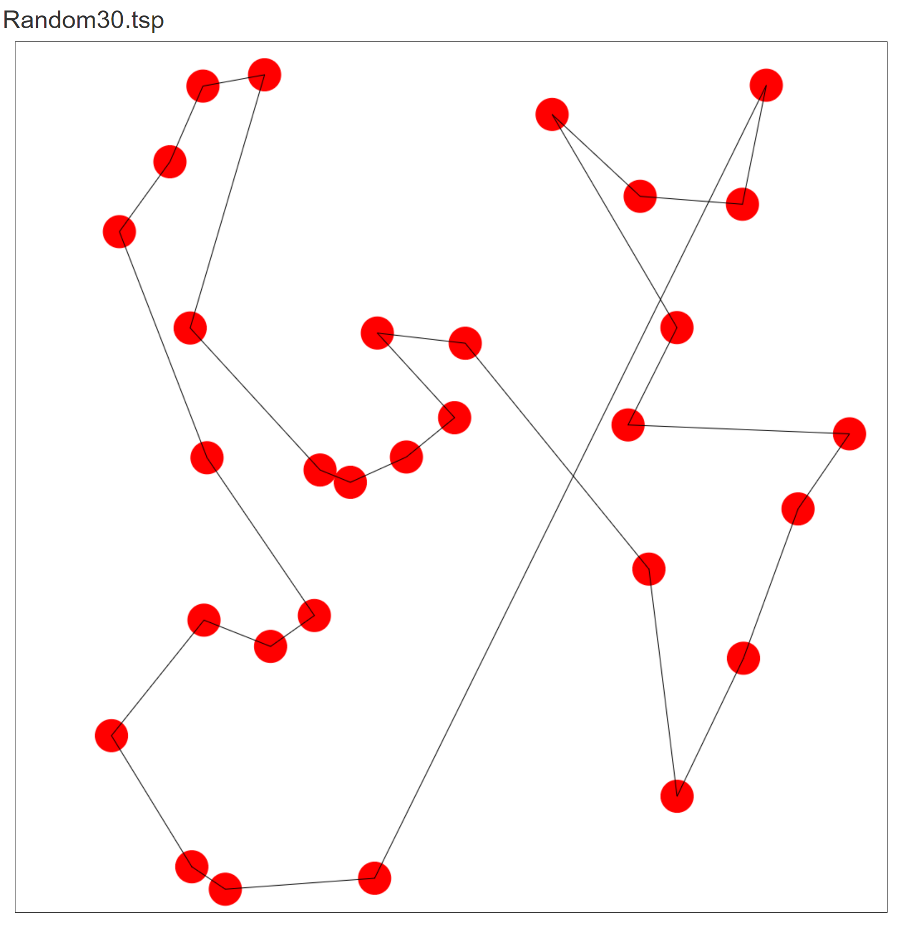

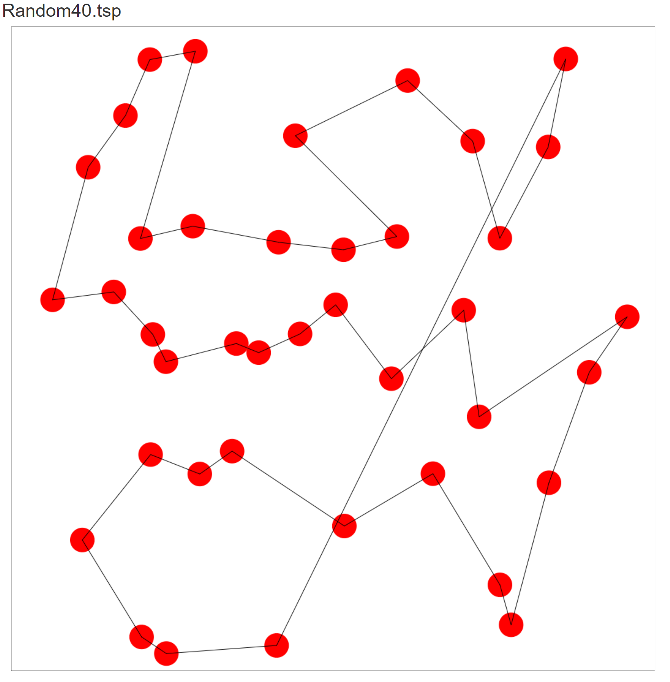

- Discussion (Talk about the results you got and answer any specific questions mentioned in the assignment.)
Both results seemed to follow more of a zigzag pattern with a line connected the last two points. The last line always goes all the way across the diagram, which is not ideal, but I did not understand how the algorithm was supposed to handle this specifically. The only idea I had that could handle this differently was if you provided a closed loop at the beginning, but I thought that seemed like an odd way to handle it.

The results definitely seemed to not exclude a group of points. So for example; where, in the screenshot below, the path could go from node 1 > 2 and that’s a shorter distance, it instead went from 1>3 so it could get all of the top left cities without back tracking for them.

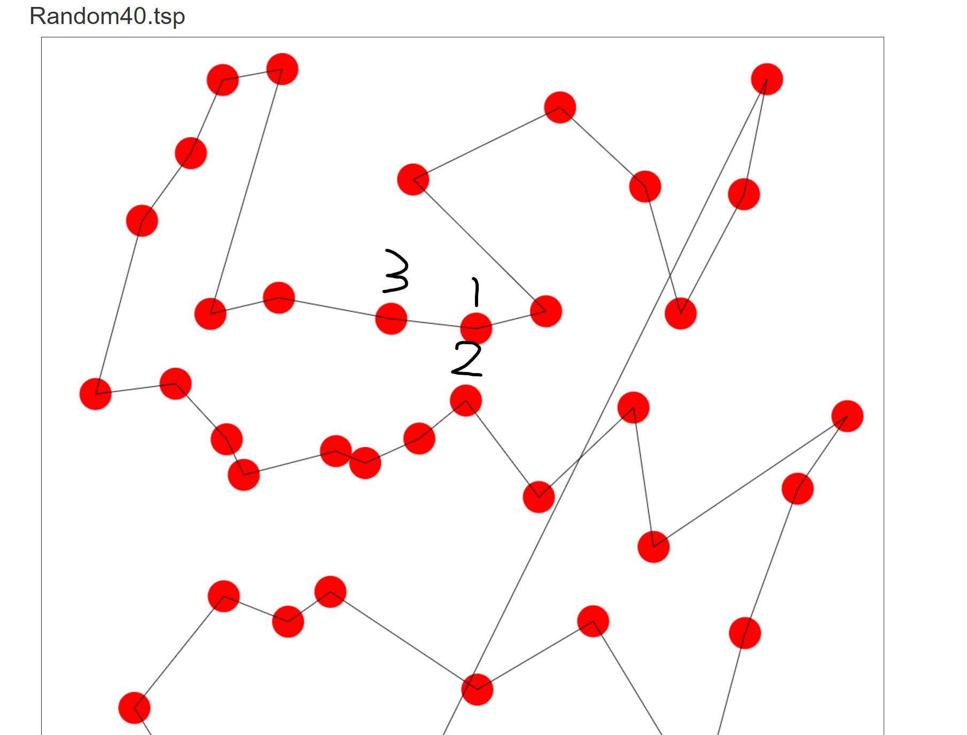

- References (If you used any sources in addition to lectures please include them here.)

