Project 5

Bracken Adams
Computer of Science
Speed School of Engineering
University of Louisville, USA
NameID@louisville.edu

- Introduction (What did you do in this project and why?)
In this project, I expanded on my Genetic Algorithm from project 4 and added in a Wisdom of the Crowds approach to solve several Traveling Sales Person problems. The Traveling Sales Person problems had 11, 22, 44, 77, 97, and 222 coordinates.

I implemented this algorithm in C# in a .net Core environment using the MVC architecture. I used .net Core with MVC because it is the architecture that I am most familiar with in order to show something in a UI.

- Approach (Describe algorithm you are using for this project)
The Genetic Algorithm that was used in project 4 was updated slightly to allow for more variables and took in more children. Once all of the children come out for a file, they are ran through a method to discover the best Wisdom of the Crowds approach. This is done by selecting the most common step from each previous city.

If there wasn’t a connection between the last city in the Wisdom of the Crowds path that was being built and the available cities, a random city would be selected and appended to the path.

- Results (How well did the algorithm perform?)
The algorithm seemed to perform very well. The algorithm uses a modified version of the genetic algorithm I used in project 4 that provides 9 children. Using the 9 children for the Wisdom of the Crowds approach seemed like a great path to take. Through 5 runs, out of the 10 outputs, the Wisdom of the Crowds approach had the shortest average distance in 5 of the 6 different TSP files.

  - Data (Describe the data you used.)
I used the data provided in .TSP file. The file gives a description through the first 7 lines and then each new line following is a city Id and a set of coordinates. There were 6 different files with varying amounts of coordinates.

For each of the files, I ran through 9 different combinations of variables:
 | Mutation Rate A: 5% | Mutation Rate B: 12% | Mutation Rate B: 15%
Mating Method A | Mutation A & Mating A | Mutation B & Mating A | Mutation C & Mating A
Mating Method B | Mutation A & Mating B | Mutation B & Mating B | Mutation C & Mating B
Mating Method C | Mutation A & Mating C | Mutation B & Mating C | Mutation C & Mating C

The mutation rate is applied to each step of the path.

Mating Method A:
- Take the most fit parent and mate it with the second, third, and fourth most fit parents twice. Ends up being mating between:
  - Most fit and second most fit
  - Most fit and third most fit
  - Most fit and fourth most fit
  - Second most fit and most fit
  - Third most fit and most fit
  - Fourth most fit and most fit
Mating Method B:
- Takes random of the top 4 most fit parents and mates them together randomly. Ends up being mating between:
  - Random 1st - 4th and random 1st - 4th most fit
  - Random 1st - 4th and random 1st - 4th most fit
  - Random 1st - 4th and random 1st - 4th most fit
  - Random 1st - 4th and random 1st - 4th most fit
  - Random 1st - 4th and random 1st - 4th most fit
  - Random 1st - 4th and random 1st - 4th most fit
Mating Method C:
- Takes most fit path and mates it with the second, third, fourth, and fifth most fit paths randomly. Ends up being mating between:
  - Most fit and random 1st - 5th most fit
  - Most fit and random 1st - 5th most fit
  - Most fit and random 1st - 5th most fit
  - Random 1st - 5th and most fit
  - Random 1st - 5th and most fit
  - Random 1st - 5th and most fit
  - Results (Numerical results and any figures or tables.)
The results were printed out to an HTML canvas for each separate population that used different variables. A red dot is used to represent each city and a black line to represent the paths taken between each city.

Running the genetic algorithm 5 times on different randomly generated parent paths, these are the results:

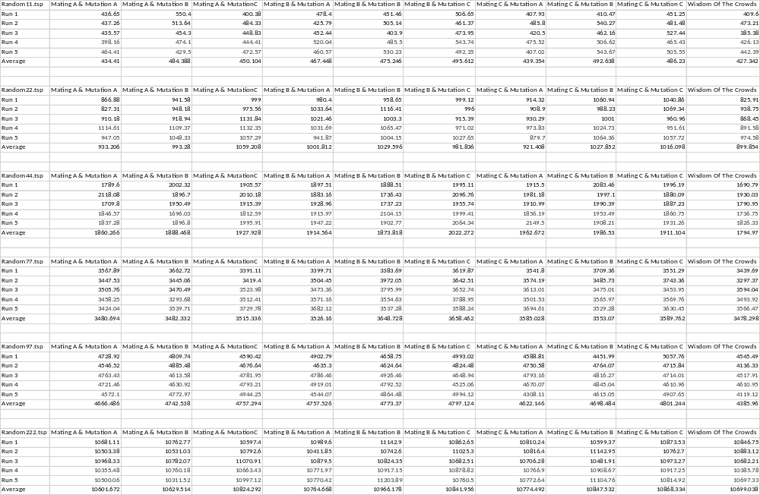

The far-right column all the way through is the Wisdom of the Crowds results. As you can see, it performs extremely well and seems to have some of the best runs and the best averages.

- Discussion (Talk about the results you got and answer any specific questions mentioned in the assignment.)
Averaging out the other 9 datasets from each of the TSP files:
Random11.tsp
- 469.492
- Compared to 427.342 from Wisdom of the Crowds (8.97% better)

Random22.tsp
- 996.033
- Compared to 1794.97 from Wisdom of the Crowds (6.88% better)

Random44.tsp
- 1927.514
- Compared to 1794.97 from Wisdom of the Crowds (6.87% better)

Random77.tsp
- 3559.952
- Compared to 3478.298 from Wisdom of the Crowds (2.29% better)

Random97.tsp
- 4735.135
- Compared to 4385.96 from Wisdom of the Crowds (7.37% better)

Random222.tsp
- 10790.95978
- Compared to 10699.038 from Wisdom of the Crowds (0.85% better)

Random222.tsp
- 469.492
- Compared to 427.342 from Wisdom of the Crowds (8.97% better)

I did not calculate the speed difference for the Wisdom of the Crowds approach, since it was ran extremely quick after the genetic algorithm collected their results. If the whole problem was considered, the Wisdom of the Crowds approach would be much slower than any of the genetic algorithm problems.

It seemed like the larger the problem, the worse this approach would perform. I believe this is because we are only working with 9 datasets. It’s hard to find the most common path on a problem with 100+ cities if there are only 18 connections for one city.

- References (If you used any sources in addition to lectures please include them here.)

