StoreMaster
Project Overview: StoreMaster is a modern, integrated retail management system designed for small to medium-sized stores or outlets. It streamlines sales processing, inventory management, and business reporting, while providing secure user authentication and role-based access control. The system is designed to be scalable, user-friendly, and data-driven, enabling store owners and managers to operate efficiently and make informed decisions.

Team Members:
Mudasir Shah (232393)
Hassan Ali (232390)
Hashim Ahmed Khan (232474)

MODULES
- StoreMaster consists of four core modules:
- User Authentication Module – Handles user login, registration, and role-based access.
- Sales & Billing Management Module – Processes transactions, generates invoices, and updates stock.
- Inventory & Stock Control Module – Manages products, stock-in/out, and provides real-time inventory tracking.
- Reports & Business Analytics Module – Generates sales, inventory, and profit/loss reports for business insights.

MODULE DESCRIPTION & SUB-MODULES
2.1 User Authentication Module Purpose:
Ensures secure access to the system and assigns permissions based on user roles.
Sub-Modules / Features: -
User Login / Logout
User Registration
Role-Based Access Control
Password Reset / Recovery
Activity Logging

2.2 Sales & Billing Management Module Purpose:
Facilitates efficient sales transactions and automated billing.
Sub-Modules / Features:
POS Interface / Create Sale
Add Items to Bill
Tax & Discount Calculation
Invoice Generation
Payment Handling
Automatic Stock Deduction

2.3 Inventory & Stock Control Module Purpose:
Maintains accurate inventory records and monitors stock levels.
Sub-Modules / Features:
Product Management
Category Management
Stock-In (Restocking)
Stock-Out (Damage/Manual Adjustment)
Real-Time Stock Tracking
Low Stock Alerts
2.4 Reports & Business Analytics Module Purpose:
Provides actionable insights through detailed reporting.
Sub-Modules / Features:
Sales Reports
Product-Wise Performance
Profit & Loss Analysis
Inventory Valuation Report
Stock Movement History
Export Options

USER ROLES
Role | Permissions / Responsibilities
Admin | Full system access, manage users, inventory, system settings, view all reports
Manager | Manage inventory, view reports, monitor stock; cannot change system settings
Cashier | Process sales, generate invoices; cannot access inventory or system settings

KEY ENTITIES / DATABASE TABLES
Table Name | Purpose
users | Store login credentials, role, and authentication info
products | Product details (name, SKU, category, price, stock)
categories | Product categorization
stock_logs | Tracks all stock-in and stock-out entries
sales | Sale headers including invoice number, total amount, date
sale_items | Products included in each sale with quantity and price
settings | Configurable system parameters (tax, discounts, invoice format)
activity_logs | Tracks user activity for security and auditing

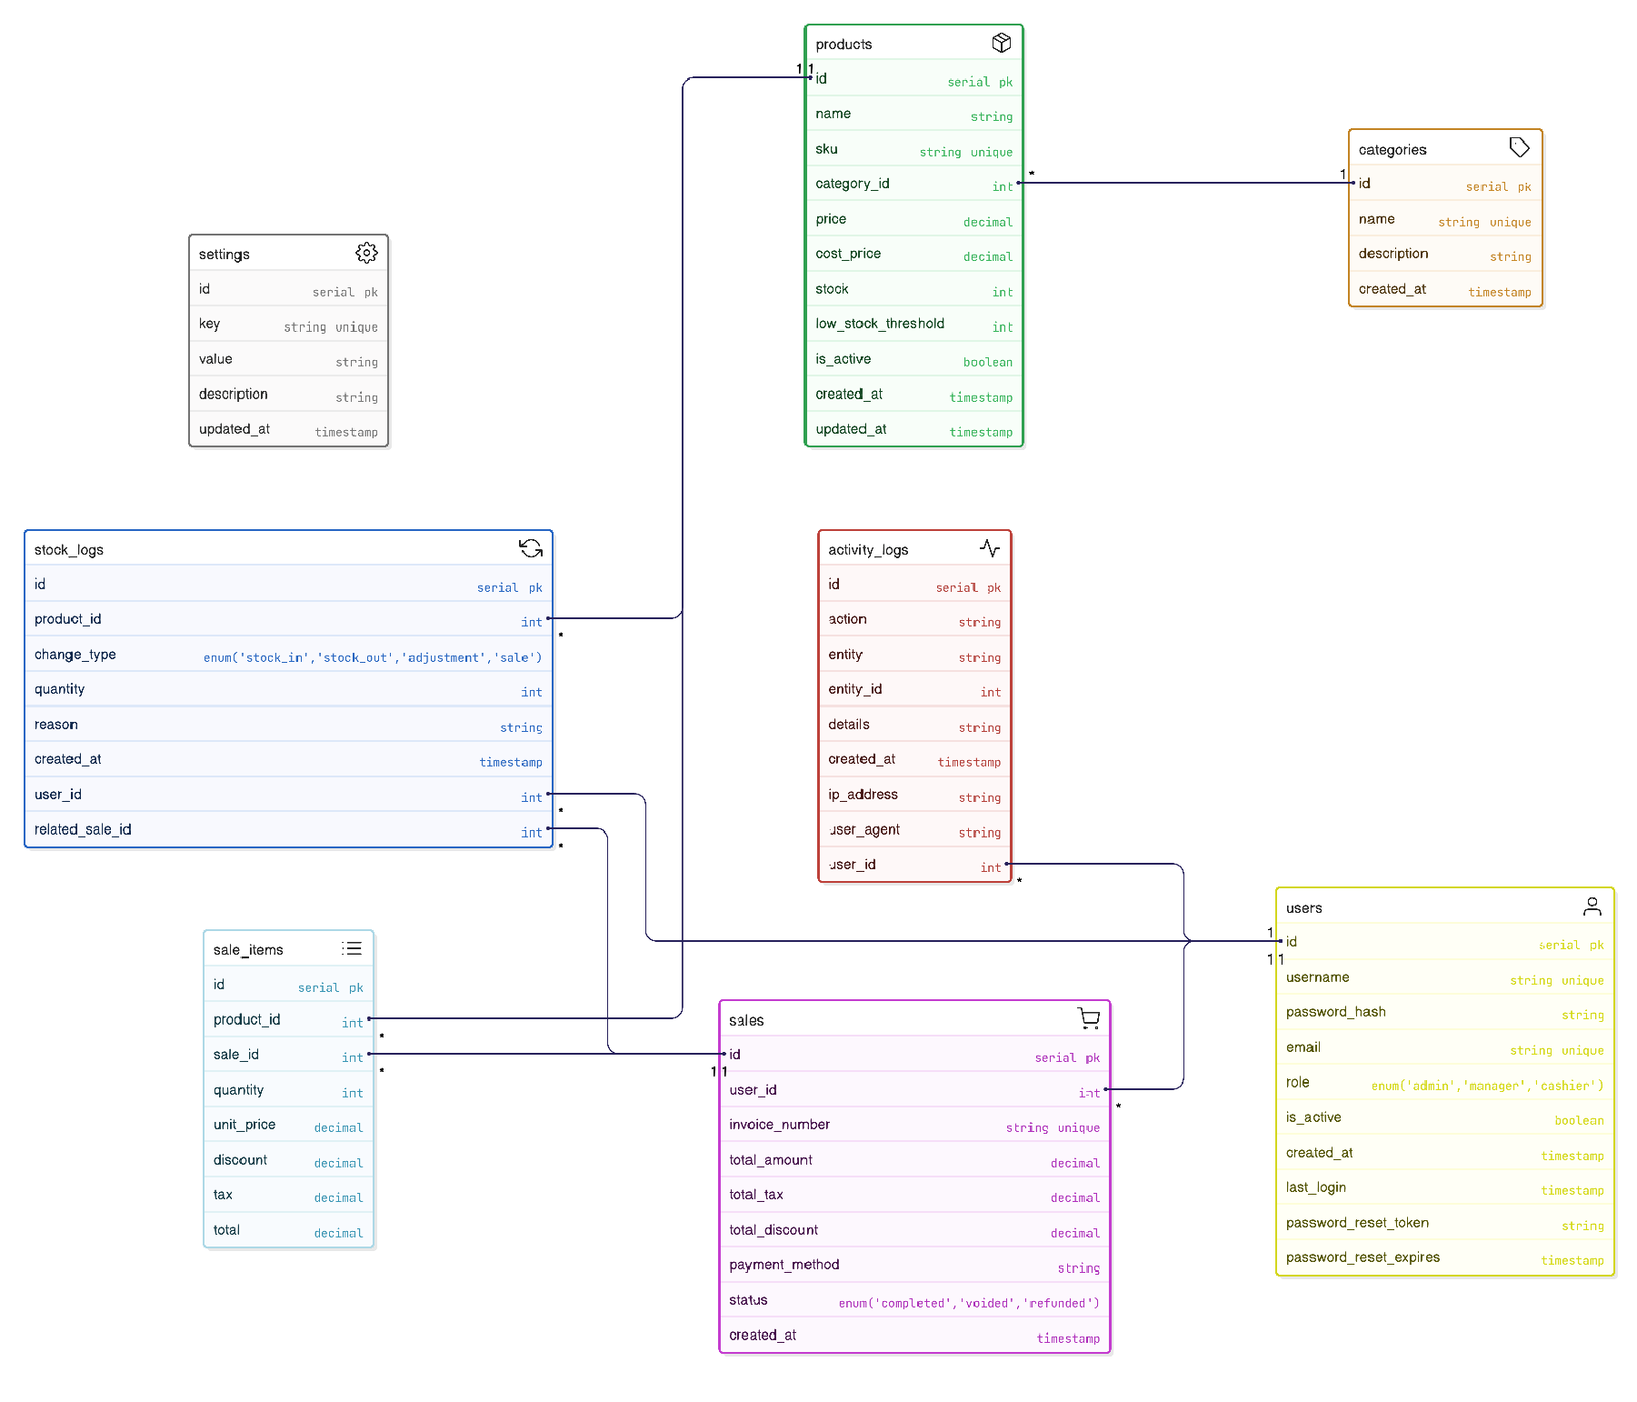

SYSTEM ARCHITECTURE
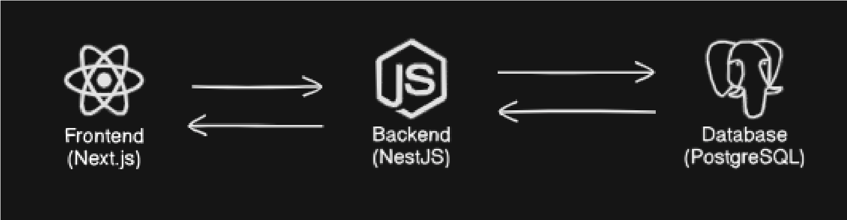
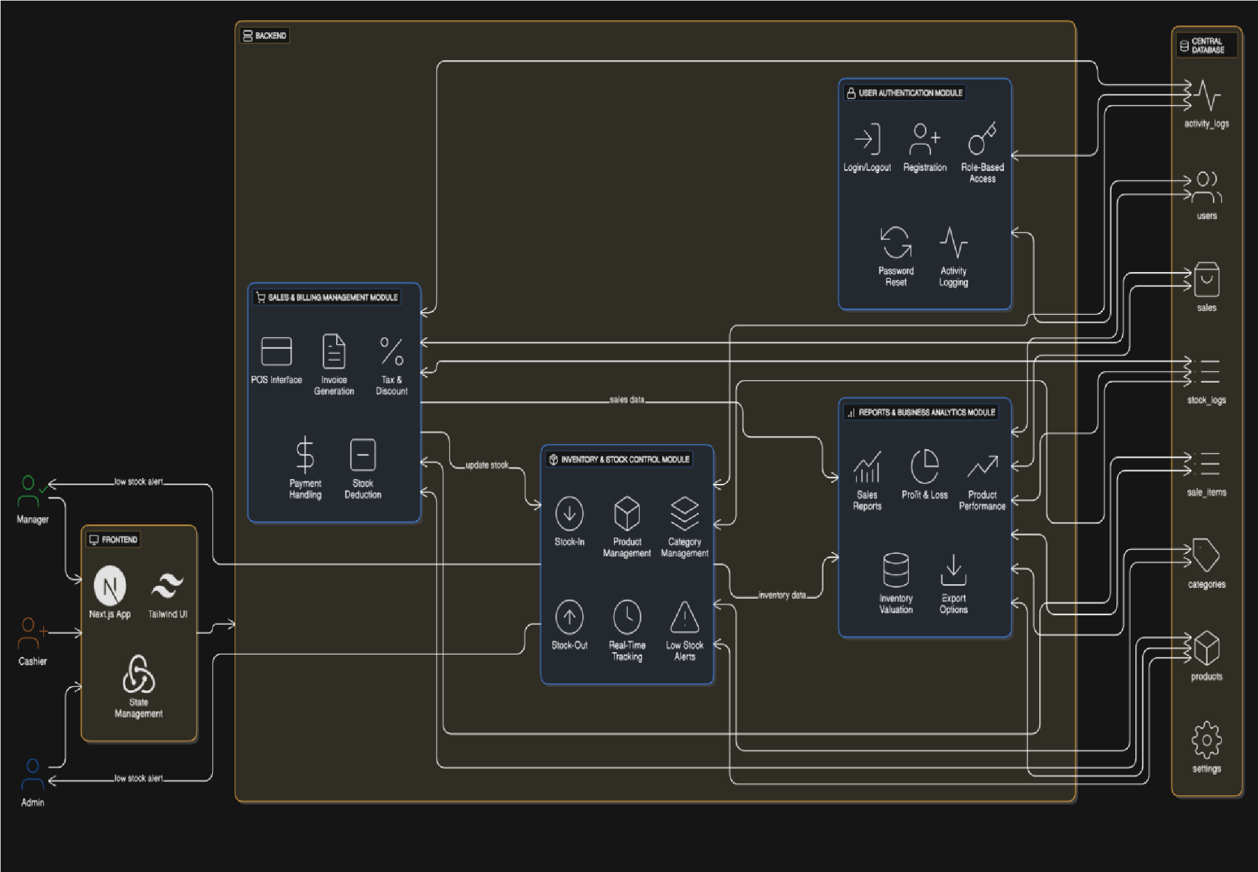

SYSTEM WORKFLOW DESCRIPTION
- Users log in through the User Authentication Module with role-based access.
- Cashiers use the Sales & Billing Module to process transactions, calculate taxes/discounts, and generate invoices.
- Stock levels are automatically updated in the Inventory Module after each sale.
- Admins or Managers manage products, categories, and stock levels via Inventory.
- All sales and inventory actions are logged and stored in the central database.
- Reports & Analytics Module generates insights including sales summaries, product performance, and profit/loss calculations.
- Low stock alerts notify Admin/Manager when inventory is running low.
- System ensures secure operations, real-time updates, and actionable business intelligence.

Technology Stack
Layer Technologies
Frontend Next.js, Tailwind CSS, Redux Toolkit / Context API
NestJS (TypeScript), JWT Authentication, bcrypt, Prisma,
Backend
class-validator / class-transformer
Database PostgreSQL, Redis (optional)
Reports &
Chart.js / Recharts, pdfkit / jsPDF, ExcelJS
Analytics

