Scalable 2D Systolic Array Architecture for High-Throughput Matrix Computation
Track 1 (FPGA)
Processors
Abstract
This project presents a parameterized, scalable 2D systolic array architecture implemented in Verilog HDL for accelerating matrix multiplication — the fundamental operation in deep learning inference, signal processing, and scientific computing. The design employs an output-stationary dataflow where N×N Processing Elements (PEs) perform multiply-accumulate (MAC) operations while passing data to neighboring PEs in a pipelined manner. The architecture features automated input skewing via shift-register-based skew buffers, an FSM-based controller for sequencing operations, and full parameterization allowing scalability from 2×2 to 16×16 and beyond. The design is verified through comprehensive simulation using Icarus Verilog and GTKWave with multiple test cases (identity matrix, scalar multiply, and general matrix multiplication), achieving 100% correctness. The system will be synthesized and implemented on a Xilinx FPGA platform using Vivado, targeting high throughput (N² MACs per cycle), low latency (3N-1 cycles per computation), and efficient hardware resource utilization.

Main Idea
System-Level Block Diagram:
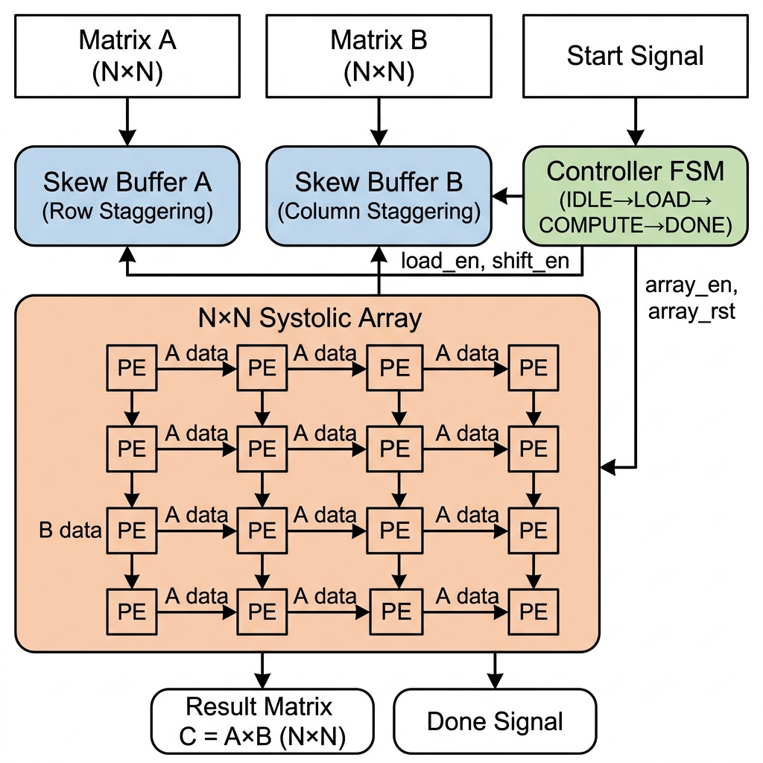

Application
Solution Flowchart:

(Include flowcharts of the proposed solution (if any))

Value Add
1. Full Scalability:
The design is fully parameterized — changing a single parameter (N) scales the array from 2×2 to any N×N size. This is demonstrated through verified simulations at multiple sizes, making the architecture adaptable to different resource constraints and performance requirements.
2. High Parallelism & Throughput:
N² PEs operate simultaneously, delivering N² MAC operations per clock cycle. For a 4×4 array at 100 MHz, this yields 1.6 GMAC/s. For a 16×16 array, this scales to 25.6 GMAC/s — comparable to dedicated AI accelerators.
3. Optimal Data Reuse:
Each input value is read from memory exactly ONCE but reused N times as it flows through the PE chain. This reduces memory bandwidth requirements by a factor of N compared to naive implementations — critical for bandwidth-limited embedded systems.
4. Simple, Local Wiring:
Each PE only communicates with its immediate neighbors. No long global wires are needed, enabling high clock frequencies, easy physical layout, and predictable timing closure in FPGA synthesis.
5. Clean Integration Interface:
The top-level module provides a simple load-start-done handshake protocol, making it easy to integrate as an accelerator IP core in larger SoC designs with AXI bus interfaces or UART communication.
6. Comprehensive Verification:
The design includes automated testbenches with software golden models that verify correctness across multiple test cases (identity, scalar, general multiply), ensuring reliability before hardware deployment.
7. Novelty:
The B-matrix transposition technique allows reuse of a single skew buffer module for both A and B inputs, reducing hardware duplication. The 3N-1 cycle compute timing precisely accounts for skew buffer latency and pipeline drain, maximizing PE utilization.

References
[1] H. T. Kung, C. E. Leiserson, "Systolic Arrays (for VLSI)," in Sparse Matrix Proceedings, SIAM, 1978, pp. 256-282.
[2] N. P. Jouppi et al., "In-Datacenter Performance Analysis of a Tensor Processing Unit," Proceedings of the 44th Annual International Symposium on Computer Architecture (ISCA), 2017, pp. 1-12.
[3] Y. Chen et al., "Eyeriss: A Spatial Architecture for Energy-Efficient Dataflow for Convolutional Neural Networks," Proceedings of ISCA, 2016.
[4] Xilinx, "Vivado Design Suite User Guide: Synthesis (UG901)," Xilinx Inc., 2023.
[5] S. Williams, A. Waterman, D. Patterson, "Roofline: An Insightful Visual Performance Model for Multicore Architectures," Communications of the ACM, 2009.

