Scalable 2D Systolic Array Architecture for High-Throughput Matrix Computation
Track 1 (FPGA)
Processors
Abstract
Edge AI applications are severely bottlenecked by memory bandwidth and power constraints during heavy matrix computations.This project presents a parameterized, scalable 2D systolic array architecture implemented in Verilog HDL for accelerating matrix multiplication — the fundamental operation in deep learning inference, signal processing, and scientific computing. The design employs an output-stationary dataflow where N×N Processing Elements (PEs) perform multiply-accumulate (MAC) operations while passing data to neighboring PEs in a pipelined manner. The architecture features automated input skewing via shift-register-based skew buffers, an FSM-based controller for sequencing operations, and full parameterization allowing scalability from 2×2 to 16×16 and beyond. The design is verified through comprehensive simulation using the Vivado Simulator with multiple test cases (identity matrix, scalar multiply, and general matrix multiplication), achieving 100% correctness. The system will be synthesized and implemented on a Xilinx FPGA platform using Vivado, targeting high throughput (N² MACs per cycle), deterministic low latency (3N-1 cycles per computation), and highly optimized utilization of FPGA logic resources including DSP slices, LUTs, and block RAM.

Main Idea
The proposed system is a complete, hardware-synthesizable 2D systolic array architecture consisting of five key modules:
1. Processing Element (PE): The fundamental building block. Each PE performs a single multiply-accumulate (MAC) operation per clock cycle: acc = acc + (a_in × b_in). It also passes a_in to its right neighbor and b_in to its bottom neighbor, enabling pipelined data flow.
2. N×N Systolic Array: A parameterized grid of N² PEs wired together using Verilog generate statements. Matrix A values flow left-to-right; Matrix B flows top-to-bottom.
3. Skew Buffers: Shift-register-based input staggering. Row I of A is delayed by I cycles, Column j of B by j cycles. B-matrix transposition enables reusing the same module for both directions.
4. Controller FSM: 4-state machine (IDLE → LOAD → COMPUTE → DONE). Compute phase = exactly 3N-1 cycles.
5. Top-Level Wrapper: Integrates all components with a clean load-start-done interface.

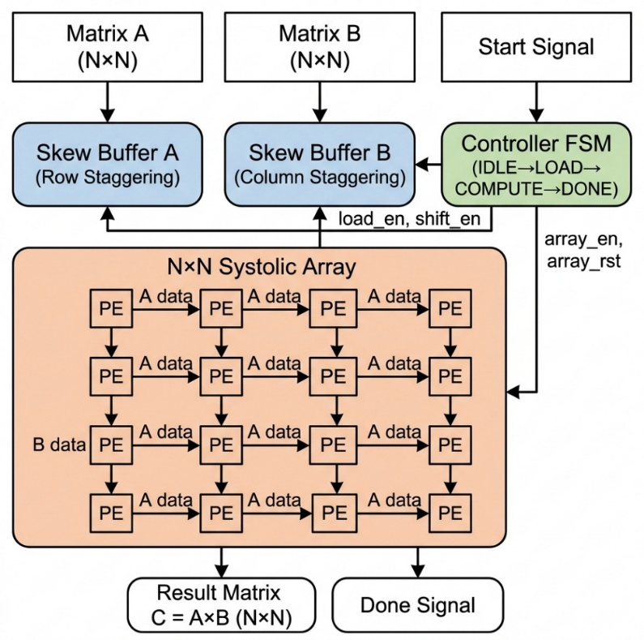
Figure 1: System-Level Block Diagram of the parameterized N×N Systolic Array.
Design Parameters:
- N (array dimension): Configurable, tested for N=2, 4
- DATA_WIDTH: 8-bit signed inputs, 16-bit accumulators
- Dataflow: Output-stationary
- Latency: 3N-1 clock cycles per matrix multiplication
- Throughput: N² MAC operations per clock cycle
Tools Used:
- HDL: Verilog (SystemVerilog-2012 features for parameterized arrays)
- Simulation & Synthesis: Xilinx Vivado Design Suite
- Target FPGA: Basys 3 (Artix-7) or Arty A7-100T
Application
1. Deep Learning Inference Acceleration: Matrix multiplication is the core computation in neural networks. A systolic array on an FPGA enables real-time, on-device AI inference (for convolutional and fully-connected layers) without cloud dependency — a critical requirement for edge AI applications.
2. Digital Signal Processing (DSP): FIR filtering, FFT butterfly operations, beamforming, and correlation are all heavily matrix-based. The systolic array provides deterministic, low-latency processing ideal for real-time communication and radar systems.
3. Scientific Computing & Simulation: Linear algebra operations (such as matrix solvers and LU decomposition) form the backbone of scientific simulations. The scalable architecture can significantly accelerate these computations on embedded FPGA platforms.
4. Image & Video Processing: 2D spatial convolutions used in image filtering, edge detection, and feature extraction can be efficiently mapped onto this pipelined architecture for real-time video processing at the edge.
5. Autonomous Systems & Robotics: Sensor fusion and path planning algorithms require fast, parallel matrix computations. An FPGA-based systolic array provides the necessary computational throughput while maintaining the low power consumption required for battery-operated autonomous systems.
6. 5G/6G Wireless Communication Systems: Modern telecommunication infrastructure, specifically Massive MIMO (Multiple-Input Multiple-Output) technology, relies heavily on complex matrix inversions and multiplications to process signals from dozens of antennas simultaneously. The proposed systolic array can accelerate these beamforming and signal detection algorithms directly at the edge cell-tower, reducing latency.
7. Cryptography and Hardware Security: Advanced encryption standards and post-quantum cryptography algorithms frequently utilize large-scale matrix operations. Implementing these algorithms on an isolated, hardware-level systolic array provides a secure, high-throughput execution environment that is significantly harder to compromise than software-based cryptographic engines.
8. Genomics and Bioinformatics: Edge-based medical devices used for rapid DNA sequencing and genomic analysis utilize dynamic programming and sequence alignment algorithms (like Smith-Waterman). These algorithms map perfectly onto a 2D systolic grid, allowing for rapid, on-device bioinformatics processing without needing to transmit sensitive genetic data to the cloud.

Solution Flowchart:
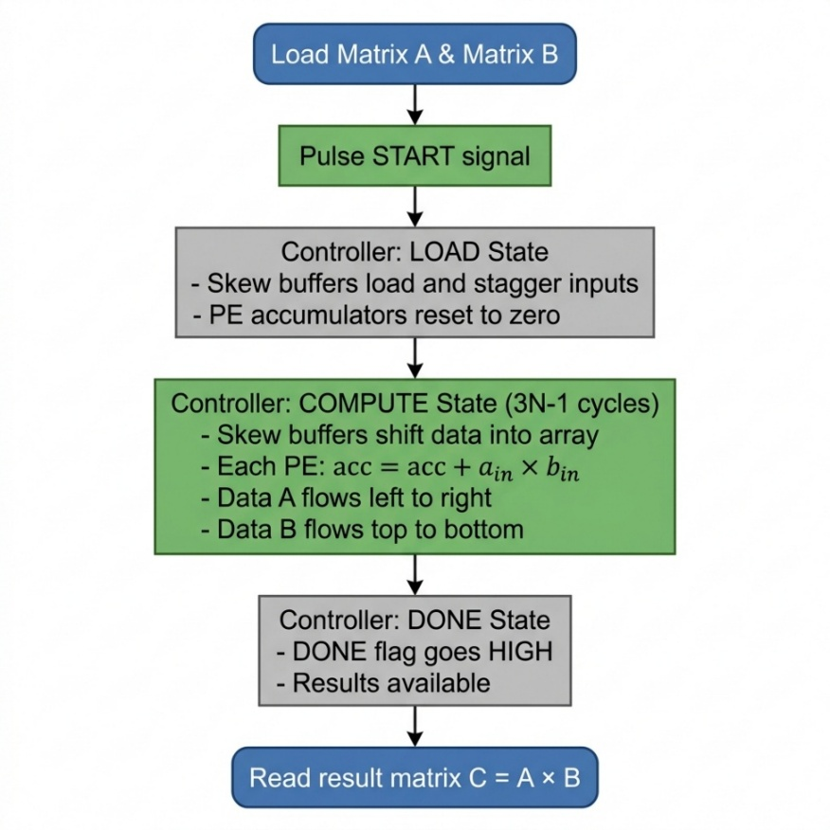

Figure 2: Operational Flowchart detailing the FSM Controller states and pipeline timing.

Value Add:
1. Full Scalability: Single parameter change (N) scales from 2×2 to any N×N.
2. High Parallelism & Throughput: The architecture features N² Processing Elements operating simultaneously. This achieves a massive throughput of N² MAC operations per clock cycle. For a 4×4 array running at 100 MHz, this delivers 1.6 GMAC/s. For a 16×16 array, this scales efficiently to 25.6 GMAC/s, providing substantial on-device compute capability for resource-constrained edge environments.
3. Optimal Data Reuse: Each input read ONCE from memory, reused N times through PE chain → N× bandwidth reduction.
4. Simple Local Wiring: Only nearest-neighbor connections → high clock frequencies, easy layout, predictable timing.
5. Clean Interface: Load-start-done handshake for easy SoC integration.
6. Comprehensive Verification: Automated testbenches with software golden models across multiple test cases.
7. Architectural Novelty & Differentiation: While standard systolic arrays often require complex, duplicated control logic for staggering inputs, our architecture introduces a unique B-matrix transposition technique prior to skewing. This explicitly allows the complete reuse of a single, highly optimized shift-register buffer module for both horizontal and vertical data streams. This reduces hardware duplication and control overhead. Combined with a precise 3N-1 cycle state machine, the architecture guarantees maximum PE utilization with zero wasted clock cycles.

REFERENCES
[1] H. T. Kung and C. E. Leiserson, "Systolic Arrays (for VLSI)," Sparse Matrix Proceedings, SIAM, 1978, pp. 256-282. Available: Carnegie Mellon University Archive
[2] Xilinx Inc., "Vivado Design Suite User Guide: Synthesis (UG901)," 2023. Available: Xilinx Official Documentation
[3] N. P. Jouppi et al., "In-Datacenter Performance Analysis of a Tensor Processing Unit," Proceedings of the 44th Annual International Symposium on Computer Architecture (ISCA), 2017. Available: arXiv:1704.04760
[4] S. Williams, A. Waterman, and D. Patterson, "Roofline: An Insightful Visual Performance Model for Multicore Architectures," Communications of the ACM, 2009. Available: UC Berkeley EECS
[5] Hardware & Architecture Mastery, "Understanding 2D Systolic Arrays for Deep Learning," YouTube, 2023. Available: https://youtu.be/2VrnkXd9QR8?si=te232d1pGU8O6iaR
[6] Y. Chen, J. Emer, and V. Sze, "Eyeriss: A Spatial Architecture for Energy-Efficient Dataflow for Convolutional Neural Networks," Proceedings of ISCA, 2016. Available: MIT Eyeriss Project

