**Name: Nishant Awasthi** 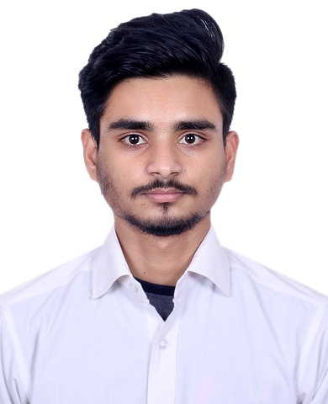

TFT Email: [awasthi.nishant@thinkfuture.us](mailto:awasthi.nishant@thinkfuture.us)

**Experience Summary**

4 years of IT work experience through the entire Software Development Life Cycle as a Ruby Developer at Think Future Technologies, Gurgaon.

**Professional Summary**

To further enhance and sharpen my development and technical skills through constant learning in a dynamic and competitive environment and to use the same towards the growth of the organization.

* Experience with Scrapy, Flask along with other common libraries
* Good understanding of the syntax of Python and its nuances
* Solid understanding of object-oriented programming
* Basic understanding of front-end technologies
* Familiarity with concepts of ORM, and Restful
* A knack for writing clean, readable Python code
* Able to create database schemas that represent and support business processes
* Proficient understanding of code versioning tool Git
* Familiar with APIs

Note:

* Do put full stop for any bullet point
* Write the project details in chronological order
* Please add the percentage and Year of passing out each
* Do mention you project for internship if any

**Academic Credentials**

* Pursuing B.Tech from Maharshi Dayanand University 2021, 68%
* 12th from CBSE Board 2017, 84.00 %
* 10th from CBSE Board 2015, 76.00 %

**IT Skill set**

**Server Management:** Heroku

**Programming Languages:** Python, C++, C, Object Oriented Programming, MySQL

**Framework:** Scrapy, Flask, Django

**Web Services:** Restful

**Web Designing Tool**: HTML, CSS, Bootstrap

**Operating System:** WINDOWS10/8/7/XP, LINUX

**Software Tools:** VS Code, Postman, PyCharm, GIT

**Team Management Tools**: Slack

**Professional Experience**

* Currently working as Software Trainee with Think Future Technologies, Gurgaon

**Projects:**

* **Project Name1: Stores and Items REST API**

**Duration:** November 2020 – December 2020

Organization:

**URL:** [www.xyz.com](http://www.xyz.com)

**Description:** Interakt is built to empower us by adding a management and engagement layer over our existing app.

We can move the data mining, analytics and interaction tasks out of the app to a separate platform and our app can perform its core features.

**Roles and Responsibilities**:

* Experience in migration of 10 servers from Digital Ocean to azure.
* Management of servers and handling issues regarding to it performance.
* Fixing bugs and resolving bottleneck.
* Integration of monitoring services like newrelic.
* Designing and coding of web applications through use of Ruby and HTML scripting languages.
* Code reviews to make necessary adjustments prior to execution.
* Handled database using psql.
* Implementing new features like DKIM check
* Real time chat using Pusher
* Accepting payment from Global market using Stripe

**Environment**: Linux, OSX, Ruby, Rails, MVC, REST SERVICES, Html, Nginx, Haproxy, Monit, Slanger, Postfix, Redis, Elastic search, Sidekiq, Capistrano