Recovering the Fake Key of a Side-Channel Countermeasure on AES-128
Background
Conventional side-channel countermeasures such as masking and hiding try to break the link between the secret key and the device's power consumption. A more recent class of designs keeps that link intact and points it at a fake key that is wired into the data path but never used to produce the ciphertext. A standard CPA attack still converges cleanly and still returns a 128-bit result , but of a key the device never applies. Functional correctness is preserved by a small precomputed lookup table that cancels the fake key out of the result, so the device continues to produce standard AES ciphertext under its actual key.
Hint: The target in this challenge implements such a countermeasure on its final round.
Challenge
Recent AES implementations defend against power side-channel attacks not by hiding the key, but by steering the attack towards a fake key wired into the data path and never used to produce the ciphertext. The attack converges cleanly and returns a confident 128-bit result, but of a key the device never applies.
Participants are given power traces from an AES-128 FPGA design implementing such a countermeasure on its final round. The actual key is withheld. The participants' goal is to attack these traces and do the following:
- Key Recovery - Recover the 16-byte round-10 key that the attack converges on.
- Attack Characterisation - Report the minimum number of traces for full 16-byte recovery, with correlation and rank plots.
- Actual Key Recovery (bonus) - The countermeasure protects the final round only. Recover the actual AES-128 master key or the actual round-10 key.
- Recover the actual master key as well.
Data Provided
Round10_traces.csv - 100,000 traces from the target device, with the ciphertext of every encryption. The actual and fake keys are not provided.
The circuit diagram of the implemented hardware design with and without the countermeasure are also given here: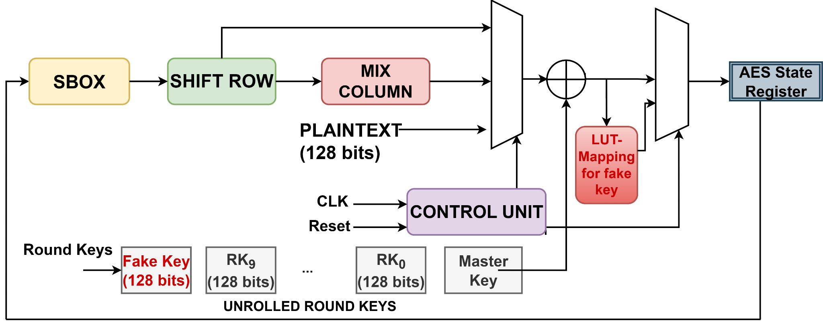 With countermeasure

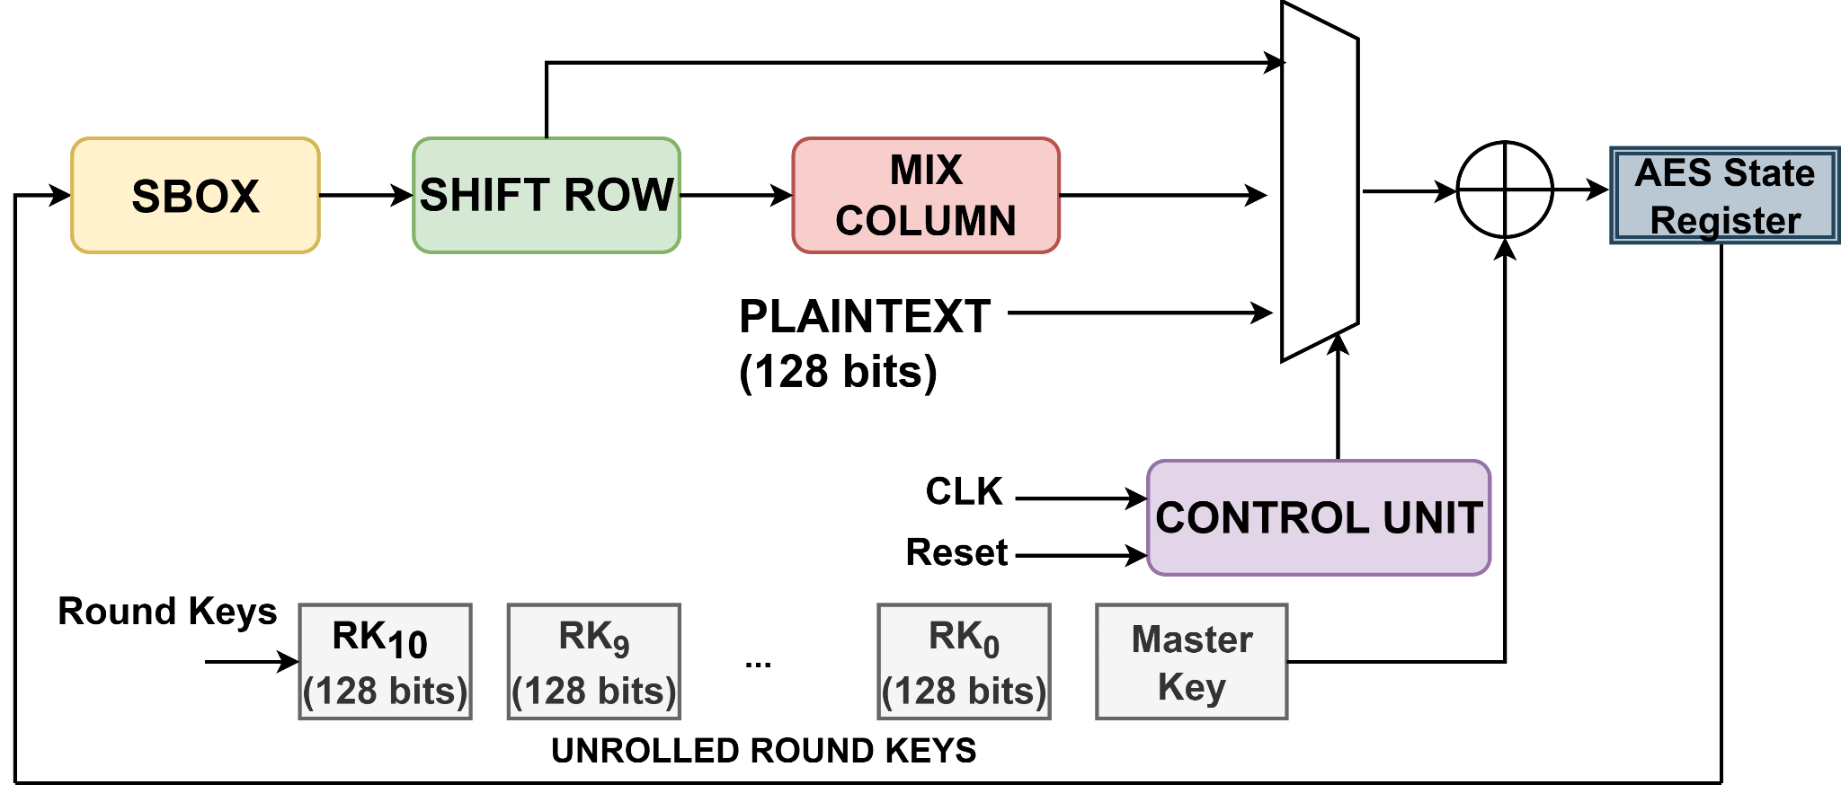
Without countermeasure

File Format
CSV, no header, 100,000 rows × 201 columns, one row per encryption:
Column | Content
0 | Ciphertext, 32 hex chars (byte 0 first)
1 – 200 | 200 time samples, floating point

What to Recover
The recommended attack is CPA on the final-round state register. It needs no profiling phase. For each byte position, over all 256 candidates:
(Hint: Use Hamming distance, HD_i[k] = HW( InvSBox[C[i] XOR k] XOR C[INV_SR[i]] ))
Take the candidate with the highest absolute correlation peak. Locating the leaking samples in the 200-sample window is part of the task.
Deliverables:
- The recovered 16-byte round-10 key, in hex.
- Correlation plots, one per key byte, 16 in total. Each plot shows correlation against sample index for all 256 candidates, with the winning candidate highlighted and its peak clearly visible. A 4×4 grid is acceptable.
- The number of traces required to retrieve.
- Bonus: Recover the actual round 10 key and produce the corresponding correlation plots.

