ANALYTICAL REPORT
FRA-Regulated Transit Mode
Major Security Events
2007 – 2025

A comprehensive analysis of 3,177 security incidents across 30 U.S. transit agencies — covering suicides, assaults, robberies, rail collisions, and related events from April 2007 through December 2025.

Prepared by:
Juan Lacia
Data & Operations Analyst · April 2026
Tools: Python (pandas, matplotlib) · Microsoft Excel · FRA National Transit Database

Executive Summary
This report analyses 3,177 major security incidents recorded across 30 FRA-regulated U.S. transit agencies from April 2007 to December 2025. The dataset, sourced from the Federal Railroad Administration's National Transit Database, covers events classified as suicides, assaults, aggravated assaults, robberies, rail collisions, bomb threats, and other security-related incidents.

3,177  Total Incidents | 1,707  Total Fatalities | 1,327  Total Injuries | $1.80M  Property Damage

Key Findings
- Suicide is the dominant event type — 1,876 incidents (59.1% of all events) accounting for 1,697 of 1,707 total fatalities. The 90.5% fatality rate per suicide incident makes it the overwhelming driver of mortality in this dataset.
- Assault is the leading injury event — 686 incidents resulting in 736 injuries. No fatalities were recorded for assault events, indicating a clear operational distinction between violence-oriented and fatality-oriented incident types.
- LIRR leads in incident volume — MTA Long Island Rail Road recorded 661 incidents (20.8% of total), the highest among all agencies. NJ Transit (527) and Metro-North (393) follow.
- Metra and Caltrain show extreme fatality rates — Metra (Chicago) recorded an 83.0% fatality rate; Peninsula Corridor/Caltrain recorded 78.6%. Both are high-volume suicide corridor agencies.
- July peaks; November troughs — 306 incidents recorded in July across all years — the highest monthly total. November recorded the fewest at 223. Summer months consistently show elevated activity.
- Incident volume has grown since 2008 — From 51 incidents in 2008, the dataset shows a general upward trend reaching 265 incidents in 2024. 58.7% of all incidents were classified as intentional.

The core operational implication of this data is straightforward: suicide prevention and response capacity are the single highest-leverage intervention point for reducing transit fatalities. Assault prevention and response are the highest-leverage point for reducing injuries.

Section 1 — Dataset Overview & Quality Assessment

1.1 Data Source
The source dataset is the FRA_Regulated_Mode_Major_Security_Events file from the Federal Railroad Administration's National Transit Database (NTD). The FRA mandates that all regulated commuter and intercity rail operators report major security incidents under 49 CFR Part 674. This dataset represents the full reporting universe for FRA-regulated commuter rail modes (CR), with limited entries for heavy rail (HR), hybrid rail (YR), and Alaska Railroad (AR).
Parameter | Value
Total Records | 3,177
Header Row | 1 (excluded from analysis)
Total Columns | 99
Columns Used in Analysis | 13 (core) + derived fields
Date Range | April 10, 2007 — December 26, 2025
Reporting Agencies | 30 distinct transit authorities
Primary Mode | CR (Commuter Rail) — 3,149 of 3,177 records
Data Classification | Security incidents (SEC: 3,167) and Safety (SFT: 10)

1.2 Data Quality Issues Identified & Resolved
The following quality issues were identified during exploratory analysis and addressed prior to any calculations:
- Person List missing for 230 records (7.2%) — demographic breakdowns exclude these records; aggregate incident counts are unaffected.
- Gender not available as a direct column — extracted via Person List parsing. Approximately 1,760 of 3,034 parsed persons have Unknown gender, limiting gender analysis to ~40% of the total person population.
- Age Group column contains #N/A for ~150 records — the raw column was not used; age was parsed from Person List strings instead, providing better coverage.
- Property Damage values are missing for 2,006 records — treated as $0 in sum calculations. The reported total ($1,798,118) is therefore a minimum estimate.
- Partial year data for 2007 (1 record) and 2025 (142 records through December 26) — year-over-year trend comparisons use 2008–2024 for full-year consistency.
- Inconsistent age group labelling — early records use ranges (36–45, 46–60); later records use categories (Adult, Teen, Senior). Standardized to 8 unified brackets for analysis.
- 99 columns in source — full dataset preserved in the Raw Data sheet of the accompanying Excel workbook; this report focuses on the 13 most analytically relevant fields.

Section 2 — Overview Dashboard
The dashboard below presents the six core KPIs alongside the annual trend, event type distribution, top agencies, and monthly seasonality pattern in a single composite view.

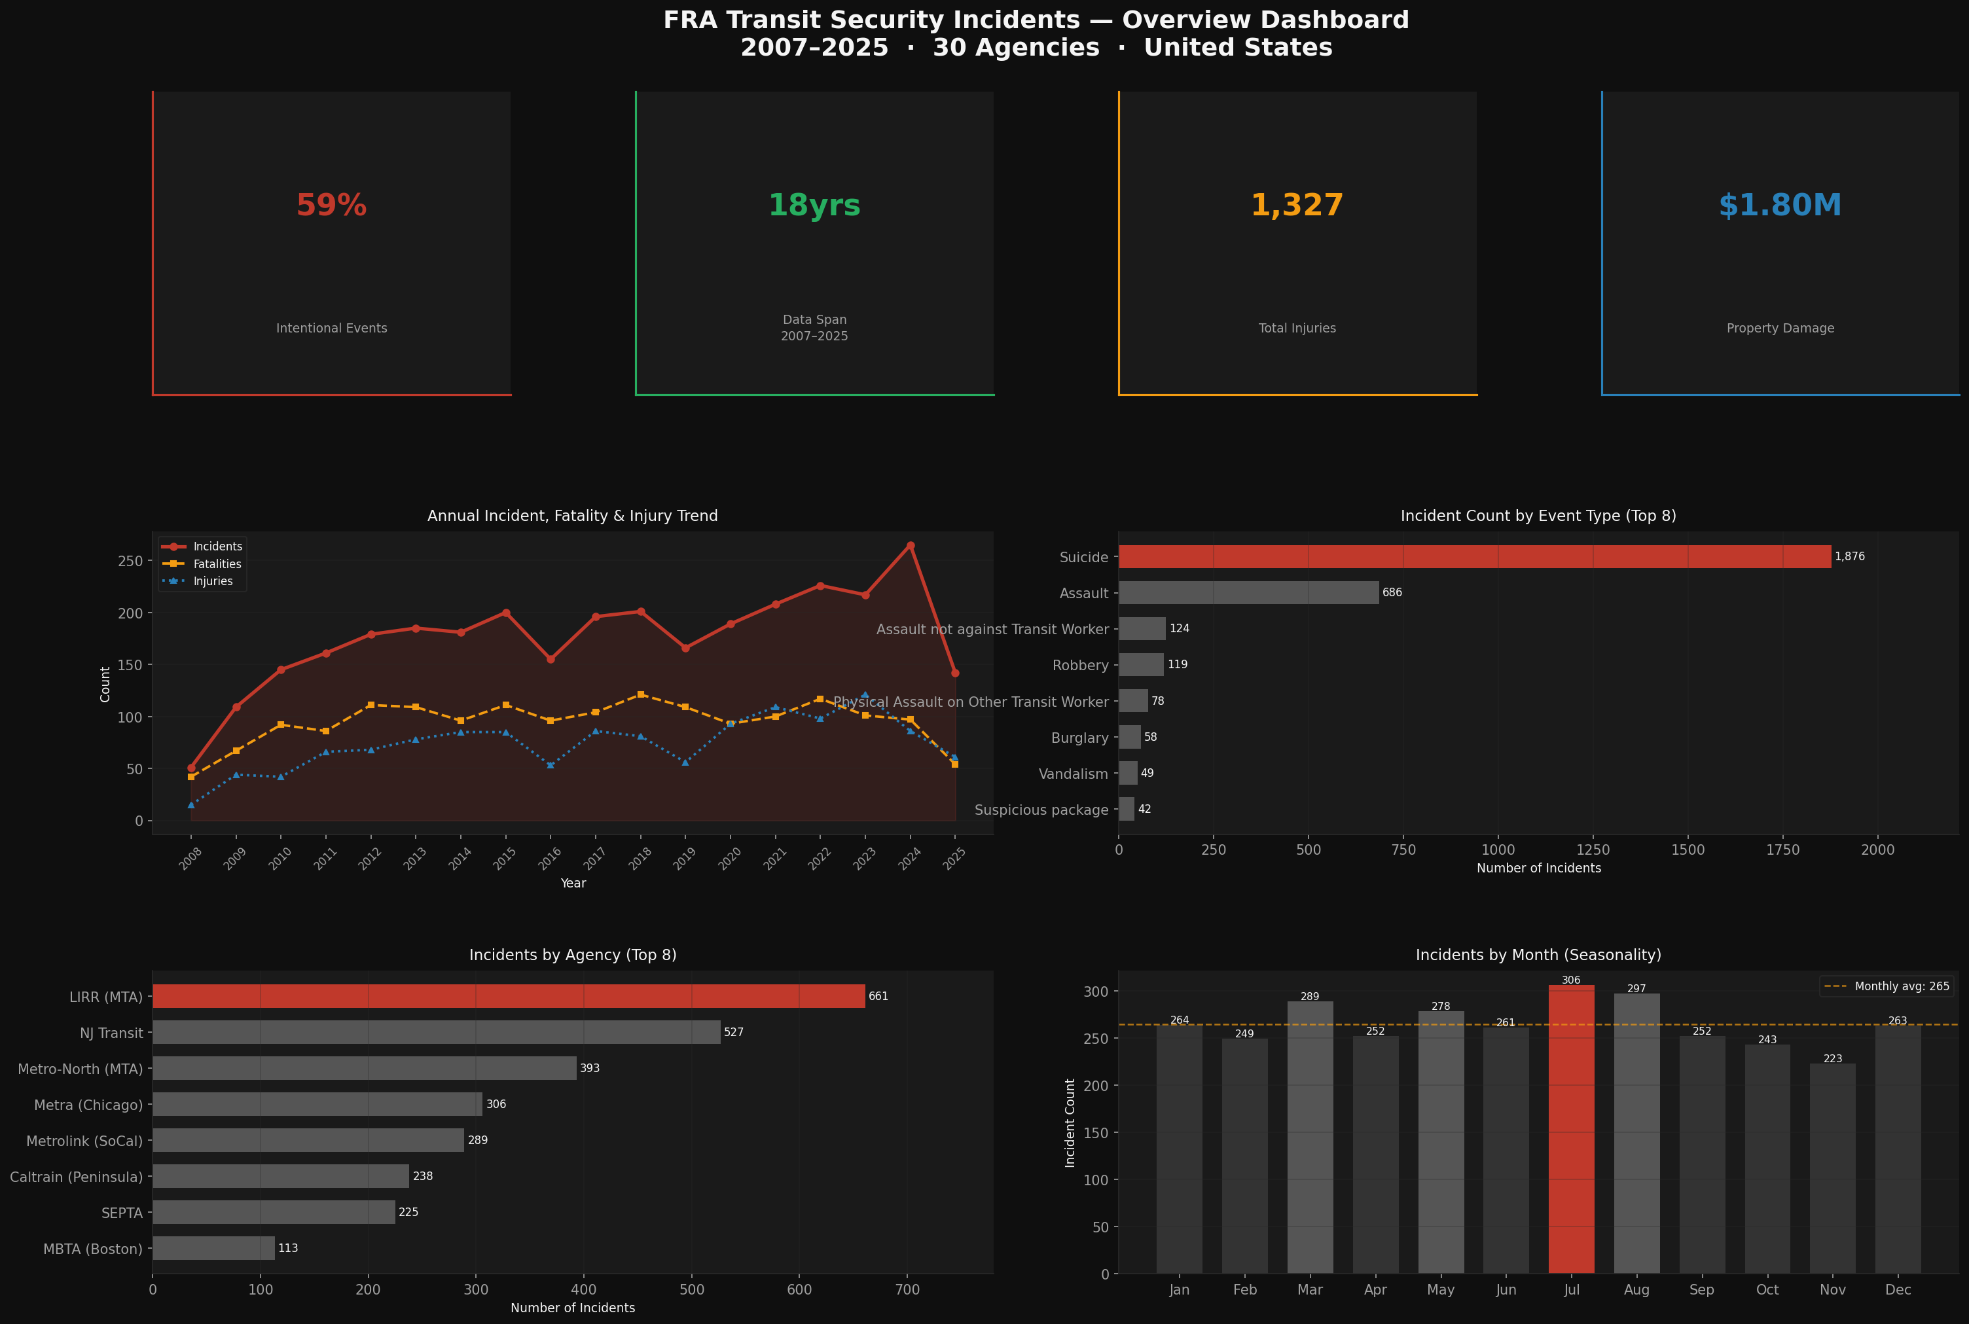

2.1 Annual Trend Interpretation
The annual trend shows a persistent upward trajectory in total incidents from 2008 (51 incidents) through 2024 (265 incidents) — a 419% increase over 16 years. Several observations:
- 2020 does not show the dramatic drop one might expect from COVID-19 pandemic service reductions — 189 incidents were recorded, only slightly below the multi-year trend. This suggests that suicide and security incidents on transit infrastructure do not follow the same patterns as ridership.
- Fatality counts track closely with incident counts year-over-year, reflecting the dominance of suicide events (90.5% fatality rate) in driving the total.
- Injury counts are more variable, reflecting the unpredictability of assault events — the primary injury driver.

2.2 Event Type Distribution
Suicide accounts for 59.1% of all incidents — more than the next seven event types combined. The remainder of the distribution is fragmented across assaults, robberies, and administrative classifications (Burglary, Vandalism, Suspicious Package) that produce no injuries or fatalities.

Section 3 — Event Type Analysis

3.1 Full Event Type Summary
Event Type | Incidents | Fatalities | Injuries | Fatality Rate
Suicide | 1,876 | 1,697 | 188 | 90.5%
Assault | 686 | 0 | 736 | 0.0%
Assault (not vs Transit Worker) | 124 | 0 | 129 | 0.0%
Robbery | 119 | 0 | 118 | 0.0%
Physical Assault on Transit Worker | 78 | 0 | 80 | 0.0%
Burglary | 58 | 0 | 0 | 0.0%
Vandalism | 49 | 0 | 0 | 0.0%
Suspicious Package | 42 | 0 | 3 | 0.0%
Aggravated Assault | 28 | 0 | 31 | 0.0%
Larceny / Theft | 27 | 0 | 0 | 0.0%
Bomb Threat | 26 | 0 | 3 | 0.0%
Homicide | 6 | 6 | 0 | 100.0%
Homicide (not vs Transit Worker) | 3 | 3 | 0 | 100.0%
Rail Collision | 7 | 1 | 11 | 14.3%
Rail Fire | 1 | 0 | 0 | 0.0%
Other / Misc. | 26 | 0 | 12 | 0.0%

3.2 The Suicide / Assault Operational Divide
This dataset reveals a fundamental operational divide in transit security incidents:
Suicide events are fatal but low-injury. Assault events are injurious but produce zero recorded fatalities. These two event types require entirely different operational responses and prevention strategies.
- For suicide prevention: The relevant intervention points are infrastructure-level (platform barriers, track access control), protocol-level (staff training for intervention), and coordination-level (mental health services referral at high-risk stations). The data suggests that when a suicide attempt occurs on transit infrastructure, the outcome is fatal 90.5% of the time — making prevention far more effective than response.
- For assault reduction: The 736 injuries from 686 assault incidents indicate an average of 1.07 injuries per assault event. Interventions are operational: increased platform presence, CCTV coverage, lighting standards, and wait-area design. Unlike suicide events, assault frequency correlates more directly with ridership volume and time-of-day patterns.

Section 4 — Fatality & Demographic Analysis
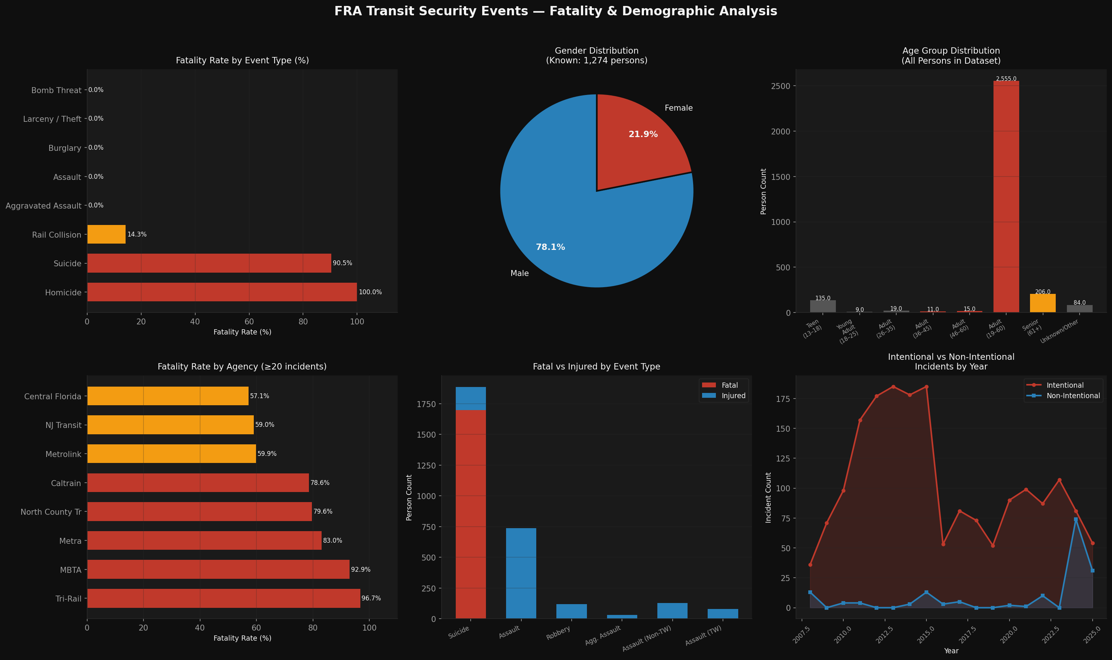

4.1 Gender Distribution
Of the 3,034 persons parsed from the Person List field, 1,274 have known gender (42%). Among those with known gender:
- Male: 995 persons (78.1%)
- Female: 279 persons (21.9%)
The male-dominant skew is consistent across event types. In suicide incidents specifically, male victims account for the substantial majority — consistent with broader public health data on railway suicides, which globally show a 2:1 to 4:1 male-to-female ratio. The high Unknown gender count (1,760 persons, 58%) reflects the multi-person incident encoding in the Person List field, particularly for assault events with multiple involved parties.

4.2 Age Group Distribution
Adults aged 19–60 represent 84.2% of all persons in the dataset. This reflects both the demographic makeup of transit ridership and the age-risk profile of railway-related events. Key observations:
- Senior citizens (61+): 206 persons (6.8%) — disproportionately represented relative to their share of ridership, particularly in suicide events.
- Teenagers (13–18): 135 persons (4.5%) — present in both suicide and assault categories.
- Children under 13: 6 persons (0.2%) — very low representation, as expected.

Section 5 — Agency Analysis
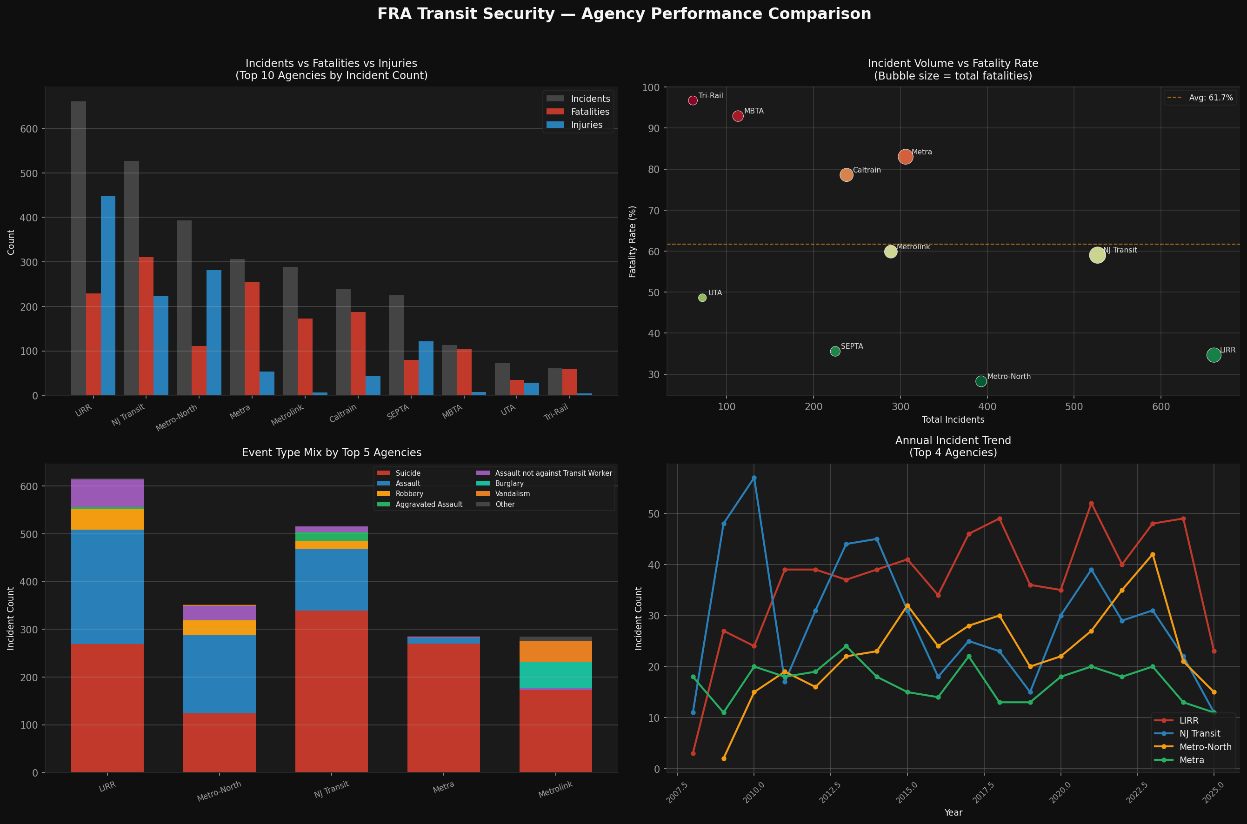

5.1 Top 10 Agencies by Incident Count
Agency | Incidents | Fatalities | Injuries | Fatality Rate
MTA Long Island Rail Road | 661 | 229 | 448 | 34.6%
New Jersey Transit | 527 | 311 | 224 | 59.0%
Metro-North (MTA) | 393 | 111 | 281 | 28.2%
Metra (Chicago) | 306 | 254 | 54 | 83.0%
Metrolink (SoCal) | 289 | 173 | 7 | 59.9%
Caltrain (Peninsula) | 238 | 187 | 43 | 78.6%
SEPTA | 225 | 80 | 121 | 35.6%
MBTA (Boston) | 113 | 105 | 8 | 92.9%
Utah Transit Authority | 72 | 35 | 28 | 48.6%
Tri-Rail (South Florida) | 61 | 59 | 4 | 96.7%

5.2 Agency Risk Profiles
The data reveals two distinct agency risk profiles:
High-Volume, Balanced-Risk Agencies
LIRR (661 incidents, 34.6% fatality rate) and Metro-North (393 incidents, 28.2%) have the highest incident counts but relatively moderate fatality rates. This reflects a higher proportion of assault and robbery events relative to suicides — these are heavily urban agencies serving high-density corridors where person-on-person crime is more prevalent.
Lower-Volume, Extreme-Fatality Agencies
MBTA (92.9% fatality rate), Tri-Rail (96.7%), Metra (83.0%), and Caltrain (78.6%) have dramatically higher fatality rates despite lower incident counts. These agencies serve corridors where the predominant event type is suicide — the combination of track accessibility, right-of-way characteristics, and geographic factors makes prevention the critical intervention.
A transit authority with a 90%+ fatality rate is not failing at incident response — it is operating in an environment where the nature of the incidents makes post-event survival statistically unlikely. The policy implication is platform barriers and trespass prevention, not enhanced emergency response.

Section 6 — Seasonal & Temporal Patterns

6.1 Monthly Distribution
Month | Incidents | Fatalities | Injuries
January | 264 | n/a | n/a
February | 249 | n/a | n/a
March | 289 | n/a | n/a
April | 252 | n/a | n/a
May | 278 | n/a | n/a
June | 261 | n/a | n/a
July | 306 ▲ PEAK | n/a | n/a
August | 297 | n/a | n/a
September | 252 | n/a | n/a
October | 243 | n/a | n/a
November | 223 ▼ LOWEST | n/a | n/a
December | 263 | n/a | n/a

6.2 Summer Peak Analysis
July (306) and August (297) represent the two highest-incident months — a combined 18.9% of all annual incidents. This summer concentration is consistent across multiple years in the dataset and reflects several factors:
- Increased ridership during summer months raises the base rate for all person-on-infrastructure events.
- Extended daylight hours may contribute to behavioral patterns associated with both assault incidents (higher outdoor activity) and suicide events (seasonal affective patterns).
- School recess periods bring different demographic patterns to transit systems, particularly in the Teen (13–18) age bracket.
November's low (223 incidents) likely reflects the combination of reduced daylight hours, lower outdoor temperatures, and the holiday period beginning in late November — all of which correlate with reduced transit use and platform exposure time.

Section 7 — Methodology & Analytical Approach

7.1 Tools Used
- Python 3.12 (pandas, numpy, matplotlib) — data ingestion, cleaning, parsing, and chart generation.
- Microsoft Excel (openpyxl) — structured workbook with 6 analysis sheets, formatted tables, and KPI summaries.
- Claude (Anthropic) — AI development partner for code generation, methodology review, and documentation. All analytical decisions and interpretations were made by the analyst.

7.2 Person List Parsing Logic
The Person List column encodes one or more persons per incident as semicolon-delimited strings in the format: [Outcome] [Location] [AgeGroup] [Gender]. For example: "F Ped Walking Tracks Adult (19 to 60) M" decodes as: Fatal outcome, Pedestrian walking on tracks, Adult aged 19–60, Male.
A custom Python function split each record on semicolons, extracted the first token (F=Fatal, I=Injured) as outcome, the last token (M/F) as gender, and the middle tokens as age group. Age group strings were then standardized to 8 unified brackets using keyword matching.

7.3 Analytical Questions Answered
- Which agency has the highest incident frequency and fatality rate? — Section 5
- What is the year-over-year trend in total incidents? — Section 2
- Which event types are most lethal? — Section 3
- What demographic patterns are associated with each event type? — Section 4
- Are incidents concentrated in specific months or seasons? — Section 6
- What is the intentional vs non-intentional event split? — Section 2
- How do agency risk profiles differ operationally? — Section 5

Section 8 — Operational Recommendations
The following recommendations are derived directly from the data patterns identified in this analysis. They are presented in order of potential impact on the two primary outcome metrics: fatalities and injuries.

Recommendation 1 — Platform Barrier Prioritization for High-Fatality-Rate Agencies
For agencies with fatality rates above 75% (MBTA, Tri-Rail, Metra, Caltrain), the data strongly supports prioritization of physical infrastructure intervention over enhanced emergency response capacity. At these agencies, the 90%+ fatality rate per incident means response protocol improvements will not meaningfully reduce outcomes. Capital investment in platform screen doors, end-of-platform barriers, and intrusion detection systems offers the highest return per dollar on fatality reduction.

Recommendation 2 — Assault Reduction Focus for High-Volume Urban Agencies
LIRR (448 injuries from 661 incidents) and Metro-North (281 injuries from 393 incidents) have injury profiles dominated by assault events. For these agencies, operational interventions — increased platform security staffing during peak periods, enhanced CCTV coverage with active monitoring, and wait-area design improvements — are more appropriate than infrastructure capital investment.

Recommendation 3 — Summer Surge Operational Planning
July and August consistently produce the highest incident volumes. Agencies should plan surge staffing, enhanced monitoring, and targeted outreach programs for June through August, with particular focus on the peak July period.

Recommendation 4 — Gender-Targeted Prevention Messaging
The 78% male predominance among known-gender persons in the dataset — particularly in suicide incidents — suggests that prevention and intervention messaging should be designed with the primary demographic in mind. Transit agency mental health resources, crisis line signage, and staff intervention training should reflect this demographic reality.

END OF REPORT
FRA Transit Security Analysis · Juan Lacia · April 2026
Data Source: Federal Railroad Administration National Transit Database (NTD)
Tools: Python · pandas · matplotlib · Microsoft Excel · Claude (Anthropic)

