**Manual:**

This is the instruction manual for DVD rental system.

When you start using it, three options appear on the screen shown in Figure 1.

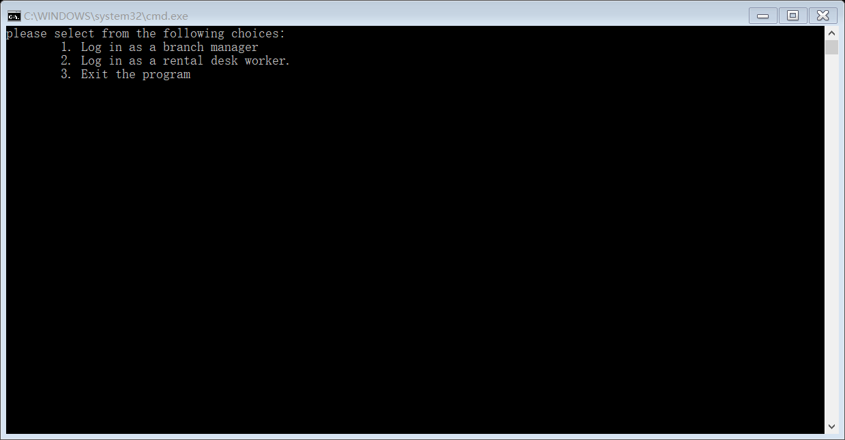

**Figure 1:** The start page

If the user enters 1, the screen will be jumped to the branch management page shown in Figure 2, which is mainly used to manage DVD and customer information.

If the user enters 2, the screen will be jumped to the rental desk staff page shown in Figure 3, which mainly allows existing customers to rent and return existing DVDs or current loans, and determines the customer's charges and penalties.

If the user enters 3, the screen will be exited.

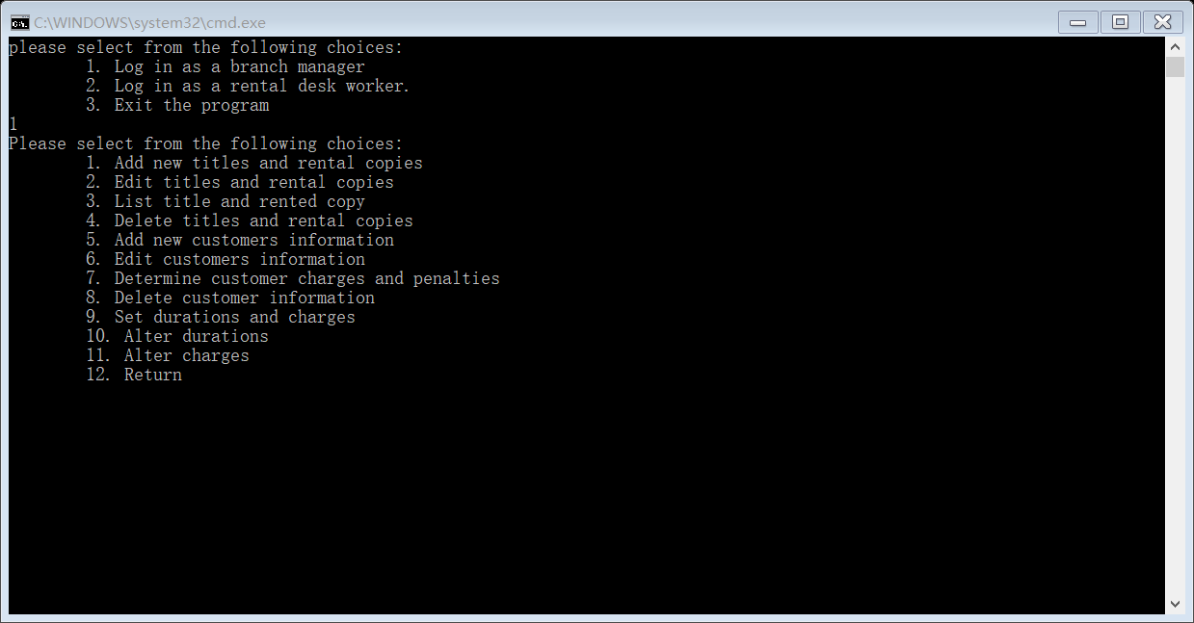

**Figure 2:** The branch management page

As shown in Figure 2, the branch management page has 12 options (functions).

If the user enters 1, a new DVD information (including DVD title, title information, age limit and genre) and rented copies can be added.

If the user enters 2, the DVD specified (need to enter DVD titles) by the user can be edited (modify DVD information and rented copies).

If the user enters 3, all titles are added to the screen before listing to see the current inventory status.

If the user enters 4, the DVD specified (need to enter DVD titles) by the user can be deleted.

If the user enters 5, a new customer information (including number, name, age, telephone, address, pending charges and rental history) can be added.

If the user enters 6, the customer information specified (need to enter name) by the user can be edited (modify customer information).

If the user enters 7, all customer names are added to the screen before listing to determine the charges and penalties.

If the user enters 8, the customer information specified (need to enter name) by the user can be deleted.

If the user enters 9, the user can specify the lease period and setup/change costs. (three rental durations need to be entered, and four charge standards are required in three of them)

If the user enters 10, three rental durations can be edited (modify rental durations).

If the user enters 11, four charge standards can be edited (modify charge standards).

If the user enters 12, the screen will be return to start page.

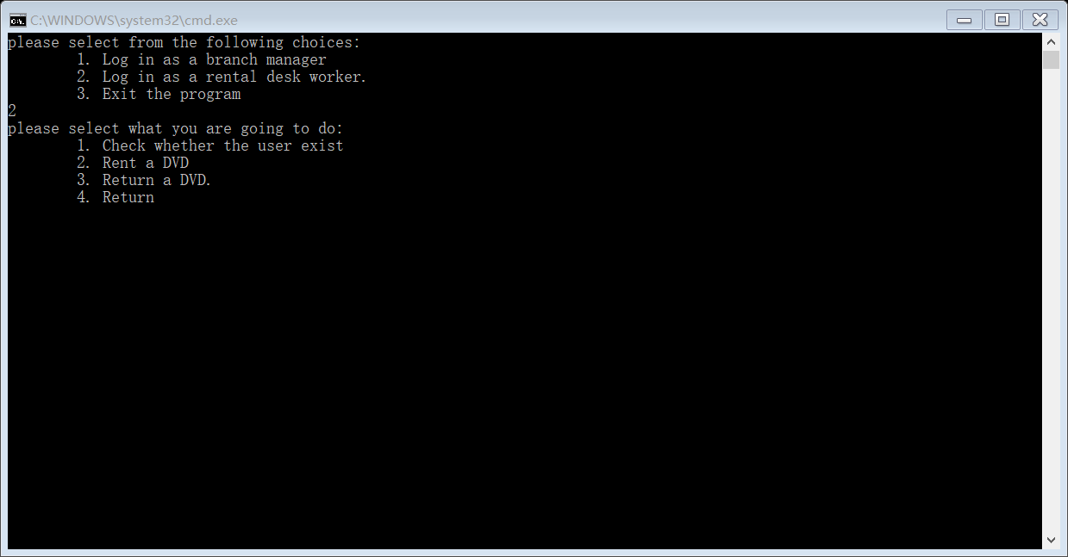

**Figure 3:** The rental desk staff page

If the user enters 1, the user can check whether the customer exists. (need to enter name)

If the user enters 2, the user can enter the specified DVD (need to enter DVD titles) and lease date (need to enter year, month and day) that the customer rents.

If the user enters 3, the user can enter the specified DVD (need to enter DVD titles) and return date (need to enter year, month and day) that the customer returns.

If the user enters 4, the screen will be return to start page.