**Assignment 1_Report**

**Introduction**

This Assignment is to use Quartus II to create a digital system on the DE2 board. The requirement is to count from 1 to 73 when you press the KEY2 button, and stop counting when you press the KEY0 button. Then the numbers will be displayed on HE5 and HE4 for 4 seconds, and it will end after 4 numbers appear. It is similar to a lottery and cannot be repeated. However, this Assignment 1 is mainly to design a counter and a 7-segment decoder, and simulate them together.

**Block Diagram**

Figure 1 is a block diagram made according to Assignment 1 requirements. This project mainly consists of a controller, two counters and two 7-segment decoders. Key_2 and Key_0 are the buttons on the DE2 board respectively. Key_2 will be used as a start key, and Key_0 will be used as a display key. The clk will be used to control the frequency of counting. The rst will be used to reset all signals. The counting of the counter will be carried out in the controller. When key0 is pressed, the number is decoded by the 7-segment decoder and then displayed on HEX5 and HEX4 on the DE2 board. Among them, 7segmentdisplay_0 will be used to display single digits on HEX4, and 7segmentdisplay_1 will be used to display ten digits on HEX5.

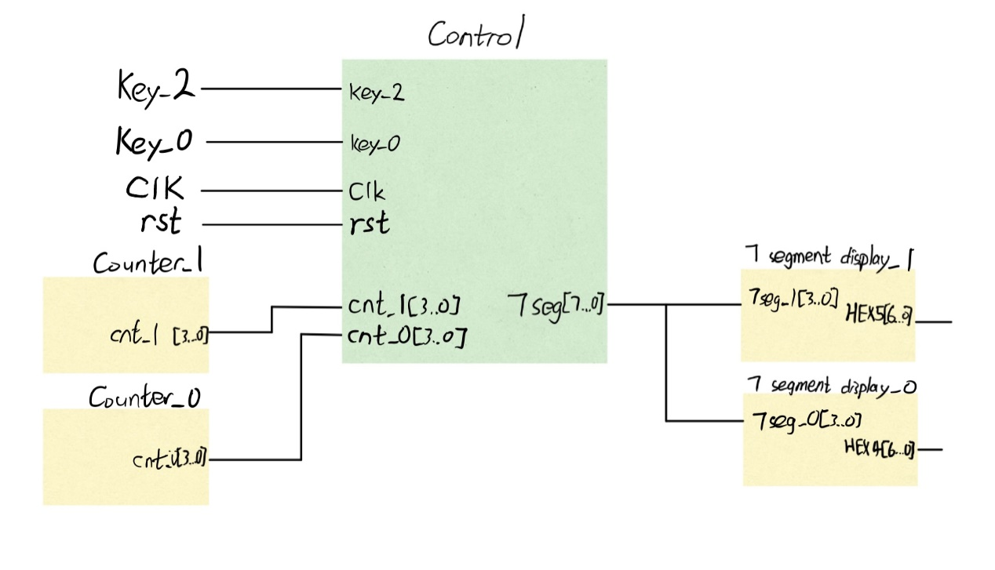

**Figure 1:** The Block Diagram

**ASM Chart**

Figure 2 is the ASM diagram, where Z is the number of times the button Key_0 was pressed on the DE2 board, and Y was the number of seconds displayed on the HEX5-4 of the DE2 board. When the number of times of pressing Key_0 Z is 4, the system will end the job. Y is for the number to display for 4 seconds.

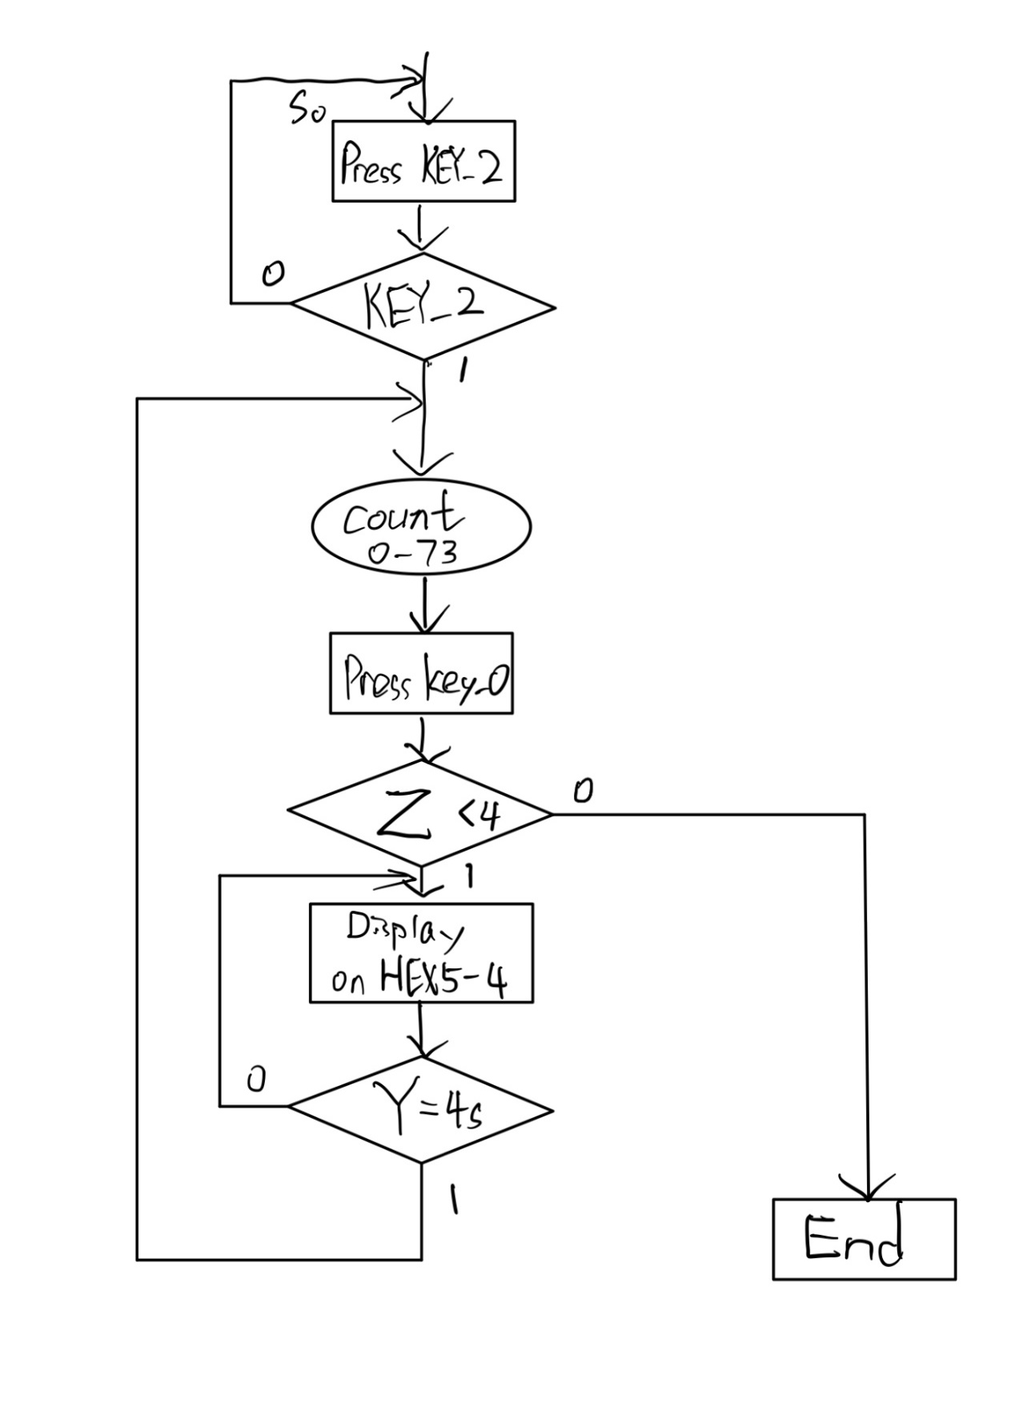**Figure 2:** The ASM chart

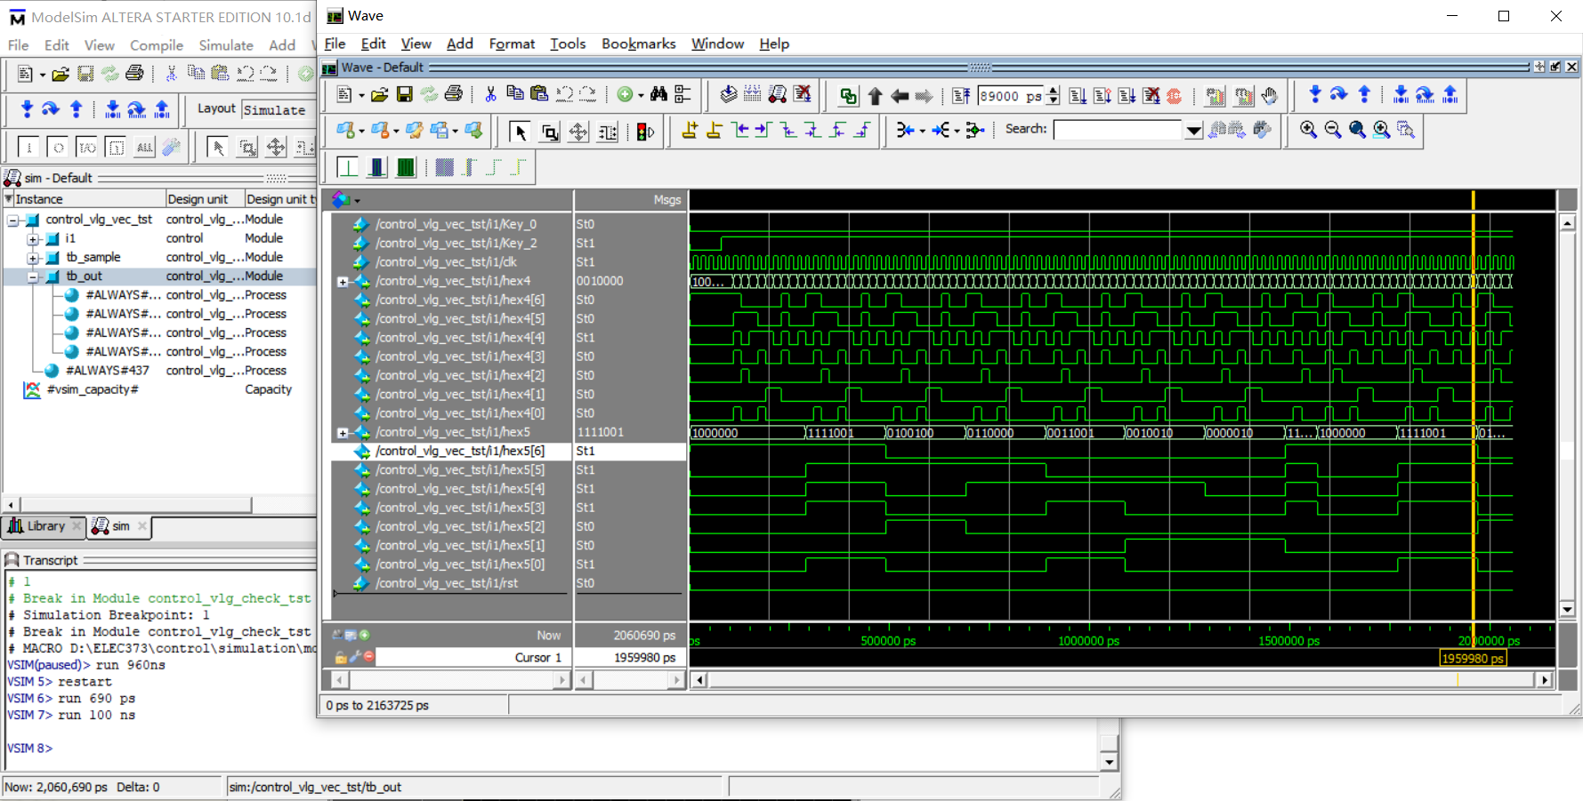**Simulations**

**Figure 3:** Simulation of counter and 7-segment decoder

Figure 3 is to simulate a controller, which contains a counter and a 7-segment decoder.

**Discuss and Conclusion**

This design only used some basic codes of Quartus2, and had not yet completed the coding of the number of times the button Key_0 is pressed and the display of Y seconds on HEX5-4. These codes will be added to the next task, and the design will be tested on the DE2 board.

**Appendix-Coding**

**Controller**

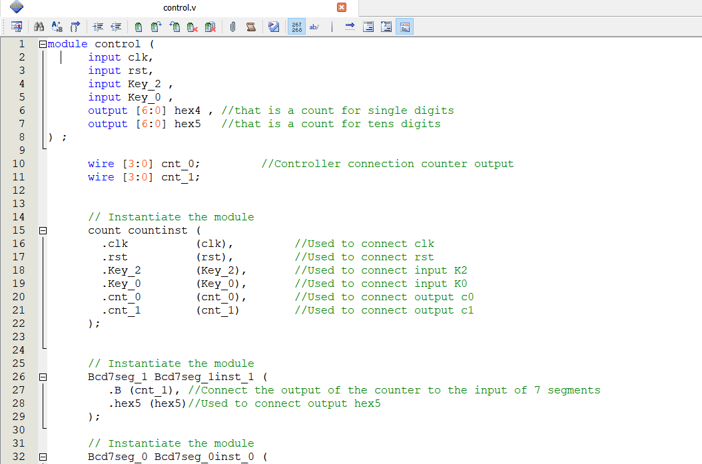



**Counter**

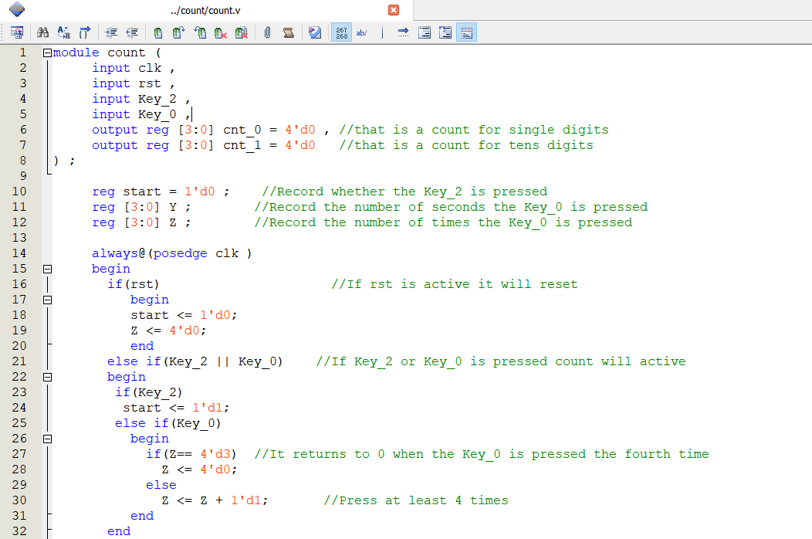

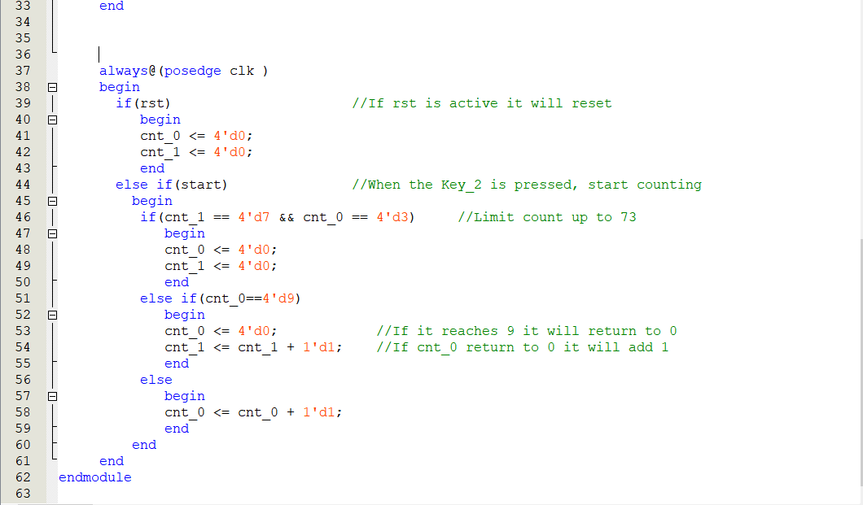

**Bcd7seg_0**

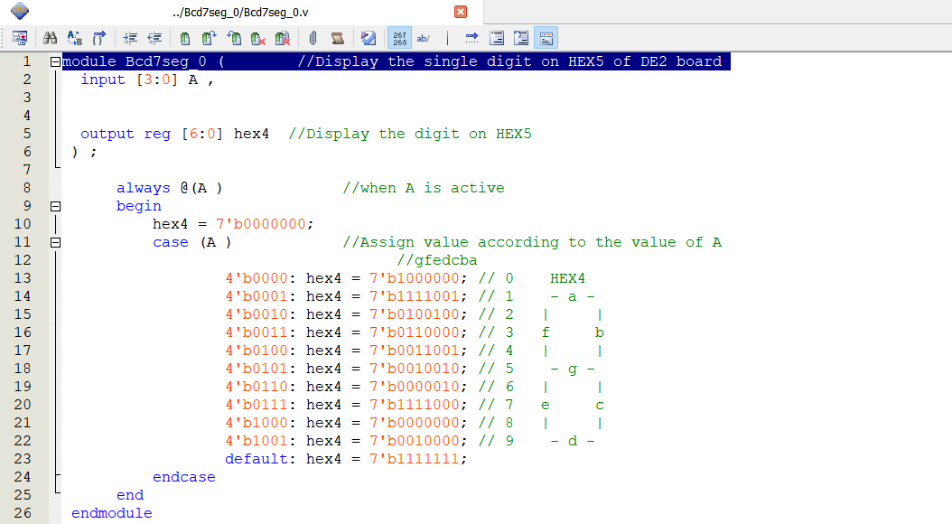

**Bcd7seg_1**

