**Table 1.** A summary of samples used for differential gene expression analysis. A total of 48 samples are characterized by their genotype, treatment, time point, phenotype, and sequencing type.

Genotype Treatment Timepoint Phenotype Sequencing_Type

1 RR Control 0 hrs resistant single

2 RR Control 0 hrs resistant single

3 RR Control 0 hrs resistant single

4 RR Control 0 hrs resistant single

5 RR Control 0 hrs resistant single

6 RR Control 0 hrs resistant single

7 RR Control 0 hrs resistant single

8 RR Control 0 hrs resistant single

9 RR Control 0 hrs resistant single

10 RR Control 0 hrs resistant single

11 RR Control 0 hrs resistant single

12 RR Control 0 hrs resistant single

13 RR Control 0 hrs resistant paired

14 RR Control 0 hrs resistant paired

15 RR Control 0 hrs resistant paired

16 RR Control 0 hrs resistant paired

17 RR Control 0 hrs resistant paired

18 RR Control 0 hrs resistant paired

19 S1 Control 0 hrs susceptible single

20 S1 Control 0 hrs susceptible single

21 S1 Control 0 hrs susceptible single

22 S1 Control 0 hrs susceptible single

23 S1 Control 0 hrs susceptible single

24 S1 Control 0 hrs susceptible single

25 S1 Control 0 hrs susceptible paired

26 S1 Control 0 hrs susceptible paired

27 S1 Control 0 hrs susceptible paired

28 S2 Control 0 hrs susceptible single

29 S2 Control 0 hrs susceptible single

30 S2 Control 0 hrs susceptible single

31 S2 Control 0 hrs susceptible single

32 S2 Control 0 hrs susceptible single

33 S2 Control 0 hrs susceptible single

34 S2 Control 0 hrs susceptible paired

35 S2 Control 0 hrs susceptible paired

36 S2 Control 0 hrs susceptible paired

37 RR Challenge 2 hrs resistant single

38 RR Challenge 2 hrs resistant single

39 RR Challenge 2 hrs resistant single

40 S1 Challenge 2 hrs susceptible single

41 S2 Challenge 2 hrs susceptible single

42 S2 Challenge 2 hrs susceptible single

43 RR Challenge 6 hrs resistant single

44 RR Challenge 6 hrs resistant single

45 RR Challenge 6 hrs resistant single

46 S1 Challenge 6 hrs susceptible single

47 S2 Challenge 6 hrs susceptible single

48 S2 Challenge 6 hrs susceptible single

**Table 2** Significantly differentially expressed genesranked by Benjamini-Hochberg adjusted p-value. Those present in annotation file contain descriptions.

**Figure 1**

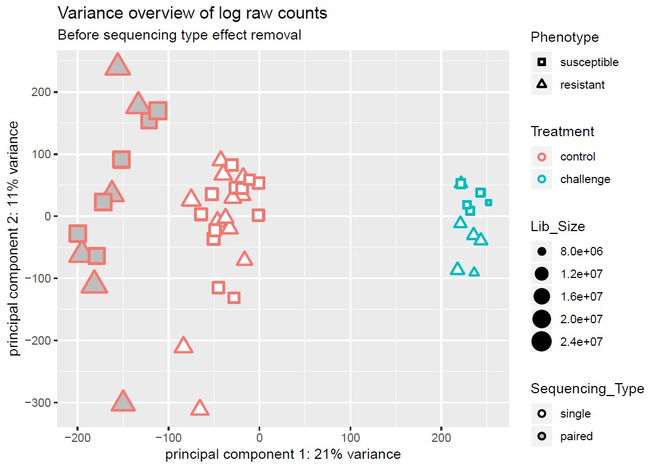

Figure 1: Overview of the variance in raw counts of sample transcriptomes by principal component analysis (PCA). Sample attributes are keyed to shape, color, size, and shade. Each point represents the sum of 59,245 products of log2  raw gene counts and their respective weights, according to PC1 (x coordinate) and PC2 (y coordinate). Correlation between sequencing type and library size is worthy of note.

**Figure 2**

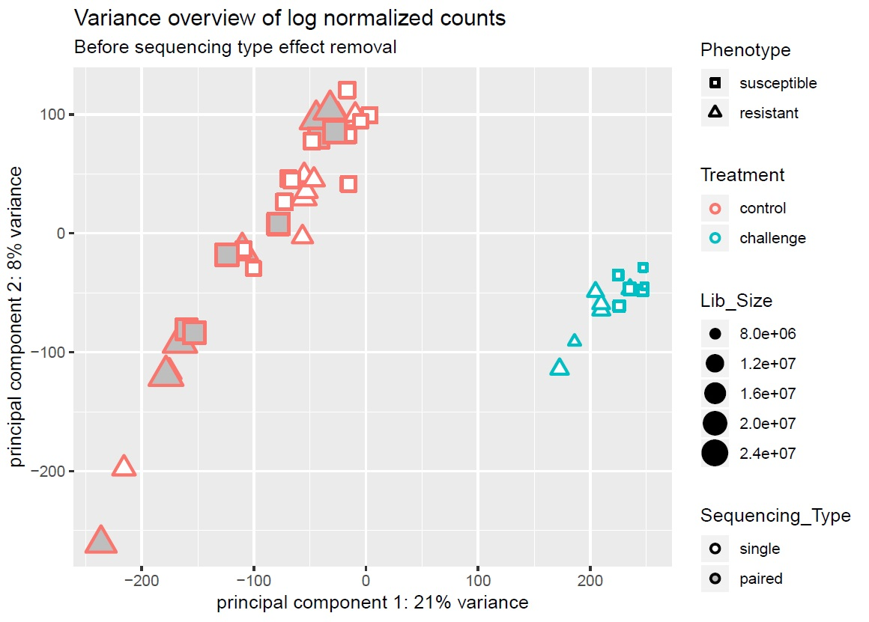

Figure 2: Overview of the variance in normalized counts of sample transcriptomes by principal component analysis (PCA), with relevant attributes keyed to shape, color, size, and shade. Each point represents the sum of 59,245 products of loggene counts after normalization and their respective weights, according to PC1 (x coordinate) and PC2 (y coordinate). Correction of the library size effect has reduced the visually apparent point clusters.

**Figure 3**

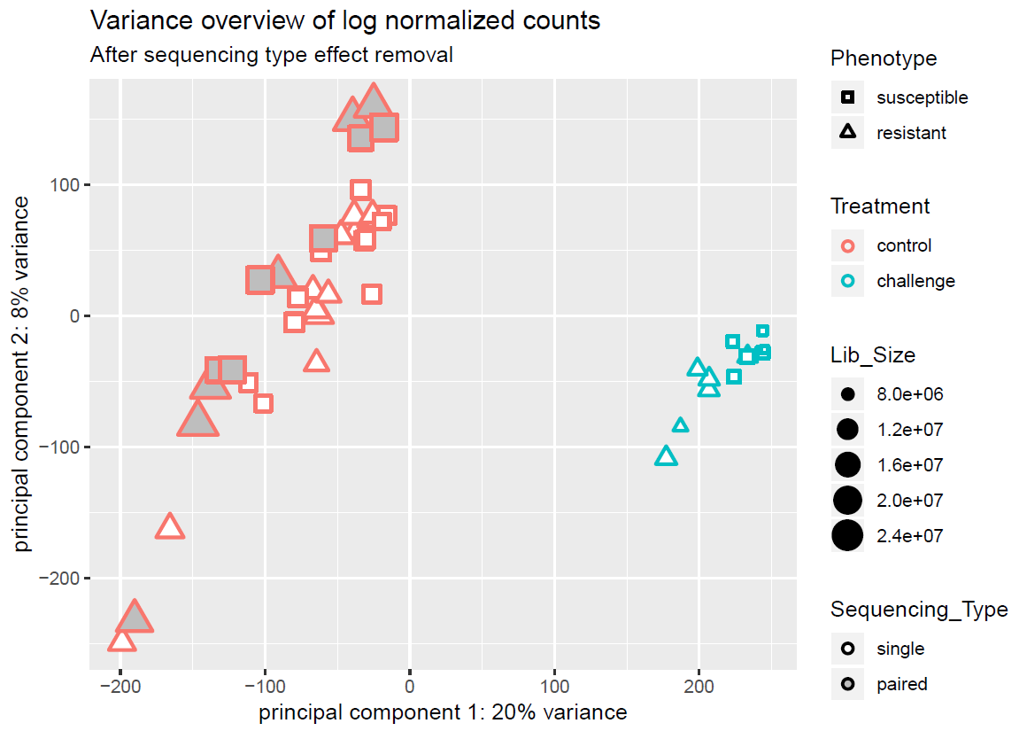

Figure 3: Overview of the variance in normalized counts of transcriptomes by principal component analysis (PCA), where the sequencing type effect has been removed. Sample attributes are keyed to shape, color, size, and shade. Each point represents the sum of 59,245 products of log2 gene counts after normalization and sequencing type effect subtraction and their respective weights, according to PC1 (x coordinate) and PC2 (y coordinate). Adjustment to remove the unwanted technical effect produces only a subtle change compared to Figure 3.

**Figure 4**

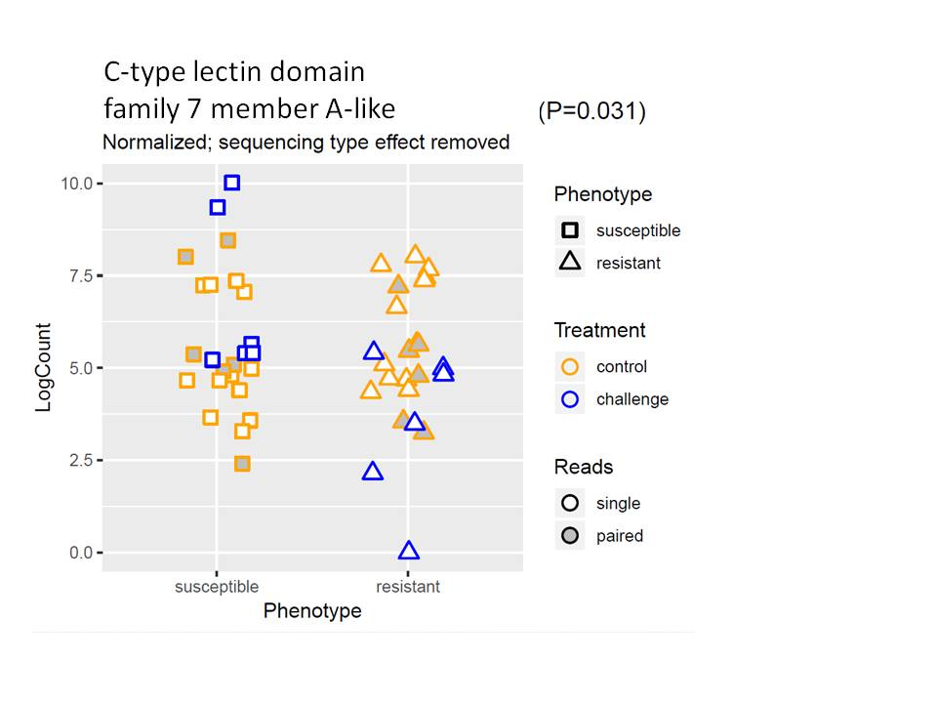

Figure 4: Log normalized counts by phenotype for the #34 DEG, with each point representing a single number. Points are arbitrarily “jittered” along the x-axis to enable clearer visualization.