SE-Blackboard: Evaluating Blackboard vs. Message-Passing Communication in Multi-Agent Software Engineering

Abstract
LLM-based multi-agent systems for software engineering typically employ message-passing communication, where agents relay information through sequential natural language messages. This architecture causes knowledge drift: key technical details progressively degrade as they pass through the agent chain.

We present SE-Blackboard, a multi-agent framework that introduces the Blackboard shared-state architecture for software engineering, where all agents read from and write to a structured shared workspace. We further propose the Information Fidelity Score (IFS), a metric that quantifies preservation of key technical entities across pipeline stages.

In controlled experiments on 50 SWE-bench Lite issues comparing Message-Passing (MP), Blackboard (BB), and Hybrid architectures within a four-agent pipeline, BB improves Coder-stage information fidelity by 50% over MP (IFS: 0.584 vs. 0.390, Wilcoxon p=0.058). This translates to a correct file targeting rate of 83% for BB versus 55% for MP. The resolve rate increases from 12.0% (MP) to 16.0% (BB), though this difference is not statistically significant (p=0.625) due to limited sample size. A patch quality decomposition reveals that once the correct file is targeted, all modes achieve similar resolve rates (~22%), identifying LLM patch generation as the binding constraint rather than information quality.

We propose an information flow bottleneck model: BB's upstream advantages (IFS +50%, file targeting +28pp) are attenuated by a systematic patch generation bottleneck, yielding an observed
+4pp resolve gain consistent with the ~22% downstream conversion rate. Our findings demonstrate that shared-state communication effectively mitigates information loss and suggest its benefits will compound as LLM diff generation precision improves.

Introduction
The rapid advancement of large language models (LLMs) has catalyzed the emergence of multi-agent systems for software engineering (SE). Systems such as MetaGPT [Hong et al., 2024], ChatDev [Qian et al., 2024], SWE-Agent [Yang et al., 2024], and AgentCoder [Huang et al., 2024] demonstrate that multiple AI agents can collaboratively tackle complex tasks including code generation, bug fixing, and code review, representing a shift from monolithic tools toward modular, role-based architectures.
Despite their promise, current multi-agent SE systems share a common architectural assumption: message-passing communication. Agents communicate by forwarding natural language messages along a predefined chain—the output of one agent becomes the input of the next. This approach suffers from a fundamental limitation: information fidelity degrades at each handoff. Critical technical details—function signatures, parameter types, error stack traces—may be paraphrased, simplified, or omitted. This progressive degradation, which we term knowledge drift, has been identified as a primary failure mode in multi-agent LLM systems [Cemri et al., 2025].
Knowledge drift is particularly acute in software engineering contexts. Unlike general reasoning tasks where paraphrasing may preserve semantic equivalence, SE tasks demand exact technical precision: a single character difference in a function name or file path can determine whether a patch applies correctly. This precision

requirement makes SE an ideal domain for studying information preservation in multi-agent architectures.
Existing approaches to communication quality have focused on post-hoc remediation. RTADev [Fang et al., 2025] proposes intention alignment to verify that agents' interpretations match the original intent, but detects information loss only after it has occurred. The Blackboard architecture—a classical AI pattern featuring a shared workspace accessible to all agents [Nii, 1986]—offers a proactive alternative. Recent work has demonstrated Blackboard's effectiveness for LLM-based reasoning [Han and Zhang, 2025] and data science [Salemi et al., 2025] tasks, but it has never been applied to software engineering.
This paper makes the following contributions:
- SE-Blackboard Framework: The first application of the Blackboard shared-state architecture to multi-agent software engineering, supporting three pluggable communication modes (Message-Passing, Blackboard, and Hybrid) within identical agent pipelines.
- Information Fidelity Score (IFS): A novel metric quantifying the preservation of key technical entities across pipeline stages, enabling measurement of information retention independent of downstream task success.
- Controlled Empirical Evaluation: Experiments on 50 SWE-bench Lite issues demonstrating that BB improves Coder-stage IFS by 50% (0.584 vs. 0.390, p=0.058) and resolve rate by 4 percentage points (16% vs. 12%), with patch formatting identified as the primary bottleneck.
- Open-Source Framework: A modular framework with pluggable communication architectures, structured state schemas, and comprehensive logging for future research.

Related Work

Multi-Agent Systems for Software Engineering
Recent work has produced numerous multi-agent SE systems spanning different architectures and interaction paradigms. Role-based frameworks like MetaGPT [Hong et al., 2024] and ChatDev [Qian et al., 2024] assign specialized roles to agents and coordinate them through structured workflows or dialogue. Tool-augmented approaches such as SWE-Agent [Yang et al., 2024] equip agents with repository navigation tools, achieving competitive results without explicit multi-agent coordination. For automated bug fixing specifically, AgentCoder [Huang et al., 2024] and CodeR [Chen et al., 2024] employ multi-agent pipelines with iterative test feedback, while Agentless [Xia et al., 2024] demonstrates that structured prompting can match agent-based approaches, suggesting that the interaction pattern may matter as much as agent autonomy.
A common thread across these systems is their reliance on message-passing for inter-agent communication. While some systems incorporate shared artifacts, the communication architecture itself is not treated as an independent variable. Our work addresses this gap.

Communication Architectures for LLM Agents
He et al. [2025] survey LLM-based multi-agent systems for SE, identifying several communication modes—including direct messaging, shared memory, and blackboard systems—but note that most existing systems use simple sequential communication. Cemri et al. [2025] systematically analyze why multi-agent LLM systems fail, identifying knowledge drift as a primary failure mode and demonstrating that longer agent chains exhibit higher drift rates. RTADev [Fang et al., 2025] addresses this through intention alignment—a reactive approach that detects information loss post-hoc. In contrast, the Blackboard architecture we adopt is proactive, ensuring all agents maintain access to source information regardless of intermediate processing.

Blackboard Architecture

The Blackboard architecture, originally proposed by Nii [1986], provides a framework in which multiple knowledge sources collaborate through a shared workspace. Historically applied to speech understanding and planning systems, it has recently resurfaced for LLM-based multi-agent coordination. Wang et al. [2025] demonstrate that shared-state communication significantly reduces information loss compared to message-passing for reasoning tasks, with advantages scaling with task complexity and agent chain length. Salemi et al. [2025] apply the pattern to data science tasks, showing improved coherence when agents directly observe each other's outputs.
Our work extends this line of research to software engineering for the first time. SE tasks present unique challenges: the state must represent heterogeneous artifacts (issue descriptions, code context, patches, test results) with clear ownership semantics, and precision requirements for code-related information are substantially higher than for natural language reasoning.

System Design
SE-Blackboard is a modular framework designed to isolate the effect of communication architecture on SE task performance. Figure 1 illustrates the system architecture, comprising four components: a structured state schema, three pluggable communication modes, four specialized agents, and a pipeline topology.
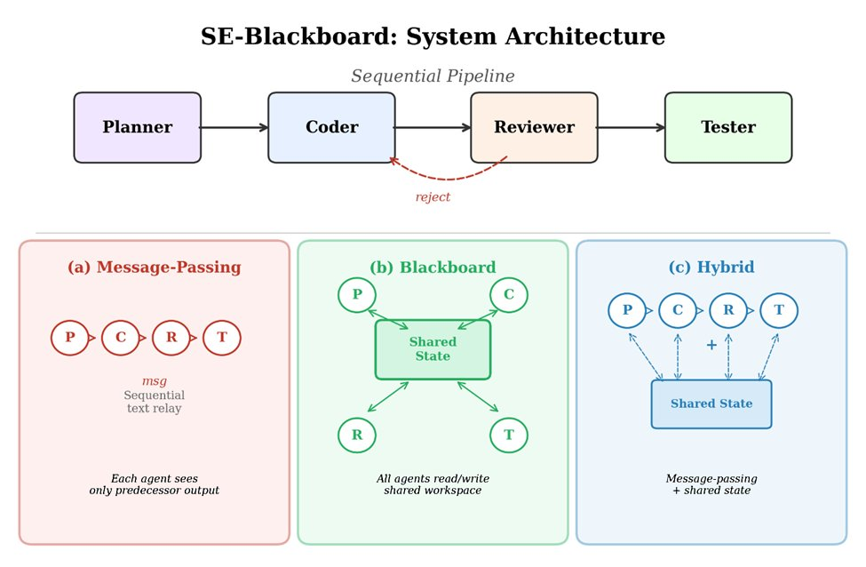
[Figure 1: System Architecture]

SE State Schema
The framework uses a domain-specific state schema implemented as Pydantic models, capturing key artifacts of a bug-fixing pipeline: IssueInfo (original issue description, repository, base commit), Analysis (Planner's root cause analysis and fix strategy), Patch (Coder's unified diff output), Review (Reviewer's accept/reject decision with feedback), and TestResult (Tester's pass/fail evaluation).
A critical design principle is field ownership: each agent writes only to its designated fields while having read access to upstream fields. Crucially, the original issue description is always preserved and directly accessible to all agents—the architectural mechanism by which the Blackboard prevents knowledge drift.

Communication Modes
The framework supports three communication modes (Figure 1, bottom):
Message-Passing (MP): Each agent receives only the output of its immediate predecessor as natural language input. No structured state is shared. This mirrors most existing multi-agent SE systems.
Blackboard (BB): All agents read from and write to a shared state instance. Each agent receives a role-tailored view via get_state_for_agent(role), including all upstream fields plus the original issue. The Coder receives both the Planner's structured analysis and the original issue text, enabling cross-referencing.
Hybrid: Agents receive both message-passing context and blackboard state access, combining both information channels.
All three modes share identical agent implementations and prompt templates (with mode-specific context formatting), ensuring that observed differences are attributable to communication architecture.

Agent Design
The pipeline employs four agents: Planner (analyzes the issue to produce root cause analysis and fix strategy), Coder (generates a unified diff patch from the analysis and repository source code), Reviewer (evaluates the patch and provides accept/reject feedback), and Tester (evaluates the final patch via the SWE-bench Docker harness). Each agent has mode-specific prompt variants that guide it to use the available information sources appropriately.
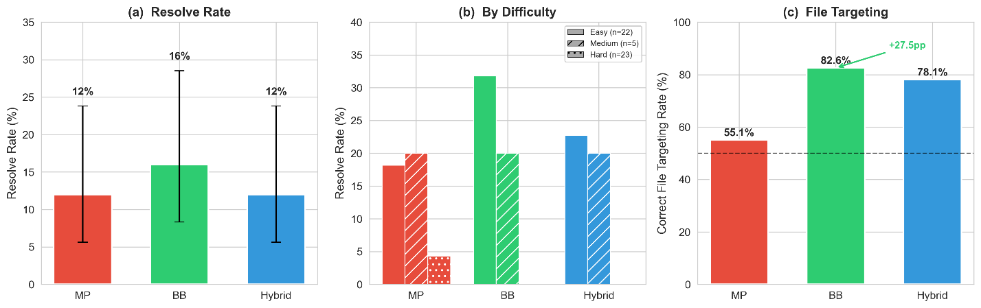
[Figure 2: Main Results]

Pipeline Topology
The framework implements a Sequential Pipeline: Planner → Coder → Reviewer → Tester, with a rejection loop from Reviewer back to Coder (up to 3 iterations). On acceptance—or when the maximum iteration count is reached—the Tester evaluates the final patch. The Tester always executes regardless of the Reviewer's decision, ensuring every run produces a test result. The full topology is illustrated in Figure 1.

Experimental Setup

Benchmark
We evaluate on SWE-bench Lite [Jimenez et al., 2024], a curated subset of 300 real-world GitHub issues from 12 popular Python repositories. Each issue includes a natural language problem description, a base commit, and test cases that the fix must pass (FAIL_TO_PASS) while not breaking existing functionality (PASS_TO_PASS).
We select a stratified sample of 50 issues to balance feasibility with coverage. Issues were initially sampled in equal strata based on repository metadata, then reclassified post-hoc using gold patch complexity as an objective difficulty proxy: Easy (single-file, <20 lines): 22 issues, predominantly Django; Medium (single-file, 20–50 lines or multi-file with small changes): 5 issues; Hard (multi-file, >50 lines, or complex reasoning): 23 issues. The sample covers 8 repositories, with Django overrepresented (22/50) due to its comprehensive test coverage.

Configurations
We evaluate three configurations combining the Sequential Pipeline with different communication modes:

Configuration | Communication | Label
A-Seq(MP) | Message-Passing | MP
B-Seq(BB) | Blackboard | BB
C-Seq(Hy) | Hybrid | Hybrid
Table 1: Experimental configurations for the three communication modes.
All configurations use identical hyperparameters: Claude Sonnet 4.5 (claude-sonnet-4-5-20250929), temperature 0, max 3 Coder-Reviewer iterations, and function-level code context retrieved via git checkout. The single LLM with deterministic generation ensures that observed differences are attributable to communication architecture. Each issue is evaluated once per configuration, yielding 150 total runs.

Evaluation Metrics
Resolve Rate. An issue is resolved if the generated patch causes all FAIL_TO_PASS tests to pass while maintaining PASS_TO_PASS tests, evaluated via the official SWE-bench Docker harness.
Information Fidelity Score (IFS). We extract key technical entities from the original issue (function names, class names, file paths, error types) using rule-based patterns, then measure what fraction appears in each agent's output:
IFSs = |entities in agents's output| / |entities in issue description|
In MP mode, IFS is computed only at the Coder stage; in BB and Hybrid modes, at all four stages. The rule-based extraction may undercount semantically equivalent references; Section 7 discusses this limitation.
Patch Quality Metrics. To localize the performance bottleneck, we analyze: patch generation rate (non-empty output), correct file targeting rate (among non-empty patches, those modifying files in the gold patch), and conditional resolve rate (among correct-file patches, those passing evaluation).

Efficiency Metrics. Token consumption, latency, and iteration count per issue.

Statistical Methods
Given the paired design (each issue under all three configurations), we employ McNemar's exact test for resolve rate comparisons, Wilcoxon signed-rank test for continuous measurements (tokens, latency, IFS), Cohen's h for effect size, and odds ratio with 95% CI. All tests use α = 0.05. With N=50 and expected resolve rates of 12–16%, statistical power for detecting resolve rate differences is limited; we therefore interpret results in conjunction with IFS and failure analysis.

Results

Resolve Rate
Table 2 presents the main experimental results across three communication architectures.

Communication | Resolved | Rate | Avg Tokens | Avg Latency | Avg Iter.
Message-Passing | 6/50 | 12.0% | 25,316 | 106s | 2.78
Blackboard | 8/50 | 16.0% | 54,849 | 171s | 2.70
Hybrid | 6/50 | 12.0% | 43,278 | 128s | 2.80
Table 2: Main experimental results on SWE-bench Lite (N=50, Sequential pipeline).

The Blackboard configuration resolves 8/50 issues (16.0%), compared to 6/50 (12.0%) for both MP and Hybrid—a 4 percentage-point absolute and 33% relative improvement (Figure 2a). However, McNemar's exact test yields p=0.625 (Table 8) based on only 4 discordant pairs (b=1, c=3), indicating insufficient statistical power. Cohen's h = 0.116 confirms a negligible effect size, and the odds ratio of 1.40 (95% CI: 0.45—4.37) does not exclude the null hypothesis.

Difficulty Breakdown.
The Blackboard advantage concentrates in easy-difficulty issues (Table 3, Figure 2b). Among 22 easy issues, BB resolves 7 (31.8%) compared to MP's 4 (18.2%). In the medium category (5 issues), all configurations resolve exactly 1 (20.0%). Among 23 hard issues, only MP resolves 1 (sphinx-8713, 4.3%). This suggests that BB's information preservation benefit is most impactful when the task is within the agent's capability range.

Difficulty | MP | BB | Hybrid
Easy (Django) | 4/22 (18.2%) | 7/22 (31.8%) | 5/22 (22.7%)
Medium | 1/5 (20.0%) | 1/5 (20.0%) | 1/5 (20.0%)
Hard | 1/23 (4.3%) | 0/23 (0.0%) | 0/23 (0.0%)
Table 3: Resolve rate by difficulty level.

Issue-Level Overlap.
Five issues form a "common core" resolved by all three configurations. BB uniquely resolves two additional issues (django-12915, django-13028); MP uniquely resolves sphinx-8713. In total, 9/50 issues (18%) are resolved by at least one configuration.

Information Fidelity Score
The IFS analysis provides the strongest evidence for BB's benefit (Table 4, Figure 3).

Communication | Planner | Coder | Reviewer | Tester
Message-Passing | N/A | 0.390 | N/A | N/A
Blackboard | 0.749 | 0.584 | 0.454 | 0.074
Hybrid | 0.738 | 0.539 | 0.503 | 0.079
Table 4: Average Information Fidelity Score by pipeline stage.

Coder Stage.
BB achieves an average Coder IFS of 0.584 compared to MP's 0.390—a 50% relative improvement (Wilcoxon W=36.5, p=0.058, n=28 non-zero pairs; Figure 3a). In MP mode, the Coder receives only the Planner's text summary; in BB mode, it reads both the Planner's analysis and the original issue, enabling cross-referencing. This architectural difference accounts for the improvement in entity preservation.

Information Decay Pattern.
For BB and Hybrid, IFS decays across stages (Figure 3b): Planner (~0.74) → Coder (~0.56) → Reviewer (~0.48)
→ Tester (~0.08), as downstream stages focus increasingly on implementation rather than reproducing issue terminology.

IFS and Resolve Rate.
While higher IFS does not guarantee resolution, BB's two uniquely resolved issues (django-12915, django-13028) both have notably higher Coder IFS under BB than under MP, suggesting that information preservation contributed to their resolution.
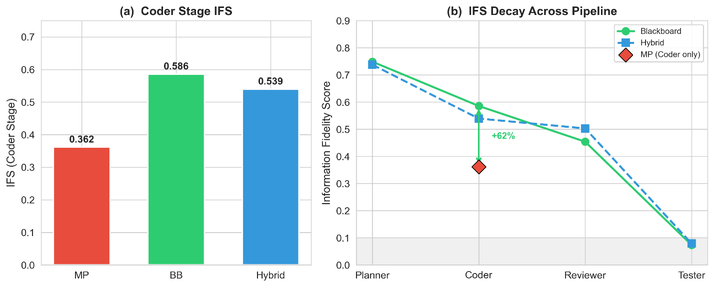
[Figure 3: IFS Analysis]

Failure Analysis
Patch formatting—rather than information quality—constitutes the dominant bottleneck across all configurations (Table 5).

Category | MP | BB | Hybrid
Resolved | 6 | 8 | 6
Empty Patch | 1 | 4 | 18
Patch Apply Error | 43 | 38 | 26
Total | 50 | 50 | 50
Table 5: Failure mode distribution.

Patch Apply Error is the dominant failure mode (MP: 43/50, BB: 38/50, Hybrid: 26/50), occurring when generated diffs contain context lines that do not match repository content. Empty Patch failures are notably prevalent in Hybrid mode (18/50, 36%) compared to MP (1/50, 2%) and BB (4/50, 8%), suggesting that the combined dual-channel context overwhelms the Coder. The gap between BB's IFS advantage (50%) and its resolve rate advantage (4pp) is explained by this patch formatting bottleneck; Section 5.4 provides a fine-grained decomposition.

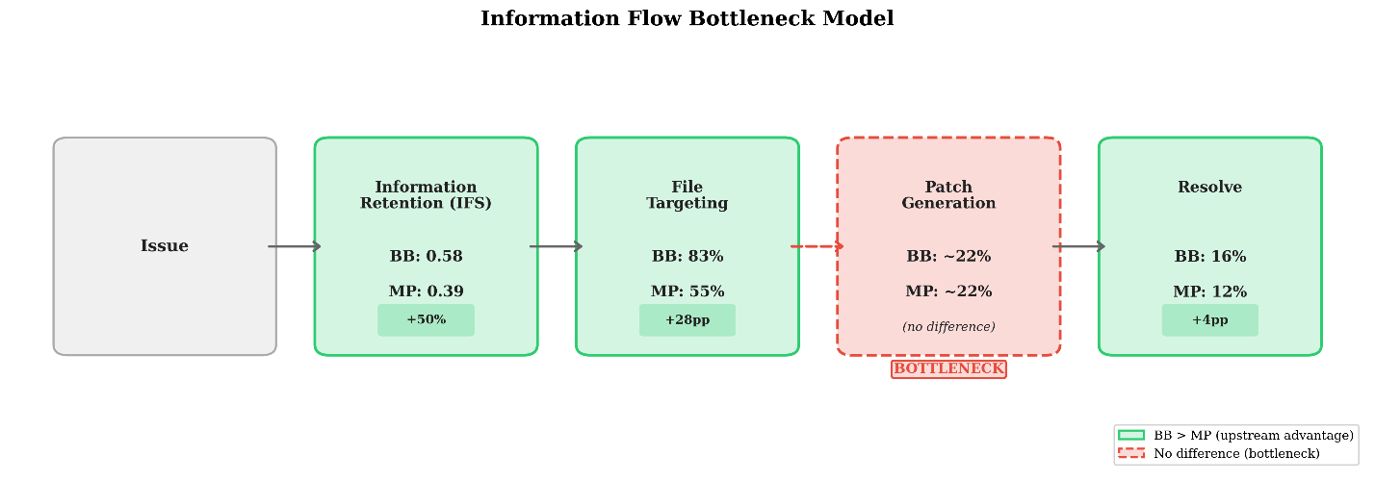
[Figure 4: Bottleneck Model]

Patch Quality Analysis
We decompose the path from issue to resolution into intermediate stages (Table 6, Figure 4).

Metric | MP | BB | Hybrid
Non-empty patch rate | 98.0% | 92.0% | 64.0%
Correct file targeting | 55.1% | 82.6% | 78.1%

Metric | MP | BB | Hybrid
Resolve rate (of correct file) | 22.2% | 21.1% | 24.0%
Table 6: Patch quality decomposition by communication mode (N=50).

File Targeting.
Among non-empty patches, the BB Coder correctly identifies the file(s) requiring modification in 82.6% of cases versus 55.1% for MP—a 27.5 percentage-point improvement (Figure 2c). Hybrid achieves 78.1%, close to BB. This directly mirrors the IFS advantage: shared-state access enables more accurate code localization.

Conditional Resolve Rate.
Once the correct file is targeted, all three modes achieve similar resolve rates: MP 22.2%, BB 21.1%, Hybrid 24.0%. The near-identical conditional rates confirm that patch generation precision—not information quality—is the binding constraint.

Information Flow Bottleneck Model.
These findings support a stage-by-stage model of how information quality translates into task outcomes (Figure 4):
Issue → [IFS] → File Targeting → [Patch Gen.] → Patch Apply → [Test] → Resolve
BB outperforms MP at IFS (+50%) and file targeting (+27.5pp), but all modes converge to ~22% conditional resolve rate at the patch generation stage. This bottleneck attenuates BB's upstream advantages, explaining why a 50% IFS improvement yields only a 4pp resolve rate gain.

Tool Use Ablation Study
To test whether tool access can address the patch generation bottleneck, we equipped the Coder with five tools (read_file, search_code, read_lines, validate_patch, submit_patch) and evaluated 10 issues under both MP and BB (Table 7).

Config | No Tool Use | Tool Use | Delta
MP | 3/10 | 3/10 | 0
BB | 4/10 | 4/10 | 0
Table 7: Resolve rate with and without tool use (10-issue ablation).

Tool use does not improve resolve rates for either configuration. The validate_patch tool detects format errors, but the LLM cannot correct them even with multiple retries. Token consumption increases 2—4x without additional resolutions. This confirms that the bottleneck resides in the LLM's intrinsic diff generation ability, not in information insufficiency or lack of tool access.

Cost-Efficiency
BB incurs significantly higher token costs: 54,849 tokens per issue versus MP's 25,316 (2.17x, Wilcoxon p<0.001). Latency shows a similar pattern (171s vs. 106s, 1.61x, p<0.001). The overhead stems from blackboard state serialization. In terms of tokens per resolved issue, MP uses ~211,000 while BB uses ~343,000. The marginal cost of BB's additional resolutions is high at current resolve rates, but the fixed serialization overhead would be amortized as resolve rates improve.

Case Study: django-13028
We examine django-13028, resolved exclusively by BB (Figure 5).
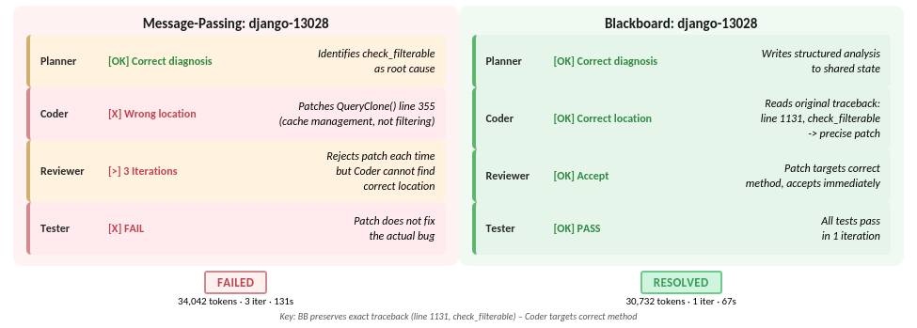
[Figure 5: Case Study]

MP Failure: The Planner correctly identifies the root cause—a naming collision between a user-defined filterable field and Django's internal check_filterable method. However, its summary compresses the diagnosis into ~679 tokens without exact traceback line numbers or method location (Query.check_filterable at line 1131 of django/db/models/sql/query.py). The Coder instead patches Query.clone() at line 355—a different method dealing with query cache management. Despite three iterations, the Coder never locates the actual check_filterable method.
BB Success: The Coder reads the Planner's analysis alongside the verbatim issue description, which includes the full traceback: File "django/db/models/sql/query.py", line 1131, in check_filterable. With direct access, the Coder generates a precisely targeted one-iteration patch adding a hasattr(expression, '_meta') guard, correctly resolving the issue.
Concrete Impact: MP consumed 34,042 tokens across 3 iterations (131s) and failed; BB consumed 30,732 tokens in 1 iteration (67s) and succeeded. The failure illustrates how message-passing creates a lossy summarization bottleneck: even when the Planner's diagnosis is correct, compression strips the precise location information needed for targeted patching.

5.8 Statistical Summary
Test | Comparison | Statistic | p-value
McNemar (exact) | MP vs BB | b=1, c=3 | p=0.625
McNemar (exact) | MP vs Hybrid | b=1, c=1 | p=1.000
McNemar (exact) | BB vs Hybrid | b=2, c=0 | p=0.500
Cohen's h | BB vs MP | h=0.116 | negligible
Odds Ratio | BB vs MP | OR=1.40 | CI [0.45, 4.37]
Wilcoxon | MP vs BB tokens | W=34 | p<0.001*
Wilcoxon | MP vs Hybrid tokens | W=183 | p<0.001*
Wilcoxon | MP vs BB latency | W=63 | p<0.001*
Wilcoxon (IFS) | MP vs BB Coder | W=36.5 | p=0.058
Table 8: Statistical test results. * indicates significance at α=0.05.

Discussion

The Information Preservation Advantage
Our results provide clear evidence that the Blackboard architecture improves information preservation in multi-agent SE pipelines. The 50% improvement in Coder-stage IFS (0.584 vs. 0.390) demonstrates that shared-state access meaningfully increases retention of key technical entities. This aligns with prior work on Blackboard architectures for reasoning [Han and Zhang, 2025] and data science [Salemi et al., 2025], extending the evidence to software engineering.
The mechanism is straightforward: in MP mode, the Coder's only information source is the Planner's natural language summary, which inevitably compresses the original content. In BB mode, the Coder has simultaneous access to both the Planner's analysis and the original issue text, enabling cross-referencing. The marginal significance (p=0.058) with 28 non-zero paired differences suggests that a modestly larger experiment (~35–40 pairs) would likely yield p<0.05.
Importantly, we argue that IFS and file targeting—not resolve rate—constitute the primary empirical contributions of this study. Resolve rate is a coarse binary outcome subject to downstream bottlenecks beyond

the communication layer's control. IFS and file targeting isolate the specific pipeline stages that communication architecture directly affects, providing a more precise and actionable signal. The 27.5 percentage-point file targeting advantage (82.6% vs. 55.1%) is a large, practically meaningful effect that would benefit any downstream patch generation method.

Why Is the Resolve Rate Difference Limited?
The central puzzle is the gap between the large IFS improvement (50%) and the modest resolve rate gain (4pp). The patch quality analysis (Section 5.4) and tool use ablation (Section 5.5) together reveal a clear causal chain, formalized as our information flow bottleneck model (Figure 4):
    - Upstream: BB significantly outperforms MP. BB achieves 50% higher IFS, translating to a 27.5pp advantage in correct file targeting (82.6% vs. 55.1%). These are large, practically meaningful differences.
    - Downstream: A systematic bottleneck limits all modes. Once the correct file is identified, all modes achieve ~22% conditional resolve rate. The LLM's inability to reliably generate context-correct unified diffs is a rate-limiting step independent of communication architecture.
    - Tool use does not resolve the bottleneck. Despite file access and validate_patch capability, the LLM cannot generate corrected patches (Section 5.5). Token consumption increases 2—4x without improving resolve rates.
    - The bottleneck attenuates upstream advantages. BB's 27.5pp file-targeting advantage translates to approximately 27.5 × 0.22 ≈ 6 additional resolve-rate percentage points in expectation—close to the observed 4pp gain.
This reframes the discussion: BB's advantage is exactly the size predicted by the downstream bottleneck. As LLM diff generation improves—or as alternative patch representations bypass the bottleneck—BB's upstream advantage should translate more fully into resolve rate gains.
The predictive accuracy of this model deserves emphasis. From BB's 27.5pp file-targeting advantage and the
~22% conditional resolve rate, the model predicts an expected resolve rate gain of 27.5 × 0.22 ≈ 6pp. The observed gain is 4pp (16% vs. 12%), falling within the expected range given sampling variance on 50 issues. This close correspondence between predicted and observed effects provides strong internal validity for the bottleneck model, independent of whether the resolve rate difference itself achieves statistical significance.
A note on statistical power. A post-hoc power analysis indicates that detecting a 4pp difference (12% vs. 16%) with McNemar's test at α=0.05 and 80% power requires approximately N=300 paired observations—six times our sample. This study was not designed to achieve significance on resolve rate; rather, we use resolve rate as one element in a multi-metric evaluation strategy where IFS (p=0.058), file targeting (+27.5pp), the bottleneck model, the tool use ablation, and the case study converge on a consistent narrative. We consider this triangulation of evidence more informative than any single p-value.

Why Does Hybrid Not Outperform?
The Hybrid configuration (12.0%) matches MP rather than exceeding BB. Its most striking failure is a 36% empty-patch rate (18/50), compared to 2% for MP and 8% for BB—the dual-channel input overwhelms the Coder. However, among non-empty patches, Hybrid's file targeting rate (78.1%) approaches BB's 82.6%, and its conditional resolve rate (24.0%) is the highest. The failure is one of input format compatibility, not information quality. Future hybrid designs should focus on reducing context overload through selective sharing or progressive disclosure.

Implications for Practice and System Design
Adopt shared state for long pipelines. BB's information preservation benefit likely increases with pipeline length, as each MP handoff introduces another compression step. For pipelines with 2+ stages, shared state should

be a default architectural choice.
Communication and code generation are orthogonal concerns. Communication architecture optimization (upstream: information preservation, file targeting) and code generation optimization (downstream: patch correctness) address fundamentally different pipeline stages. Systems should adopt Blackboard for upstream quality while investing separately in downstream improvements—alternative patch representations, retrieval-augmented generation for context lines, or model fine-tuning for diff generation. The combination is expected to be multiplicative.
IFS as a diagnostic metric. IFS provides stage-by-stage diagnostics independent of task success. Even when resolve rates appear similar, IFS differences reveal information quality gaps that may become significant as other bottlenecks are resolved.
Avoid naive hybrid designs. Combining communication channels without careful integration can degrade performance, as evidenced by Hybrid's 36% empty-patch rate.

Beyond Resolve Rate: A Case for Multi-Metric Evaluation
A reviewer might reasonably ask: if resolve rate is not statistically significant, what has this study demonstrated? We argue that multi-agent SE research requires evaluation strategies that go beyond end-to-end binary outcomes. Resolve rate conflates every pipeline stage into a single bit, making it insensitive to improvements in any single stage when other stages dominate failure. In our experiments, 86–88% of all runs fail at patch application regardless of communication mode—a noise floor that masks upstream signal.
Our multi-metric approach decomposes the pipeline into measurable stages: IFS quantifies information preservation, file targeting quantifies code localization accuracy, and conditional resolve rate quantifies patch generation precision. This decomposition reveals that BB substantially outperforms MP on the stages it is designed to affect (IFS: +50%, file targeting: +27.5pp) while confirming that the stages it cannot affect (patch generation: ~22% for all modes) limit end-to-end outcomes equally. Without this decomposition, one might incorrectly conclude that communication architecture does not matter—when in fact it matters precisely where expected, and a downstream bottleneck independently limits all architectures.
We propose that future multi-agent SE evaluations adopt similar decomposition strategies, reporting intermediate metrics alongside end-to-end outcomes. This enables meaningful comparison even when sample sizes are insufficient for end-to-end significance, and provides actionable guidance about which pipeline stages most need improvement.

Threats to Validity
Internal Validity. We use a single LLM (Claude Sonnet 4.5) with temperature 0. This is a deliberate design choice: using a single deterministic model eliminates model-specific variance as a confound, ensuring that observed differences between configurations are attributable to communication architecture rather than model behavior. The tradeoff is limited generalizability—the specific magnitudes of IFS improvement or resolve rate difference may vary with other models. However, the direction of BB's advantage (better information preservation through shared state access) is an architectural property independent of the underlying LLM. The sequential pipeline introduces an ordering effect: a poor Planner analysis affects all downstream agents regardless of communication architecture; we mitigate this by using identical Planner prompts across all configurations.
External Validity. Our 50-issue sample from SWE-bench Lite covers only well-maintained Python repositories. Django issues are overrepresented (22/50), and since BB's resolve rate advantage concentrates in easy-difficulty Django issues, the effect may be partially confounded with repository-specific factors such as Django's detailed issue descriptions and well-structured codebase. Results may not generalize to other languages, less-documented repositories, or SE task types beyond bug fixing. We note, however, that the IFS advantage is observed across all repositories, not only Django, suggesting that the information preservation mechanism is

general.
Construct Validity. IFS uses rule-based entity extraction, which may miss semantically equivalent references and count incidental mentions as preservation. As discussed in Section 6.2, resolve rate alone understates architectural impact; our intermediate metrics provide a more complete picture.
Statistical Validity. With 50 issues and only 4 discordant pairs, McNemar's test is underpowered for detecting the observed 4pp resolve rate difference (estimated N≈300 required for 80% power). The IFS result (p=0.058) approaches but does not meet conventional significance at α=0.05. We address this limitation through triangulation: the consistency across IFS, file targeting, the bottleneck model's predictive accuracy, the tool use ablation, and the case study provides converging evidence that is robust to any single metric's statistical limitations. We present our findings as suggestive evidence warranting larger-scale validation, and explicitly provide effect sizes and confidence intervals to facilitate meta-analytic integration with future work.

Conclusion and Future Work

Conclusion
This paper introduced SE-Blackboard, the first application of the Blackboard shared-state architecture to multi-agent software engineering. Through controlled experiments on 50 SWE-bench Lite issues, we demonstrated that communication architecture measurably impacts information preservation and task performance. Our key findings are:
    - Information Preservation: BB improves Coder-stage IFS by 50% over MP (0.584 vs. 0.390, p=0.058), demonstrating that shared-state access effectively mitigates knowledge drift.
    - Code Localization: BB's information advantage translates to 82.6% correct file targeting versus 55.1% for MP—the critical prerequisite for successful patching.
    - Information Flow Bottleneck Model: Once the correct file is targeted, all modes achieve ~22% conditional resolve rate, identifying LLM patch generation precision as the binding constraint. A tool use ablation confirms this bottleneck cannot be resolved through tool access alone (Figure 4).
    - Resolve Rate: BB achieves 16.0% versus MP's 12.0% (33% relative improvement), consistent with the bottleneck model's prediction of ~6pp expected gain from the 27.5pp file-targeting advantage.
    - Hybrid Caution: Naively combining communication channels degrades performance due to context overload (36% empty-patch rate), though functional Hybrid patches approach BB's file targeting rate.
These findings establish communication architecture as an important design dimension for multi-agent SE systems, and the information flow bottleneck model provides a framework for predicting when upstream advantages will translate into task-level improvements.

Future Work
Alternative Patch Representations. The unified diff bottleneck is not resolved by tool augmentation. Future work should explore representations that bypass context-line matching: search-and-replace specifications, AST-level edits, or whole-file rewriting.
Improved Diff Generation. Fine-tuning on patch corpora, constrained decoding for diff syntax, or retrieval-augmented generation for context lines could address the bottleneck while retaining the unified diff format.
Larger-Scale Evaluation. Extending to the full SWE-bench Lite (300 issues) with multiple LLMs would provide statistical power for resolve rate comparisons and test generalizability.

Broader Applications. The Blackboard architecture may benefit other SE tasks (feature development, code review, test generation) and other domains requiring precision in multi-agent information transfer.

. References
[Cemri et al., 2025] Cemri, M., Pan, M. Z., Yang, S., et al. "Why Do Multi-Agent LLM Systems Fail?" Proc. NeurIPS Datasets and Benchmarks Track, 2025.
[Chen et al., 2024] Chen, Y., et al. "CodeR: Issue Resolving with Multi-Agent and Task Graphs." arXiv preprint arXiv:2406.01304, 2024.
[Fang et al., 2025] Fang, X., et al. "RTADev: Intention Aligned Multi-Agent Framework for Software Development." Findings of ACL, 2025.
[Han and Zhang, 2025] Han, B. and Zhang, S. "Exploring Advanced LLM Multi-Agent Systems Based on Blackboard Architecture." arXiv preprint arXiv:2507.01701, 2025.
[He et al., 2025] He, J., Treude, C., and Lo, D. "LLM-Based Multi-Agent Systems for Software Engineering: Literature Review, Vision and the Road Ahead." ACM Trans. Softw. Eng. Methodol. 34(5), 2025.
[Hong et al., 2024] Hong, S., et al. "MetaGPT: Meta Programming for A Multi-Agent Collaborative Framework." Proc. ICLR, 2024.
[Huang et al., 2024] Huang, D., et al. "AgentCoder: Multi-Agent-based Code Generation with Iterative Testing and Optimisation." arXiv:2312.13010, 2024.
[Jimenez et al., 2024] Jimenez, C. E., et al. "SWE-bench: Can Language Models Resolve Real-World GitHub Issues?" Proc.
ICLR, 2024.
[Liu et al., 2024] Liu, N. F., et al. "Lost in the Middle: How Language Models Use Long Contexts." TACL, 12, 157-173, 2024. [Nii, 1986] Nii, H. P. "Blackboard Systems: The Blackboard Model of Problem Solving and the Evolution of Blackboard
Architectures." AI Magazine, 7(2), 38-53, 1986.
[Qian et al., 2024] Qian, C., et al. "ChatDev: Communicative Agents for Software Development." Proc. ACL, 2024.
[Salemi et al., 2025] Salemi, A., Parmar, M., Goyal, P., Song, Y., Yoon, J., Zamani, H., Palangi, H., and Pfister, T. "LLM-based Multi-Agent Blackboard System for Information Discovery in Data Science." arXiv preprint arXiv:2510.01285, 2025.
[Xia et al., 2024] Xia, C. S., et al. "Agentless: Demystifying LLM-based Software Engineering Agents." arXiv:2407.01489, 2024.
[Yang et al., 2024] Yang, J., et al. "SWE-agent: Agent-Computer Interfaces Enable Automated Software Engineering." arXiv:2405.15793, 2024.

