EmbedSkill (Elearning Platform)
• Built on ASP.NET MVC
• Uses ASP.NET MVC, Razor Engine, Tailwind CSS, and Microsoft SQL Server
• Features user authentication, role management, admin dashboard, video uploading, and more
Introduction:
EmbedSkill is an eLearning platform designed to host specialized courses, with a focus on (FOTA) courses. It allows users to create, manage, and enroll in courses, upload video content, and manage their learning experience. Admins can oversee course approvals, user roles, and platform management through a dedicated dashboard. The platform aims to provide an intuitive and engaging learning environment for photography enthusiasts and learners.
System Design:
Technology Stack
- ASP.NET MVC: A robust framework for building scalable web applications with a clear separation of concerns.
- Razor Engine: Enables dynamic and efficient rendering of views for the front-end.
- Tailwind CSS: A utility-first CSS framework for creating modern, responsive user interfaces.
- Microsoft SQL Server: A relational database for structured storage of course, user, and content data.
- Paymob: A payment processing service for secure and seamless course enrollment transactions.
- HtmlSanitizer: A library to sanitize HTML input, protecting against cross-site scripting (XSS) attacks.
- Trumbowyg: A lightweight WYSIWYG editor for rich text editing in course creation and management.
- Cloudinary: A cloud-based service for managing and serving video and image content.
- Postman: A tool for testing and interacting with API endpoints.

Used Design Patterns:
• MVC Pattern: Ensures a clear separation of concerns for maintainable and scalable code.
• Repository Pattern & Unit of Work: Facilitates data access and transaction management for efficient database operations.
• Clean Architecture: Promotes modular, testable, and maintainable code by separating business logic from infrastructure.

Database Design and ERD:

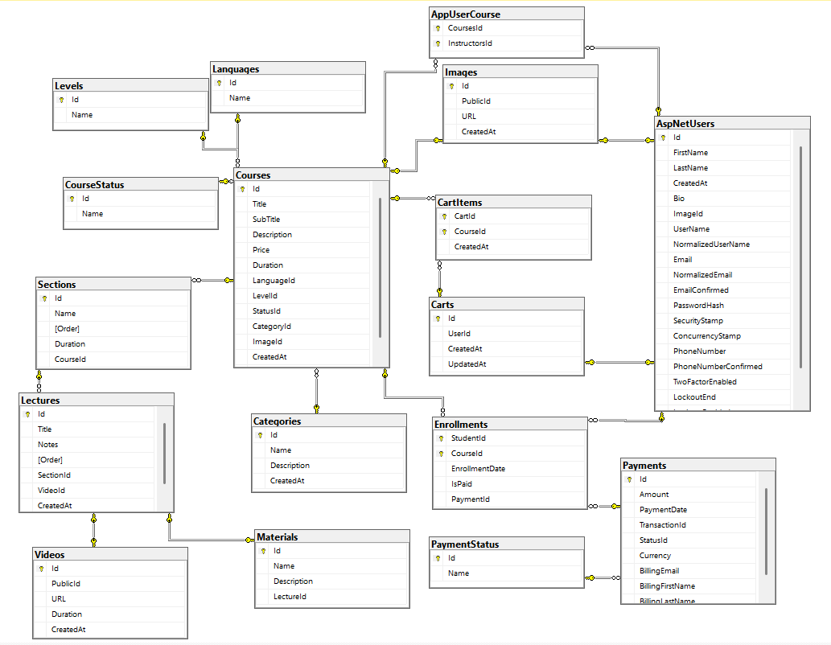

================================================================================

Postman:
Link: https://www.postman.com/aly-4956456/embedskill/
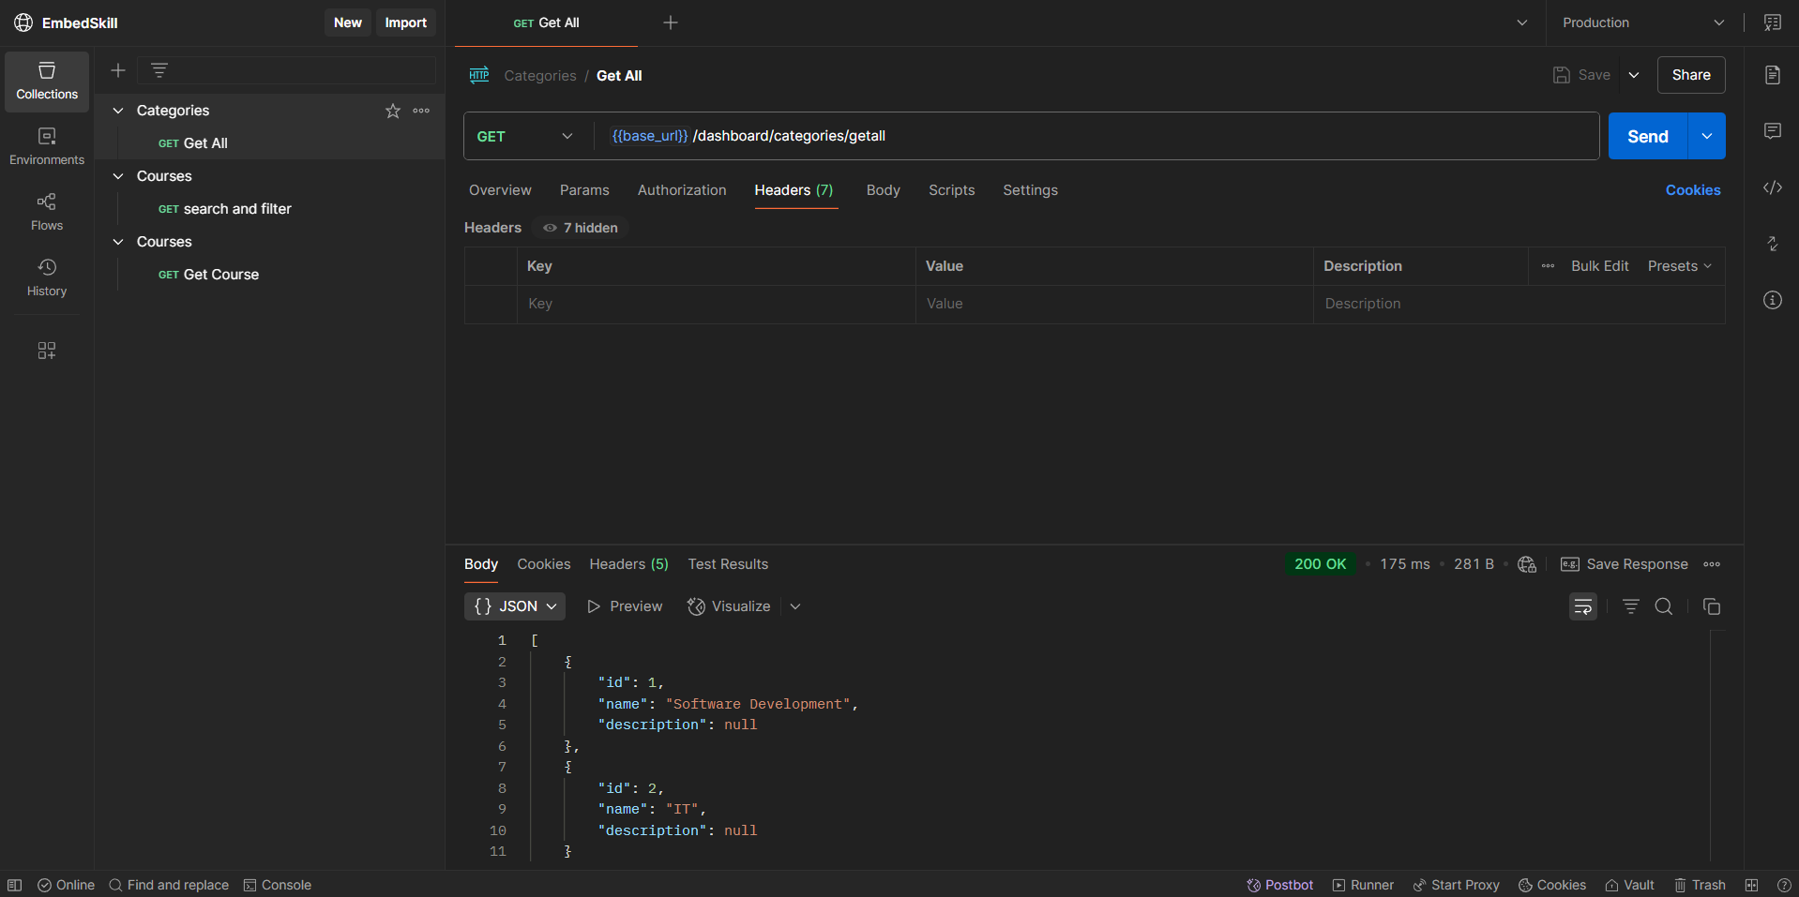

====================================================================================

User Authentication and Authorization:
ASP.NET Core Identity: Manages user authentication and role-based access with three roles: Admin (manages platform), Instructor (creates courses), and Student (enrolls in courses). Supports secure login, password hashing, and a forgot password feature for user account recovery, integrated with Microsoft SQL Server.
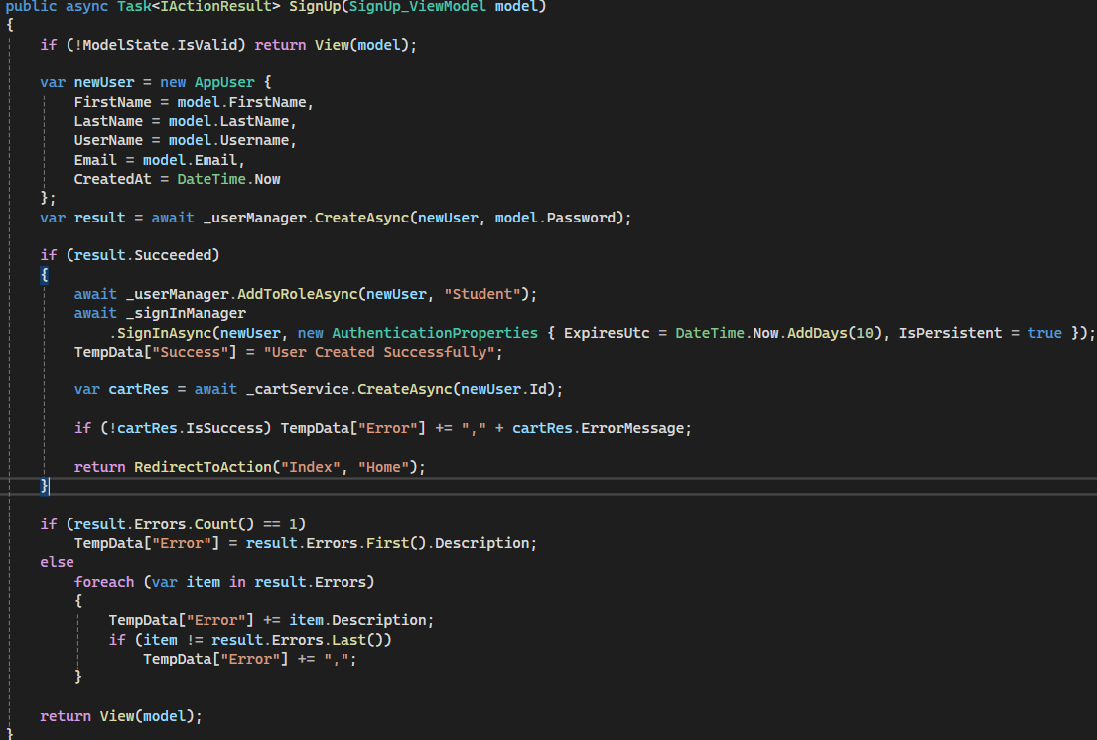
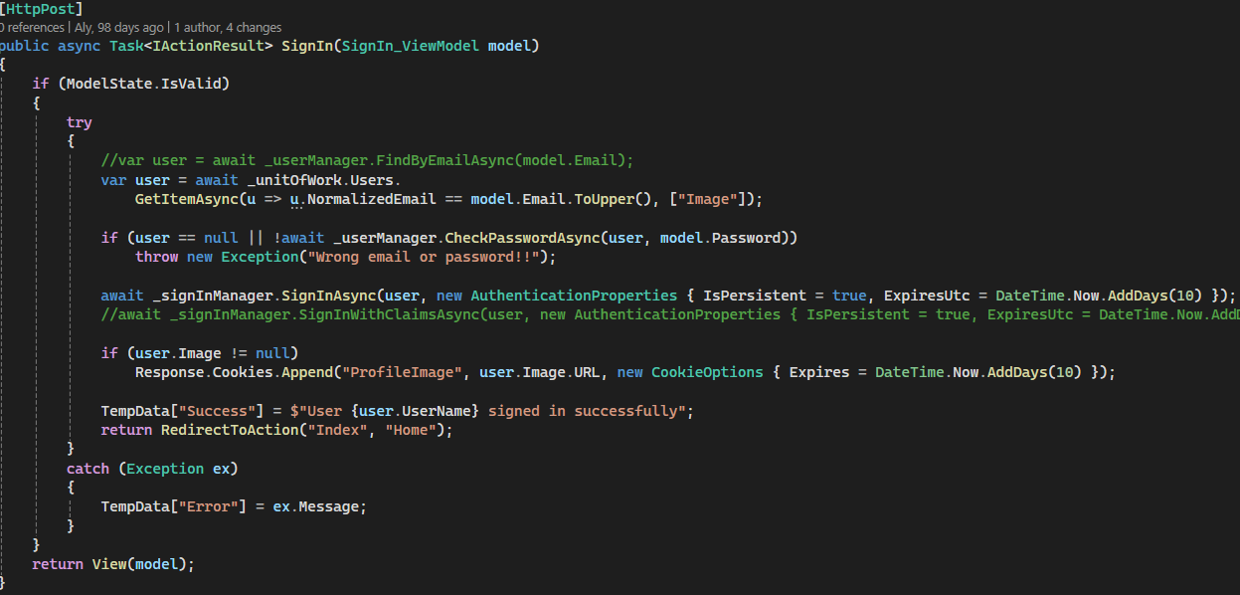
=========================================================================

Reset Password
- App sends an OTP which is valid for 10 minutes to the user’s email.
- App verifies the OTP then redirects to the reset password page
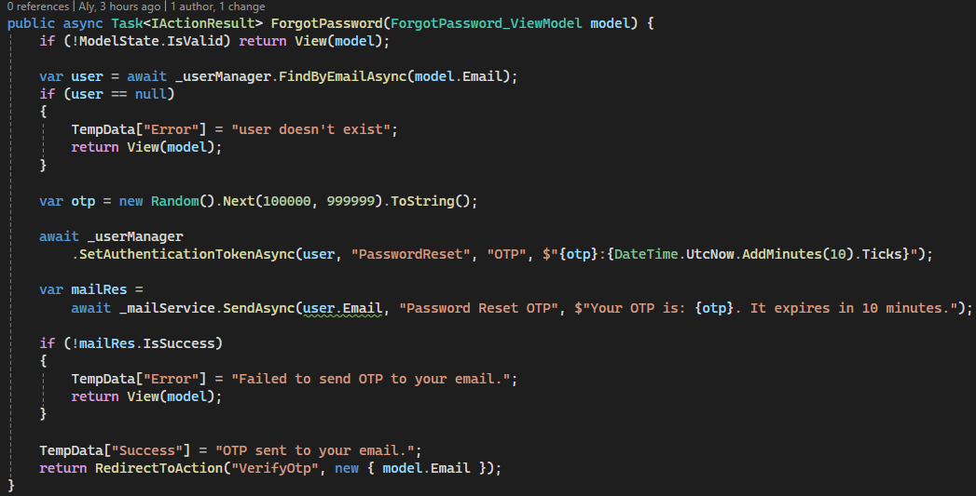
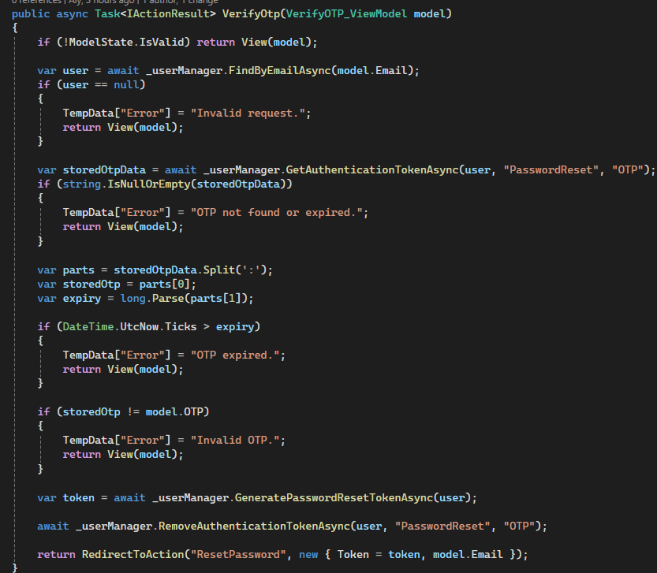
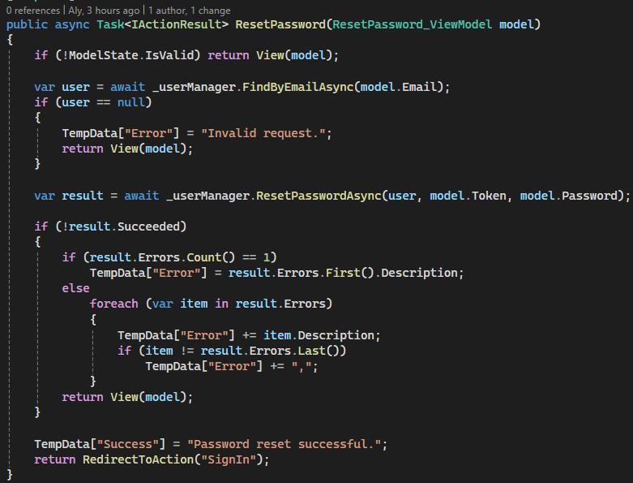

User Profile Management
- User can update his info and change his photo
- User can become an instructor
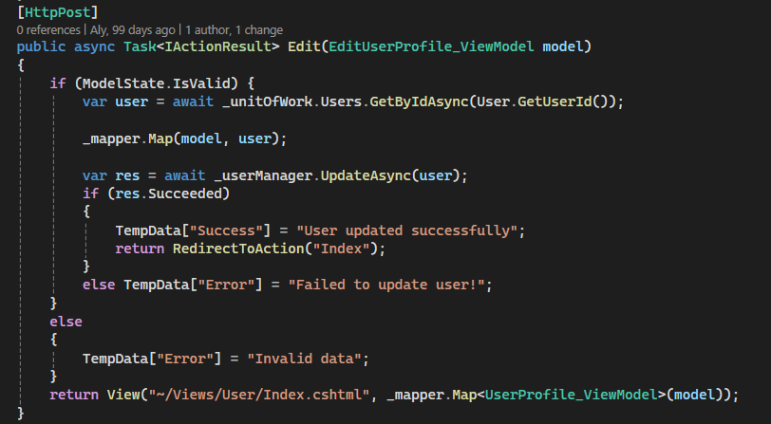
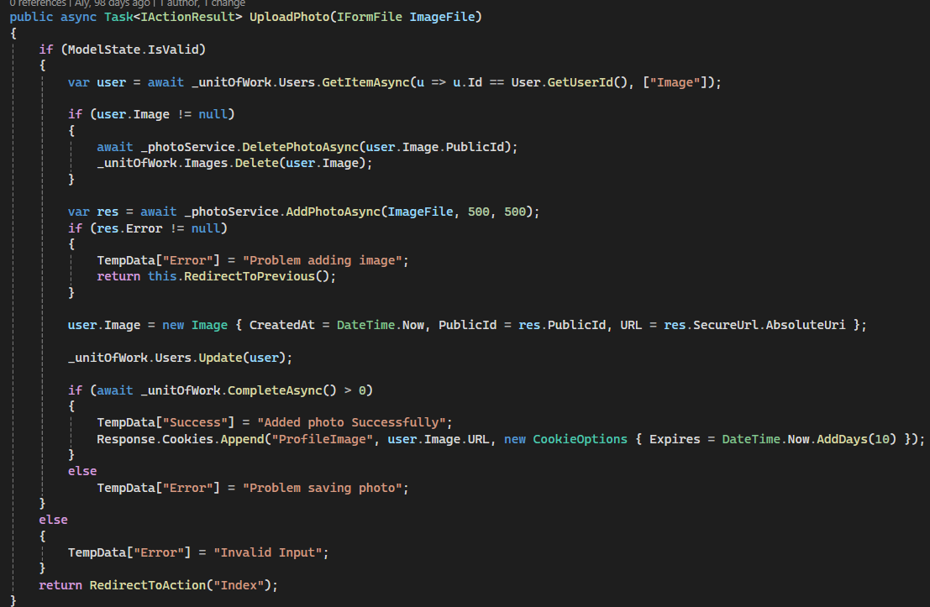
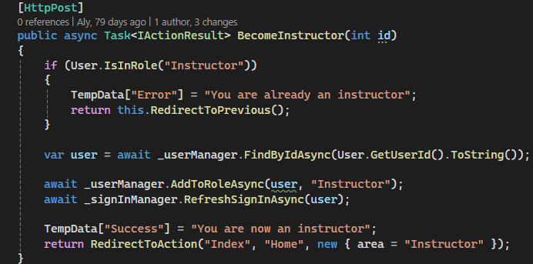

Categories management:

Admin can add, remove, edit categories
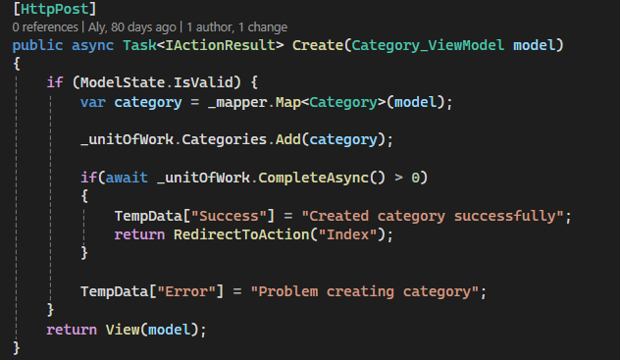
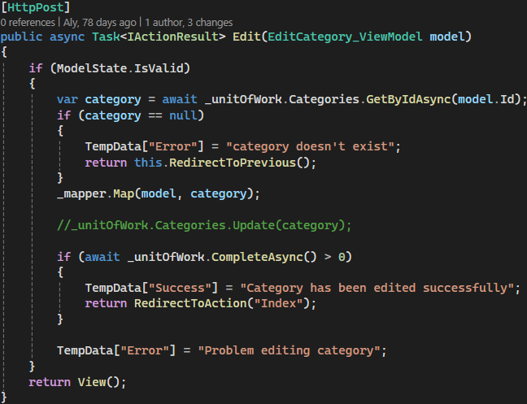
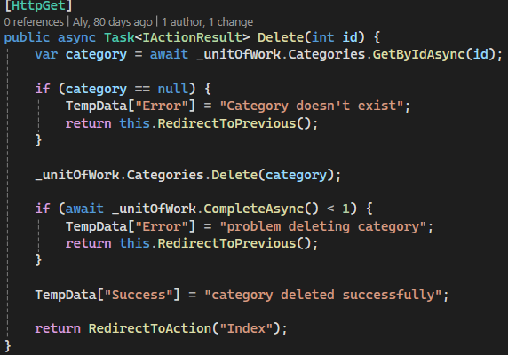

Languages management:

Admin can add, remove, edit Languages

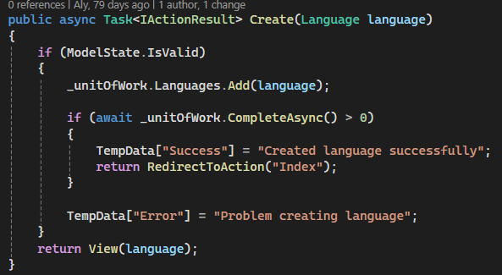

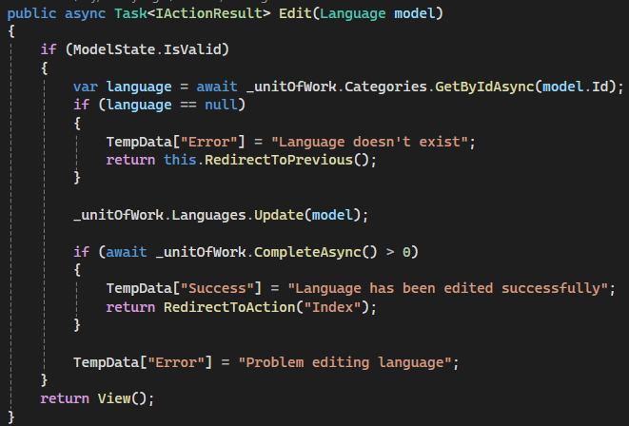

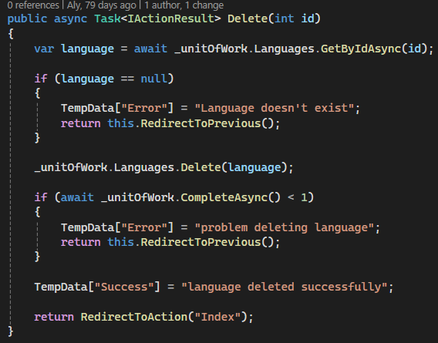

Courses:
- Instructor can add, remove, edit courses
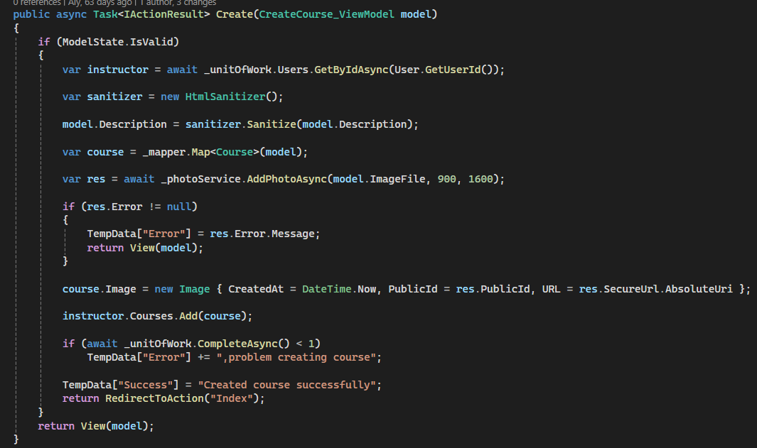
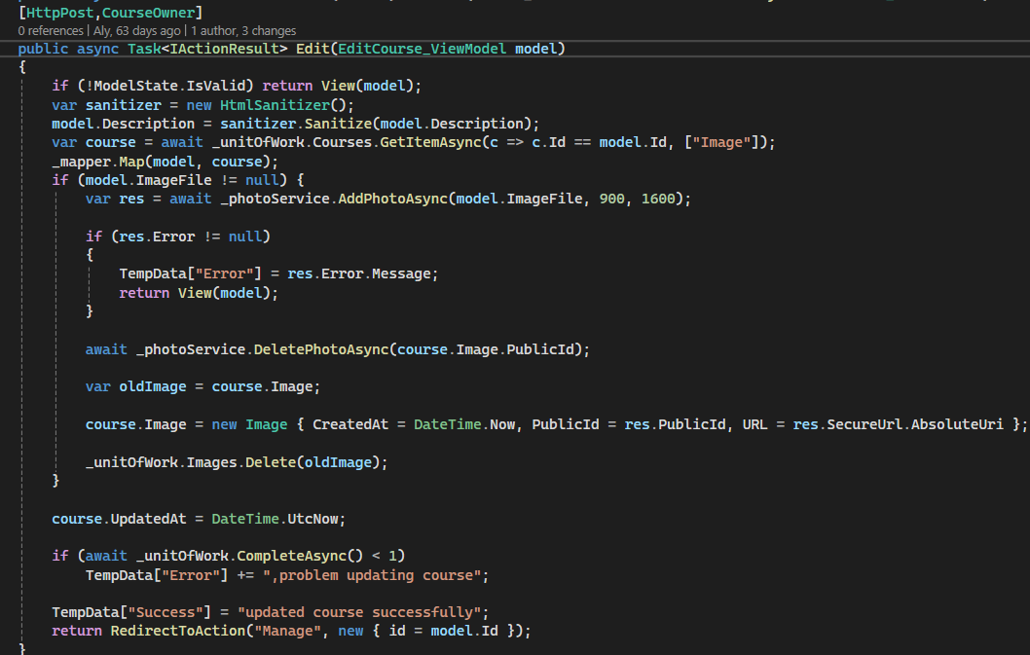
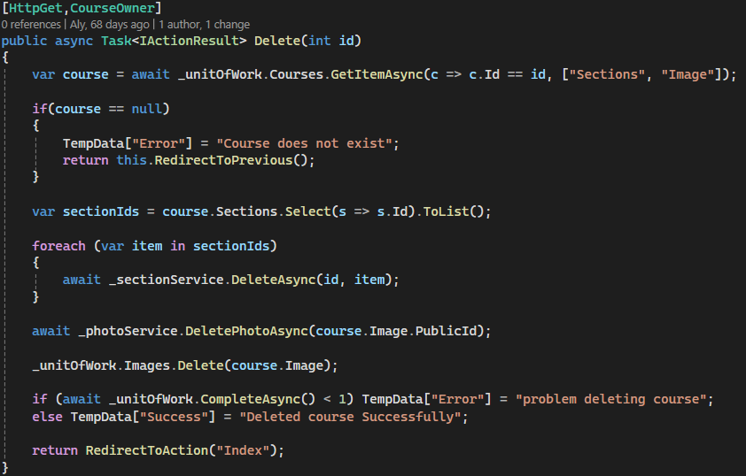

- Instructor can publish, unpublish courses
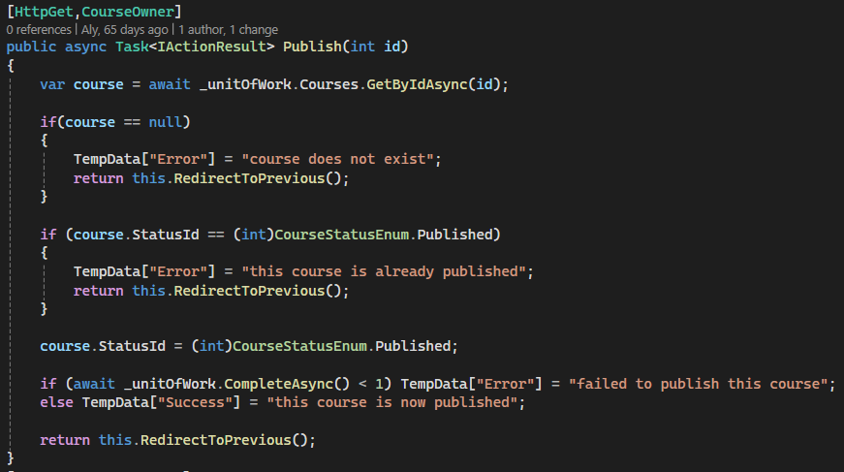
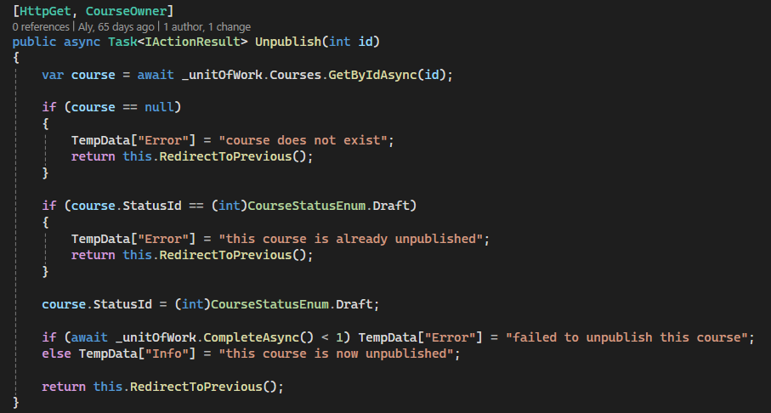

- student search and filter courses
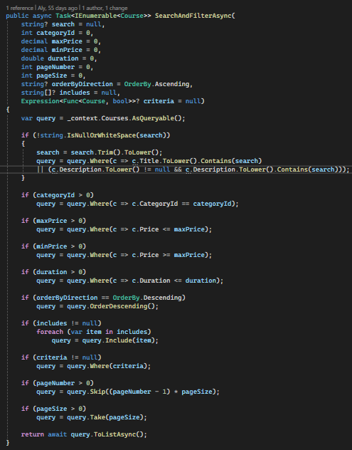

Sections management:
Instructor can add, delete, rearrange course sections
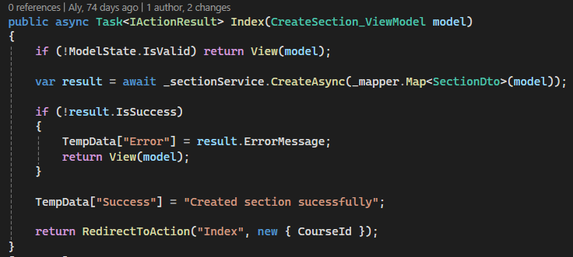
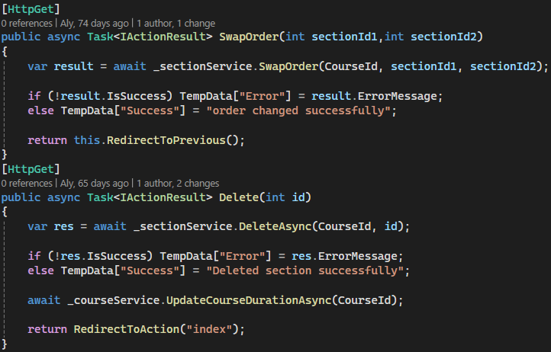

Lectures management:
Instructor can add, delete, edit, rearrange section lectures
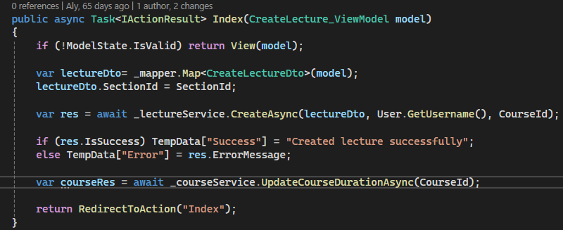
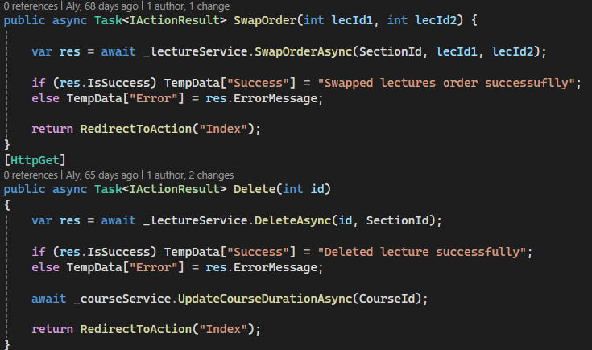
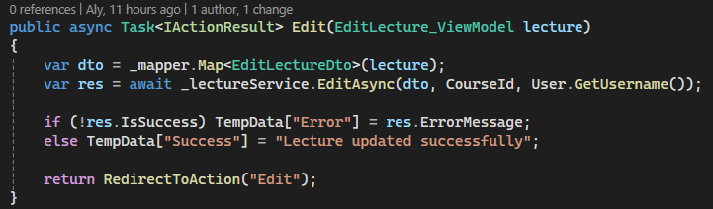

Videos
- Instructor can upload video to each lecture
- Videos are hosted on cloudinary
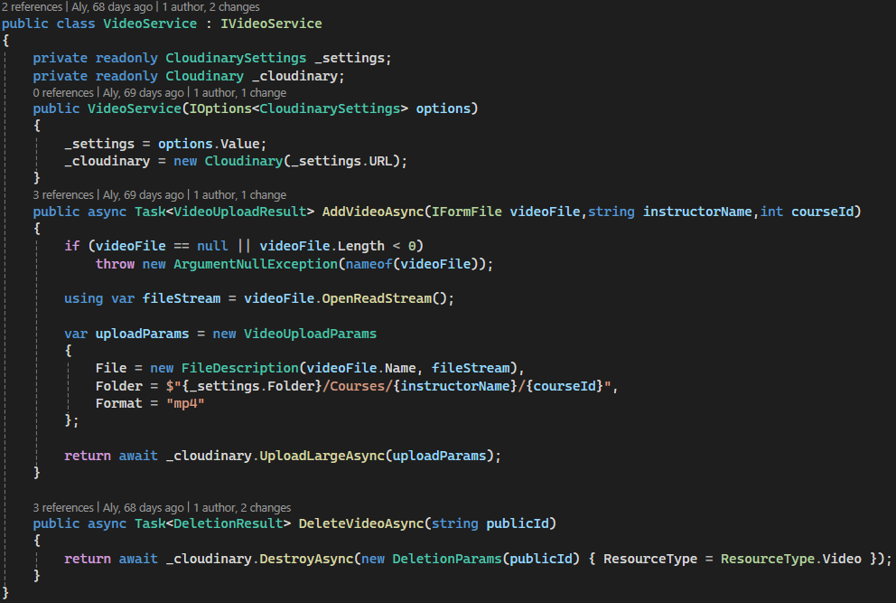

Services:
Mail Service
- Sending emails
- Reset password
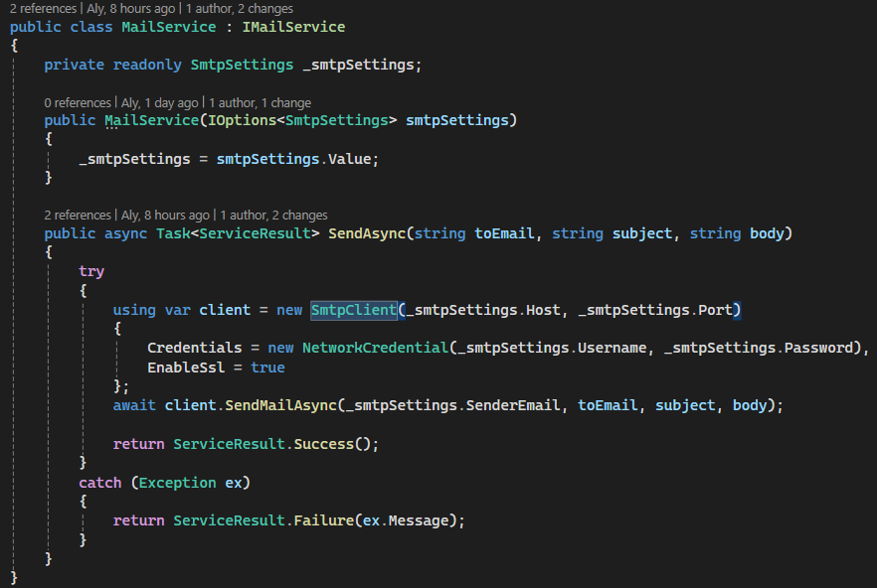

Payment Service
- PayMob is integrated to handle payment transactions.
- Users can make payments securely, and the system updates the booking status upon successful payment.
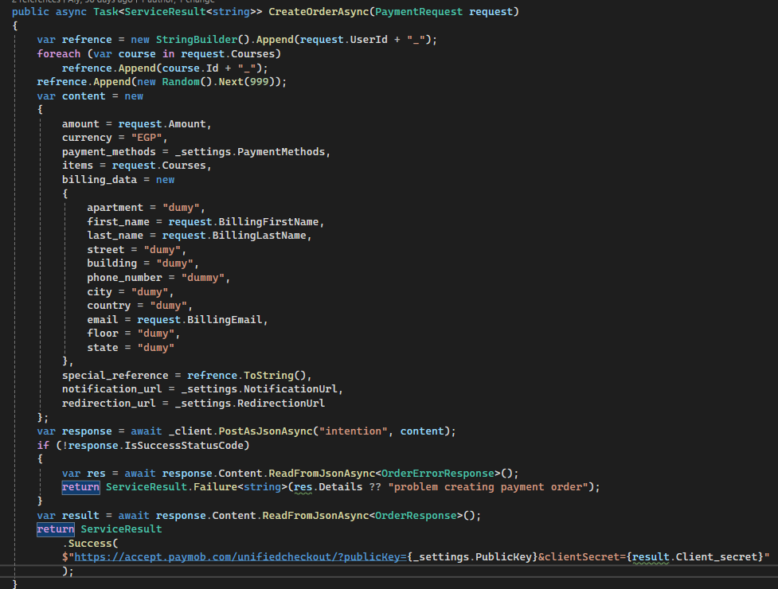

Photo Service:

Using cloudinary to upload images
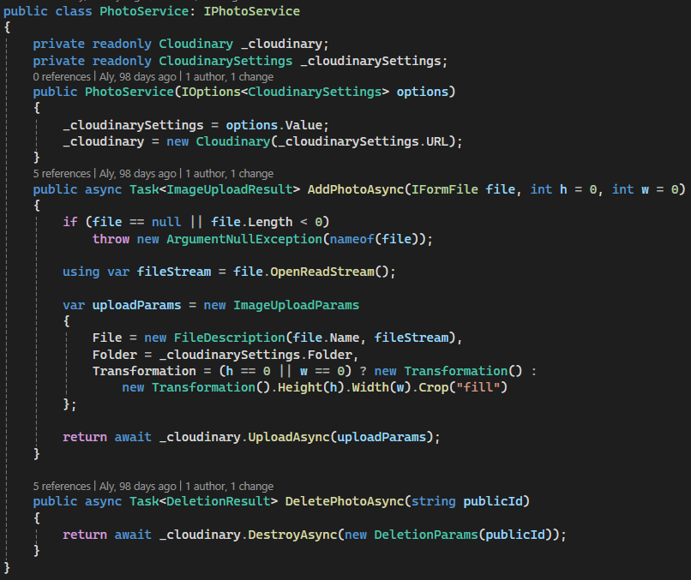

Data seeding:

App seeds roles, languages, levels, course statuses, payment statuses and admin account on first run

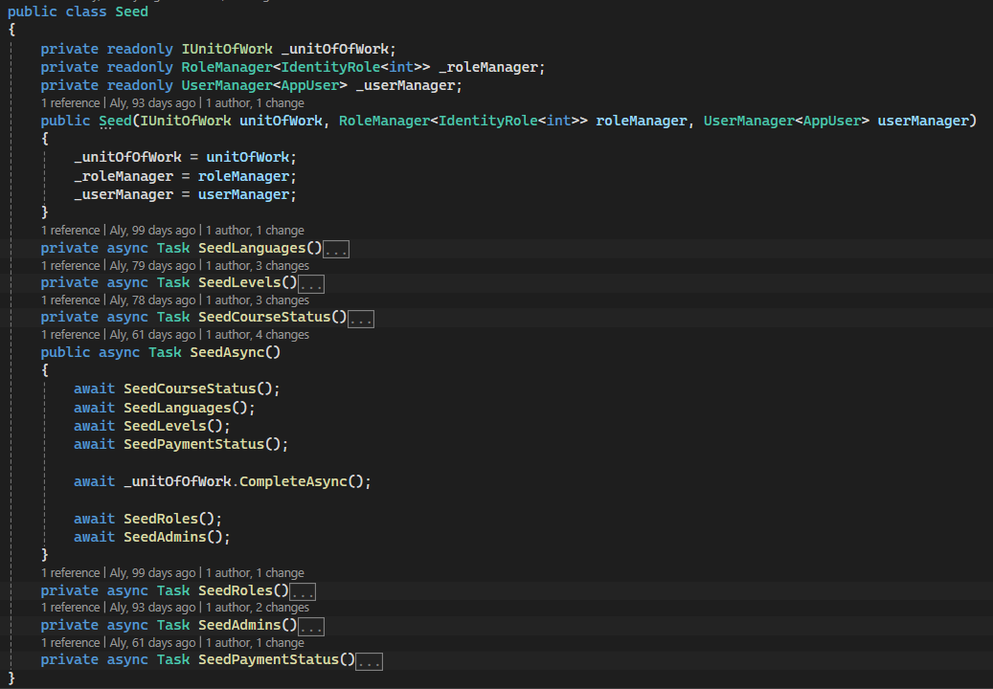

Initiate app
