Задание 1

Форма Авторизации - https://calm-river-86040.herokuapp.com/

1. Расписать тест-кейсы(не более 5)
2. Протестировать
3. Составить 2-3 баг-репорта
4. Сделать скрин успешно отправленных данных из Dev-Tools

**Требования:**

1. Поле Name принимает только значения Кириллицой
2. Поле Phone принимает значения только украинских операторов мобильной сети
3. После нажатия на кнопку Submit выводиться сообщение об успешной отправки данных

|  |  |  |  |  |  |
| --- | --- | --- | --- | --- | --- |
| Name | Test Step # | Step Description | Values | Expected Result | Status |
| Authorization form | 1 | Open the Authorization form  by link | <https://calm-river-86040.herokuapp.com/?phone-number=&email=&pwd=> | Authorization form is open and all fields are available | True |
| Phone field | 1 | Enter Ukrainian phone number | +380994016538 | Phone number is accepted | True |
| Email field | 1 | Enter validly Email | Skydan0304@gmail.com | Email is accepted | True |
| Password field | 1 | Enter password | 12345678 | Password is accepted | True |
| Check box | 1 | Click on Check box “Remember me” |  | Check box is filled | True |
| Submit button | 1 | Press “Submit” button |  | After actions appear popup message “ Data are successfully sent” | True |
| Popup | 1 | On popup message verify that access is successful, than press button “Ok” |  | Popup mssage is closed |  |

**Test cases**

Note: here only positive test cases.

**Bug reports**

**#1**

|  |  |
| --- | --- |
| Summary | Authorization form accept empty fields and shows successful result |
| Projects | herokuapp.com |
| URL | <https://calm-river-86040.herokuapp.com/?phone-number=&email=&pwd=> |
| Component | Authorization form |
| Version | **ex 1.2** (unknown) |
| Severity | S2 |
| Priority | P1 |
| Author | Skydan Vladyslav |
| Assigned to | Dev team “Vasya” |
| Environment | PC, Google chrome |
| Steps to reproduce | 1. Open app by link 2. Skip all fields 3. Press button ‘Submit’ |
| Actual result | After actions appear popup message “ Data are successfully sent” |
| Expected result | All fields should be required for filling. Button shouldn’t be active when fields are empty |
| Attachments  C:\Users\Влад\AppData\Local\Monosnap\Temp\Test QA - Google Chrome 2019-10-23 17.03.02.png | |

**#2**

|  |  |
| --- | --- |
| Summary | Email field accepts invalid values without @ and domen. |
| Projects | herokuapp.com |
| URL | <https://calm-river-86040.herokuapp.com/?phone-number=&email=&pwd=> |
| Component | Authorization form |
| Version | **ex 1.2** (unknown) |
| Severity | S3 |
| Priority | P1 |
| Author | Skydan Vladyslav |
| Assigned to | Dev team “Vasya” |
| Environment | PC, Google chrome |
| Steps to reproduce | 1. Open app by link 2. Enter Ukrainian operators phone number 3. Enter Email address without @ and .com 4. Enter password. 5. Press button ‘Submit’ 6. On popup message verify that access is successful, than press button “Ok” |
| Actual result | Entering successful was were |
| Expected result | Before pressing button “Submit” should be popup message “Invalid Email address” it appears after step 6. Message “Invalid Email address” appear after pressing button “Ok” in successful popup |
| Attachments  C:\Users\Влад\AppData\Local\Monosnap\Temp\Test QA - Google Chrome 2019-10-23 14.58.57.png    C:\Users\Влад\AppData\Local\Monosnap\Temp\Test QA - Google Chrome 2019-10-23 15.02.44.png | |

**1.4**

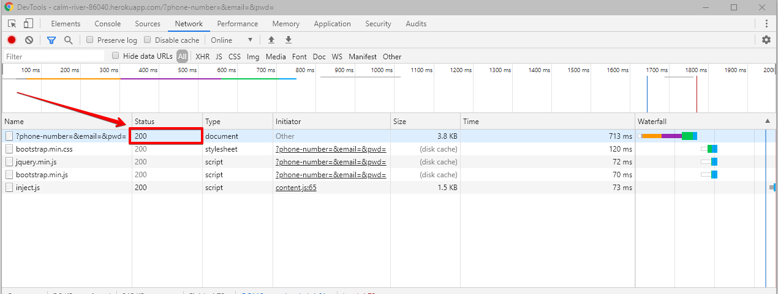

**Traceability matrix**

|  |  |  |
| --- | --- | --- |
| **1** | Поле Name принимает только значения Кириллицой | **False** |
| **2** | Поле Phone принимает значения только украинских операторов мобильной сети | **False** |
| **3** | После нажатия на кнопку Submit выводиться сообщение об успешной отправки данных | **True** |

Ps

Requirements are not enough

Задание 2

Название таблицы BOOKS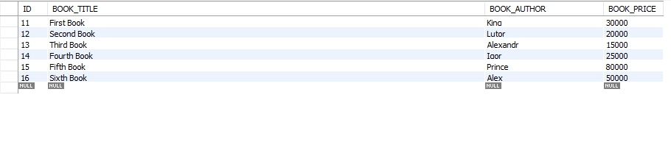

**Составить запросы:**

1. Выбрать все данные где цена книги равняется 15000
2. Выбрать все данные где цена книги не равняется 30000
3. Выбрать название книги Автора Lutor
4. Отсортировать по цене книги по убыванию
5. Отсортировать по цене книги по возрастанию

**#1**

**SELECT * FROM BOOKS**

**WHERE BOOK_PRICE = '15000';**

**#2**

**SELECT * FROM BOOKS**

**WHERE NOT BOOK_PRICE = '30000';**

**#3**

**SELECT BOOK_TITLE * FROM BOOKS**

**WHERE BOOK_AUTHOR = 'Lutor';**

**#4**

**SELECT * FROM BOOKS**

**ORDER BY BOOK_PRICE DESC;**

**#5**

**SELECT * FROM BOOKS**

**ORDER BY BOOK_PRICE ASC;**

Задание 3

**Таблицу берем из задания 2**

1. Необходимо выбрать все результаты автора Alex, разработчик составил запрос-

select * from BOOKS where BOOK_AUTHOR like “Alex%”’

Найти ошибку и составить баг репорт

|  |  |
| --- | --- |
| Summary | Query shows more results than it needed |
| Projects | herokuapp.com |
| URL | <https://calm-river-86040.herokuapp.com/?phone-number=&email=&pwd=> |
| Component | Authorization form |
| Version | **ex 1.2** (unknown) |
| Severity | S5 |
| Priority | P3 (EstablishesPM) |
| Author | Skydan Vladyslav |
| Assigned to | Dev team “Vasya” |
| Environment | PC, Google chrome |
| Description | This query :  select * from BOOKS where BOOK_AUTHOR like “Alex%”’  shows all results which starts from “Alex”, table has two authors which name starts from “Alex” is “Alex” and “Alexander” |
| Actual result | Two authors results selected |
| Expected result | Must be results only from author “Alex” |
| Attachments  C:\Users\Влад\AppData\Local\Monosnap\Temp\Задание - Google Документы - Google Chrome 2019-10-23 17.19.09.png | |

Задание 4

Протестировать API:

1. Выписать все названия книг
2. Купить 2 книги
3. Записать название сумму любимой книги с использованием промокодов
4. Написать текущий баланс пользователя

Прикрепить скрины запросов, составить репорты.

Данные:

**API:** [**https://calm-river-86040.herokuapp.com/**](https://calm-river-86040.herokuapp.com/)

**NumberBook - Номера книг в формате 2, 3, 4 и т.д.**

**promoCode - Промокоды: ByBookWithPromo2018 и ByBookWithPromo2017**

**GET:**

**Информация о книге**

**/bookStore/NumberBook/**

**Расчет стоимости и покупка 2 книг**

**/bookStore/NumberBook/NumberBook**

**POST:**

**Расчет стоимости с промокодом**

**/bookStore/NumberBook/userPromo/promoCode**

**4.1**

1. "Harry Pooter"
2. "Lord of the ring"
3. "Figth Club"
4. "CHERRY"
5. "KATERINA"
6. "FRENCH EXIT"
7. "HOW TO BE FAMOUS"
8. "A TERRIBLE COUNTRY"
9. "BAD BLOOD: SECRETS AND LIES IN A SILICON VALLEY STARTUP"

**4.2**

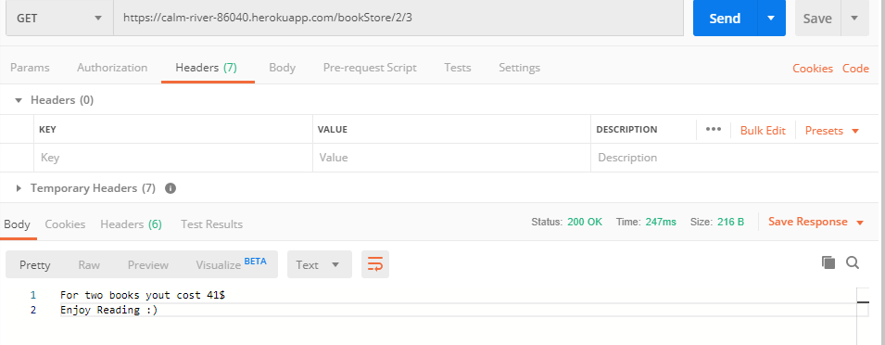

**4.3**

"KATERINA"

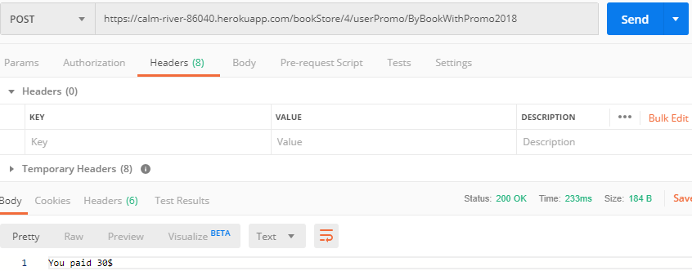

"CHERRY"

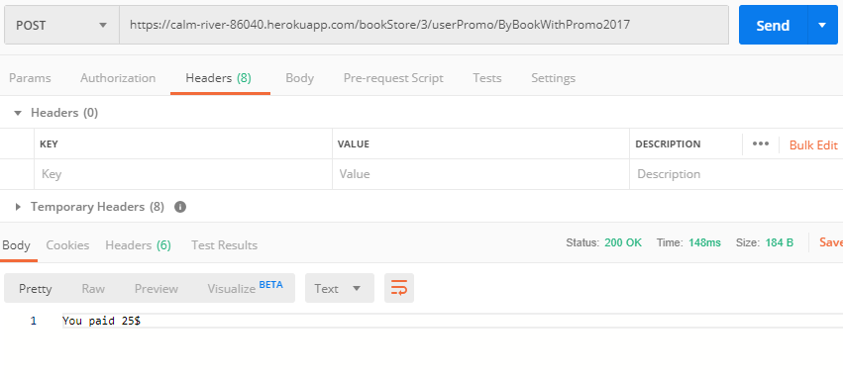

**4.4**

**Unable to view user balance**