Challenge 1: SQL Injection
In this part, you must discover user account information on a server and crack the password of Bob Smith's account. You will then locate the file with Challenge 1 code and use Bob Smith's account credentials to open the file at 192.168.0.10 to view its contents.
Step 1: Preliminary setup
- Open a browser and go to the website on 10.5.5.12.
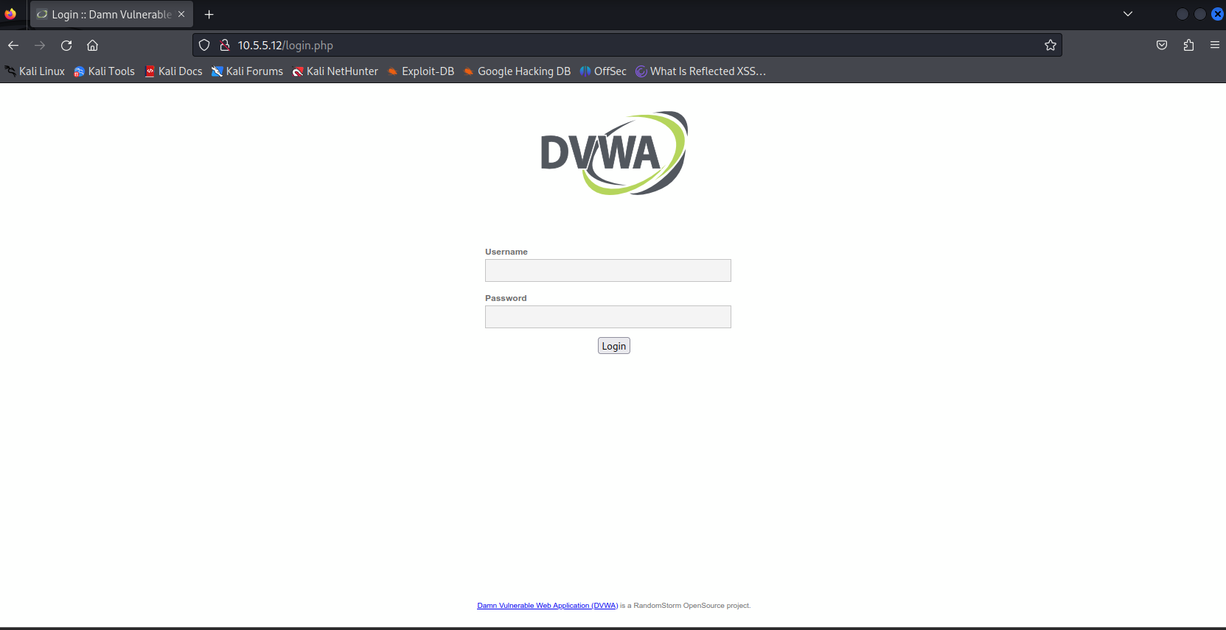
- Login with the credential admin / password
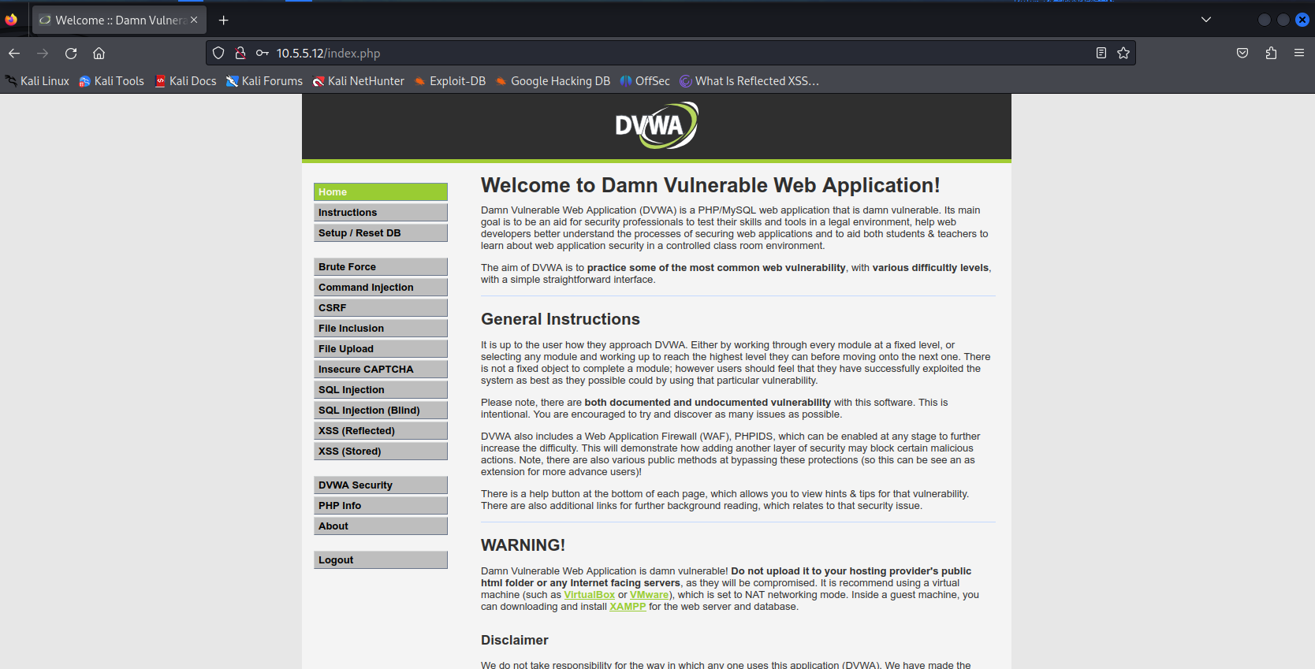
- Set the DVWA security level to low and click Submit.
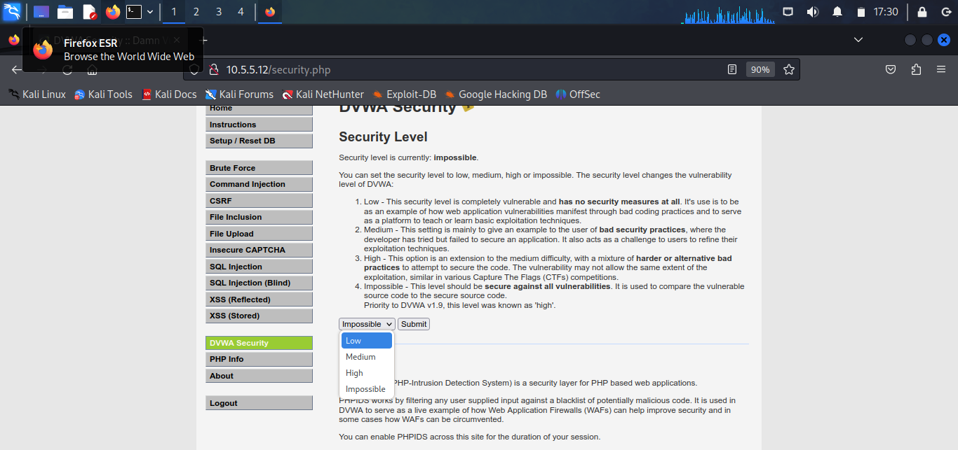
Step 2: Retrieve the user credentials for Bob Smith’s account
- Identify the table that contains usernames and passwords
- Locate a vulnerable input form that will allow you to inject SQL commands.
Using the payload: 1' OR 1=1 UNION SELECT 1,column_name FROM information_schema.columns WHERE table_name='users'#
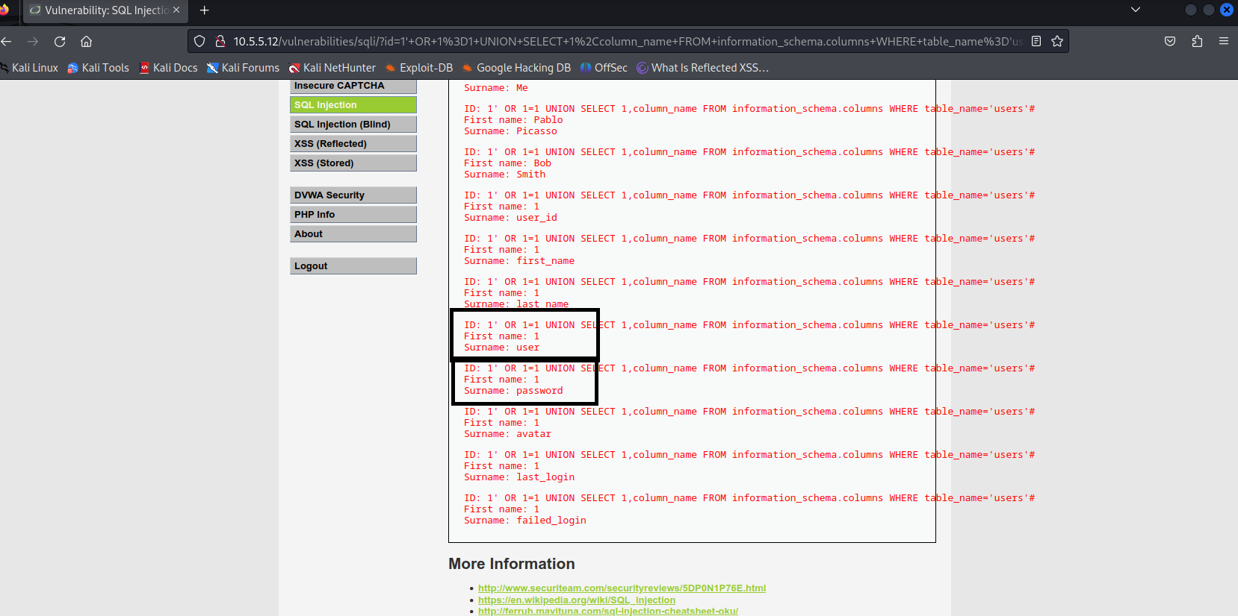
- Retrieve the username and the password hash for Bob Smith's account.
To retrieve the password for the user Bob,
use the payload: 1' OR 1=1 UNION SELECT user, password FROM users #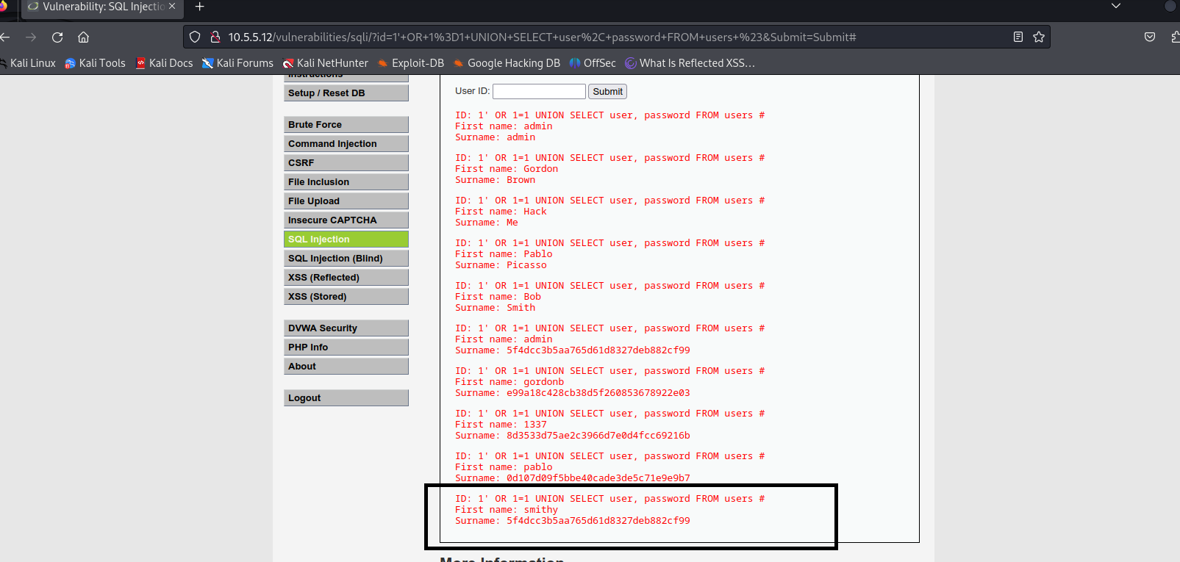
Step 3: Crack Bob Smith’s account password
We will use crackstation to crack the hash
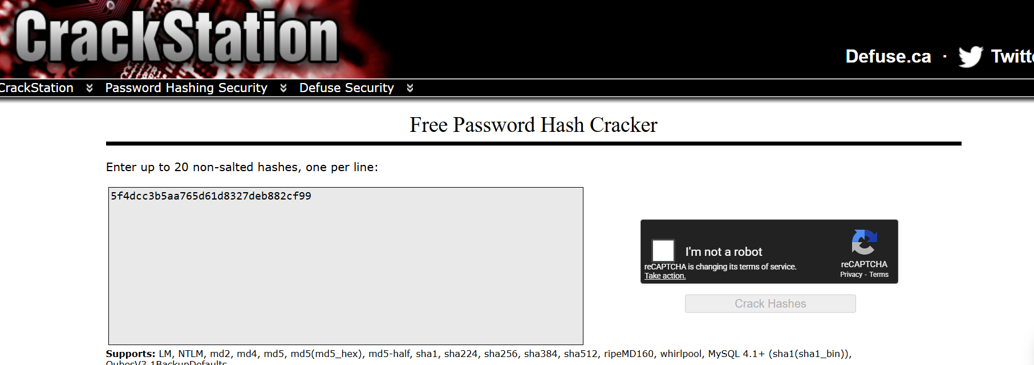
The password of Bob Smith’s account:
Step 4: Locate and open the file with Challenge 1 code
- Log into 192.168.0.10 as Bob Smith through SSH
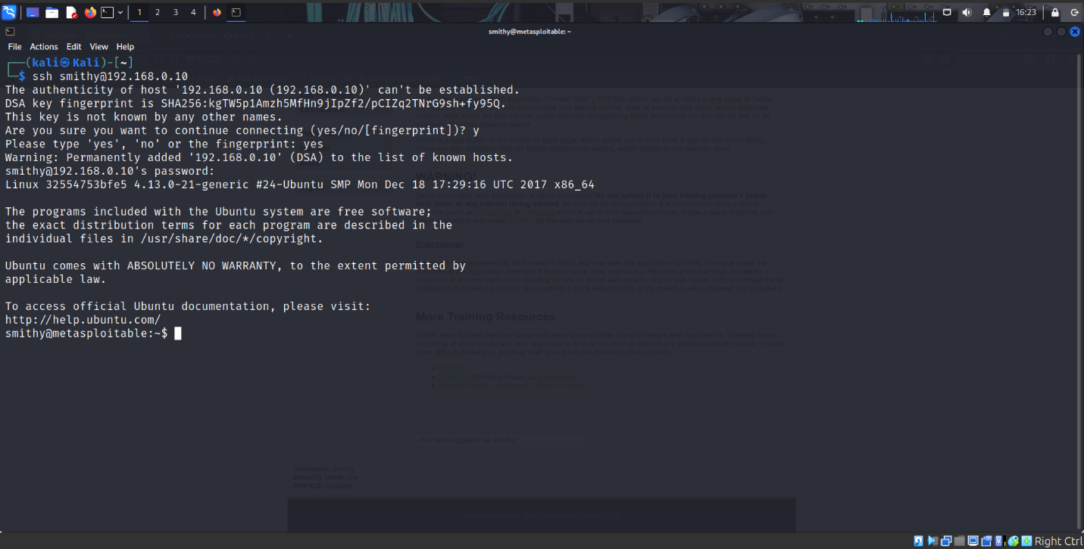
- Locate and open the flag file in the user's home directory. What is the name of the file with the code?
What is the message contained in the file?
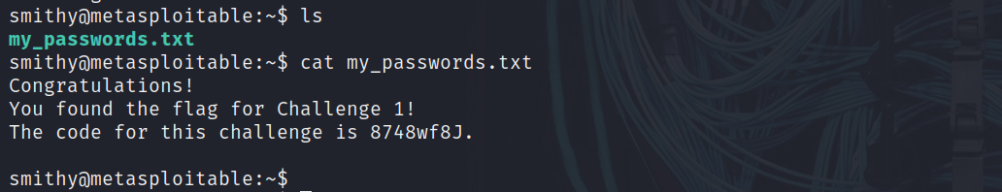
Step 5: Research and propose SQL attack remediation
What are five remediation methods for preventing SQL injection exploits?
SQL Injection Remediation
- Use parameterized queries (prepared statements) to ensure that user input is handled strictly as data and never interpreted as executable SQL code. This prevents attackers from altering the structure of database queries.
- Leverage secure ORM frameworks to manage database interactions safely. ORMs automatically generate parameterized queries and reduce the risk introduced by manual SQL string concatenation.
- Implement strict input validation using allow-lists to accept only expected data formats. This adds an additional layer of defense by blocking malformed or malicious input before it reaches the database.
- Apply the principle of least privilege to database accounts used by applications. Restricting permissions limits the damage an attacker can cause even if an SQL injection vulnerability is successfully exploited.
- Use proper error handling and secure logging practices to prevent detailed database error messages from being exposed to users. At the same time, maintain internal logs to detect and investigate suspicious activity.

Challenge 2: Web Server Vulnerabilities
In this part, you must find vulnerabilities on an HTTP server. Misconfiguration of a web server can allow for the listing of files contained in directories on the server. You can use any of the tools you learned in earlier labs to perform reconnaissance to find the vulnerable directories. In this challenge, you will locate the flag file in a vulnerable directory on a web server.
Step 1: Preliminary setup
- Log into the server at 10.5.5.12 with the admin / password credentials
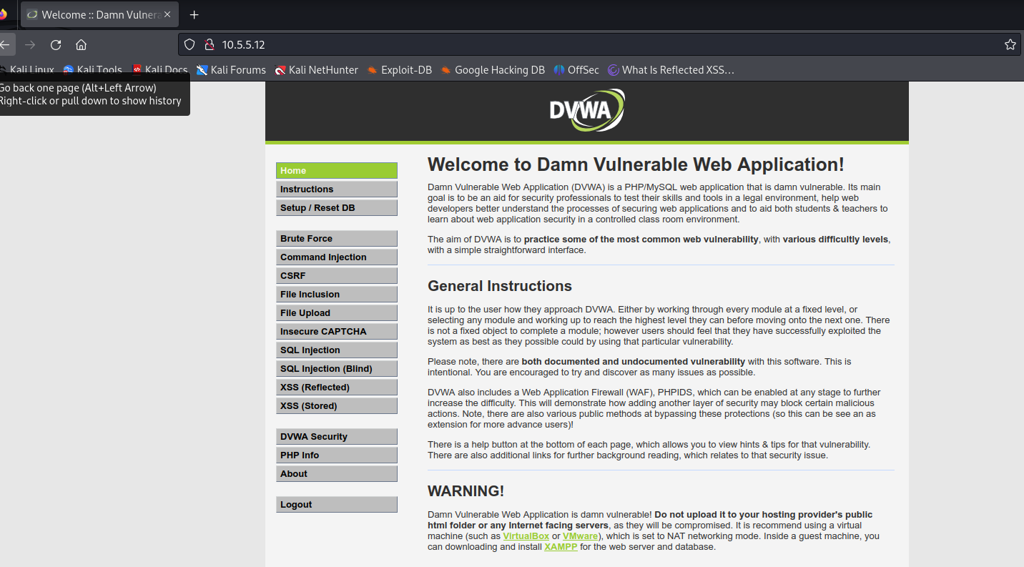
- Set the application security level to low
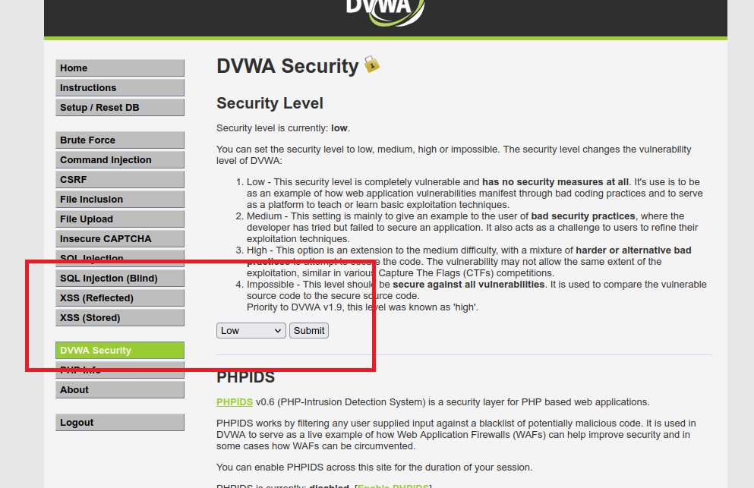
Step 2: From the results of your reconnaissance, determine which directories are viewable using a web browser and URL manipulation
Perform reconnaissance on the server to find directories where indexing was found using Nikto Command: nikto -h 10.5.5.12
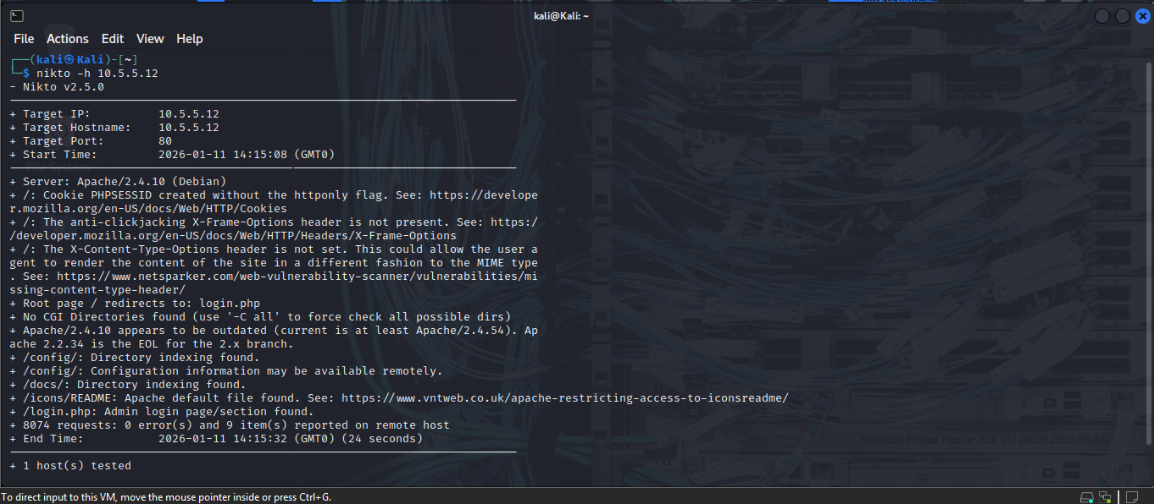
Which directories can be accessed through a web browser to list the files and subdirectories that they contain?
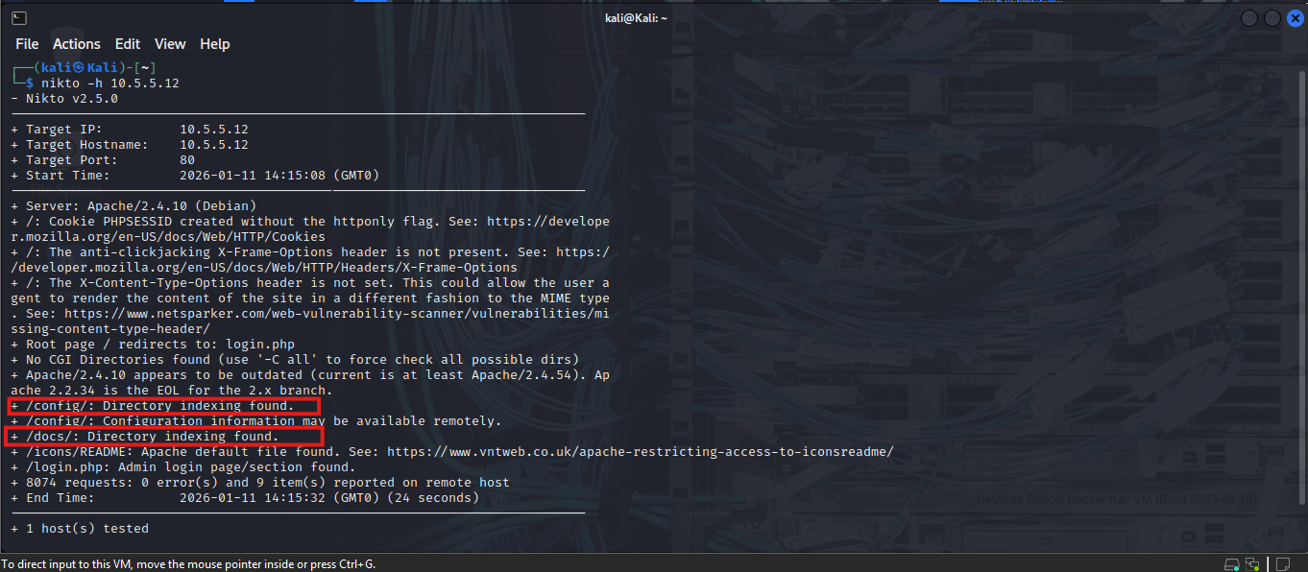
Step 3: View the files contained in each directory to find the db_form.html file.
Create a URL in the web browser to access the viewable subdirectories. Find the file with the code for Challenge 2 located in one of the subdirectories
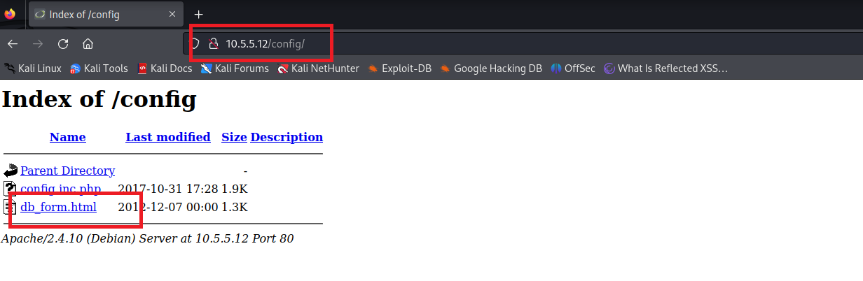
In which two subdirectories can you look for the file?
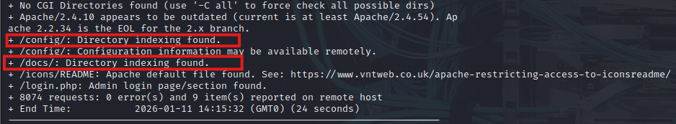What is the filename with the Challenge 2 code?

What is the message contained in the flag file?

Step 4: Research and propose directory listing exploit remediation
What are two remediation methods for preventing directory listing exploits?
Directory Listing Exploit Remediation
- Disable directory listing on web servers to prevent attackers from viewing file and folder contents when no index file is present. This stops unauthorized users from discovering sensitive files, backup data, configuration files, or application logic exposed through misconfigured directories.
- Enforce proper access controls and file permissions to ensure that only authorized users can access sensitive directories and files. Restricting permissions at the operating system and web server level reduces the risk of information disclosure even if directory browsing is accidentally enabled.

