Univerzitet u Beogradu
Fakultet organizacionih nauka
Katedra za elektronsko poslovanje

Razvoj klijentske veb aplikacije: React
  - Domaći zadatak 2
Ime | Prezime | Broj indeksa
Link ka Github-u

Sadržaj
1 Tema seminarskog rada i korisnički zahtev 3
2 Implementacija 4
3 Korisničko uputstvo 37

Tema seminarskog rada i korisnički zahtev
Agrimart je web aplikacija za elektronsku pijacu koja korisnicima omogućava pregled, filtriranje i kupovinu proizvoda od lokalnih prodavaca. Projekat je razvijen u Vite + React okruženju sa TypeScript-om, a za stilizaciju koristi čist TailwindCSS (bazne klase, bez dodatnih konfiguracija). UI je dosledan, responzivan i lagan: paleta je u zelenim tonovima, umesto bordera koriste se meke senke i zaobljenja, a ikone dolaze iz lucide-react biblioteke. Osnovni layout čine navigaciona traka sa nazivom Agrimart, linkovima ka početnoj i katalogu, kao i “badge” sa brojem artikala u korpi, zatim glavni sadržaj preko celog preostalog ekrana i futer.
Model podataka je tipizovan kroz TypeScript interfejse: Product, Seller i pomoćne tipove (ProductType, Unit). Katalog sadrži reprezentativan skup proizvoda iz kategorija Fruit, Vegetable i Dairy, sa realnim opisima, cenama, poreklom i validnim URL-ovima slika. Prikaz proizvoda je izgrađen oko reusabilne komponente ProductCard i paginacije (12 po strani), dok filteri po tipu proizvoda, prodavcu i organskom poreklu rade preko URL parametara, pa su deljivi i “bookmarkable”. Početna (Home) nudi hero sekciju, kratke benefite, prečice po kategorijama i istaknute proizvode.
Stranica pojedinačnog proizvoda prikazuje sve dostupne atribute, uz male “pills” za tip i jedinicu mere, i listu povezanih artikala istog prodavca i iste kategorije (do tri). Dodatno, integrisan je modul za recepte koji koristi javne API-je (primarno Forkify, uz rezervu TheMealDB): iz naziva proizvoda se izvlači ključni sastojak (npr. “apple”, “tomato”), pretragom se dobijaju recepti, a linkovi vode na “human-friendly” stranice (ili pretragu po naslovu kada izvorni URL nije dostupan). Recepti se prikazuju ispod povezanih proizvoda u formi kartica.
Logika korpe je enkapsulirana u klasi Cart sa čistim, imutabilnim operacijama (add, set, inc, dec, remove, clear) i metodama za agregate (subtotal, totalItems, filter po prodavcu/tipu). CartItem i CartSnapshot interfejsi obezbeđuju tipnu sigurnost. Globalni kontekst (CartContext) izlaže API hook useCart za rad sa korpom, a posebna klasa LocalStorageCartStore brine o perzistenciji u localStorage-u i sinhronizaciji između više tabova (osluškivanjem “storage” događaja). Navigacija prikazuje tačan broj stavki u realnom vremenu.
Stranica korpe (Cart) donosi pregled artikala sa slikom, nazivom, cenom, mogućnošću promene količine (−/input/+), uklanjanjem i jasno istaknutim međuzbirom (subtotal). Checkout uvodi kompaktnu tabelu porudžbine i formu za unos podataka za dostavu (ime i prezime, e-mail, grad, država, adresa) sa osnovnom validacijom. Nakon uspešne validacije korisnik dobija modal sa potvrdom porudžbine i procenom isporuke 3–5 radnih dana; korpa se čisti, a po zatvaranju modala korisnik se automatski vraća na početnu stranicu. Time je zaokružen minimalni, ali funkcionalno potpun tok kupovine.
Kod je organizovan u jasne module i reusabilne komponente (ProductCard, Pagination, Modal, FormField, CartItemsCompactTable), što olakšava održavanje i nadogradnju. Dalje smernice razvoja uključuju autentikaciju i korisničke naloge, naplatu i integraciju sa eksternim payment provajderima, administrativni panel za prodavce (inventar, cene, dostupnost), naprednije pretrage/filtre, kao i i18n. Sve u svemu, Agrimart demonstrira modernu front-end arhitekturu sa snažnim fokusom na tipnu bezbednost, UX performanse i čitljivost koda.

Implementacija
src/lib/cart.ts
Centralna logika korpe inkapsulirana u klasi Cart sa imutabilnim operacijama (add, set, inc, dec, remove, clear) i agregatima (totalItems, subtotal). Tipovi CartItem i CartSnapshot obezbeđuju tipnu bezbednost, a pomoćne metode kao itemsBySeller i itemsByType olakšavaju kasnije scenarije (grouping, checkout po prodavcu).
import type { Product, Unit, ProductType } from '../data/products';

export interface CartItem {
productId: string;
name: string;
price: number;
unit: Unit;
quantity: number;
imageUrl: string;
sellerId: string;
sellerName: string;
isOrganic: boolean;
type: ProductType;
}

export interface CartSnapshot {
items: CartItem[];
totalItems: number;
subtotal: number;
}

const clampQty = (q: number) => Math.max(0, Math.floor(q || 0));
const asKey = (productId: string) => productId.trim();
const round2 = (n: number) => Math.round((n + Number.EPSILON) * 100) / 100;

export class Cart {
private readonly _items: Map<string, CartItem>;

constructor(items?: CartItem[] | Map<string, CartItem>) {
if (items instanceof Map) {
this._items = new Map(items);
} else if (Array.isArray(items)) {
this._items = new Map(
items.map((it) => [asKey(it.productId), { ...it }])
);
} else {
this._items = new Map();
}
}

static from(
source: CartItem[] | CartSnapshot | Map<string, CartItem> | undefined
): Cart {
if (!source) return new Cart();
if (source instanceof Map) return new Cart(source);
if (Array.isArray(source)) return new Cart(source);
return new Cart(source.items);
}

items(): CartItem[] {
return Array.from(this._items.values()).map((it) => ({ ...it }));
}

has(productId: string): boolean {
return this._items.has(asKey(productId));
}

get(productId: string): CartItem | undefined {
const it = this._items.get(asKey(productId));
return it ? { ...it } : undefined;
}

get totalItems(): number {
let sum = 0;
for (const it of this._items.values()) sum += it.quantity;
return sum;
}

get subtotal(): number {
let sum = 0;
for (const it of this._items.values()) sum += it.price * it.quantity;
return round2(sum);
}

add(product: Product, quantity = 1): Cart {
const q = clampQty(quantity);
if (q <= 0) return this;

const key = asKey(product.id);
const next = new Map(this._items);

const existing = next.get(key);
if (existing) {
next.set(key, { ...existing, quantity: existing.quantity + q });
} else {
const item: CartItem = {
productId: product.id,
name: product.name,
price: product.price,
unit: product.unit,
quantity: q,
imageUrl: product.imageUrl,
sellerId: product.seller.id,
sellerName: product.seller.name,
isOrganic: product.isOrganic,
type: product.type,
};
next.set(key, item);
}
return new Cart(next);
}

set(productId: string, quantity: number): Cart {
const q = clampQty(quantity);
const key = asKey(productId);
if (!this._items.has(key)) return this;

const next = new Map(this._items);
if (q <= 0) next.delete(key);
else next.set(key, { ...next.get(key)!, quantity: q });
return new Cart(next);
}

inc(productId: string, delta = 1): Cart {
const key = asKey(productId);
const it = this._items.get(key);
if (!it) return this;

const newQty = clampQty(it.quantity + delta);
const next = new Map(this._items);
if (newQty <= 0) next.delete(key);
else next.set(key, { ...it, quantity: newQty });
return new Cart(next);
}

dec(productId: string, delta = 1): Cart {
return this.inc(productId, -Math.abs(delta));
}

remove(productId: string): Cart {
const key = asKey(productId);
if (!this._items.has(key)) return this;
const next = new Map(this._items);
next.delete(key);
return new Cart(next);
}

clear(): Cart {
if (this._items.size === 0) return this;
return new Cart();
}

toJSON(): CartSnapshot {
const items = this.items();
return {
items,
totalItems: this.totalItems,
subtotal: this.subtotal,
};
}

itemsBySeller(sellerId: string): CartItem[] {
return this.items().filter((it) => it.sellerId === sellerId);
}

itemsByType(type: ProductType): CartItem[] {
return this.items().filter((it) => it.type === type);
}
}

export default Cart;

src/state/CartContext.tsx
React kontekst koji izlaže useCart() API i povezuje UI sa Cart klasom. Radi “hydrate” iz storage-a pri mount-u, automatski snima snapshot pri svakoj promeni i sinhronizuje stanje između tabova (osluškuje storage event). Odatle dolaze akcije add, setQty, inc, dec, remove, clear.
import {
createContext,
useContext,
useMemo,
useState,
useEffect,
type ReactNode,
} from 'react';
import Cart, { type CartSnapshot } from '../lib/cart';
import type { Product } from '../data/products';
import { LocalStorageCartStore } from '../lib/cartStorage';

type CartAPI = {
cart: Cart;
snapshot: CartSnapshot;
add: (product: Product, quantity?: number) => void;
setQty: (productId: string, quantity: number) => void;
inc: (productId: string, delta?: number) => void;
dec: (productId: string, delta?: number) => void;
remove: (productId: string) => void;
clear: () => void;
};

const CartContext = createContext<CartAPI | null>(null);
const store = new LocalStorageCartStore('agrimart:cart');

export function CartProvider({ children }: { children: ReactNode }) {
const [cart, setCart] = useState<Cart>(() => Cart.from(store.load()));

useEffect(() => {
store.save(cart.toJSON());
}, [cart]);

useEffect(() => {
const onStorage = (e: StorageEvent) => {
if (e.key !== store.key) return;
setCart(Cart.from(store.load()));
};
window.addEventListener('storage', onStorage);
return () => window.removeEventListener('storage', onStorage);
}, []);

const api: CartAPI = useMemo(() => {
const add = (product: Product, quantity = 1) =>
setCart((c) => c.add(product, quantity));
const setQty = (productId: string, quantity: number) =>
setCart((c) => c.set(productId, quantity));
const inc = (productId: string, delta = 1) =>
setCart((c) => c.inc(productId, delta));
const dec = (productId: string, delta = 1) =>
setCart((c) => c.dec(productId, delta));
const remove = (productId: string) => setCart((c) => c.remove(productId));
const clear = () => setCart((c) => c.clear());

return {
cart,
snapshot: cart.toJSON(),
add,
setQty,
inc,
dec,
remove,
clear,
};
}, [cart]);

return <CartContext.Provider value={api}>{children}</CartContext.Provider>;
}

export function useCart(): CartAPI {
const ctx = useContext(CartContext);
if (!ctx) throw new Error('useCart must be used within <CartProvider>');
return ctx;
}

src/lib/cartStorage.ts
Jednostavan adapter za localStorage (LocalStorageCartStore) koji snima/učitava CartSnapshot pod stabilnim ključem i bezbedno parsiduje podatke (tolerantan na ranije formate). Ovaj sloj izoluje storage pristup od ostatka aplikacije.
import type { CartSnapshot } from './cart';

const isBrowser = typeof window !== 'undefined';

export interface CartStorage {
load(): CartSnapshot | undefined;
save(data: CartSnapshot): void;
clear(): void;
readonly key: string;
}

const DEFAULT_KEY = 'agrimart:cart';

function isValidSnapshot(obj: any): obj is CartSnapshot {
return (
obj &&
typeof obj === 'object' &&
Array.isArray(obj.items) &&
typeof obj.totalItems === 'number' &&
typeof obj.subtotal === 'number'
);
}

function parse(json: string | null): CartSnapshot | undefined {
if (!json) return undefined;
try {
const obj = JSON.parse(json);
if (isValidSnapshot(obj)) return obj;
if (obj && typeof obj === 'object' && isValidSnapshot((obj as any).data)) {
return (obj as any).data as CartSnapshot;
}
} catch {}
return undefined;
}

export class LocalStorageCartStore implements CartStorage {
public readonly key: string;

constructor(key = DEFAULT_KEY) {
this.key = key;
}

load(): CartSnapshot | undefined {
if (!isBrowser) return undefined;
return parse(window.localStorage.getItem(this.key));
}

save(data: CartSnapshot): void {
if (!isBrowser) return;
try {
window.localStorage.setItem(this.key, JSON.stringify(data));
} catch {}
}

clear(): void {
if (!isBrowser) return;
try {
window.localStorage.removeItem(this.key);
} catch {}
}
}

src/lib/recipes.ts
Servis za recepte: izvodi sastojak iz imena proizvoda (deriveIngredient) i pokušava pretragu na dva javna API-ja (Forkify primarno, TheMealDB fallback). Rezultate normalizuje u tip Recipe i uvek vraća “human-friendly” link (izvorni URL ili pretragu po naslovu) kako bi se izbegli JSON endpointi.
import type { ProductType } from '../data/products';

export type Recipe = {
id: string;
title: string;
image: string;
sourceUrl: string;
source: 'forkify' | 'mealdb';
};

const toHumanUrl = (title: string, preferred?: string) => {
if (preferred && /^https?:\/\//i.test(preferred)) return preferred;
return `https://duckduckgo.com/?q=${encodeURIComponent(`${title} recipe`)}`;
};

export function deriveIngredient(productName: string): string {
const name = productName.toLowerCase();
const known = [
'apple',
'banana',
'orange',
'lemon',
'lime',
'strawberry',
'blueberry',
'raspberry',
'avocado',
'tomato',
'cucumber',
'carrot',
'lettuce',
'potato',
'milk',
'yogurt',
'cheese',
'butter',
'egg',
'eggs',
];
for (const k of known) if (name.includes(k)) return k;
const token = name.match(/[a-z]+/g)?.[0];
return token ?? name.trim();
}

async function fetchForkify(q: string, limit = 3): Promise<Recipe[]> {
const url = `https://forkify-api.herokuapp.com/api/v2/recipes?search=${encodeURIComponent(
q
)}`;
const res = await fetch(url);
if (!res.ok) throw new Error('Forkify request failed');
const json = await res.json();
const list: any[] = json?.data?.recipes ?? [];
return list.slice(0, limit).map((r) => {
const title = String(r.title);
const srcUrl = toHumanUrl(title, r.source_url);
return {
id: String(r.id),
title,
image: String(r.image_url),
sourceUrl: srcUrl,
source: 'forkify' as const,
};
});
}

async function fetchMealDB(q: string, limit = 3): Promise<Recipe[]> {
const filterUrl = `https://www.themealdb.com/api/json/v1/1/filter.php?i=${encodeURIComponent(
q
)}`;
const res = await fetch(filterUrl);
if (!res.ok) throw new Error('TheMealDB filter failed');
const json = await res.json();
const meals: any[] = json?.meals ?? [];
const chosen = meals.slice(0, limit);

if (chosen.length === 0) return [];

const details = await Promise.all(
chosen.map(async (m) => {
const id = m.idMeal;
try {
const detRes = await fetch(
`https://www.themealdb.com/api/json/v1/1/lookup.php?i=${id}`
);
if (!detRes.ok) throw new Error('lookup failed');
const detJson = await detRes.json();
const meal = detJson?.meals?.[0];
const title = String(meal?.strMeal ?? m.strMeal);
const srcUrl = toHumanUrl(title, meal?.strSource || meal?.strYoutube);
return {
id: String(id),
title,
image: String(meal?.strMealThumb ?? m.strMealThumb),
sourceUrl: srcUrl,
source: 'mealdb' as const,
} as Recipe;
} catch {
const title = String(m.strMeal);
return {
id: String(id),
title,
image: String(m.strMealThumb),
sourceUrl: toHumanUrl(title),
source: 'mealdb' as const,
} as Recipe;
}
})
);

return details;
}

export async function fetchRecipes(params: {
type: ProductType;
ingredient: string;
limit?: number;
}): Promise<Recipe[]> {
const { ingredient, limit = 3 } = params;
const q = ingredient.trim();
if (!q) return [];
try {
const a = await fetchForkify(q, limit);
if (a.length) return a;
} catch {}
try {
return await fetchMealDB(q, limit);
} catch {}
return [];
}

src/components/ProductCard.tsx
Reusabilna kartica proizvoda (slika, naziv, kratki opis, cena/jedinica) u zelenoj paleti, sa senkama umesto bordera. Dizajnirana za grid prikaze i različite širine (1–4 kolone), koristi “object-cover” slike i minimalni tekstualni sadržaj za čitljivost.
import { Link } from 'react-router-dom';
import { ArrowRight, Leaf, Store } from 'lucide-react';

import type { Product } from '../data/products';

export type ProductCardProps = {
product: Product;
className?: string;
};

export default function ProductCard({ product, className }: ProductCardProps) {
return (
<article
className={`rounded-2xl shadow-md hover:shadow-lg transition bg-white overflow-hidden ${
className ?? ''
}`}
>
<Link to={`/products/${product.id}`} className='block'>
<div className='h-48 bg-green-50'>
<img
src={product.imageUrl}
alt={product.name}
loading='lazy'
className='w-full h-full object-cover'
/>
</div>
</Link>

<div className='p-4'>
<div className='flex items-start gap-2'>
<h3 className='text-lg font-semibold text-green-900 flex-1'>
{product.name}
</h3>
{product.isOrganic && (
<span className='inline-flex items-center gap-1 text-xs px-2 py-1 rounded-full bg-green-100 text-green-700 shadow-sm'>
<Leaf className='w-3.5 h-3.5' />
Organic
</span>
)}
</div>

<p className='mt-1 text-sm text-green-800'>
{product.shortDescription}
</p>

<div className='mt-3 flex flex-wrap items-center gap-2 text-xs text-green-800'>
<span className='px-2 py-1 rounded-full bg-green-50 shadow-sm'>
{product.type}
</span>
<span className='px-2 py-1 rounded-full bg-green-50 shadow-sm'>
{product.unit}
</span>
{product.origin && (
<span className='px-2 py-1 rounded-full bg-green-50 shadow-sm'>
{product.origin}
</span>
)}
</div>

<div className='mt-4 flex items-center justify-between'>
<div>
<div className='text-lg font-semibold text-green-900'>
€{product.price.toFixed(2)}
</div>
<div className='text-xs text-green-700'>per {product.unit}</div>
</div>
<Link
to={`/products/${product.id}`}
className='inline-flex items-center gap-1 px-3 py-2 rounded-xl bg-green-600 text-white shadow-md hover:shadow-lg transition'
aria-label={`View ${product.name}`}
>
View <ArrowRight className='w-4 h-4' />
</Link>
</div>

<div className='mt-3 flex items-center gap-2 text-xs text-green-700'>
<Store className='w-4 h-4' />
<span>{product.seller.name}</span>
<span>•</span>
<span>{product.seller.location}</span>
</div>
</div>
</article>
);
}

src/pages/Products.tsx
Katalog sa filterima (po tipu, prodavcu i organskom poreklu) i paginacijom 12 po strani. Filteri su sinhronizovani kroz URL parametre pa su “bookmarkable”; prikaz koristi ProductCard grid i pokazuje “Showing X–Y of Z”.
import { useMemo, useEffect, useCallback } from 'react';
import { useSearchParams } from 'react-router-dom';
import { Filter, Leaf, Store, X } from 'lucide-react';
import ProductCard from '../components/ProductCard';
import Pagination from '../components/Pagination';
import { products, sellers } from '../data/products';
import type { ProductType } from '../data/products';

const PER_PAGE = 12;

const ALL_TYPES: readonly ProductType[] = ['Fruit', 'Vegetable', 'Dairy'];

function isProductType(v: string | null): v is ProductType {
return !!v && (ALL_TYPES as readonly string[]).includes(v);
}

type OrgFilter = 'any' | 'true' | 'false';
type TypeFilter = ProductType | 'all';

export default function Products() {
const [searchParams, setSearchParams] = useSearchParams();

const typeParam = searchParams.get('type');
const sellerParam = searchParams.get('seller');
const orgParam = (searchParams.get('org') as OrgFilter) || 'any';

const validType: TypeFilter = isProductType(typeParam) ? typeParam : 'all';

const sellerMap = useMemo(
() => new Map(sellers.map((s) => [s.id, s] as const)),
[]
);
const validSeller =
sellerParam && sellerMap.has(sellerParam) ? sellerParam : 'all';

const validOrg: OrgFilter =
orgParam === 'true' || orgParam === 'false' ? orgParam : 'any';

const filtered = useMemo(() => {
return products.filter((p) => {
const byType = validType === 'all' ? true : p.type === validType;
const bySeller =
validSeller === 'all' ? true : p.seller.id === validSeller;
const byOrg =
validOrg === 'any'
? true
: validOrg === 'true'
? p.isOrganic
: !p.isOrganic;
return byType && bySeller && byOrg;
});
}, [validType, validSeller, validOrg]);

const total = filtered.length;
const totalPages = Math.max(1, Math.ceil(total / PER_PAGE));

const rawPage = Number(searchParams.get('page') || 1);
const safePage =
Number.isFinite(rawPage) && rawPage >= 1 && rawPage <= totalPages
? Math.floor(rawPage)
: 1;

useEffect(() => {
if (rawPage !== safePage) {
const sp = new URLSearchParams(searchParams);
sp.set('page', String(safePage));
setSearchParams(sp, { replace: true });
}
}, [rawPage, safePage, searchParams, setSearchParams]);

const start = (safePage - 1) * PER_PAGE;
const end = Math.min(start + PER_PAGE, total);
const pageItems = useMemo(
() => filtered.slice(start, end),
[filtered, start, end]
);

const goTo = useCallback(
(p: number) => {
const clamped = Math.min(Math.max(1, p), totalPages);
const sp = new URLSearchParams(searchParams);
sp.set('page', String(clamped));
setSearchParams(sp);
window.scrollTo({ top: 0, behavior: 'smooth' });
},
[searchParams, setSearchParams, totalPages]
);

const setParam = (key: string, value: string | null) => {
const sp = new URLSearchParams(searchParams);
if (value === null || value === 'all' || value === 'any') sp.delete(key);
else sp.set(key, value);
sp.set('page', '1');
setSearchParams(sp);
};

const clearFilters = () => {
const sp = new URLSearchParams(searchParams);
sp.delete('type');
sp.delete('seller');
sp.delete('org');
sp.set('page', '1');
setSearchParams(sp);
};

const hasActiveFilters =
validType !== 'all' || validSeller !== 'all' || validOrg !== 'any';

return (
<section>
<header className='mb-6'>
<h1 className='text-2xl font-semibold text-green-900'>All Products</h1>
<p className='text-green-800 mt-1'>
Browse fresh items from local sellers.
</p>
</header>

<div className='mb-6 rounded-2xl bg-white shadow-md p-4'>
<div className='flex items-center gap-2 mb-3 text-green-900'>
<Filter className='w-4 h-4' />
<span className='font-semibold'>Filters</span>
{hasActiveFilters && (
<button
type='button'
onClick={clearFilters}
className='ml-auto inline-flex items-center gap-1 text-sm px-3 py-1.5 rounded-xl bg-green-100 text-green-800 shadow-sm hover:shadow-md transition'
aria-label='Clear filters'
title='Clear filters'
>
<X className='w-4 h-4' />
Clear
</button>
)}
</div>

<div className='grid grid-cols-1 sm:grid-cols-3 gap-3'>
<label className='block'>
<span className='text-sm text-green-800'>Type</span>
<select
className='mt-1 w-full rounded-xl bg-green-50 text-green-900 shadow-md px-3 py-2 focus:outline-none focus:ring-2 focus:ring-green-400'
value={validType}
onChange={(e) =>
setParam(
'type',
e.target.value === 'all' ? null : e.target.value
)
}
>
<option value='all'>All types</option>
{ALL_TYPES.map((t) => (
<option key={t} value={t}>
{t}
</option>
))}
</select>
</label>

<label className='block'>
<span className='text-sm text-green-800 flex items-center gap-1'>
<Store className='w-3.5 h-3.5' /> Seller
</span>
<select
className='mt-1 w-full rounded-xl bg-green-50 text-green-900 shadow-md px-3 py-2 focus:outline-none focus:ring-2 focus:ring-green-400'
value={validSeller}
onChange={(e) =>
setParam(
'seller',
e.target.value === 'all' ? null : e.target.value
)
}
>
<option value='all'>All sellers</option>
{sellers.map((s) => (
<option key={s.id} value={s.id}>
{s.name}
</option>
))}
</select>
</label>

<label className='block'>
<span className='text-sm text-green-800 flex items-center gap-1'>
<Leaf className='w-3.5 h-3.5' /> Organic
</span>
<select
className='mt-1 w-full rounded-xl bg-green-50 text-green-900 shadow-md px-3 py-2 focus:outline-none focus:ring-2 focus:ring-green-400'
value={validOrg}
onChange={(e) => {
const v = e.target.value as OrgFilter;
setParam('org', v === 'any' ? null : v);
}}
>
<option value='any'>Any</option>
<option value='true'>Organic only</option>
<option value='false'>Non-organic</option>
</select>
</label>
</div>
</div>

<div className='mb-4 text-sm text-green-700'>
Showing <span className='font-medium'>{total ? start + 1 : 0}</span>–
<span className='font-medium'>{end}</span> of{' '}
<span className='font-medium'>{total}</span> products
</div>

{total === 0 ? (
<div className='rounded-2xl p-6 shadow-md bg-white'>
<p className='text-green-800'>
No products found. Try adjusting filters.
</p>
</div>
) : (
<>
<div className='grid grid-cols-1 sm:grid-cols-2 lg:grid-cols-3 xl:grid-cols-4 gap-6'>
{pageItems.map((p) => (
<ProductCard key={p.id} product={p} />
))}
</div>

<Pagination
page={safePage}
totalPages={totalPages}
onPageChange={goTo}
/>
</>
)}
</section>
);
}

src/pages/Product.tsx
Detaljna stranica artikla: hero slika + specifikacije (tip, jedinica, poreklo, SKU, prodavac, organsko) i akcija “Add to cart” sa kontrolom količine. Ispod su povezani proizvodi istog prodavca i iste kategorije (do tri), kao i sekcija “Recipes using …” koja prikazuje do tri recepta iz recipes servisa.
import { useMemo, useState, useEffect } from 'react';
import { useParams, Link } from 'react-router-dom';
import { products } from '../data/products';
import ProductCard from '../components/ProductCard';
import {
ArrowLeft,
Leaf,
Store,
Tag,
Hash,
Package,
ShoppingCart as CartIcon,
ExternalLink,
Utensils,
} from 'lucide-react';
import { useCart } from '../state/CartContext';

import { fetchRecipes, deriveIngredient, type Recipe } from '../lib/recipes';

export default function Product() {
const { id } = useParams<{ id: string }>();
const { add } = useCart();
const [qty, setQty] = useState<number>(1);

const [recipes, setRecipes] = useState<Recipe[]>([]);
const [recipesLoading, setRecipesLoading] = useState(false);
const [recipesError, setRecipesError] = useState<string | null>(null);
const [ingredient, setIngredient] = useState<string>('');

const product = useMemo(() => products.find((p) => p.id === id), [id]);

if (!product) {
return (
<section className='rounded-2xl p-6 shadow-md bg-white'>
<div className='flex items-center gap-2 mb-4'>
<ArrowLeft className='w-4 h-4 text-green-800' />
<Link to='/products' className='text-green-800 hover:underline'>
Back to products
</Link>
</div>
<h1 className='text-2xl font-semibold text-green-900'>
Product not found
</h1>
<p className='mt-2 text-green-800'>
The product you’re looking for doesn’t exist or was removed.
</p>
</section>
);
}

const formatPrice = (n: number) => `€${n.toFixed(2)}`;

const related = products
.filter(
(p) =>
p.id !== product.id &&
p.seller.id === product.seller.id &&
p.type === product.type
)
.slice(0, 3);

const clampQty = (n: number) => {
if (!Number.isFinite(n)) return 1;
return Math.min(99, Math.max(1, Math.floor(n)));
};

const handleAdd = () => {
add(product, clampQty(qty));
};

useEffect(() => {
const ingr = deriveIngredient(product.name);
setIngredient(ingr);

let aborted = false;
(async () => {
setRecipesLoading(true);
setRecipesError(null);
try {
const list = await fetchRecipes({
type: product.type,
ingredient: ingr,
limit: 3,
});
if (!aborted) setRecipes(list);
} catch (e: any) {
if (!aborted) setRecipesError(e?.message || 'Failed to load recipes');
} finally {
if (!aborted) setRecipesLoading(false);
}
})();

return () => {
aborted = true;
};
}, [product]);

useEffect(() => {
window.scrollTo({ top: 0, left: 0, behavior: 'smooth' });
}, [id]);

return (
<section className='grid gap-6'>
<div className='flex items-center gap-2'>
<ArrowLeft className='w-4 h-4 text-green-800' />
<Link to='/products' className='text-green-800 hover:underline'>
Back to products
</Link>
</div>

<article className='rounded-2xl shadow-md bg-white overflow-hidden'>
<div className='grid grid-cols-1 lg:grid-cols-2'>
<div className='bg-green-50'>
<img
src={product.imageUrl}
alt={product.name}
className='w-full h-full object-cover max-h-[480px]'
loading='eager'
/>
</div>

<div className='p-6 sm:p-8'>
<div className='flex items-start gap-2'>
<h1 className='text-2xl font-semibold text-green-900 flex-1'>
{product.name}
</h1>
{product.isOrganic && (
<span className='inline-flex items-center gap-1 text-xs px-2 py-1 rounded-full bg-green-100 text-green-700 shadow-sm'>
<Leaf className='w-3.5 h-3.5' />
Organic
</span>
)}
</div>

<p className='mt-3 text-green-800'>{product.shortDescription}</p>

<div className='mt-4 flex flex-wrap items-center gap-2 text-xs text-green-800'>
<span className='px-2 py-1 rounded-full bg-green-50 shadow-sm inline-flex items-center gap-1'>
<Tag className='w-3.5 h-3.5' />
{product.type}
</span>
<span className='px-2 py-1 rounded-full bg-green-50 shadow-sm inline-flex items-center gap-1'>
<Package className='w-3.5 h-3.5' />
{product.unit}
</span>
{product.origin && (
<span className='px-2 py-1 rounded-full bg-green-50 shadow-sm'>
{product.origin}
</span>
)}
</div>

<div className='mt-6 flex flex-col sm:flex-row sm:items-end sm:justify-between gap-4'>
<div>
<div className='text-2xl font-semibold text-green-900'>
{formatPrice(product.price)}
</div>
<div className='text-xs text-green-700'>per {product.unit}</div>
</div>

<div className='flex items-center gap-3'>
<label className='text-sm text-green-800' htmlFor='qty'>
Qty
</label>
<input
id='qty'
type='number'
inputMode='numeric'
min={1}
max={99}
value={qty}
onChange={(e) => setQty(clampQty(Number(e.target.value)))}
className='w-20 rounded-xl bg-green-50 text-green-900 shadow-md px-3 py-2 focus:outline-none focus:ring-2 focus:ring-green-400'
/>
<button
type='button'
onClick={handleAdd}
className='inline-flex items-center gap-2 px-4 py-2 rounded-xl bg-green-600 text-white shadow-md hover:shadow-lg transition focus:outline-none focus:ring-2 focus:ring-green-400'
aria-label={`Add ${qty} to cart`}
>
<CartIcon className='w-4 h-4' />
Add to cart
</button>
</div>
</div>

<dl className='mt-6 grid grid-cols-1 sm:grid-cols-2 gap-3 text-sm'>
<div className='rounded-xl bg-green-50 shadow-sm p-3'>
<dt className='text-green-700'>Product ID</dt>
<dd className='text-green-900 font-medium'>{product.id}</dd>
</div>

<div className='rounded-xl bg-green-50 shadow-sm p-3'>
<dt className='text-green-700'>SKU</dt>
<dd className='text-green-900 font-medium'>
{product.sku ?? '—'}
</dd>
</div>

<div className='rounded-xl bg-green-50 shadow-sm p-3'>
<dt className='text-green-700'>Type</dt>
<dd className='text-green-900 font-medium'>{product.type}</dd>
</div>

<div className='rounded-xl bg-green-50 shadow-sm p-3'>
<dt className='text-green-700'>Unit</dt>
<dd className='text-green-900 font-medium'>{product.unit}</dd>
</div>

<div className='rounded-xl bg-green-50 shadow-sm p-3'>
<dt className='text-green-700'>Origin</dt>
<dd className='text-green-900 font-medium'>
{product.origin ?? '—'}
</dd>
</div>

<div className='rounded-xl bg-green-50 shadow-sm p-3'>
<dt className='text-green-700 inline-flex items-center gap-1'>
<Store className='w-3.5 h-3.5' />
Seller
</dt>
<dd className='text-green-900 font-medium'>
{product.seller.name} · {product.seller.location}{' '}
{product.seller.rating ? (
<span className='text-green-700 font-normal'>
(rating {product.seller.rating.toFixed(1)})
</span>
) : null}
</dd>
</div>

<div className='rounded-xl bg-green-50 shadow-sm p-3'>
<dt className='text-green-700 inline-flex items-center gap-1'>
<Leaf className='w-3.5 h-3.5' />
Organic
</dt>
<dd className='text-green-900 font-medium'>
{product.isOrganic ? 'Yes' : 'No'}
</dd>
</div>

<div className='rounded-xl bg-green-50 shadow-sm p-3'>
<dt className='text-green-700 inline-flex items-center gap-1'>
<Hash className='w-3.5 h-3.5' />
Price (EUR)
</dt>
<dd className='text-green-900 font-medium'>
{formatPrice(product.price)} / {product.unit}
</dd>
</div>
</dl>
</div>
</div>
</article>

{related.length > 0 && (
<section className='grid gap-4'>
<h2 className='text-xl font-semibold text-green-900'>
More from {product.seller.name} in {product.type}
</h2>
<div className='grid grid-cols-1 sm:grid-cols-2 lg:grid-cols-3 gap-6'>
{related.map((p) => (
<ProductCard key={p.id} product={p} />
))}
</div>
</section>
)}

<section className='grid gap-4'>
<h2 className='text-xl font-semibold text-green-900 inline-flex items-center gap-2'>
<Utensils className='w-5 h-5' />
Recipes using {ingredient || product.name}
</h2>

{recipesLoading ? (
<div className='rounded-2xl bg-white p-4 shadow-md text-green-800'>
Loading recipes…
</div>
) : recipesError ? (
<div className='rounded-2xl bg-white p-4 shadow-md text-red-700'>
{recipesError}
</div>
) : recipes.length === 0 ? (
<div className='rounded-2xl bg-white p-4 shadow-md text-green-800'>
No recipes found for “{ingredient}”. Try another ingredient.
</div>
) : (
<div className='grid grid-cols-1 sm:grid-cols-2 lg:grid-cols-3 gap-6'>
{recipes.map((r) => (
<article
key={`${r.source}-${r.id}`}
className='rounded-2xl bg-white shadow-md overflow-hidden'
>
<div className='aspect-video bg-green-50'>
<img
src={r.image}
alt={r.title}
className='w-full h-full object-cover'
loading='lazy'
/>
</div>
<div className='p-4'>
<h3 className='text-green-900 font-medium line-clamp-2'>
{r.title}
</h3>
<div className='mt-3'>
<a
href={r.sourceUrl}
target='_blank'
rel='noreferrer'
className='inline-flex items-center gap-2 text-sm px-3 py-1.5 rounded-xl bg-green-600 text-white shadow-md hover:shadow-lg transition'
>
View recipe
<ExternalLink className='w-4 h-4' />
</a>
</div>
</div>
</article>
))}
</div>
)}
</section>
</section>
);
}

src/components/CartItemsCompactTable.tsx
Kompaktna tabela za checkout sa četiri kolone (proizvod, cena, qty, line total), bez bordera — koristi svetle pozadine i senke. Prima items i subtotal kao props i služi za pregled pre slanja porudžbine.
import type { CartItem } from '../lib/cart';

type Props = {
items: CartItem[];
subtotal: number;
title?: string;
currency?: string;
};

export default function CartItemsCompactTable({
items,
subtotal,
title = 'Your items',
currency = '€',
}: Props) {
const formatPrice = (n: number) => `${currency}${n.toFixed(2)}`;

return (
<div className='rounded-2xl shadow-md bg-white p-4'>
<h2 className='text-lg font-semibold text-green-900'>{title}</h2>
<div className='mt-3 grid gap-3'>
<div className='hidden sm:grid grid-cols-12 text-xs text-green-700 px-2'>
<div className='col-span-6'>Product</div>
<div className='col-span-2 text-right'>Price</div>
<div className='col-span-2 text-center'>Qty</div>
<div className='col-span-2 text-right'>Total</div>
</div>

{items.map((it) => {
const line = it.price * it.quantity;
return (
<div
key={it.productId}
className='grid grid-cols-12 items-center rounded-xl bg-green-50 p-2 shadow-sm'
>
<div className='col-span-12 sm:col-span-6 flex items-center gap-3'>
<div className='w-14 h-14 rounded-lg overflow-hidden bg-white shadow'>
<img
src={it.imageUrl}
alt={it.name}
className='w-full h-full object-cover'
loading='lazy'
/>
</div>
<div>
<div className='text-green-900 text-sm font-medium'>
{it.name}
</div>
<div className='text-xs text-green-700'>
{formatPrice(it.price)} / {it.unit}
</div>
</div>
</div>

<div className='col-span-6 sm:col-span-2 sm:text-right text-green-900 text-sm px-2 mt-2 sm:mt-0'>
{formatPrice(it.price)}
</div>

<div className='col-span-3 sm:col-span-2 text-center text-green-900 text-sm mt-2 sm:mt-0'>
{it.quantity}
</div>

<div className='col-span-3 sm:col-span-2 sm:text-right text-green-900 font-semibold text-sm mt-2 sm:mt-0'>
{formatPrice(line)}
</div>
</div>
);
})}

<div className='flex items-center justify-end gap-4 mt-2 px-2'>
<div className='text-green-700 text-sm'>Subtotal</div>
<div className='text-green-900 font-semibold'>
{formatPrice(subtotal)}
</div>
</div>
</div>
</div>
);
}

src/pages/Checkout.tsx
Završni korak kupovine: levo kompaktan pregled artikala, desno forma (ime, email, grad, država, adresa) sa osnovnom validacijom. Na submit otvara modal sa potvrdom (3–5 radnih dana), čisti korpu i po zatvaranju modala preusmerava korisnika na početnu.
import { useState } from 'react';
import { Link, useNavigate } from 'react-router-dom';
import { CheckCircle2, Truck } from 'lucide-react';
import { useCart } from '../state/CartContext';
import Modal from '../components/Modal';
import FormField from '../components/FormField';
import CartItemsCompactTable from '../components/CartItemsCompactTable';

export default function Checkout() {
const navigate = useNavigate();
const { snapshot, clear } = useCart();
const items = snapshot.items;
const empty = snapshot.totalItems === 0;

const [fullName, setFullName] = useState('');
const [email, setEmail] = useState('');
const [city, setCity] = useState('');
const [country, setCountry] = useState('');
const [address, setAddress] = useState('');
const [errors, setErrors] = useState<Record<string, string>>({});
const [isModalOpen, setModalOpen] = useState(false);
const [orderId, setOrderId] = useState<string>('');

const formatPrice = (n: number) => `€${n.toFixed(2)}`;

const validate = () => {
const e: Record<string, string> = {};
if (!fullName.trim()) e.fullName = 'Full name is required.';
if (!email.trim()) e.email = 'Email is required.';
else if (!/^\S+@\S+\.\S+$/.test(email)) e.email = 'Enter a valid email.';
if (!city.trim()) e.city = 'City is required.';
if (!country.trim()) e.country = 'Country is required.';
if (!address.trim()) e.address = 'Address is required.';
setErrors(e);
return Object.keys(e).length === 0;
};

const computeOrderId = () =>
`AGR-${Date.now().toString(36).toUpperCase()}-${Math.floor(
Math.random() * 999
)
.toString()
.padStart(3, '0')}`;

const onSubmit = (ev: React.FormEvent) => {
ev.preventDefault();
if (!validate()) return;
setOrderId(computeOrderId());
setModalOpen(true);
clear();
};

const closeModal = () => {
setModalOpen(false);
navigate('/');
};

if (empty && !isModalOpen) {
return (
<section className='rounded-2xl p-8 shadow-md bg-white text-center'>
<h1 className='text-2xl font-semibold text-green-900'>Checkout</h1>
<p className='mt-2 text-green-800'>Your cart is currently empty.</p>
<Link
to='/products'
className='inline-flex items-center gap-2 mt-4 px-4 py-2 rounded-xl bg-green-600 text-white shadow-md hover:shadow-lg transition'
>
Browse products
</Link>
</section>
);
}

return (
<>
<section className='grid gap-6 lg:grid-cols-3'>
<div className='lg:col-span-2'>
<CartItemsCompactTable items={items} subtotal={snapshot.subtotal} />
</div>

<aside className='rounded-2xl shadow-md bg-white p-4 h-max'>
<h2 className='text-lg font-semibold text-green-900'>
Shipping details
</h2>
<form className='mt-3 grid gap-3' onSubmit={onSubmit} noValidate>
<FormField
label='Full name'
value={fullName}
onChange={setFullName}
error={errors.fullName}
autoComplete='name'
/>
<FormField
label='Email'
type='email'
value={email}
onChange={setEmail}
error={errors.email}
autoComplete='email'
/>
<div className='grid grid-cols-1 sm:grid-cols-2 gap-3'>
<FormField
label='City'
value={city}
onChange={setCity}
error={errors.city}
autoComplete='address-level2'
/>
<FormField
label='Country'
value={country}
onChange={setCountry}
error={errors.country}
autoComplete='country-name'
/>
</div>
<FormField
label='Address'
value={address}
onChange={setAddress}
error={errors.address}
autoComplete='street-address'
as='textarea'
rows={3}
/>

<button
type='submit'
className='mt-2 inline-flex w-full items-center justify-center gap-2 px-4 py-2 rounded-xl bg-green-600 text-white shadow-md hover:shadow-lg transition focus:outline-none focus:ring-2 focus:ring-green-400'
>
Place order
</button>

<p className='text-xs text-green-700 text-center mt-1'>
By placing the order, you agree to our terms and refund policy.
</p>
</form>

<div className='mt-4 rounded-xl bg-green-50 shadow-sm p-3'>
<div className='flex items-center justify-between text-green-900'>
<span className='font-semibold'>Total</span>
<span className='text-xl font-semibold'>
{formatPrice(snapshot.subtotal)}
</span>
</div>
</div>
</aside>
</section>

<Modal
title='Order placed successfully'
isOpen={isModalOpen}
onClose={closeModal}
>
<div className='flex items-start gap-3'>
<div className='mt-1'>
<CheckCircle2 className='w-6 h-6 text-green-700' />
</div>
<div>
<p className='text-green-900 font-medium'>
Thank you! Your order{' '}
<span className='font-semibold'>{orderId}</span> was received.
</p>
<p className='text-green-800 mt-2 flex items-center gap-2'>
<Truck className='w-4 h-4' />
Expected delivery in{' '}
<span className='font-semibold'>3–5 business days</span>.
</p>
<p className='text-green-800 mt-2'>
A confirmation email will be sent to{' '}
<span className='font-medium'>{email}</span>.
</p>

<button
type='button'
onClick={closeModal}
className='mt-4 inline-flex items-center justify-center px-4 py-2 rounded-xl bg-green-600 text-white shadow-md hover:shadow-lg transition focus:outline-none focus:ring-2 focus:ring-green-400'
>
Close
</button>
</div>
</div>
</Modal>
</>
);
}

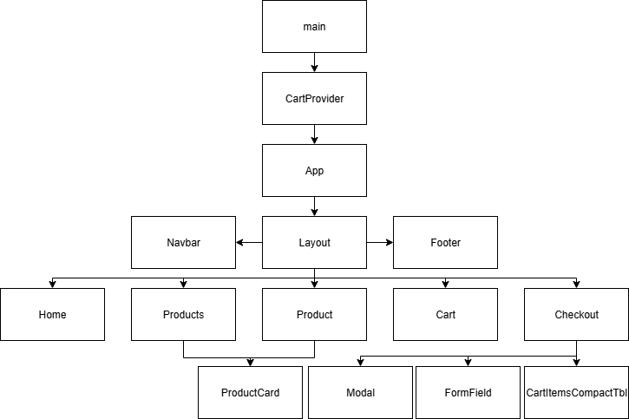
Slika 1: Drvo komponenti

Korisničko uputstvo
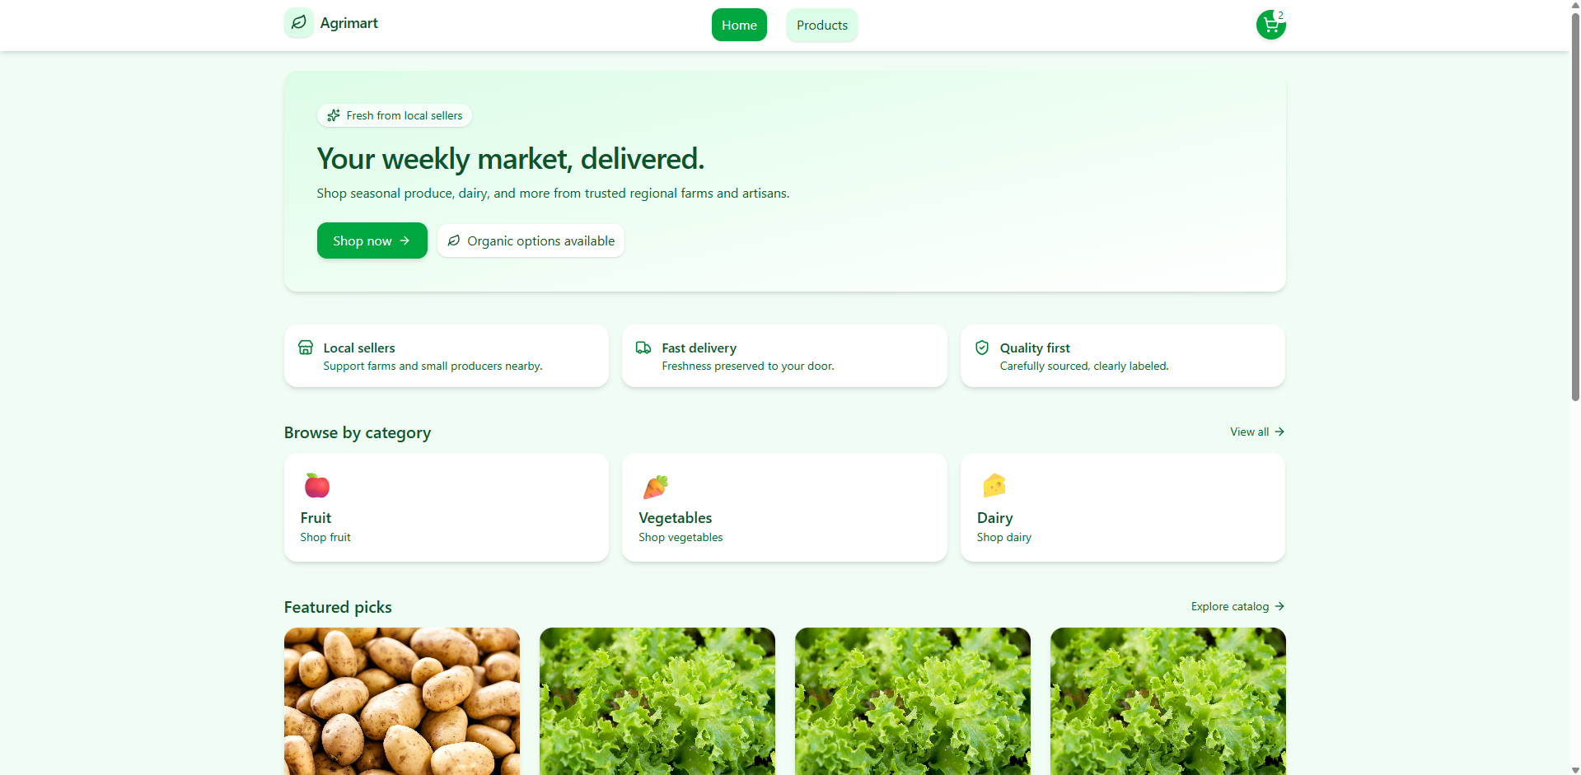
Slika 2: Početna strana
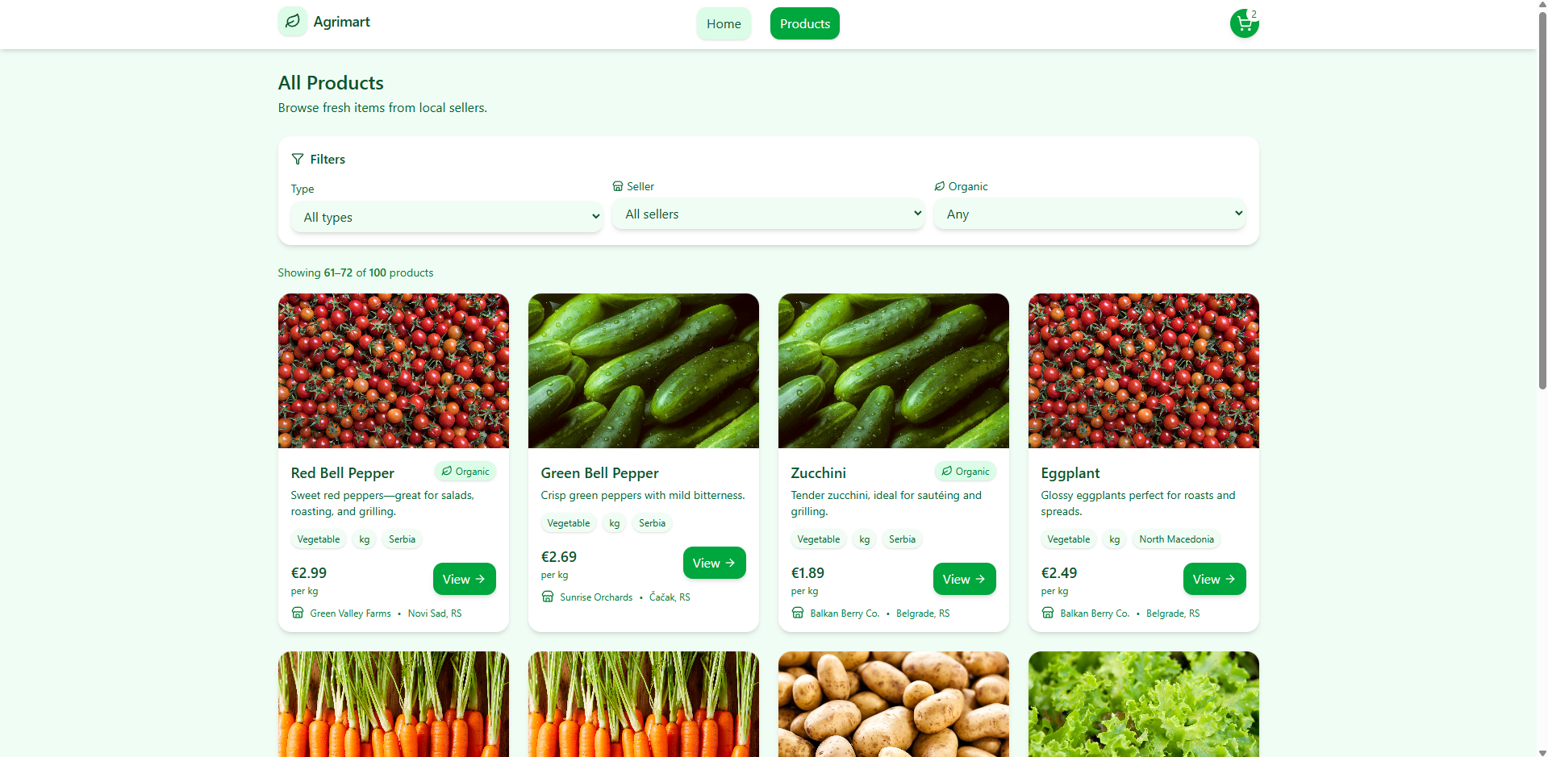
Slika 3: Stranica svih proizvoda
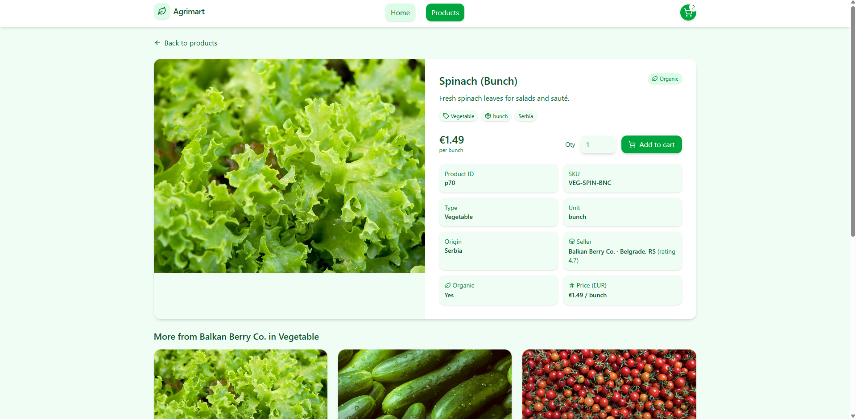
Slika 4: Stranica jednog proizvoda
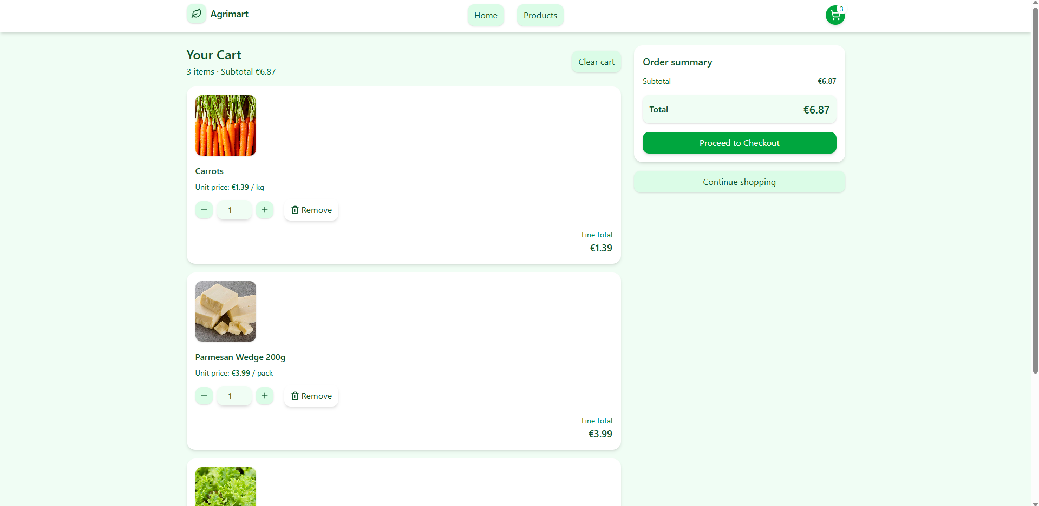
Slika 5: Korpa
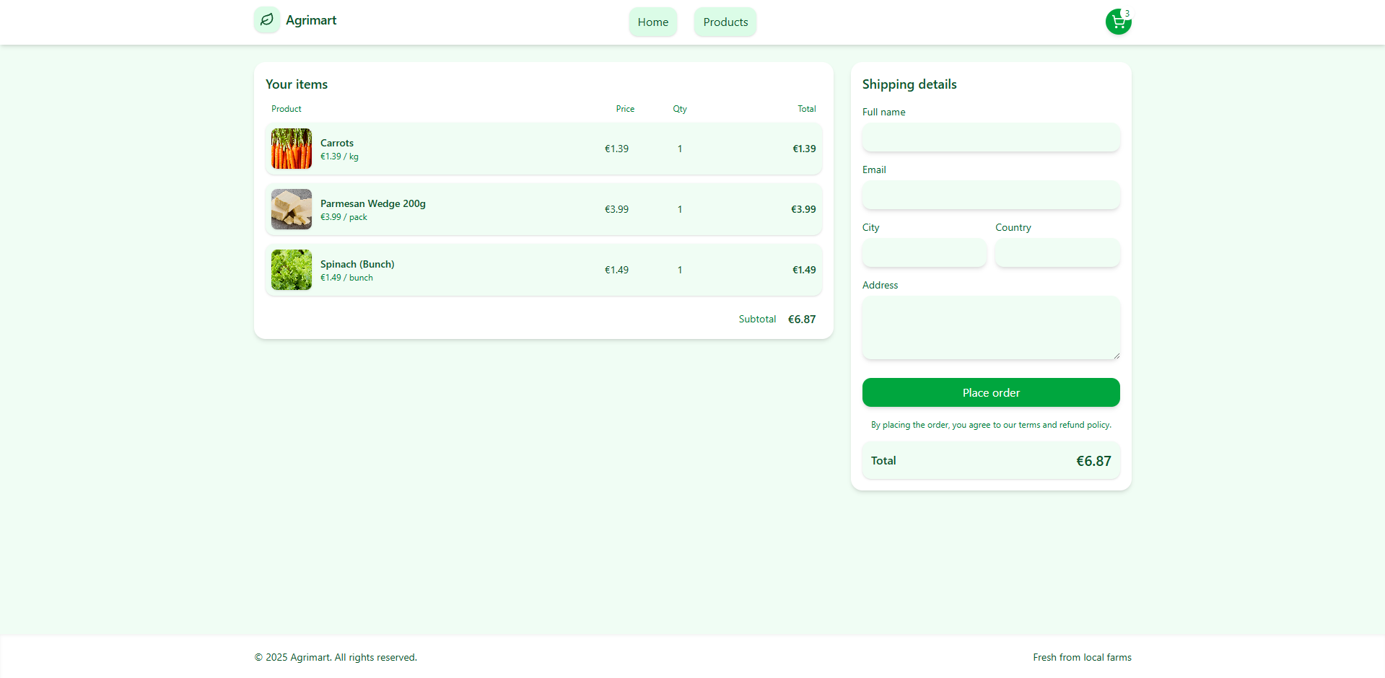
Slika 6: Checkout
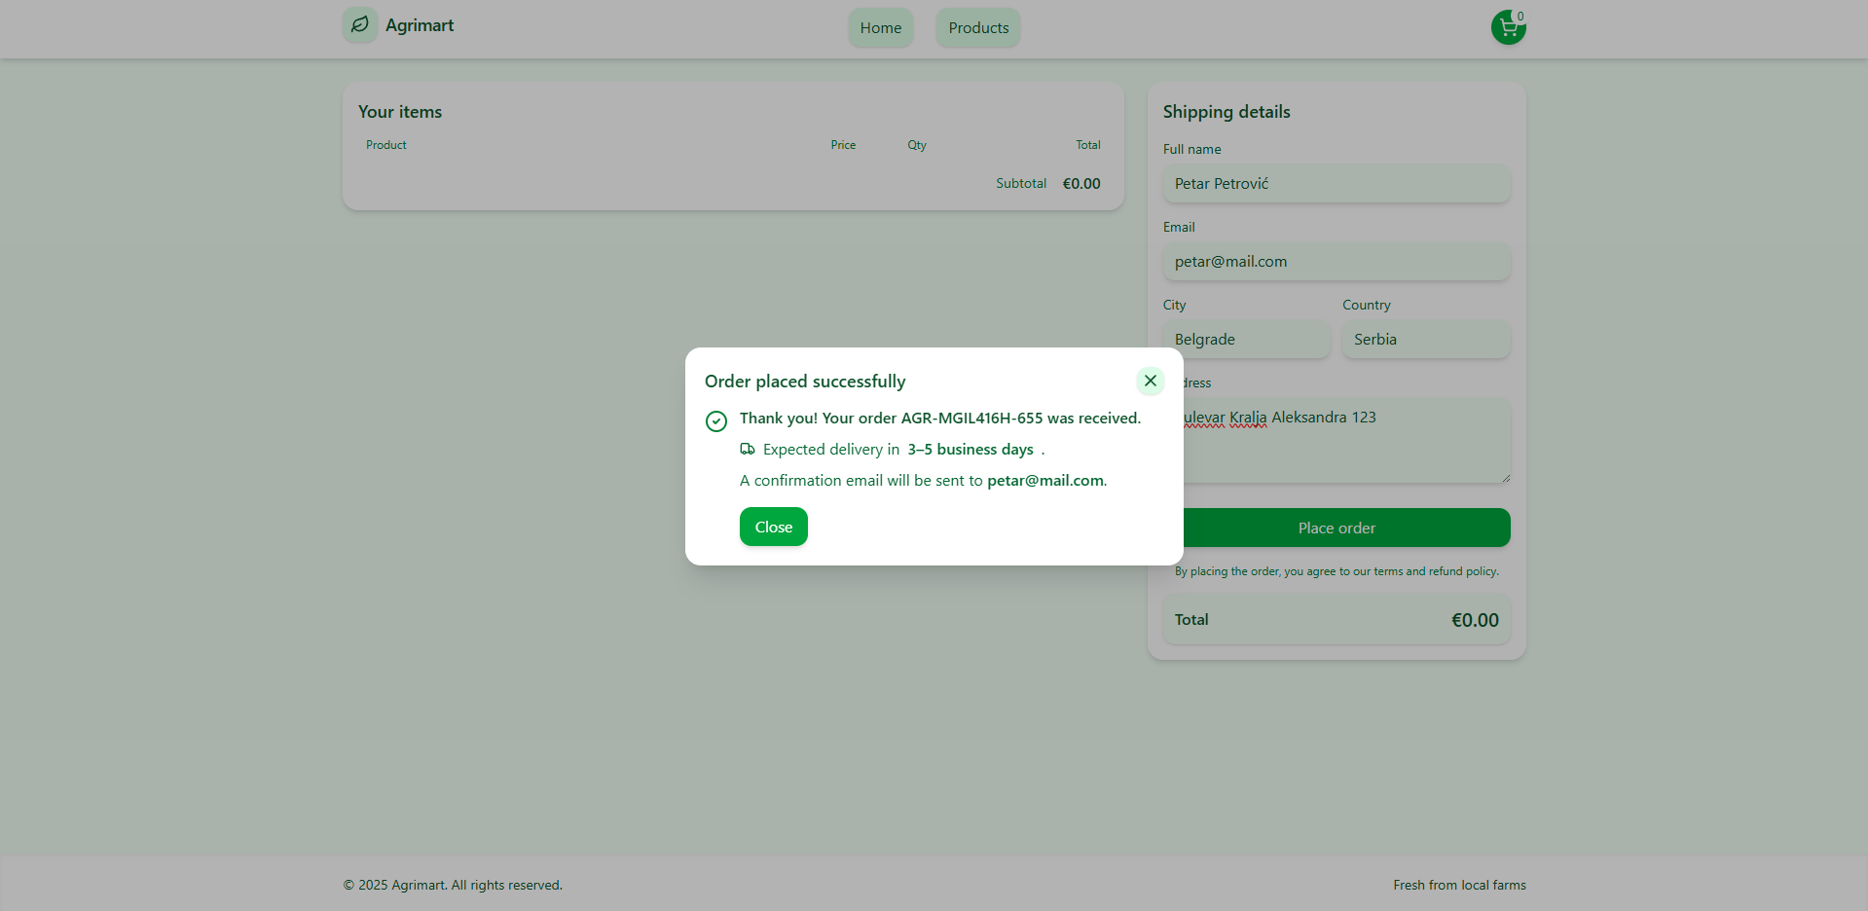
Slika 7: Poslata porudžbina

