# Solution_delivery_11503

1. **Issue Summary：**

0011503: Create a macro to transform store locator excel to IS53 file

1. **Issue Description：**

Create a macro or a standalone program to transform store locator excel to IS53 file

1. **Root Reason:**

No function

1. **Solution：**
2. Open eclipse, unzip “AutoGeneratedCVS.7z”,import project
3. Install JDK1.6 ,set JAVA HOME

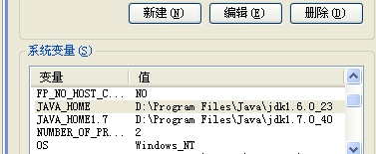

1. In Console, Run “IS53Generator.bat .\wtchk_prod_storelocator_201406011.xls .\wtchk_prod_storelocator_201406011.csv ”
2. Run SQL “\igc\patches\oracle\longstring.sql”

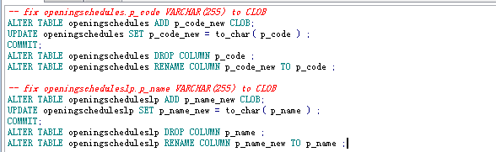

1. Import csv file
2. **Tested Environment:**

|  |  |  |  |
| --- | --- | --- | --- |
| Device | Browser | version | Test Result |
| Desktop | IE 8 |  |  |
| IE 9 |  |  |
| Firefox25.0 |  |  |
| Chrome32.0 |  |  |
| Mobile IOS 5.0+ | Safari |  |  |
| Mobile Android 3.0+ | Webkit(Chrome) |  |  |

1. **Comment：**
2. **Appendix:**