for="obj in objects"
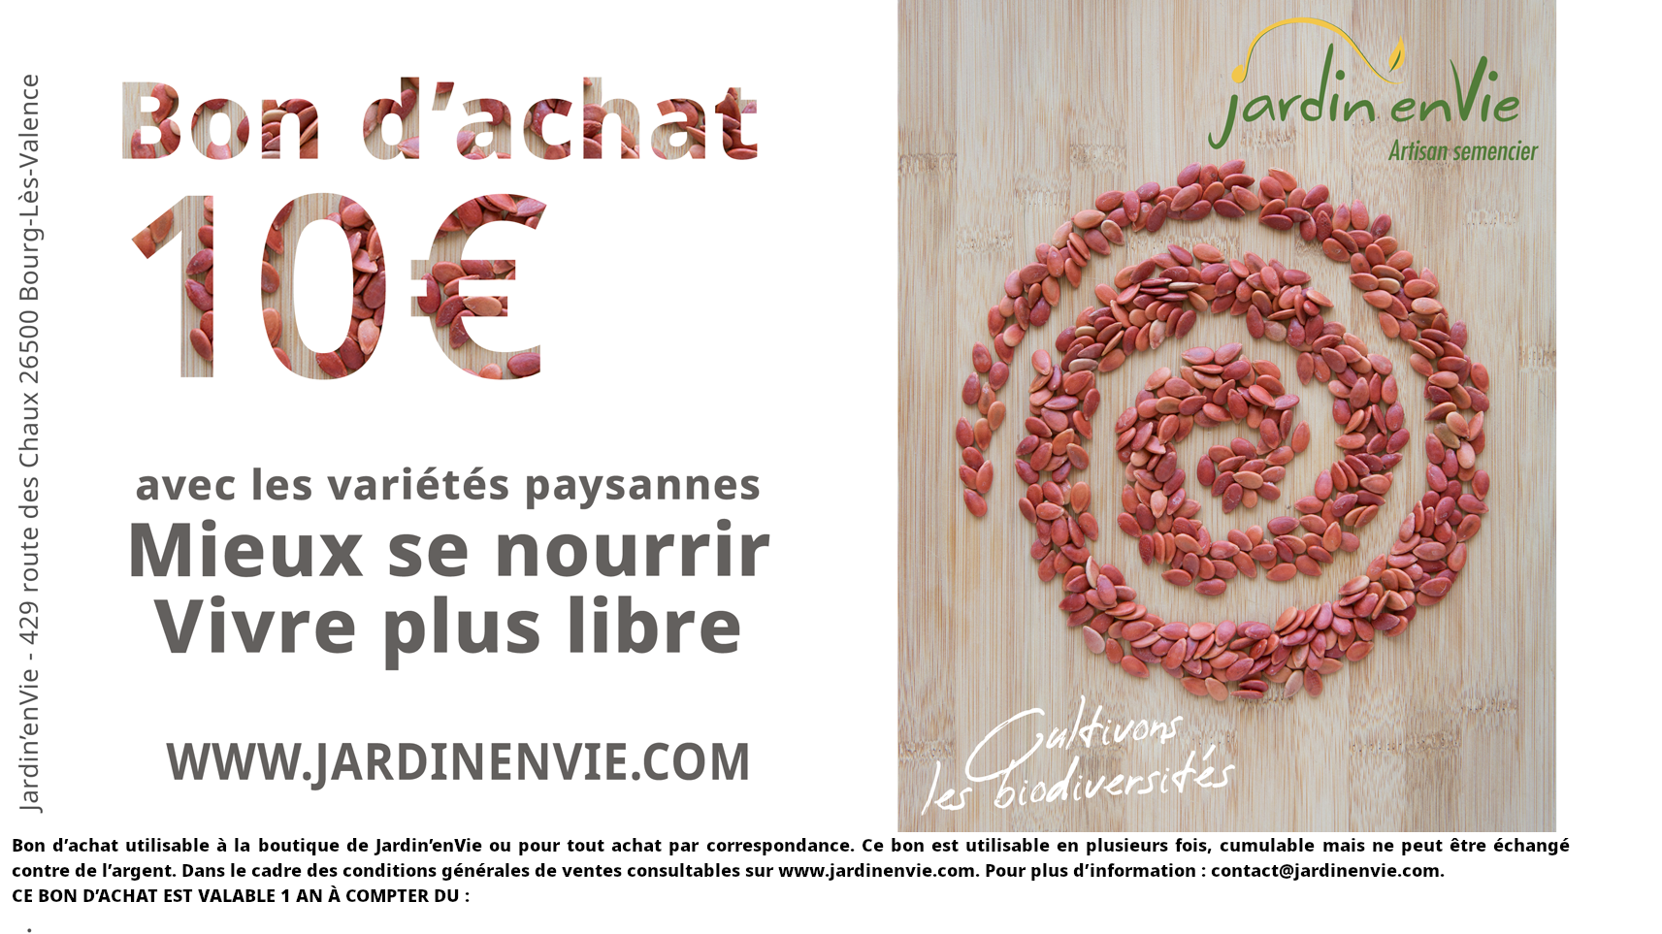
0
0

/for

