Watering Dashboard
Interactive management system for watering zones, plants, permissions, photos, and audit logs
Elad Hayek - 211873542 | Shirin Fakiri - 208154815 | Daniel Gunko - 340969674 | Gleb Tyutrin - 324726306

Problem  Watering areas, plant locations, and access permissions are difficult to manage when the information is spread between maps, files, and manual updates.  Solution  A local full-stack web dashboard centralizes watering zones, plant markers, uploaded photos, user permissions, and activity history in one organized interface.  Main Capabilities  • Interactive maps: create and edit watering areas with Leaflet.  • Plant management: place plants or watering stations inside each area.  • Access control: assign users to areas and control who can update data.  • Audit log: track important user and system actions.  Technology  React, Leaflet, Node.js, Express, MySQL, authentication, image uploads, and role-based access control.  Impact  The dashboard improves visibility, reduces manual tracking, and gives managers a reliable operational history for watering activity. | Selected Screens  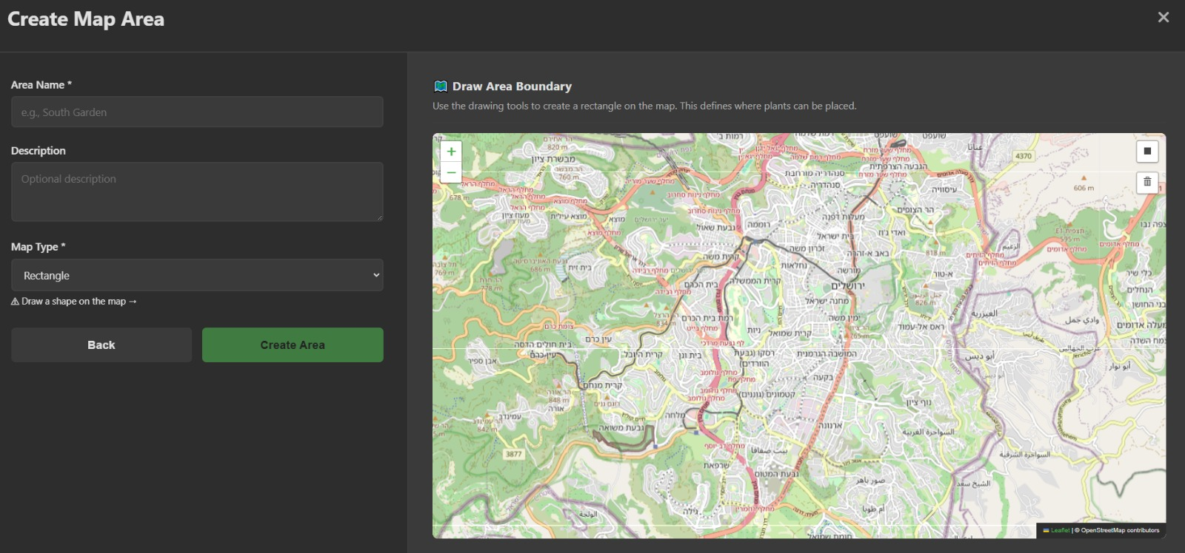 Create Map Area 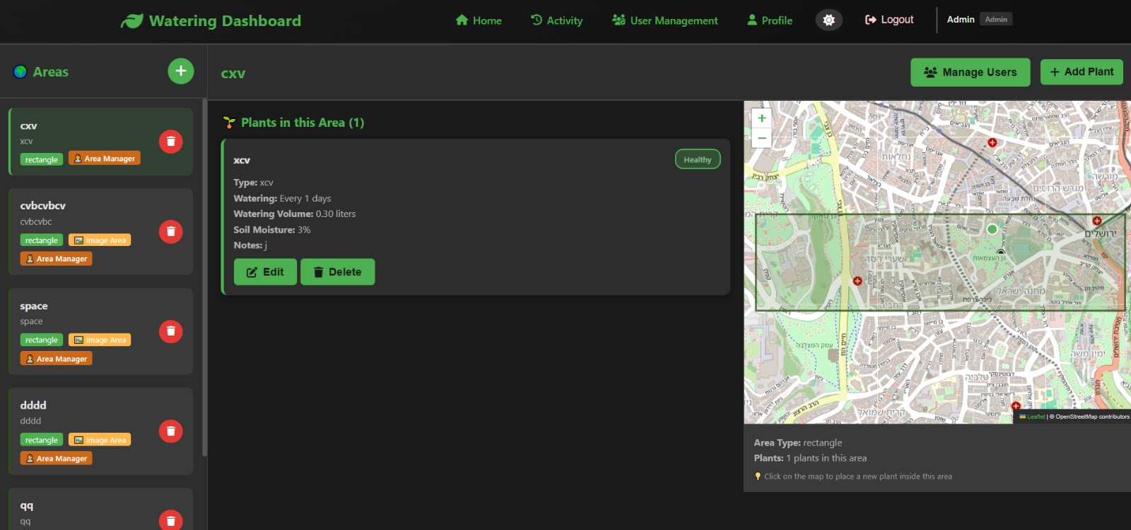 Selected Area View  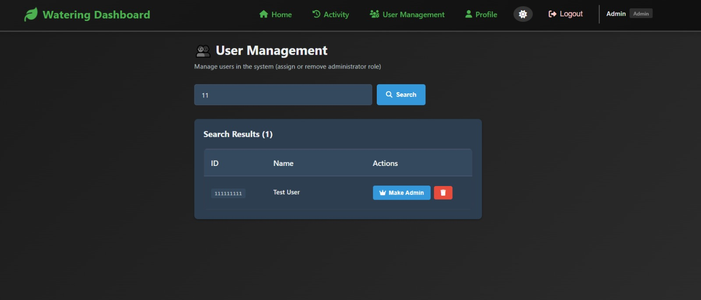 User Permissions 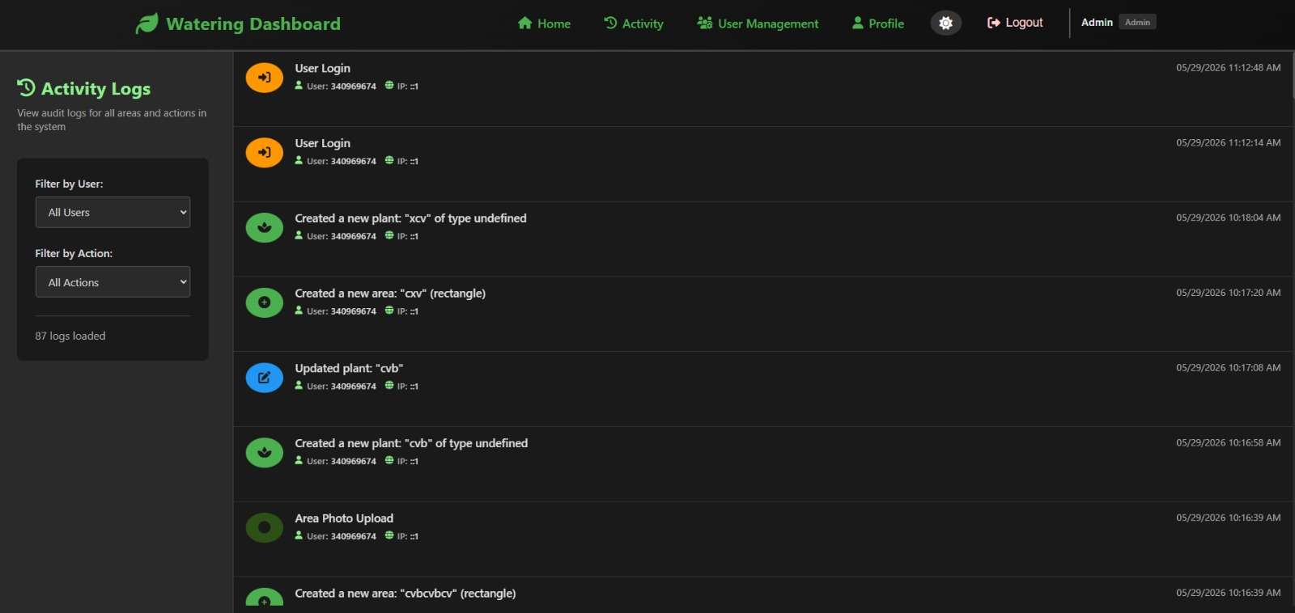 System Logs  Future Work  Mobile field updates, automatic watering schedules, sensor integration, GIS layers, and reporting dashboards.

