[TRACKING: instructions.md Step 1; syllabus p.1 metadata requirement]
Full Name (Hebrew) | Full Name (English) | ID Number (ת”ז) | Email Address | Phone Number | Lecture Group (Day/Hour)
[Insert Name] | [Insert Name] | [Insert ID] | [Insert Email] | [Insert Phone] | [Insert Group]
[TRACKING: instructions.md report title; syllabus Tasks 1 and 2]

Reverse Engineering Research Project
TrickBot Modular Malware, Independent Technical Briefings, and Conti Leaked Source-Code Evaluation
Research date: 6 June 2026
Scope rule: Sections explicitly marked optional in the syllabus are omitted.
Safety rule: This report describes architecture and defensive implications. It does not reproduce deployable malware, exploit code, or operational instructions.

[TRACKING: instructions.md Step 2; syllabus Task 1, mandatory technical profile]

Task 1 - TrickBot Modular Malware Dossier
[TRACKING: instructions.md Step 2, Architecture Overview; syllabus Task 1 technical-detail requirement]

1. Architecture Overview
TrickBot is a modular, multi-stage Windows malware platform, not merely a single banking Trojan. Microsoft describes a typical chain containing a changing wrapper, an in-memory loader, and the main malware module. The loader decrypts functions only when needed, resolves APIs dynamically, and starts the main module in memory. On 64-bit systems, some variants use Heaven’s Gate and a 64-bit loader before injection into a suspended process [S1].
The main component establishes persistence, identifies the host, decrypts its configuration, and retrieves only the modules needed for that campaign. This design separates stable orchestration from specialized capabilities and lets operators replace individual components without rebuilding the entire platform. Kaspersky catalogued dozens of 32-bit and 64-bit modules, while Check Point reported more than 20 modules active across TrickBot’s lifetime [S2][S3].
Representative functional modules
Module or family | Defensive interpretation
systeminfo / networkDll | Collects operating-system, process, domain, network, and Active Directory context.
pwgrab / tdpwgrab | Targets credentials and application data, including browsers, mail, remote-access tools, keys, and wallets.
injectDll / webiDll | Performs browser interception and web-inject activity against financial sessions.
adll | Uses native administration tools to collect Active Directory database and registry-hive material.
bcClient / NewBCtestn | Supplies reverse-proxy capability and can support movement through a compromised host.
mshare, tab, mworm / nworm, wormDll | Implements network propagation through shares, remote execution, stolen credentials, or an SMB exploit path.
Architectural consequence: defenders should correlate the loader, module-fetch behavior, memory execution, process injection, scheduled-task persistence, and the behavior of each downloaded module. A signature for one module cannot represent the full TrickBot platform.
[TRACKING: instructions.md Step 2, Infection Chain; syllabus Task 1 internal-mechanism requirement]

2. Infection and Execution Chain
- Delivery: historically, malicious Office documents, links, or another loader such as Emotet delivered the first stage [S4].
- Wrapper execution: a frequently changing wrapper obscures the stable loader and reduces simple hash-based detection [S1].
- In-memory loading: the loader decrypts code and strings at runtime, resolves Windows APIs dynamically, and launches the core component [S1].
- Privilege and persistence: variants may attempt UAC bypass and create scheduled tasks. Main components and plug-ins are commonly injected into legitimate processes such as svchost.exe [S1][S5].
- Configuration bootstrap: the bot decrypts embedded or local configuration data, derives a bot identity and campaign tag, and contacts controller infrastructure for updated configuration and modules [S1][S6].
- Capability expansion: modules perform credential theft, discovery, browser interception, proxying, Active Directory collection, propagation, or delivery of later payloads [S2].
- Network expansion: propagation modules enumerate reachable systems and domain resources, then use SMB shares, remote execution, credentials, or an exploit-dependent path [S2][S7].
This chain also explains why a forensic image may show different artifacts on different hosts: the controller can assign modules by architecture, campaign, privilege level, and network position.
[TRACKING: instructions.md Step 2, Cryptographic Layer; syllabus Task 1 internal technical mechanism]

3. Cryptographic and Obfuscation Layer
TrickBot’s cryptography changed between generations, so no single algorithm describes every sample.
- Configuration and module protection: early documented variants used AES in CBC mode. A custom iterative SHA-256 construction derives key and IV material from the encrypted blob. If AES parsing failed, the implementation could attempt an ECC-based path [S6].
- Additional wrapping: later configurations added a first-stage DWORD-wise XOR layer before the established configuration decoder. F5 observed the key and data length stored at the front of the configuration object [S8].
- Runtime concealment: the loader decrypts individual functions and strings only for use, then can re-encrypt them. APIs are resolved dynamically instead of appearing as a complete static import table [S1][S8].
- Windows CryptoAPI in resource handling: a documented variant acquired a provider with CryptAcquireContextW, imported key material with CryptImportKey, operated on an encrypted resource, and released handles with CryptDestroyKey [S9]. These calls describe that analyzed variant, not a guaranteed invariant of all TrickBot builds.
- Certificate-chain subversion in browser interception: newer injectDll variants hooked CertGetCertificateChain and CertVerifyCertificateChainPolicy so a locally generated certificate could support interception without normal browser validation failures [S2].
The protected objects include the hardcoded bootstrap configuration, updated controller lists, module binaries, module-specific configuration, and web-inject rules. Cryptography here serves confidentiality from analysts, integrity/control of tasking, and signature instability, rather than a single user-facing encryption function.
[TRACKING: instructions.md Step 2, Vulnerability Registry; syllabus Task 1 item 9]

4. Vulnerability and Propagation Registry
The MS17-010 bulletin covers a family of SMBv1 defects represented by CVE-2017-0143 through CVE-2017-0148. These include remote-code-execution and information-disclosure conditions in Microsoft SMBv1 [S10].
CVE | Assignment-relevant interpretation
CVE-2017-0143 | SMBv1 remote-code-execution vulnerability in the MS17-010 cluster.
CVE-2017-0144 | SMBv1 remote-code-execution vulnerability most commonly associated with EternalBlue reporting.
CVE-2017-0145 | SMBv1 remote-code-execution vulnerability in the same bulletin.
CVE-2017-0146 | SMBv1 remote-code-execution vulnerability in the same bulletin.
CVE-2017-0147 | SMBv1 remote-code-execution vulnerability in the same bulletin.
CVE-2017-0148 | SMBv1 information-disclosure vulnerability in the same bulletin.
Attribution caveat: listing the complete MS17-010 cluster does not prove that every TrickBot build exploited every CVE. Kaspersky identifies wormDll as an EternalBlue propagation component that places shellcode in lsass.exe memory and retrieves TrickBot [S2]. Palo Alto also warned that other TrickBot SMB propagation behavior differed from WannaCry’s EternalBlue implementation [S4]. Therefore, the defensible conclusion is:
- TrickBot had an EternalBlue-capable propagation path.
- TrickBot also used share- and credential-based propagation.
- Sample-specific reverse engineering is required before assigning a precise exploit implementation to one CVE.
[TRACKING: instructions.md TrickBot visual placeholder]
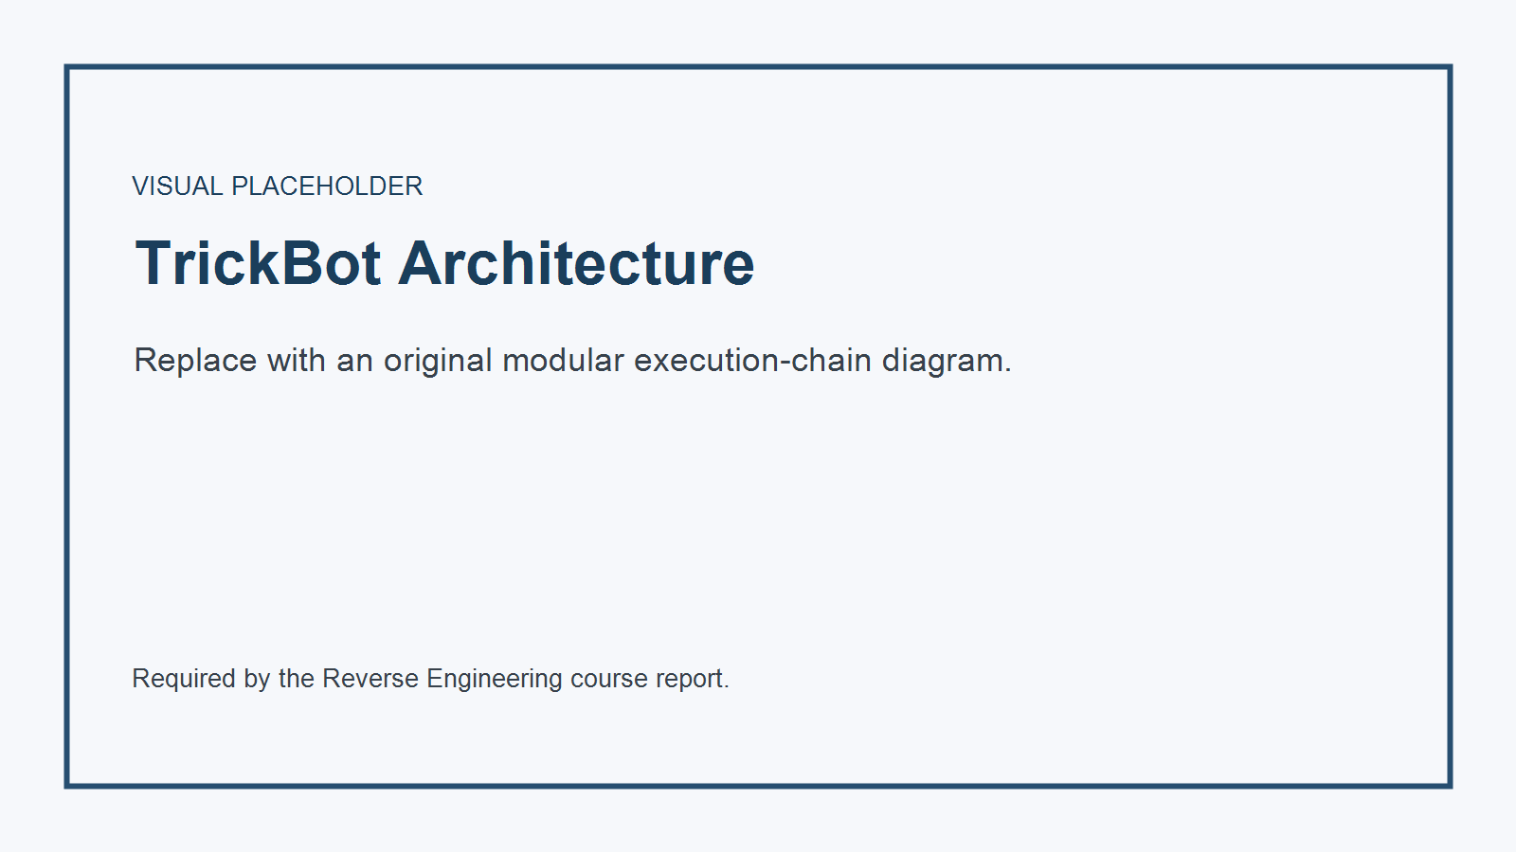
TrickBot Modular Architecture and Execution Chain Diagram

[TRACKING: instructions.md Step 3 Q11; syllabus p.4 Q11]

Q11 - Recent Vulnerability: CVE-2024-3400
CVE-2024-3400 is a critical PAN-OS GlobalProtect vulnerability disclosed on 12 April 2024. Palo Alto Networks describes the root condition as arbitrary file creation leading to operating-system command injection. On affected, specifically configured PAN-OS 10.2, 11.0, and 11.1 firewalls, an unauthenticated network attacker could execute code with root privileges [S11][S12].
Mechanism summary
- Untrusted GlobalProtect request data reached a file-creation path without a safe trust boundary.
- Attacker-controlled data later entered a privileged command-execution context.
- The impact crossed from a network-facing service to root-level appliance execution.
- Cloud NGFW, Panorama appliances, Prisma Access, and older PAN-OS branches listed by the vendor were not affected [S11].
Operationally, exploitation could provide full control of the firewall, credential or configuration access, persistence opportunities, and a pivot point into protected networks. The CVE was observed in production exploitation, which is why product configuration and exact hotfix levels matter more than the headline CVSS score alone.
[TRACKING: instructions.md Q11 visual placeholder]
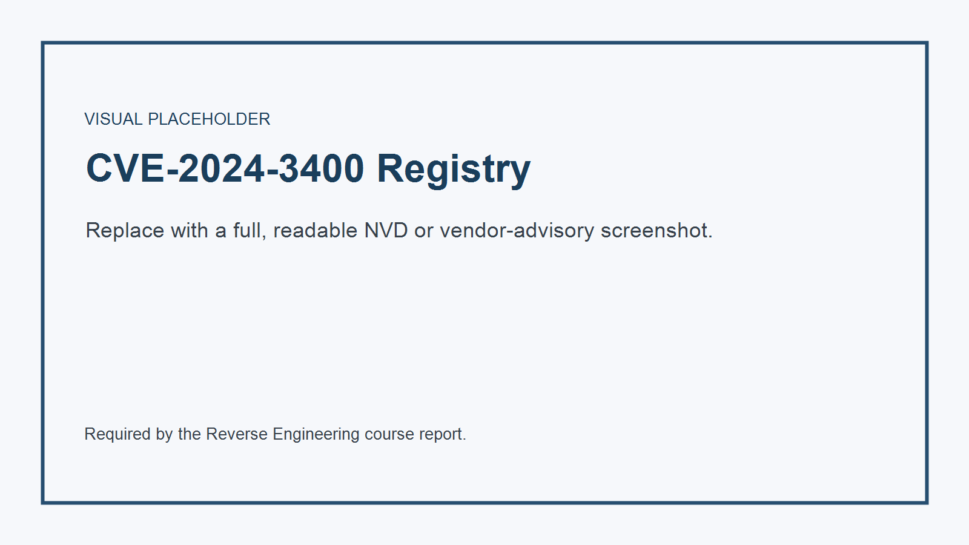
NVD Registry Technical Overview for Chosen CVE

[TRACKING: instructions.md Step 3 Q12; syllabus p.4 Q12]

Q12 - Two MITRE D3FEND Defensive Techniques
The following entries come from different D3FEND parent pillars.
[TRACKING: instructions.md Q12 Detect branch; MITRE D3FEND D3-PSA]

Detect: Process Spawn Analysis (D3-PSA)
Process Spawn Analysis evaluates process-creation attributes such as user, image path, process name, parent relationship, arguments, and security context to identify unauthorized execution [S13].
Configuration principles
- Collect process-creation telemetry with full image path, command line, user, integrity level, signer, hash, and parent process.
- Normalize command-line parsing before applying detections.
- Alert on impossible or rare parent-child relationships, execution from user-writable paths, and trusted names launched from untrusted locations.
- Do not trust parent PID alone; attackers can spoof it.
[TRACKING: instructions.md Q12 Harden branch; MITRE D3FEND D3-ACH]

Harden: Application Configuration Hardening (D3-ACH)
Application Configuration Hardening reduces attack surface by disabling unneeded features and limiting permissions according to the application’s actual environment [S14].
Configuration principles
- Disable unused remote interfaces, scripting, plug-ins, and legacy protocols.
- Run services with dedicated least-privilege identities.
- Restrict write access to configuration, extension, and executable paths.
- Maintain a version-controlled security baseline and alert on drift.
The first technique detects suspicious execution after process creation; the second reduces which application behaviors are available before exploitation.

[TRACKING: instructions.md Step 3 Q13; syllabus p.4 Q13]

Q13 - Chinese Threat Group: APT41
MITRE tracks APT41 (G0096) as a Chinese state-sponsored espionage group that also conducts financially motivated operations. Aliases include Wicked Panda, Brass Typhoon, BARIUM, and partial overlap with Winnti Group reporting [S15].
Target profile
- Healthcare, telecommunications, technology, finance, education, retail, and video-game organizations.
- Campaigns across at least 14 countries.
- Public-facing applications, software supply chains, and credentialed access are recurring entry points.
Verified custom or closely associated tooling
- BLACKCOFFEE, HIGHNOON, LOWKEY, DEADEYE
- DUSTPAN, DUSTTRAP, KEYPLUG
- Winnti-family backdoors and web shells such as China Chopper
- Commodity support tools including Cobalt Strike, Mimikatz, and Impacket
The distinction matters: commodity tools do not uniquely identify APT41. Attribution depends on infrastructure, victimology, timing, certificates, malware lineage, and TTP combinations.

[TRACKING: instructions.md Step 3 Q14; syllabus p.4 Q14]

Q14 - macOS Malware: RustBucket
RustBucket is a multi-stage macOS family associated by Jamf with the BlueNoroff/Lazarus ecosystem. Its first stage was a compiled AppleScript application masquerading as an internal PDF viewer. The Objective-C second stage opened a specially prepared PDF and retrieved a later payload [S16].
Processor architecture
- Intel Macs execute x86_64 Mach-O code natively.
- Apple Silicon Macs execute arm64 natively and may run supported Intel code through Rosetta 2.
- Jamf analyzed both ARM and Intel RustBucket executables, demonstrating that operators accounted for both hardware populations [S16].
A multi-architecture deployment can ship separate architecture-specific binaries or a universal Mach-O containing both slices. Native ARM64 support avoids relying on Rosetta availability and changes reverse-engineering details: register conventions, instruction set, calling convention, and disassembler output differ from x86-64. The high-level Objective-C application behavior, bundle structure, and Cocoa APIs can remain similar across both builds.

[TRACKING: instructions.md Step 3 Q15; syllabus p.4 Q15]

Q15 - Bring Your Own Vulnerable Driver (BYOVD)
BYOVD is a defense-evasion and privilege technique in which an attacker with sufficient installation rights loads a legitimately signed but vulnerable kernel driver. The signature satisfies the normal driver trust path, while unsafe device-control handlers expose privileged operations to user mode.
Real case: mhyprot2.sys version 1.0.0.0, the Genshin Impact anti-cheat driver, is tracked as CVE-2020-36603. NVD states that it inadequately restricts unprivileged function calls and can permit SYSTEM-level code execution after administrative installation [S17]. Trend Micro documented ransomware operators using the signed driver to terminate security processes [S18].
Pipeline
- The attacker obtains administrative execution through an earlier compromise.
- The signed vulnerable driver is dropped and registered as a kernel service.
- A user-mode controller opens the device object and sends exposed IOCTLs.
- The driver performs privileged memory or process operations on the controller’s behalf.
- Security products are terminated or altered from kernel context, after which the primary payload proceeds.
Mitigation requires more than patching the original game: vulnerable-driver blocklists, WDAC/HVCI, driver inventory, and alerts on new kernel services are needed because an old signed driver can be carried independently.

[TRACKING: instructions.md Step 3 Supply Chain; syllabus p.5 Q24; instructions label Q20]

Q24 (Instructions: Q20) - XZ Utils Supply-Chain Backdoor
The XZ Utils 5.6.0 and 5.6.1 incident, tracked as CVE-2024-3094, is a landmark attempted supply-chain compromise.
Execution/distribution timeline
- 24 February 2024: xz 5.6.0 was released.
- 9 March 2024: xz 5.6.1 was released.
- The malicious build logic was present in release tarballs, while key trigger material was absent from the ordinary Git source view.
- 29 March 2024: Andres Freund publicly reported the issue after tracing abnormal sshd CPU use and authentication latency; Red Hat issued its urgent alert the same day [S19][S20].
The injected build process produced a modified liblzma that, under specific Linux build and service conditions, could interfere with sshd authentication through systemd-linked dependencies. The compromise targeted the build and distribution trust chain, not a normal xz feature [S19].
Blast radius
Affected packages reached development or unstable distributions including Fedora Rawhide/Fedora 40 beta and Debian unstable contexts. Discovery occurred before broad inclusion in stable enterprise distributions, sharply limiting real-world deployment. The potential impact was nevertheless severe because xz is a transitive dependency in widely deployed Linux software.

[TRACKING: instructions.md Step 3 RAT briefing; syllabus p.5 Q21]

Q21 - Popular RAT Framework: Remcos
MITRE tracks Remcos (S0332) as a closed-source Windows remote-control and surveillance tool that has repeatedly appeared in malicious campaigns [S21].
Capabilities
- Keylogging and clipboard collection.
- Automated screenshots and application-window discovery.
- Microphone capture and remote environmental observation.
- File search, upload, download, deletion, and archive creation.
- Registry control, persistence through Run keys, and UAC-bypass commands.
- Stored-browser-data collection and remote command execution.
The controller sends tasking to the installed agent; the agent invokes Windows APIs, packages results, and returns them over its remote channel. Keylogging captures input events over time, while screenshots and window enumeration give the operator visual and contextual awareness. These features make Remcos both a legitimate dual-use administration product and a high-risk post-compromise tool when deployed without authorization.

[TRACKING: instructions.md Step 3 fileless briefing; syllabus p.5 Q22]

Q22 - Fileless Malware Execution
“Fileless” describes an execution technique, not an absence of all artifacts. Attackers use trusted interpreters and memory-resident loading so the principal payload does not need to exist as a conventional executable on disk.
Typical flow
- A macro, command line, WMI event, registry value, or network response holds an encoded script or payload.
- PowerShell, WMI, JavaScript/VBScript, or a .NET runtime decodes the content.
- The runtime allocates memory and executes script, shellcode, or a reflectively loaded module.
- Persistence may remain in WMI or the registry rather than a normal executable path.
Microsoft notes that PowerShell and WMI can load scripts directly in memory and that reflective DLL loading can execute a library without normal disk-backed module loading [S22][S23]. Evidence still exists in process, script-block, AMSI, WMI, registry, memory, and network telemetry.

[TRACKING: instructions.md Step 3 AI vulnerability; syllabus p.5 Q20]

Q20 - LLM Infrastructure Vulnerability: Prompt Injection
OWASP classifies Prompt Injection as LLM01:2025. A direct injection comes from the user; an indirect injection is embedded in external content such as a web page, document, email, or image that the model later processes [S24].
The core weakness is a trust-boundary failure: instructions and data are represented in the same natural-language context, while the model may also hold tools or credentials. A successful injection can manipulate output, disclose sensitive context, invoke unauthorized functions, or influence a high-impact decision.
Mitigation
- Treat retrieved content and model output as untrusted.
- Give the model least-privilege, task-specific credentials.
- Validate tool arguments and outputs with deterministic code.
- Require human approval for privileged or irreversible actions.
- Separate external content from control instructions.
- Continuously test direct, indirect, multilingual, encoded, and multimodal injection cases.
RAG and fine-tuning can improve relevance but do not remove this architectural risk [S24].

[TRACKING: instructions.md Step 3 AI-enabled threat activity; syllabus p.5 Q25]

Q25 - Documented Threat-Actor Use of AI
Public reporting supports three distinct patterns.
- Code assistance: OpenAI and Microsoft reported that Charcoal Typhoon used models to debug code and generate scripts, while other state-affiliated actors requested scripting help, vulnerability research, and methods for hiding processes or evading detection [S25].
- Social engineering: Crimson Sandstorm and Emerald Sleet used models to draft or improve content suitable for spear-phishing. Later Microsoft reporting describes AI as an accelerator for polished lures, translation, identity maintenance, and malware debugging rather than a fully autonomous attacker [S25][S26].
- Machine-learning components inside stealers: trojanized Telegram and WhatsApp applications used Google’s ML Kit OCR to find cryptocurrency seed phrases in stored screenshots. SparkCat later used an OCR plug-in in malicious Android and iOS applications for the same objective [S27][S28].
The evidence does not justify claiming that LLMs independently conducted these campaigns. Human operators retained control of targeting and deployment; AI reduced language, coding, and data-processing friction.

[TRACKING: instructions.md Step 3 Q26; syllabus p.5 Q26]

Q26 - Iranian Threat Group: MuddyWater
MITRE identifies MuddyWater (G0069) as an Iranian cyber-espionage group assessed to be subordinate to the Ministry of Intelligence and Security. Aliases include Earth Vetala, MERCURY, Static Kitten, Seedworm, TEMP.Zagros, Mango Sandstorm, TA450, and MuddyKrill [S29].
Target profile
- Government, telecommunications, finance, defense, and oil and gas.
- Strong focus on the Middle East, with activity also in Asia, Africa, Europe, and North America.
Tool registry
- POWERSTATS PowerShell backdoor
- PowGoop loader
- Small Sieve Python backdoor
- Mori and MuddyC2Go backdoors
- Out1 Python tooling
- Commodity utilities such as LaZagne, Mimikatz, and remote-administration tools
Common tradecraft includes spear-phishing, PowerShell/VBScript/JavaScript execution, cloud file-sharing services for payload delivery, browser credential theft, and HTTP-based command and control. As with APT41, a commodity tool alone is insufficient attribution evidence.

[TRACKING: instructions.md Step 3 Q29; syllabus p.6 Q29]

Q29 - iOS Vulnerability Cluster: Operation Triangulation
Operation Triangulation used a zero-click iMessage chain against iOS versions up to 16.2. The attachment was processed without visible user interaction. Kaspersky’s reconstructed chain includes:
- CVE-2023-41990: remote code execution through an undocumented TrueType font instruction.
- JavaScriptCore manipulation and a privilege-escalation stage.
- CVE-2023-32434: XNU integer overflow used to gain broad physical-memory read/write capability.
- CVE-2023-38606: bypass of hardware-backed Page Protection Layer controls through undocumented MMIO behavior on A12-A16 SoCs [S30].
After kernel-level compromise, the chain removed exploitation artifacts, launched an invisible Safari stage, and installed the TriangleDB espionage platform.
Persistence correction: the toolset was not persistent across reboot. Kaspersky reported that devices could be reinfected after reboot, which can look like persistence from outside but is technically a fresh zero-click compromise [S31]. This distinction is important in both incident response and reverse engineering.

[TRACKING: instructions.md Step 4; syllabus Task 2 mandatory leaked-source evaluation]

Task 2 - Conti Ransomware Leaked Source-Code Evaluation
[TRACKING: instructions.md Step 4 repository hyperlink; syllabus Task 2 source-code URL requirement]

1. Repository and Provenance
Public research states that Conti source material was leaked on 27 February 2022, alongside internal communications, after the group publicly supported Russia’s invasion of Ukraine [S32].
Research links
- Public mirror used for structural review: https://github.com/gharty03/Conti-Ransomware
- Course-recommended malware-source index: https://github.com/ytisf/theZoo/tree/master/malware/Source/Original
- Peer-reviewed analysis: https://doi.org/10.1109/ACCESS.2022.3207757
The GitHub mirror warns that it contains fixes to intentionally damaged or missing build material. It is therefore a secondary mirror, not an authenticated original development repository [S33]. The theZoo link is an index recommended by the course material, but its current Source/Original listing is not evidence that it hosts this exact Conti tree [S34]. This report does not download, compile, or execute either repository.
[TRACKING: instructions.md Step 4 codebase structure; syllabus Task 2 technical analysis]

2. Codebase Structure
The public mirror reports C++ (62.8%) and C (37.2%) and exposes the following root structure: .vs/, Debug/, Release/, builder/, decryptor/, locker/, ContiLocker_v2.sln, R3ADM3.txt, and repository metadata [S33]. The first three directories are development/build artifacts; the meaningful product divisions are builder, decryptor, and locker.
The high-level structure separates:
Area | Function
Builder/configuration | Produces campaign-specific locker configuration and embedded values.
Locker/encryptor | Enumerates local and network files, applies encryption policy, writes ransom notes, and coordinates worker threads.
Decryptor | Reverses file transformation when supplied with matching key material.
API and string abstraction | Resolves libraries/functions dynamically and hides sensitive strings behind hashes or obfuscation macros.
Cryptographic modules | Implements asymmetric key wrapping and high-throughput file encryption primitives.
Filesystem/share enumeration | Walks directories, applies exclusion rules, and discovers network shares.
Network scanner | Enumerates candidate hosts and services used to find reachable shares.
Thread pool and queues | Schedules file and network work concurrently for throughput.
Logging/memory/string helpers | Supplies custom runtime support shared by the operational components.
The IEEE analysis identifies dynamic library loading, API hashing, anti-hooking/unhooking, command-line modes, share enumeration, network scanning, shadow-copy deletion, and multithreaded encryption as explicit source-level flows [S32]. Representative functional units discussed in analyses include API resolution, filesystem traversal, network scanning, encryption, RSA/key handling, thread-pool queues, logging, memory allocation, and custom strings.
[TRACKING: instructions.md Step 4 functional-module analysis; syllabus Task 2]

3. Functional Interpretation
- Startup and argument parsing choose local, network, or combined encryption scope and optional host-list input.
- API resolution keeps much of the true dependency set out of the static import table.
- Anti-hook logic attempts to restore clean system-library code before sensitive operations, reducing visibility from user-mode hooks.
- Discovery enumerates local volumes, directories, network addresses, and shares while applying exclusions.
- Concurrency places file work into queues consumed by multiple threads, increasing encryption throughput.
- Cryptography uses fast symmetric file encryption combined with attacker-controlled asymmetric key protection so recovery material is not locally available.
This is an architectural description only. Build steps, weaponization changes, keys, and deployable code are intentionally excluded.
[TRACKING: instructions.md Step 4 reverse-engineering advantage; syllabus Task 2]

4. Why Source Accelerates Reverse Engineering
Source code collapses uncertainties that take substantial time to resolve in assembly:
- Function and type boundaries are explicit.
- Data structures, queue ownership, and thread synchronization are visible.
- Conditional compilation reveals variant behavior.
- Error paths and exclusions are distinguishable from anti-analysis tricks.
- Cryptographic intent can be separated from compiler-generated operations.
- Source names provide hypotheses that can be validated against binaries and telemetry.
Source review does not replace binary analysis. A leak may be incomplete, modified, older than the observed sample, or built with different flags. Reverse engineers should use it as a comparative map, then verify each claim against the executable, runtime behavior, and independent reporting.
[TRACKING: instructions.md Step 4 repository visual placeholder]
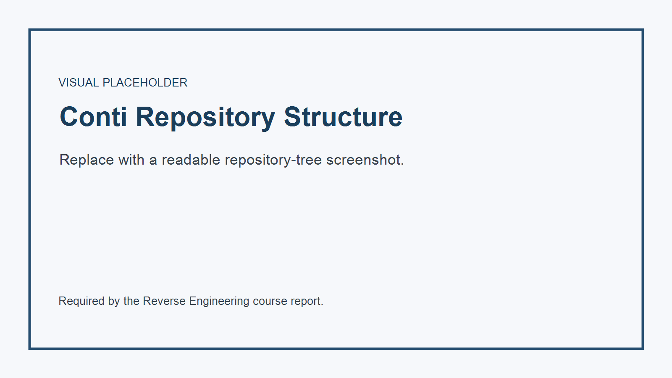
Leaked Source Code GitHub Repository Structure Overview
[TRACKING: instructions.md Step 4 code visual placeholder]
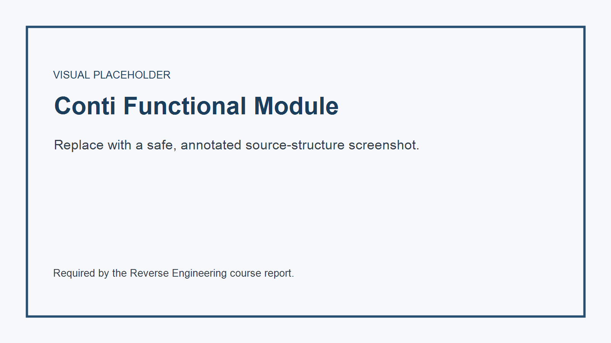
Code Snippet of Core Malware Functional Module

[TRACKING: instructions.md Step 5; syllabus source-list and article-copy requirements]

Reversed Bibliography
The complete numbered bibliography and source preservation checklist are in sources/source_manifest.md. Every inline reference [S#] maps to that register.
No full third-party articles are reproduced in this project. Before course submission, the student should create a separate, lawful PDF print or full-page screenshot of each cited article as required by the syllabus.

[TRACKING: instructions.md Step 6; syllabus p.2 AI policy]

AI Utility and Compliance Record
The AI-use record is in ai/ai_usage_log.md. It records the supplied prompts, research workflow, corrections, and manual verification tasks without claiming that AI output is an authoritative source.
[TRACKING: instructions.md Step 6 visual placeholder]
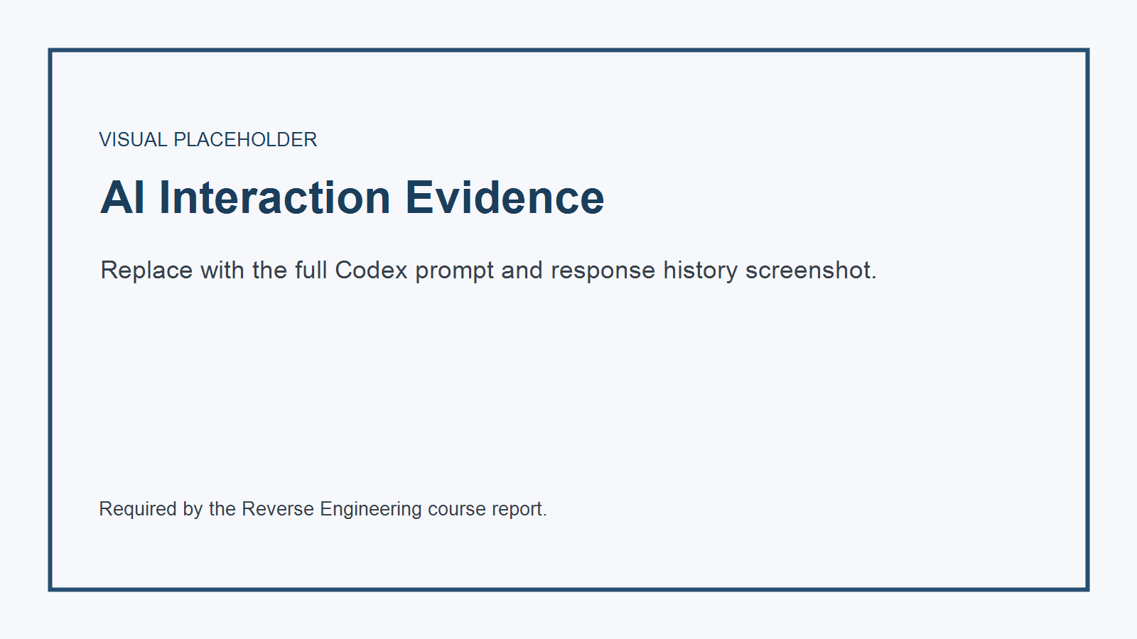
AI Workspace Interaction Audit Log History Screenshot

[TRACKING: instructions.md omission rule; syllabus optional-section policy]

Scope Compliance Statement
The report intentionally omits the syllabus sections explicitly marked optional, including historical background, full C2 infrastructure analysis, threat-group economics, Cyber Kill Chain mapping, anti-debug catalogues, additional injection-method surveys, and other optional expansions. Mandatory short independent questions selected by instructions.md are retained.

