Reverse Engineering Final Project
RCE2026B - TrickBot Malware Family and Leaked Conti Source Code
Full Name | Name in English | ID Number | Email | Mobile
Israel Mahari | Israel Mahari
Ofir | Ofir
Elad | Elad

Part I - Complex Malware Family: TrickBot
Section 1 - Sources and Research Articles
- MITRE ATT&CK, TrickBot (S0266). A broad, technique-mapped reference used to validate behavior and attribution. https://attack.mitre.org/software/S0266/
- Malpedia, win.trickbot. A consolidated timeline, alias, actor, and publication index. Individual claims were checked against the original linked reports. https://malpedia.caad.fkie.fraunhofer.de/details/win.trickbot
- SentinelOne, “How TrickBot Malware Hooking Engine Targets Windows 10 Browsers,” October 24, 2019. The principal reverse-engineering source for the WebInject hooking mechanism. https://www.sentinelone.com/labs/how-trickbot-malware-hooking-engine-targets-windows-10-browsers/
- ESET, “ESET Takes Part in Global Operation to Disrupt TrickBot,” October 12, 2020. Covers modular architecture, configuration files, fallback mechanisms, and command-and-control infrastructure. https://www.welivesecurity.com/2020/10/12/eset-takes-part-global-operation-disrupt-trickbot/
- Microsoft, “An Update on Disruption of TrickBot,” October 20, 2020. Provides operational context for the infrastructure disruption. https://blogs.microsoft.com/on-the-issues/2020/10/20/trickbot-ransomware-disruption-update/
- Eclypsium and Advanced Intelligence, “TrickBot Now Offers TrickBoot: Persist, Brick, Profit,” December 1, 2020. Technical analysis of the TrickBoot firmware module. https://eclypsium.com/wp-content/uploads/TrickBot-Now-Offers-TrickBoot-Persist-Brick-Profit.pdf
- Microsoft MSRC, MS17-010, March 14, 2017. Vendor advisory for SMBv1 vulnerabilities including CVE-2017-0144 and CVE-2017-0145. https://learn.microsoft.com/en-us/security-updates/securitybulletins/2017/ms17-010
Section 3 - General Technical Description
TrickBot is a modular malware family first observed in 2016. Its core communicates with command and control servers, receives configuration data, and downloads additional modules according to the selected target. It should not be classified as fully fileless: its campaigns used local files and services as well as in memory loading and injection.
Notable modules include:
- injectDll: injects code into browser processes and implements WebInject functionality for stealing banking credentials.
- systeminfo: collects information about the infected host and its network environment.
- pwgrab: steals passwords and data from configuration files and installed third-party applications.
Development languages and targets: MITRE describes TrickBot as primarily written in C++ and designed for Windows. Anchor, a related backdoor family used in selected TrickBot operations, also included Linux capabilities. The TrickBot core must therefore be distinguished from associated tools in the same criminal ecosystem.
Initial access commonly involved malicious attachments or links in phishing campaigns. TrickBot was also installed as a secondary payload on systems previously infected by Emotet. Its initial access was not generally based on a TrickBot zero day vulnerability.
After infection, TrickBot used vulnerabilities and remote services for lateral movement. MITRE maps it to T1210 and documents use of EternalBlue and EternalRomance in several modules. MS17-010 was disclosed and patched in March 2017, making later exploitation an n day attack against unpatched systems.
Cryptography and APIs: different versions used Windows CryptoAPI and later bcrypt functions for encryption and signing of command and control traffic. The WebInject module placed hooks inside browser processes so that data could be observed or modified before TLS encryption. The exact functions varied by browser and version.
Section 4 - Detailed Internal Mechanisms
API hooking and code injection: SentinelOne reported that WebInject components were injected into browser processes and hooked communication functions such as PR_Write in Firefox. This enabled interception of data before encryption and injection of content into displayed pages. MITRE also documents use of Nt* functions for injection into legitimate processes, including wermgr.exe.
Mutual exclusion: malware commonly creates a mutex to prevent duplicate execution. The principal sources used for this paper did not provide one stable mutex name that applies to every TrickBot version; therefore, a mutex should only be treated as an indicator of compromise when tied to a specific report and sample.
Obfuscation and anti analysis: TrickBot modules and configuration data were encrypted or obfuscated and decoded at runtime. MITRE maps the family to Software Packing and Obfuscated Files or Information. It also documents timing checks and API hammering, such as repeated printf and file input/output operations, which delay automated analysis.
Backdoor and update behavior: the malware maintained access through regular command and control communication, downloaded updated configurations and modules, and could retrieve additional payloads selected by the operator.
Section 9 - Vulnerabilities Used by TrickBot
MITRE documents TrickBot use of EternalBlue and EternalRomance for lateral movement. Microsoft advisory MS17-010 includes CVE-2017-0144 and CVE-2017-0145, remote code execution vulnerabilities in the way SMBv1 servers process specially crafted requests.
- CVE-2017-0144 - commonly associated with EternalBlue. NVD: https://nvd.nist.gov/vuln/detail/CVE-2017-0144
- CVE-2017-0145 - commonly associated with EternalRomance. NVD: https://nvd.nist.gov/vuln/detail/CVE-2017-0145
Microsoft released MS17-010 and security updates on March 14, 2017. In common exploitation scenarios, an unauthenticated attacker sends a specially crafted packet to a vulnerable SMBv1 server. Recommended mitigations include installing the updates and disabling SMBv1. TrickBot incorporated exploitation after vendor disclosure and patch availability, so its use is classified as n day exploitation.
Section 11 - Recent Vulnerability
CVE-2025-32463 - Sudo chroot Local Privilege Escalation.
Published on June 30, 2025, this vulnerability affects Sudo versions 1.9.14 through versions before 1.9.17p1. Use of the --chroot option may cause Sudo to load /etc/nsswitch.conf from a directory controlled by a local user. An attacker can cause untrusted code to be loaded and obtain root privileges. The CVE record lists a CVSS 3.1 score of 9.3. The recommended fix is an upgrade to Sudo 1.9.17p1 or later. https://www.cve.org/CVERecord?id=CVE-2025-32463
Section 12 - Two MITRE D3FEND Mechanisms
System Call Filtering - Isolate: the mechanism applies a restrictive policy to the system calls available to a process. Even after code execution, the payload may be prevented from opening network connections, accessing sensitive files, or performing other critical operations. https://d3fend.mitre.org/technique/d3f:SystemCallFiltering/
Process Termination - Evict: the operating system or an endpoint security product forcibly terminates a process that exhibits malicious behavior or violates a defined rule. Removing the active process from memory can interrupt the attack chain before additional damage occurs. https://d3fend.mitre.org/technique/d3f:ProcessEviction/
Section 13 - Chinese Threat Group
Selected group: APT41.
Names and aliases: MITRE tracks APT41 as G0096 and lists Wicked Panda, Brass Typhoon, and BARIUM. Reporting partially overlaps with the Winnti Group label. Double Dragon appears in Mandiant reporting, but vendor taxonomies are not identical and every Winnti-labelled operation should not automatically be attributed to APT41.
Regions and sectors: the group has conducted global operations against healthcare, telecommunications, technology, government, finance, education, retail, and video game organizations. Its operations include both intelligence collection and financially motivated activity.
Tools: documented software includes PlugX, ShadowPad, Cobalt Strike, PowerSploit, Mimikatz, web shells, DUSTPAN, and DUSTTRAP.
Notable operation: Operation ShadowHammer, disclosed in 2019, compromised the ASUS update mechanism and distributed a digitally signed malicious file. Researchers associated it with the Winnti/BARIUM ecosystem that overlaps with APT41. https://attack.mitre.org/groups/G0096/
Section 14 - macOS Malware
XCSSET (MITRE ATT&CK S0658) is a modular macOS malware family active since at least August 2020. It spread through infected Xcode projects and executed when a developer built the project. Capabilities include backdoor access, information theft, keylogging, screenshots, modification of development projects, and additional module downloads. https://attack.mitre.org/software/S0658/
Section 15 - Bring Your Own Vulnerable Driver
Malware: RobbinHood ransomware. Vulnerable driver: gdrv.sys, a legitimately signed Gigabyte driver. Vulnerability: CVE-2018-19320. The flaw enables privileged kernel memory access. RobbinHood used the driver to terminate antivirus and endpoint security processes before encrypting files. https://news.sophos.com/en-us/2020/02/06/robbinhood-ransomware-brings-a-vulnerable-driver-to-the-party/
Section 17 - Process Analysis Defense
Process Spawn Analysis - Detect / Process Analysis. This mechanism monitors how new processes are created and evaluates parent child relationships. Suspicious examples include Microsoft Word unexpectedly launching cmd.exe or PowerShell. Such anomalies can trigger an alert or prevention action. https://d3fend.mitre.org/dao/artifact/d3f:ProcessSpawnAnalysis/
Section 18 - Anti-Debug Mechanism
IsDebuggerPresent is a Windows API function exported by kernel32.dll. It checks the BeingDebugged field in the current process's Process Environment Block. Malware may change behavior, terminate, or conceal its payload when a debugger is detected. https://anti-debug.checkpoint.com/techniques/debug-flags.html
Section 19 - Privilege Escalation
Bypass User Account Control - MITRE ATT&CK T1548.002. Malware can abuse auto elevated Windows programs such as fodhelper.exe or sdclt.exe. By changing selected per user registry keys, the attacker can hijack the elevated program's execution flow and run a payload with administrative privileges without displaying the normal UAC consent prompt. https://attack.mitre.org/techniques/T1548/002/
Section 20 - Supply-Chain Attack
Example: the SolarWinds Orion supply chain compromise and the SUNBURST backdoor.
Insertion point: the attackers compromised the software build environment. Malicious code was incorporated into SolarWinds.Orion.Core.BusinessLayer.dll, built as part of the legitimate product, digitally signed, and distributed through the normal update channel.
Timeline: preparatory tests in the build environment began in 2019. SUNBURST bearing updates were distributed primarily from March through June 2020. FireEye publicly disclosed the incident on December 13, 2020 after investigating an intrusion into its own network.
Scale: approximately 18,000 customers downloaded an update that could contain the compromised component. This number is not the count of organizations that received follow on exploitation. the attackers selected a much smaller subset.
Technical behavior: SUNBURST delayed execution, collected environmental information, checked for conditions intended to avoid unwanted systems, and communicated with command and control infrastructure using disguised traffic. Additional payloads were delivered to selected targets. https://cloud.google.com/blog/topics/threat-intelligence/evasive-attacker-leverages-solarwinds-supply-chain-compromises-with-sunburst-backdoor
Section 21 - Popular RAT Module
NanoCore RAT is a modular remote access trojan written for the .NET environment. Its capabilities include keylogging, file transfer, screenshots, remote camera and microphone access, password theft, and plugin based extension. Leaked and cracked versions increased its availability to criminal and state linked operators. Research has associated NanoCore campaigns with multiple actors, including reporting related to APT33. https://blog.morphisec.com/nanocore-under-the-microscope
Section 22 - Fileless Malware Example
NetWalker ransomware, also known as Mailto, was reported during 2019 and 2020 campaigns. Its infection chain used PowerShell and obfuscated scripts to decode and load the ransomware payload in memory. Trend Micro documented reflective loading and injection into a legitimate process, reducing direct storage of the final payload on disk. Campaigns during 2020 targeted healthcare and educational organizations. https://www.trendmicro.com/en_us/research/20/e/netwalker-fileless-ransomware-injected-via-reflective-loading.html
Section 23 - Malware Using WebInject
Dridex is an advanced banking trojan that steals financial credentials. When a victim browses to a targeted banking site, WebInject logic can modify the page by adding fraudulent HTML or JavaScript fields that request authentication codes or payment information. Form grabbing functions capture submitted data before HTTPS protects it in transit. Dridex operators maintained target specific injection configurations rather than relying exclusively on a generic kit. https://www.virusbulletin.com/uploads/pdf/magazine/2015/vb201507-Dridex.pdf
Section 24 - Attack Against AI or LLM Systems
Prompt Injection causes an LLM enabled application to follow malicious instructions that conflict with the developer's intended behavior. In direct injection, the attacker enters the instruction in the conversation. In indirect injection, the model reads it from an external source such as a webpage, document, email, or retrieval-augmented-generation dataset. Impact can include rule bypass, unauthorized tool use, disclosure of data supplied to the model, or manipulation of an automated workflow. MITRE ATLAS maps Prompt Injection as AML.T0051. Sources: https://atlas.mitre.org/ and https://owasp.org/www-project-top-10-for-large-language-model-applications/
Section 25 - Malware Assisted by AI
Rhadamanthys Information Stealer version 0.7.0 included an AI/OCR-assisted feature for detecting images that contain cryptocurrency wallet seed phrases. The capability scans images on the infected system, identifies likely candidates, and enables sensitive text stored in screenshots or photographs to be collected. This is an example in which AI is part of the malware's collection capability rather than merely a development aid. Recorded Future, 2024: https://go.recordedfuture.com/hubfs/reports/mtp-2024-0926.pdf
Section 26 - Iranian Threat Group
MuddyWater, also known as Mango Sandstorm and Earth Vetala, is linked by public reporting to Iran's Ministry of Intelligence and Security. Its primary objectives include cyber espionage, strategic intelligence collection, and theft of sensitive information.
Recent operations targeted Israeli organizations, including local government, technology, and government sector entities, as well as organizations elsewhere in the Middle East. The group frequently abuses legitimate remote management tools such as Atera and Syncro. Check Point documented its use of a custom backdoor named BugSleep. https://research.checkpoint.com/2024/new-bugsleep-backdoor-deployed-in-recent-muddywater-campaigns/
Section 28 - Use of an AI Tool
Tool and version: OpenAI Codex (GPT-5). Documented use date: June 8, 2026.
The selected questions were Section 13, Chinese threat group, and Section 20, supply-chain attack. The raw prompts and responses are reproduced below and were checked against MITRE ATT&CK and Mandiant research.
Prompt 1 - Section 13
Write an English answer for Section 13 of a reverse-engineering assignment. Select a Chinese threat group and provide: (1) its name and aliases, (2) targeted regions and sectors, (3) major software tools, and (4) one notable operation. Use reliable sources, distinguish established facts from uncertain attribution or group overlap, and include links.
Raw Response 1
The selected group is APT41, a China-linked threat group associated with state-sponsored espionage and financially motivated activity. MITRE tracks it as G0096 and lists Wicked Panda, Brass Typhoon, and BARIUM. Reporting partially overlaps with Winnti Group, but not every Winnti-labelled activity should automatically be attributed to APT41. The group has targeted healthcare, telecommunications, technology, finance, education, government, and video-game organizations. Documented tools include PlugX, Cobalt Strike, PowerSploit, Mimikatz, web shells, DUSTPAN, and DUSTTRAP. Operation ShadowHammer compromised the ASUS update mechanism and was associated with the Winnti/BARIUM ecosystem that overlaps with APT41. Source: https://attack.mitre.org/groups/G0096/
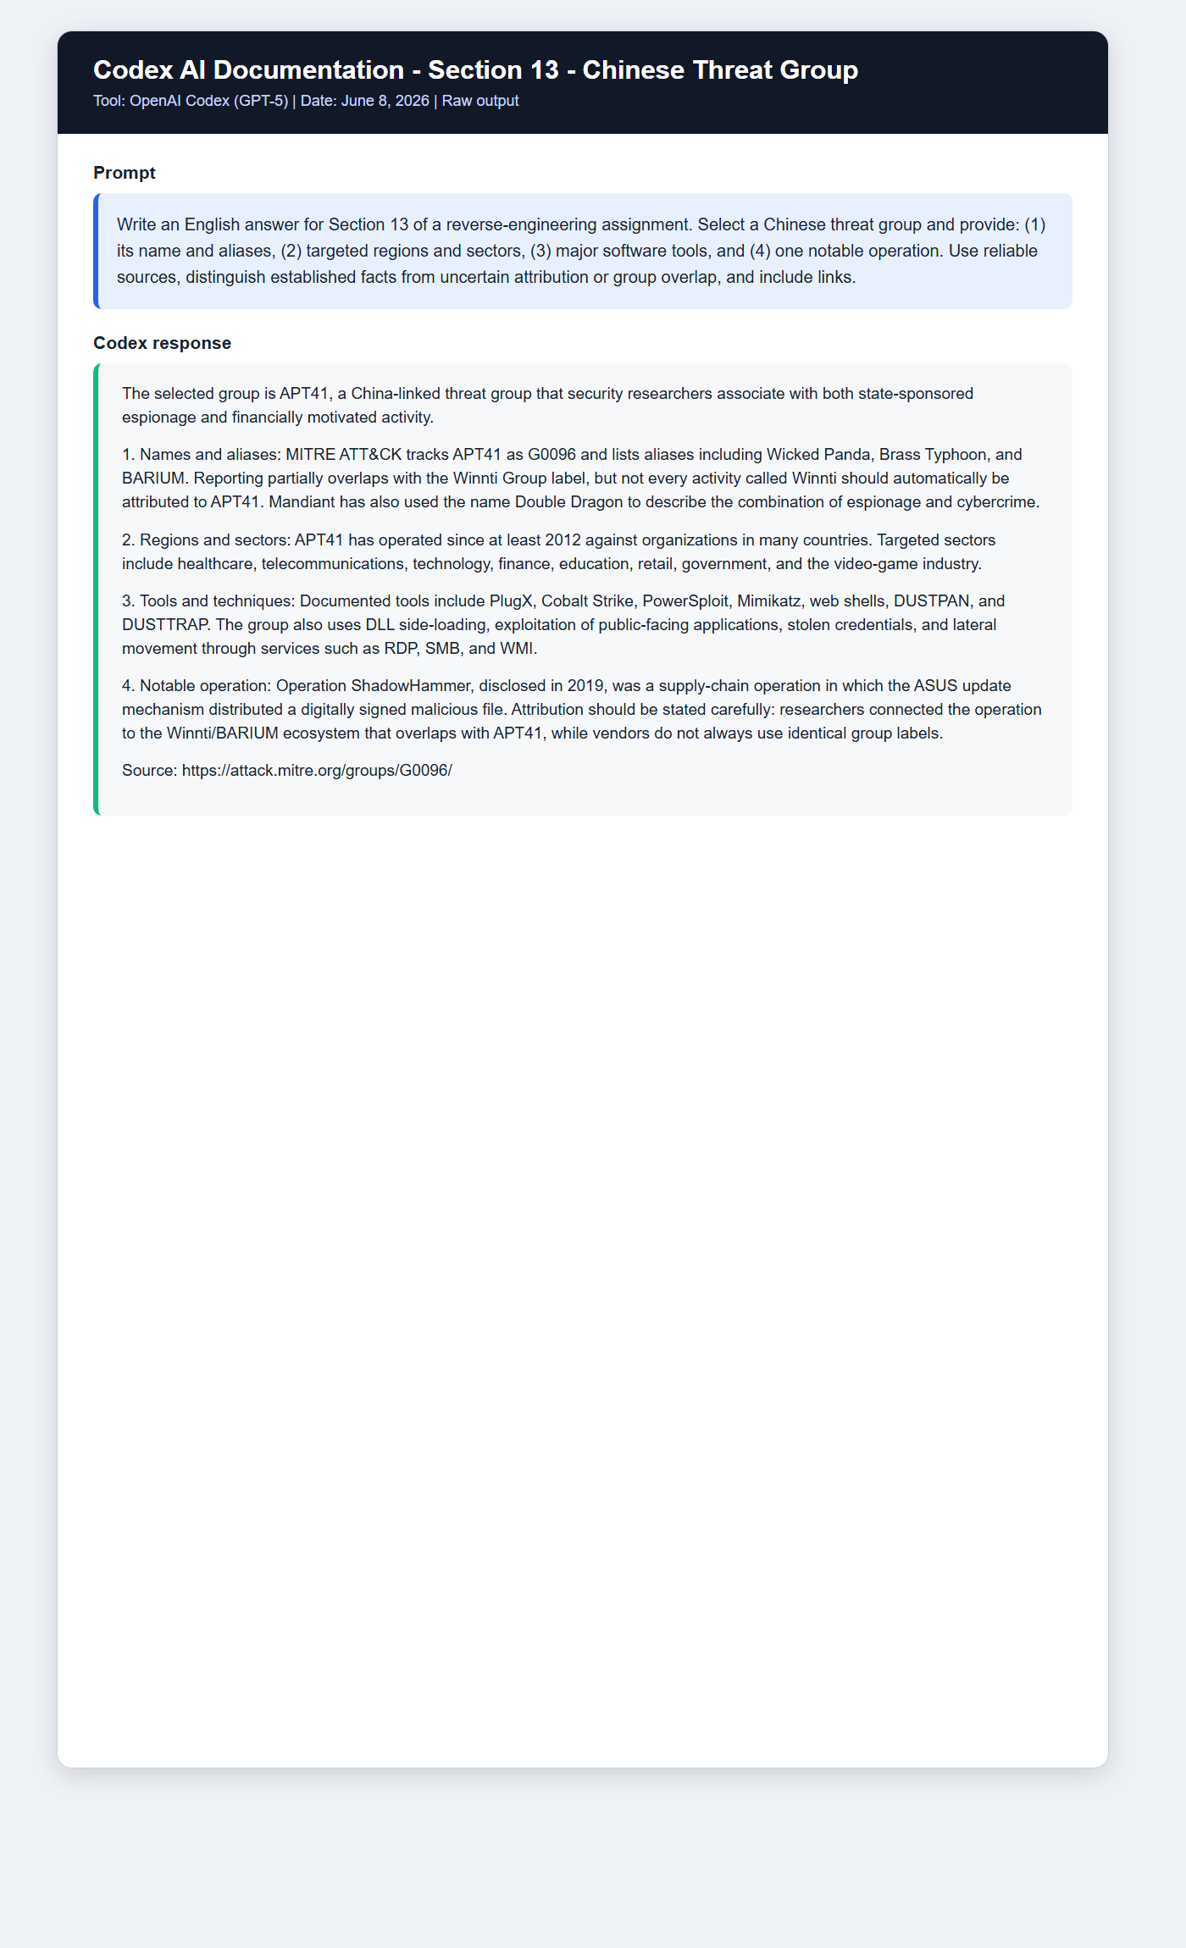
Prompt 2 - Section 20
Write an English answer for Section 20 of a reverse engineering assignment using SolarWinds/SUNBURST as a supply chain example. Explain where the code was inserted, when insertion and distribution occurred, when the incident was discovered and disclosed, how many organizations installed the update, and the technical mechanism. Clearly distinguish confirmed facts from estimates and provide primary or technical research sources.
Raw Response 2
The SolarWinds incident compromised the software build environment, allowing SUNBURST to be incorporated into an Orion DLL, digitally signed, and distributed through the legitimate update channel. Preparatory activity began in 2019, and affected updates were distributed primarily between March and June 2020. FireEye publicly disclosed the incident on December 13, 2020. Approximately 18,000 customers downloaded a potentially affected update, but only a smaller subset received follow-on exploitation. SUNBURST used delayed execution, environment checks, and disguised command-and-control traffic before delivering additional payloads to selected targets. Source: https://cloud.google.com/blog/topics/threat-intelligence/evasive-attacker-leverages-solarwinds-supply-chain-compromises-with-sunburst-backdoor
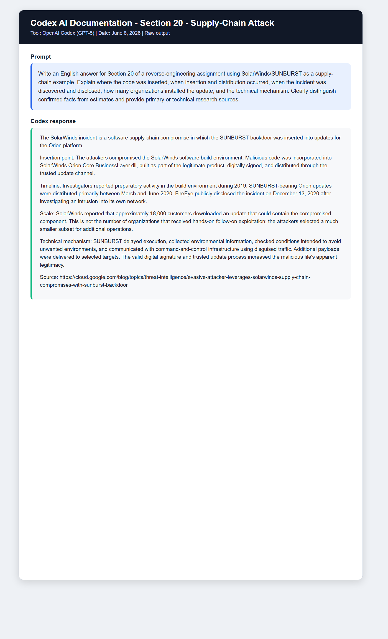
Section 29 - iPhone/iOS Vulnerability
CVE-2023-32434 is an integer-overflow vulnerability in the Apple kernel that was actively exploited as one component of the Operation Triangulation chain. It enabled kernel level code execution, but the complete zero click compromise, sandbox escape, and spyware deployment depended on multiple vulnerabilities rather than this CVE alone. Apple fixed it in iOS and iPadOS 16.5.1 and corresponding platform releases. The spyware primarily operated in memory and did not maintain conventional persistence across reboot. Sources: https://support.apple.com/en-us/102162 and https://www.kaspersky.com/blog/triangulation-attack-on-ios/48353/
Section 30 - Persistence Technique
Registry Run Keys / Startup Folder - T1547.001. Malware adds a value under a location such as HKCU\Software\Microsoft\Windows\CurrentVersion\Run. Windows launches the configured payload when the user logs in, allowing the attacker to retain access across restarts. https://attack.mitre.org/techniques/T1547/001/
Section 31 - Local Privilege Escalation
Access Token Manipulation: Token Impersonation/Theft - T1134.001. Malware uses Windows APIs such as ImpersonateLoggedOnUser or DuplicateTokenEx to copy or steal an access token from a more privileged process. The attacker then performs actions under the security context of the privileged account or SYSTEM. https://attack.mitre.org/techniques/T1134/001/
Section 32 - Lateral Movement
Remote Services: SMB/Windows Admin Shares - T1021.002. After obtaining valid credentials, an attacker copies tools or payloads to administrative shares such as C$ or ADMIN$ over SMB and executes them on remote Windows hosts. https://attack.mitre.org/techniques/T1021/002/
Section 33 - Exfiltration
Exfiltration Over C2 Channel - T1041. Stolen documents, credentials, or database content are transmitted through the command and control channel already used by the malware. Reusing an existing HTTP, HTTPS, or other disguised channel avoids creating a separate, easily identified exfiltration connection. https://attack.mitre.org/techniques/T1041/
Section 34 - Lockheed Martin Cyber Kill Chain
Selected stage: Delivery. During Delivery, the attacker transfers the exploit or payload into the victim's environment. Typical methods include phishing attachments, malicious links, compromised websites, removable media, and supply chain channels. In a TrickBot campaign, an Office document or phishing link may deliver a downloader, or Emotet may deliver TrickBot as a secondary payload. Relevant defenses include email filtering, attachment sandboxing, blocking macros from the Internet, and user training. https://www.lockheedmartin.com/en-us/capabilities/cyber/cyber-kill-chain.html

Part II - Leaked High-Level Source Code
Conti Ransomware Source-Code Leak
The selected subject is the Conti ransomware source code leaked in February 2022. It is a different malware family from TrickBot.
Conti operated as ransomware as a service. The leaked Windows oriented C/C++ code includes file and network share discovery, multithreaded encryption, command line options, dynamic API resolution, API name hashing, and anti analysis logic.
The studied leak was published on February 27, 2022. Reconstructed public repositories may contain build corrections made by repository maintainers, so they must be distinguished from the originally leaked files.
Source code repository, for static academic review only: https://github.com/gharty03/Conti-Ransomware
Analysis article: Saleh Alzahrani, Yang Xiao, and Wei Sun, “An Analysis of Conti Ransomware Leaked Source Codes,” IEEE Access, 2022, DOI 10.1109/ACCESS.2022.3207757. https://doaj.org/article/a1f9eedb587e4e7c85a488c87c61a7e7
The researchers analyzed code structure and flow, API hashing, dynamic loading, anti hook mechanisms, command line arguments, and multithreaded encryption. They also compared static and controlled dynamic observations with flows visible in the source code.
Search queries used: “Conti source code leaked,” “Conti leaked source code analysis,” and “An Analysis of Conti Ransomware Leaked Source Codes.”

Part III - Summary, Opinion, and Conclusions
TrickBot demonstrates the evolution of a banking trojan into a modular platform used for credential theft, reconnaissance, lateral movement, and delivery of additional payloads. Comparing MITRE, SentinelOne, ESET, Microsoft, and Eclypsium shows why malware findings must be tied to a version and date: a capability found in one module or sample is not necessarily present in every generation.
A central defensive lesson is the need for layered controls: hardened email and macro policies, patch management and SMBv1 removal, process and parent child monitoring, least privilege, endpoint detection and response, network monitoring, and reliable backups. Research involving leaked malware code should separate static academic review from compiling or executing operational malware.
In our opinion, one of the most important developments is the commercialization of cybercrime. Ransomware as a service, leaked RAT source code, reusable modules, and AI assisted collection capabilities lower the entry barrier for attackers. At the same time, prompt injection and other AI specific attack techniques create a new defensive surface. Security practitioners must continuously study attacker techniques through frameworks such as MITRE ATT&CK, D3FEND, and ATLAS while validating claims against primary technical research.

