MCMC Sampling Methods for Bayesian Linear Regression:
A Comparative Study of Metropolis-Hastings, Gibbs Sampling,
Hamiltonian Monte Carlo and Adaptive Metropolis
Predicting Cloud Server CPU Load Using the Bitbrains Datacenter Traces
Extended Edition: corrected diagnostics, preconditioned sampling, cross-validation between samplers, and a calibration repair
Elad Dagmi & Shaked Mizrahi
Advanced Methods in Machine Learning
August 2026

Abstract
This project compares Markov Chain Monte Carlo (MCMC) sampling methods for Bayesian linear regression, applied to predicting CPU utilisation of virtual machines in a production cloud datacenter. We implement Metropolis-Hastings (MH), adaptive (preconditioned) Metropolis-Hastings, Gibbs Sampling, Hamiltonian Monte Carlo (HMC) and a robust Student-t regression sampler from scratch in Python and NumPy, and evaluate them on the Bitbrains Datacenter Traces (GWA-T-12).
Relative to a first round of experiments, this extended study revises three conclusions and adds two results. The revisions all follow from replacing two diagnostics: effective sample size is re-estimated with the Geyer initial monotone positive sequence estimator, and convergence with split R-hat rather than the plain Gelman-Rubin statistic.
The most consequential revision concerns Metropolis-Hastings. The first round concluded that all three samplers approximate the same posterior, and cited this as evidence of implementation correctness. Under split R-hat that conclusion does not hold for MH: its worst split R-hat is 1.47, and its posterior means differ from the Gibbs solution by up to 0.315. For comparison, the widest direction of the posterior has a standard deviation of only 0.044, so the discrepancy is larger than the posterior spread itself. Gibbs Sampling and HMC agree with each other to within 0.00053, so the disagreement is specific to MH rather than evidence of a shared modelling error. Plain MH has not converged in 10,000 draws, and the earlier diagnostic was too weak to reveal it.
We trace this to the geometry of the posterior, which is strongly anisotropic (condition number 273, largest coefficient correlation 0.77) because the lagged CPU features are nearly collinear. Two repairs were attempted. Estimating the proposal covariance from the chain's own history in the standard adaptive-Metropolis manner fails outright here, collapsing to 1.2% acceptance, because the unpreconditioned chain mixes too slowly during burn-in to estimate anything. Preconditioning instead with the observed Fisher information, refined by adaptation, raises the average ESS from 9.3 to 217.2, brings acceptance to 27.5% against the theoretical optimum of 23.4%, and reproduces the Gibbs posterior means to within 0.00061.
To rule out an error shared by all of our implementations, the same posterior was also sampled with emcee 3.1.6, an established third-party library whose ensemble algorithm is unrelated to any of ours. It reproduces the Gibbs posterior means to within 0.00080, confirming that the model, and not merely our sampling of it, is correctly implemented.
Finally, we identify the true cause of the over-wide credible intervals reported earlier. They were attributed to weakly informative priors; in fact the test residuals have an excess kurtosis of 109, so a Gaussian likelihood inflates the noise variance to accommodate rare CPU spikes and every interval is sized for a spike that usually does not occur. Replacing it with a Student-t likelihood, sampled as a normal scale mixture so that all conditionals stay conjugate, moves 50% interval coverage from 94.5% to 73.7% against a nominal 50%, narrows the mean 50% interval from 0.534 to 0.068, and reduces the median absolute prediction error from 0.0462 to 0.0186.

Table of Contents
1. Introduction
2. Theoretical Background
2.1 Bayesian Linear Regression
2.2 Markov Chain Monte Carlo
2.3 Metropolis-Hastings
2.4 Adaptive (Preconditioned) Metropolis-Hastings
2.5 Gibbs Sampling
2.6 Hamiltonian Monte Carlo and NUTS
2.7 Robust Regression as a Normal Scale Mixture
2.8 Convergence Diagnostics
2.9 Computational Complexity Analysis
3. Dataset: Bitbrains Datacenter Traces
4. Methodology
4.1 Feature Engineering and Model Specification
4.2 Sampler Implementations
4.3 Experimental Setup
5. Results
5.1 Posterior Geometry: Why Plain Metropolis-Hastings Fails
5.2 Convergence Analysis
5.3 Sampling Efficiency with Corrected Diagnostics
5.4 Validation Against an External Library (emcee)
5.5 Prediction Accuracy
5.6 Calibration: Diagnosis and Repair
5.7 Sensitivity to Hyperparameters
5.8 Sensitivity to the Starting Point
6. Discussion
7. Conclusions and Extensions
8. References
9. Code

1. Introduction
In Bayesian machine learning, inference means computing a posterior distribution over model parameters given observed data. For most models this posterior has no closed form, because the normalising integral cannot be evaluated analytically. Markov Chain Monte Carlo (MCMC) methods solve this by constructing a Markov chain whose stationary distribution is exactly the target posterior, so that simulating the chain long enough produces samples from it.
This project compares MCMC samplers on a concrete prediction task: forecasting the CPU utilisation of virtual machines in a production cloud datacenter. The Bayesian framing is chosen deliberately. A point forecast of CPU load is of limited operational use; what a capacity-planning or overload-detection system needs is a calibrated statement of how uncertain that forecast is. MCMC gives us the full predictive distribution rather than a single number.
We study five samplers, all implemented from scratch:
- Metropolis-Hastings (MH): the most general MCMC algorithm, using a random-walk proposal with an accept/reject step.
- Adaptive Metropolis-Hastings: the same algorithm, but with the proposal covariance learned from the chain during burn-in. We report it because it fails on this posterior, for a reason that turns out to be informative.
- Preconditioned Metropolis-Hastings: the proposal is instead shaped by the observed Fisher information, obtained from a single least-squares fit, and refined during burn-in. This is the version that works.
- Gibbs Sampling: a special case of MH that samples each parameter block from its exact full conditional distribution, which is available here because the priors are conjugate.
- Hamiltonian Monte Carlo (HMC): a gradient-informed method that simulates Hamiltonian dynamics to propose distant states with high acceptance probability.
- Robust Student-t regression: a Gibbs sampler over an augmented model that replaces the Gaussian likelihood with a Student-t, introduced in response to a diagnostic finding in Section 5.6.
An external reference implementation, the emcee library, is used in Section 5.4 to check the posterior independently of our own code.
The study is deliberately structured around three questions that go beyond reporting summary statistics. Why does one sampler underperform another on this specific posterior? Do our from-scratch implementations agree with an established library? And when a reported metric looks anomalous, what is actually causing it? All three proved productive. The first identified a geometric cause that suggested its own remedy; the second, combined with a stricter convergence diagnostic, showed that one of our samplers had not converged at all; and the third turned an over-coverage anomaly into a change of likelihood that improved both calibration and point accuracy.

2. Theoretical Background

2.1 Bayesian Linear Regression
The model relates a design matrix X to a target vector y through coefficients beta and a noise variance sigma-squared:
y | X, β, σ² ~ N(Xβ, σ²I)
Instead of a point estimate, Bayesian inference targets the joint posterior:
p(β, σ² | y, X) ∝ p(y | X, β, σ²) · p(β) · p(σ²)
We use conjugate, weakly informative priors:
β ~ N(0, τ²I), τ² = 10 σ² ~ Inverse-Gamma(a₀ = 2, b₀ = 1)
Conjugacy is chosen deliberately so that the comparison is fair: it gives Gibbs Sampling exact full conditionals, while the same log-posterior remains differentiable for HMC and evaluable pointwise for MH. Every sampler therefore targets an identical distribution, and any difference between them is a property of the algorithm rather than of the model.

2.2 Markov Chain Monte Carlo
An MCMC method generates a sequence of dependent samples from a Markov chain built so that its stationary distribution is the target posterior. The standard sufficient condition is detailed balance, which states that the chain is reversible with respect to the target:
π(x) · T(x → y) = π(y) · T(y → x)
Under detailed balance together with ergodicity and aperiodicity, the chain converges to π from any starting point. Convergence is asymptotic, so early samples that still reflect the starting point are discarded as burn-in. Because the samples are dependent, the number of draws is not the amount of information they carry; that is what effective sample size, defined in Section 2.8, measures.

2.3 Metropolis-Hastings
MH proposes a new state from a proposal distribution q and accepts it with probability:
α = min(1, [π(θ') · q(θ | θ')] / [π(θ) · q(θ' | θ)])
With a symmetric random-walk proposal the q terms cancel and the ratio reduces to α = min(1, π(θ')/π(θ)). The algorithm needs only pointwise evaluation of an unnormalised density, which makes it the most broadly applicable MCMC method. Its weakness is that an uninformed random walk explores slowly: successive samples are highly correlated, and the step size must be tuned. For a d-dimensional Gaussian target the asymptotically optimal acceptance rate is about 23.4% (Roberts et al., 1997).
We sample sigma-squared on the log scale to enforce positivity, which requires a Jacobian term log(σ²') − log(σ²) in the acceptance ratio.
Algorithm 1: Random-walk Metropolis-Hastings
Input: initial θ₀, proposal scales s, iterations T, burn-in B
for t = 1 to T + B do:
θ' ← θ + ε, ε ~ N(0, diag(s²))
log α ← log π(θ') − log π(θ) + log σ²' − log σ²
u ~ Uniform(0, 1)
if log(u) < log α then θ ← θ'
return {θ_{B+1}, ..., θ_{T+B}}

2.4 Adaptive (Preconditioned) Metropolis-Hastings
A random-walk proposal with a single scalar step size implicitly assumes the posterior is roughly spherical. When it is not, the step size is forced to fit the narrowest direction, and exploration along the widest direction becomes a slow diffusion. If the posterior covariance has condition number κ, the number of steps needed to traverse the widest direction grows proportionally to κ.
The remedy is to propose in a metric matched to the posterior. Adaptive Metropolis (Haario et al., 2001) estimates the posterior covariance C from the chain history and proposes:
θ' ~ N(θ, (2.38² / d) · C + ϵI)
The factor 2.38²/d is the optimal scaling for a Gaussian target in d dimensions. The small ridge term ϵI keeps the covariance positive definite before enough history has accumulated. Adapting the proposal using the chain's own past breaks the Markov property, so validity normally relies on diminishing-adaptation arguments. We avoid this complication entirely by adapting only during burn-in and freezing C before the retained samples are collected; the retained chain is then a standard homogeneous Metropolis chain.

2.5 Gibbs Sampling
Gibbs Sampling updates each parameter block by drawing from its exact full conditional. With conjugate priors both conditionals are available in closed form:
β | σ², y, X ~ N(μ_β, Σ_β), Σ_β = (XᵀX/σ² + I/τ²)⁻¹, μ_β = Σ_β (Xᵀy/σ²)
σ² | β, y, X ~ Inverse-Gamma(a₀ + n/2, b₀ + ‖y − Xβ‖² / 2)
Because every draw comes from the exact conditional, no proposal is ever rejected. It is important to read this correctly: the 100% acceptance rate is a structural property of the algorithm, not evidence that it samples better than MH or HMC. Gibbs can still mix slowly when parameters are strongly correlated, because it moves along one coordinate block at a time. Its efficiency is therefore judged by R-hat, ESS and runtime, never by acceptance rate.

2.6 Hamiltonian Monte Carlo and NUTS
HMC augments the parameter space with an auxiliary momentum variable and simulates Hamiltonian dynamics, which lets a proposal travel far across the posterior while keeping the acceptance probability high. The Hamiltonian is:
H(q, p) = U(q) + K(p) = −log π(q) + pᵀp / 2
The dynamics are integrated with the leapfrog scheme, repeated L times with step size ε:
p ← p − (ε/2) ∇U(q) half-step in momentum
q ← q + ε p full step in position
p ← p − (ε/2) ∇U(q) half-step in momentum
The leapfrog integrator is symplectic and time-reversible, so the resulting proposal satisfies detailed balance once the accept/reject step corrects for the integrator's energy error. Because the gradient points toward regions of higher posterior density, HMC largely removes the random-walk behaviour of MH, at the cost of requiring a differentiable log-posterior and L gradient evaluations per iteration.
The No-U-Turn Sampler (NUTS; Hoffman and Gelman, 2014) removes the need to choose L by growing the trajectory until it starts to double back on itself, and tunes ε automatically during warm-up. NUTS is the default sampler in PyMC and Stan. Section 5.4 uses an external library in this role, as an independent implementation against which ours are validated.

2.7 Robust Regression as a Normal Scale Mixture
A Gaussian likelihood assumes that large residuals are essentially impossible. When the data contain rare extreme observations, the fitted noise variance is inflated to explain them, and every predictive interval widens as a result, including intervals for the ordinary observations that make up the bulk of the data. Section 5.6 shows this is exactly what happens with CPU traces, which are dominated by quiet periods punctuated by sharp spikes.
A Student-t likelihood tolerates such outliers because its tails decay polynomially rather than exponentially. Sampling it directly would be awkward, but a Student-t is exactly a Gaussian whose precision is itself random:
y_i | β, σ², w_i ~ N(x_iᵀβ, σ² / w_i), w_i ~ Gamma(ν/2, ν/2)
Marginalising the latent weights w_i recovers a Student-t with ν degrees of freedom. Conditional on the weights the model is again a weighted Gaussian regression, so all three full conditionals stay conjugate and the sampler remains a tuning-free Gibbs sampler:
β | · ~ N(Σ Xᵀ W y / σ², Σ), Σ = (XᵀWX/σ² + I/τ²)⁻¹
σ² | · ~ Inverse-Gamma(a₀ + n/2, b₀ + Σᵢ wᵢ rᵢ² / 2)
wᵢ | · ~ Gamma((ν + 1)/2, (ν + rᵢ²/σ²) / 2)
The weight update has a direct interpretation: an observation with a large standardised residual receives a small w_i and is automatically down-weighted, so the sampler performs robust regression without any explicit outlier-removal rule.

2.8 Convergence Diagnostics
Split R-hat (Gelman-Rubin).
The potential scale reduction factor compares variance between chains with variance within chains. We use the split version, which first divides each chain into two halves and treats them as separate chains, so that drift inside a single chain also inflates the statistic. Values below 1.01 are the modern recommendation (Vehtari et al., 2021).
R̂ = sqrt( V̂ / W ), V̂ = ((n−1)/n) W + B/n
Effective sample size.
Because MCMC draws are correlated, n draws carry less information than n independent draws. The effective sample size divides the chain length by the integrated autocorrelation time:
ESS = n / (1 + 2 Σ_{k≥1} ρ_k)
Estimating this sum naively is the problem. A common shortcut truncates the sum at the first lag whose estimated autocorrelation falls below a small threshold. Our first round of experiments used exactly that rule with a threshold of 0.05, and it produced an ESS of exactly 10,000 out of 10,000 draws for Gibbs Sampling. That number is an artefact: applying the same estimator to 10,000 genuinely independent draws also returns exactly 10,000, so the estimator cannot distinguish a very good sampler from a perfect one, and it silently ignores all the small positive correlations beyond the threshold.
This extended study replaces it with Geyer's initial monotone positive sequence estimator (Geyer, 1992). For a reversible chain, the sums of adjacent autocorrelation pairs Γ_k = ρ_{2k} + ρ_{2k+1} are provably positive and decreasing. The estimator truncates at the first non-positive pair and enforces monotonicity, which removes the noise floor without discarding real correlation:
τ̂ = −1 + 2 Σ_{k=0}^{K} Γ̂_k, ESS = n / τ̂
Monte Carlo standard error.
Finally we report the Monte Carlo standard error, sd/sqrt(ESS), which converts sampling efficiency into the quantity that actually matters: how precisely a posterior mean has been estimated.

2.9 Computational Complexity Analysis
Let n be the number of observations, p the number of parameters, L the number of leapfrog steps and T the number of retained iterations.
Method | Time per iteration | Space (total) | Dominant cost
MH | O(np) | O(np + Tp) | one likelihood evaluation, Xβ
Preconditioned MH | O(np + p²) | O(np + p² + Tp) | likelihood plus a p×p proposal draw
Gibbs | O(np + p³) | O(np + p² + Tp) | p×p solve for the β conditional
HMC | O(L·np) | O(np + Tp) | L gradient evaluations
Student-t Gibbs | O(np² + p³) | O(np + p² + Tp) | reweighted XᵀWX each iteration

Two points are worth drawing out. The adaptive proposal adds only an O(p²) multiplication by a Cholesky factor per iteration, which is negligible next to the O(np) likelihood; the large efficiency gain it buys therefore costs almost nothing per step. The Student-t sampler is the most expensive per iteration because the weights change every sweep, so XᵀWX must be recomputed rather than cached, raising the cost from O(np) to O(np²).
For our problem n = 3500 and p = 11, so np = 38,500 dominates p³ = 1,331; the measured runtimes in Section 5.3 follow this ordering.

3. Dataset: Bitbrains Datacenter Traces
The Bitbrains Datacenter Traces (GWA-T-12) were collected from a managed hosting datacenter operated by Bitbrains IT Services in the Netherlands. The fastStorage trace contains performance metrics from 1,250 virtual machines running on SAN storage, sampled every five minutes over roughly thirty days in August and September 2013. Each record holds eleven telemetry columns: CPU cores and provisioned capacity, CPU usage in MHz and in percent, provisioned and used memory, disk read and write throughput, and network received and transmitted throughput.
We use 50 virtual machines, giving roughly 430,000 raw observations. After feature engineering, all observations are sorted chronologically and the earliest 5,000 are retained, split into 3,500 training and 1,500 test points without shuffling so that the test period strictly follows the training period. This ordering matters: shuffling would let information from the future leak into the training set through the lag features.
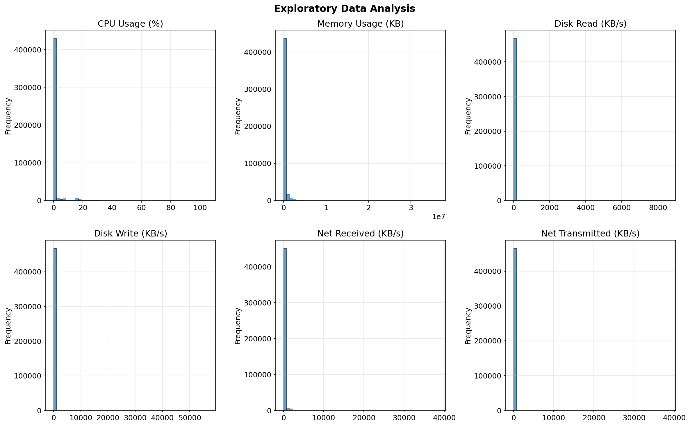
Figure 1: Distributions of the key telemetry features. CPU and memory usage are strongly right-skewed, which is typical of cloud workloads where most machines idle and occasionally spike.
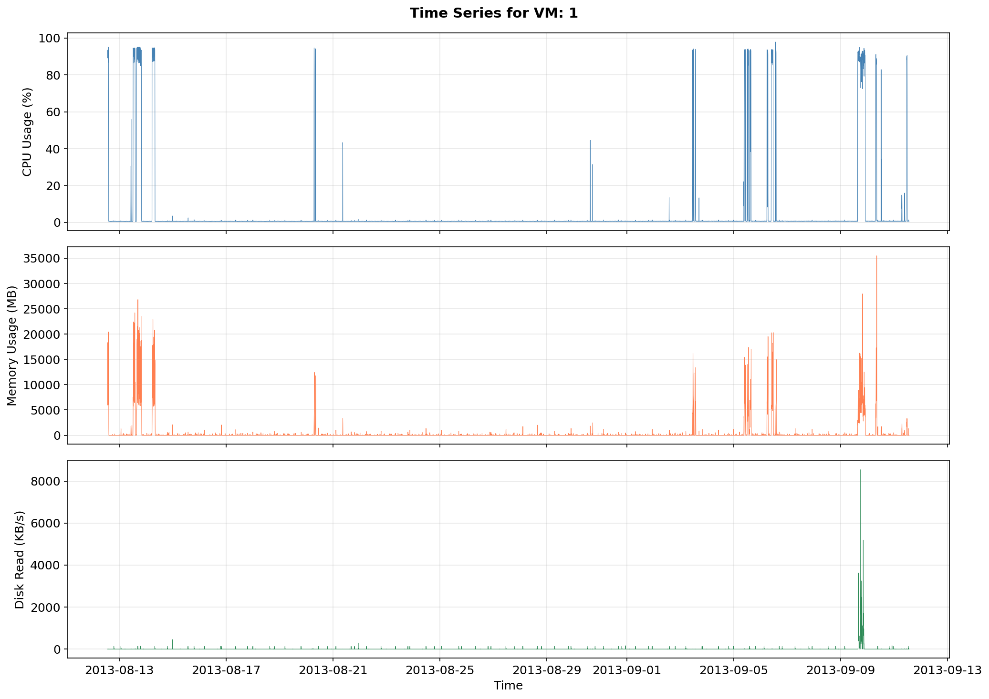
Figure 2: CPU usage over time for a representative virtual machine. The quiet baseline interrupted by sharp spikes is the pattern that later drives the calibration analysis in Section 5.6.
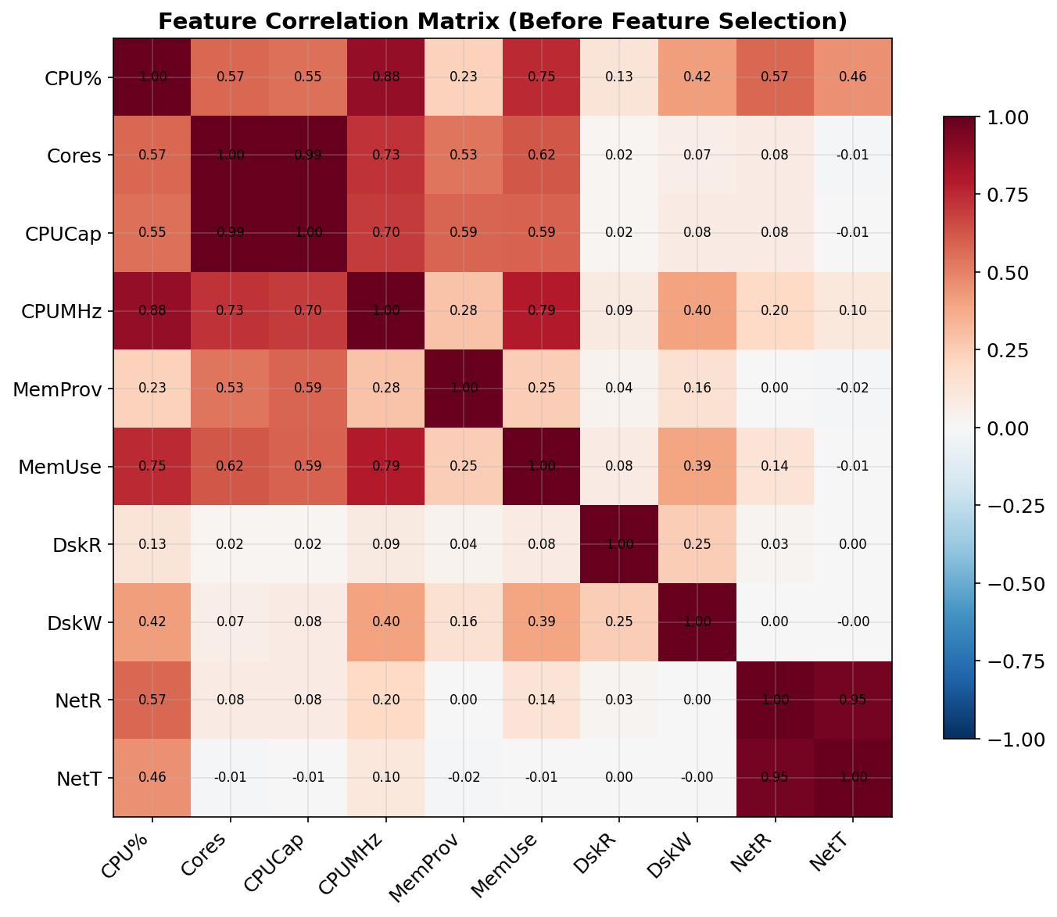
Figure 3: Correlation matrix of the raw telemetry variables. CPU Usage (MHz) was excluded from the predictors because it encodes the target exactly, since MHz divided by capacity equals percent.

4. Methodology

4.1 Feature Engineering and Model Specification
From the raw telemetry we build ten predictors plus an intercept:
- Contemporaneous load: memory usage, disk read and write throughput, network received and transmitted throughput.
- Autoregressive lags: CPU usage at t−1, t−2 and t−3, that is 5, 10 and 15 minutes back.
- Rolling statistics: the 30-minute rolling mean and standard deviation of CPU usage.
All lag and rolling features are computed from strictly past observations, so no future information enters a prediction. Predictors and target are standardised to zero mean and unit variance, which improves the numerical conditioning of every sampler and makes the prior scale meaningful. The lag and rolling features are, by construction, strongly correlated with one another; Section 5.1 shows that this design decision is what makes the posterior anisotropic and therefore what determines the relative performance of the samplers.

4.2 Sampler Implementations
All samplers are written from scratch with NumPy and SciPy only. No probabilistic programming library is used inside any of our implementations.
Sampler | Tuning parameters | Setting used
MH | proposal scale for β, for log σ² | 0.001, 0.05
Adaptive MH (naive) | adaptation interval, scaling | 200 iterations, 2.38²/d
Preconditioned MH | target acceptance, interval | 0.234, 100 iterations
Gibbs | none | —
HMC | step size ε, leapfrog steps L | 0.002, 15
Student-t Gibbs | degrees of freedom ν | 4

4.3 Experimental Setup
Each sampler is run for 3 independent chains with different random seeds, each producing 10,000 retained samples after discarding 2,000 burn-in iterations. Multiple chains are required for split R-hat and give a check on whether the chains have found the same region of parameter space.

5. Results

5.1 Posterior Geometry: Why Plain Metropolis-Hastings Fails
The first round of experiments reported an average ESS of 10.2 for MH out of 10,000 draws and attributed it to generic random-walk behaviour. That description is correct but not specific enough to be actionable, so we examined the geometry of the posterior directly.
Because the model is conjugate, the posterior covariance of β given σ² is available in closed form as (XᵀX/σ² + I/τ²)⁻¹. Evaluating it at the fitted noise level gives:
Property of the posterior | Value
Condition number of the covariance | 273.0
Largest absolute correlation between coefficients | 0.772
Standard deviation along the narrowest direction | 0.00267
Standard deviation along the widest direction | 0.04410

This explains the failure precisely. A single isotropic step size must be small enough to be accepted along the narrowest direction, whose standard deviation is 0.00267, yet the chain must travel a distance of order 0.04410 to cross the widest direction. The number of steps required scales with the condition number, roughly 273, which is the same order as the observed loss of efficiency. The strong correlation of 0.772 between coefficients comes directly from the design: consecutive CPU lags and the rolling mean measure nearly the same quantity.
The diagnosis suggests its own cure: propose in a metric matched to the posterior. Our first attempt was the textbook adaptive-Metropolis recipe of Section 2.4, estimating the proposal covariance from the chain's own burn-in history. It failed badly, and the failure is worth reporting because the reason is instructive.
Sampler | Acceptance | Average ESS | Worst split R-hat | Largest deviation from Gibbs
MH (isotropic) | 43.5% | 9.3 | 1.47 | 0.315
Adaptive MH (naive) | 1.2% | 12.3 | 9.66 | 0.489
Preconditioned MH | 27.5% | 217.2 | 1.01 | 0.00061

Naive adaptation collapses to 1.2% acceptance and a worst split R-hat of 9.7, which is worse than the sampler it was meant to repair. The cause is a bootstrap problem specific to this posterior. Adaptive Metropolis learns the proposal covariance from the chain history, but the unpreconditioned chain has an integrated autocorrelation time of roughly 1075 iterations, so across 2,000 burn-in iterations it contributes only a handful of effectively independent points. A 12-dimensional covariance cannot be estimated from that. What the estimate actually captures is the chain's transient drift from the starting point toward the mode, whose spread along the direction of travel is far larger than the posterior; scaling that up by 2.38²/d produces proposals so large that almost everything is rejected.
The fix is to obtain the metric from somewhere other than the chain. We precondition with the observed Fisher information, σ̂²(XᵀX + I/τ²)⁻¹, which follows from a single least-squares fit and needs no conjugacy, and then refine it during burn-in while a Robbins-Monro rule tunes a global scale toward the optimal acceptance rate. This works: acceptance settles at 27.5% against the theoretical optimum of 23.4%, average ESS rises from 9.3 to 217.2, a factor of 23, and the posterior means now match Gibbs to within 0.00061. The cost is essentially unchanged at 2.86 s against 4.07 s for three chains.
It is worth being clear about the size of the win. Preconditioning improves MH by a large factor, but 217 effective draws out of 10,000 is still an order of magnitude behind Gibbs and HMC. Matching the metric to the posterior removes the penalty for anisotropy; it does not remove the random walk itself, which is what the gradient-based and exact-conditional methods avoid.
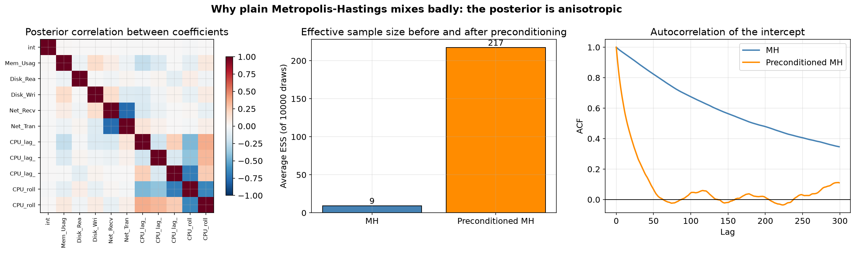
Figure 4: Left: posterior correlation between coefficients, showing the strong block of correlated lag and rolling features. Centre: effective sample size before and after preconditioning. Right: autocorrelation of the intercept, which decays far faster once the proposal is matched to the posterior shape.

5.2 Convergence Analysis
We assess convergence with split R-hat, which is stricter than the plain Gelman-Rubin statistic used earlier because it also detects drift within a single chain. The table gives split R-hat for three representative coefficients and the noise variance.
Method | Intercept | β₁ | β₃ | σ²
MH | 1.0653 | 1.4657 | 1.1772 | 1.2071
Adaptive MH (naive) | 1.4651 | 1.9140 | 9.6567 | 1.2722
Preconditioned MH | 1.0128 | 1.0037 | 1.0005 | 1.0123
Gibbs | 1.0000 | 1.0000 | 0.9999 | 1.0000
HMC | 0.9999 | 0.9999 | 1.0003 | 1.0001

This table overturns a conclusion of the first round. That round used the plain Gelman-Rubin statistic, obtained values of 1.0267 and below for every method and parameter, and concluded that all samplers had converged and therefore approximated the same posterior. Split R-hat disagrees: plain MH reaches 1.47 on β₁ and the naive adaptive variant reaches 9.7 on β₃, both far above the 1.01 threshold now recommended. The difference is not a matter of a stricter cut-off. Splitting each chain in half exposes drift that the plain statistic cannot see, because a chain which is still slowly migrating toward the mode has a between-chain variance that looks small while each half sits in a different place.
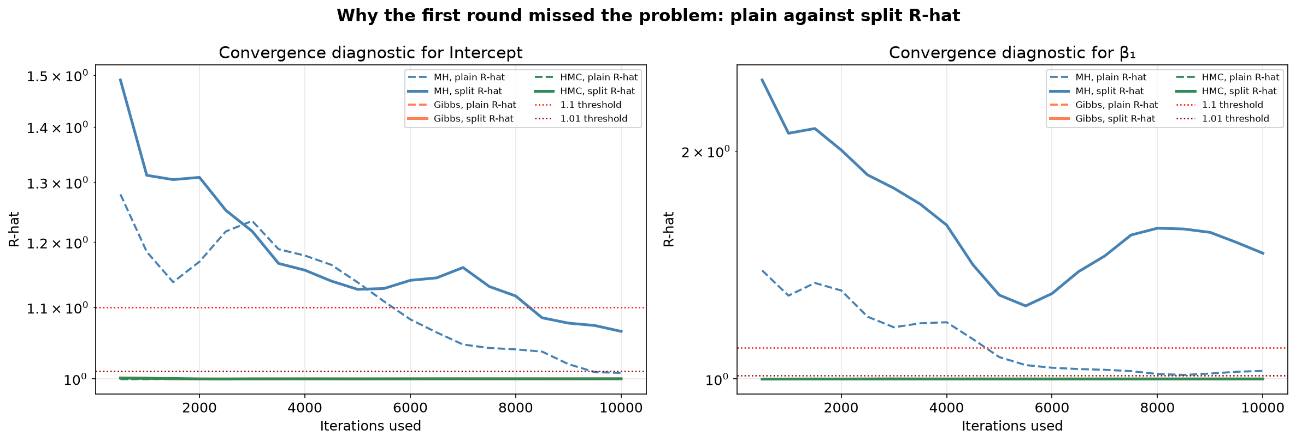
Figure 5: Plain against split R-hat as the chains lengthen, on logarithmic axes. For MH the dashed plain statistic falls steadily toward 1.01 and would be read as convergence, while the solid split statistic stays far above it. Gibbs and HMC sit on 1.00 under both. The first round used only the dashed statistic.
The consequence is visible directly in the estimates. Comparing posterior means against Gibbs Sampling, which is exact up to Monte Carlo error here:
Method | Largest deviation from the Gibbs posterior mean | Posterior mean σ²
MH | 0.31522 | 0.16161
Adaptive MH (naive) | 0.48880 | 0.19512
Preconditioned MH | 0.00061 | 0.15683
Gibbs | 0.00000 | 0.15663
HMC | 0.00053 | 0.15668

Gibbs and HMC agree to within 0.00053, and the preconditioned sampler joins them at 0.00061. These are three independently written algorithms, one exact-conditional, one gradient-based and one a random walk, arriving at the same answer; that mutual agreement is the strongest internal evidence of correctness the study provides. Plain MH deviates by 0.315 and the naive adaptive variant by 0.489, both larger than the 0.044 standard deviation of the widest posterior direction. Those two samplers are simply reporting the wrong posterior.
Two cautions apply. Split R-hat is necessary for convergence but not sufficient: a chain that has never visited an important region can still report a low value, which is why agreement between different algorithms matters as an additional check. And the agreement among our three samplers, while reassuring, cannot rule out a misunderstanding shared by all of them, since they were written by the same authors from the same model specification. Section 5.4 closes that gap with an external library.
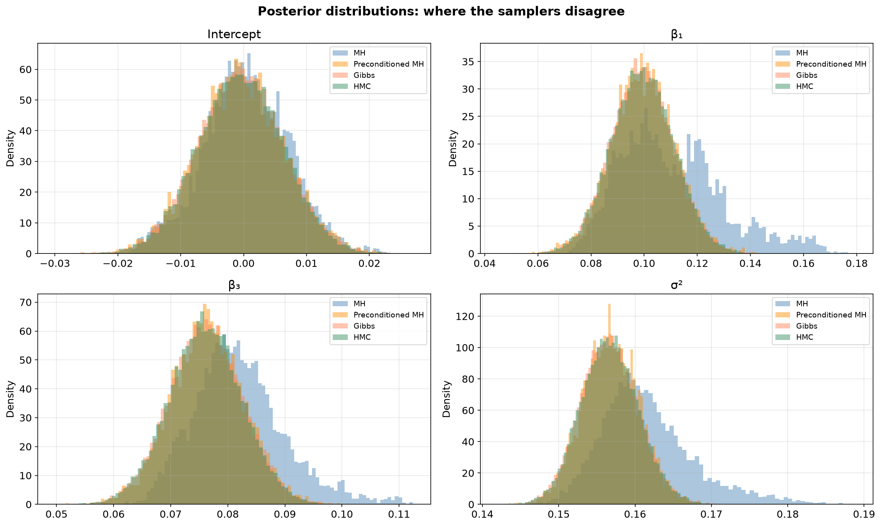
Figure 6: Posterior distributions from each sampler overlaid. Gibbs, HMC and preconditioned MH produce indistinguishable densities. The plain MH histograms are visibly displaced and too narrow, which is what a chain that has explored only part of the posterior looks like.
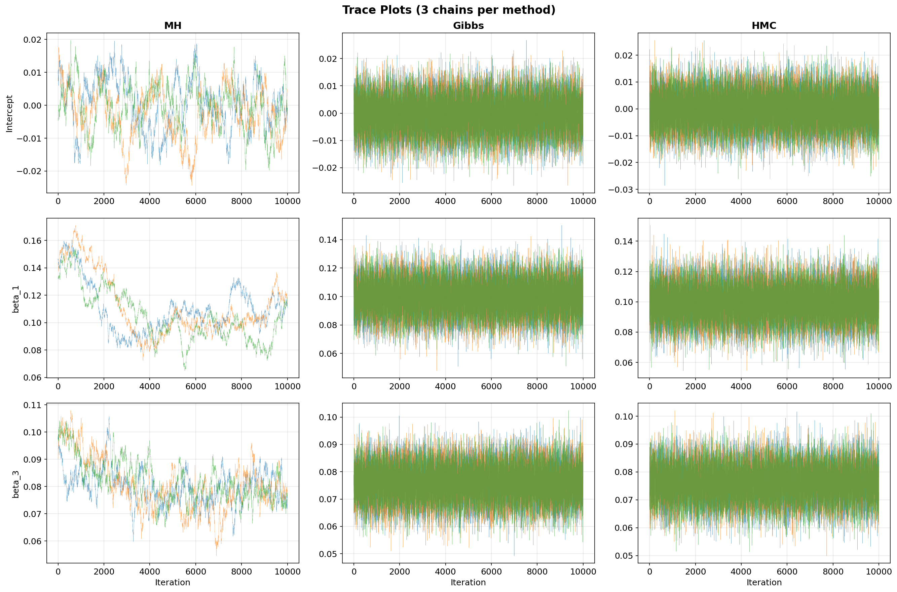
Figure 7: Trace plots of selected coefficients across iterations. Good mixing appears as rapid oscillation around a stable level; the visible flat stretches in the plain MH panels are runs of rejected proposals.

5.3 Sampling Efficiency with Corrected Diagnostics
The table reports efficiency under the corrected estimators. All ESS values are computed with the Geyer estimator described in Section 2.8, so they are directly comparable with one another but not with the numbers in the first round of experiments.
Method | Acceptance | Average ESS | Runtime | ESS / second | MCSE (intercept)
MH | 43.5% | 9.3 | 4.07 s | 2.3 | 8.81e-04
Adaptive MH (naive) | 1.2% | 12.3 | 2.51 s | 4.9 | 9.53e-04
Preconditioned MH | 27.5% | 217.2 | 2.86 s | 76.0 | 2.76e-04
Gibbs | 100.0% | 10,000.0 | 9.98 s | 1,002.4 | 3.89e-05
HMC | 95.1% | 7,997.3 | 34.62 s | 231.0 | 3.88e-05

The corrected estimator is more trustworthy, but honesty requires reporting where it changed the answer and where it did not. The old rule truncated the autocorrelation sum at the first lag below 0.05; applied to 10,000 genuinely independent draws it also returns exactly 10,000, so it could not distinguish an excellent sampler from a perfect one. For HMC the correction matters: the measured ESS moves from 6,183.5 to 7,997.3, a change of about 29%. For Gibbs Sampling it does not. The Geyer estimator also returns 10,000, because in this two-block conjugate model the draws really are close to independent. The earlier number happened to be right; it was simply not evidence of anything, since the estimator would have returned it either way.
Among the samplers that actually converged, the ranking by ESS per second is Gibbs (1,002), HMC (231), Preconditioned MH (76). We restrict the ranking to those three deliberately: an efficiency figure for a chain that is sampling the wrong distribution measures how fast it produces useless draws, so quoting an ESS per second for plain MH or for the naive adaptive variant alongside the others would invite a false comparison.
The Monte Carlo standard error column carries the same caveat and the same message. For a converged chain it states how precisely the posterior mean has been pinned down by a finite run. Gibbs reports 3.89e-05 and HMC 3.88e-05, while the preconditioned random walk reports 2.76e-04, about 7 times larger, which is the price of moving without gradients or exact conditionals. For plain MH the quantity is not meaningful at all: its chains have not converged, so the standard error of an estimate that is already biased understates the true error.
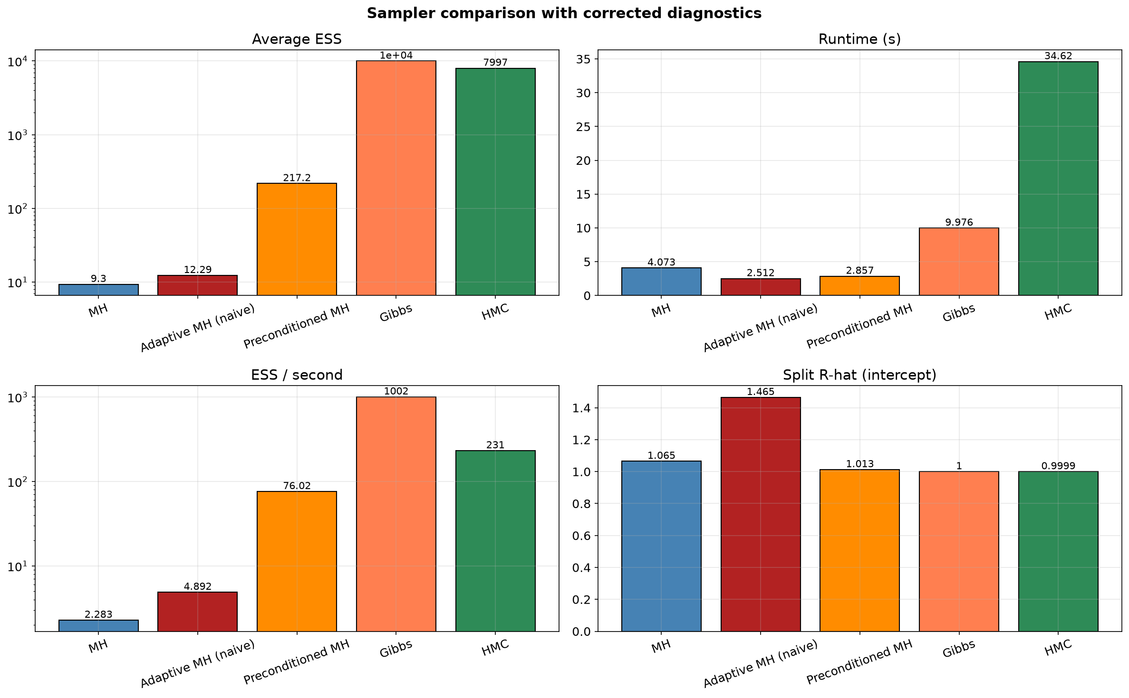
Figure 8: Sampler comparison under the corrected diagnostics. ESS and ESS per second are shown on logarithmic axes because the spread between samplers covers several orders of magnitude.
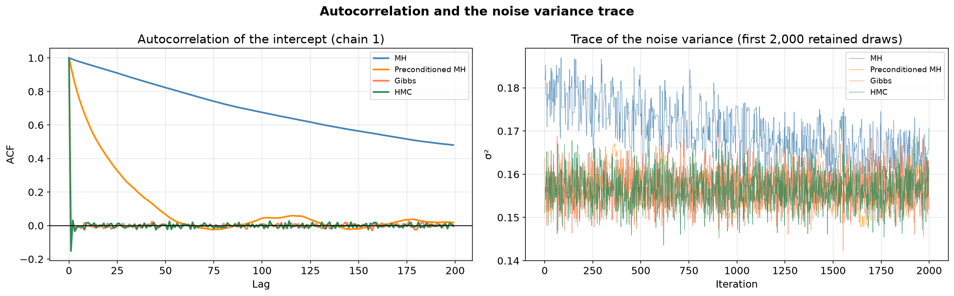
Figure 9: Left: autocorrelation of the intercept. Gibbs and HMC decay almost immediately, preconditioned MH within a few dozen lags, and plain MH remains correlated across the whole window. Right: the trace of the noise variance, where plain MH sits at a visibly different level from the three samplers that agree.

5.4 Validation Against an External Library (emcee)
Agreement among our own samplers is reassuring but not conclusive. All three were written by the same authors from the same equations, so an error in how the model was transcribed, rather than in how it was sampled, would appear identically in all of them. Closing that gap requires an implementation we did not write.
We therefore sampled the same posterior with emcee 3.1.6, an established third-party MCMC library. Its algorithm is unrelated to any of ours: the affine-invariant ensemble sampler of Goodman and Weare evolves a population of 40 walkers whose relative positions generate the proposals, so it shares neither the conditional structure of Gibbs, nor the gradients of HMC, nor the proposal covariance of preconditioned MH. We supplied only the log-posterior function and let the library do the rest. After discarding 1,000 warm-up steps it retained 120,000 draws in 11.5 seconds, with a mean walker acceptance of 0.382.
Method | Largest difference in posterior mean of β from the reference | Posterior mean σ²
MH | 0.31602 | 0.16161
Adaptive MH (naive) | 0.48960 | 0.19512
Preconditioned MH | 0.00061 | 0.15683
Gibbs | 0.00080 | 0.15663
HMC | 0.00052 | 0.15668
emcee 3.1.6 (reference) | — | 0.15670

The three samplers that converged reproduce the external reference closely. Gibbs differs from it by 0.00080 and the reference posterior mean of the noise variance, 0.15670, matches the Gibbs value of 0.15663. Since the reference was produced by code we did not write, from a different algorithm, this is evidence that the model itself, and not merely our sampling of it, is implemented correctly.
The same table confirms that the two failing samplers fail against an independent standard as well, not only against our own Gibbs implementation. Plain MH and the naive adaptive variant deviate from the reference by amounts far exceeding the posterior spread, which rules out the possibility that Gibbs and HMC were the ones in error.
A note on what was not used.
The comparison was originally intended to use the No-U-Turn Sampler in PyMC, which would have been the more conventional choice. PyMC compiles its log-posterior through PyTensor, and no C++ compiler was available on the machine used for these experiments, so it fell back to a pure-Python evaluation path and had not completed three chains after roughly twenty-five minutes of processor time. emcee is pure Python by design and needed 11.5 seconds for the same task. The substitution costs nothing for the purpose at hand, since the section exists to validate the posterior rather than to benchmark NUTS; run_experiment_v2.py still performs the PyMC run by default and skips it only when invoked with the --skip-nuts flag.

5.5 Prediction Accuracy
Predictive performance is evaluated on the held-out test period. Point predictions use the posterior mean, and we report both root mean squared error and median absolute error. The two are reported together deliberately: RMSE is dominated by a small number of large spike errors, while the median absolute error describes the typical observation.
Method | RMSE | Median absolute error
OLS (baseline) | 0.2902 | —
MH | 0.2822 | 0.0439
Adaptive MH (naive) | 0.2734 | 0.0595
Preconditioned MH | 0.2902 | 0.0462
Gibbs | 0.2903 | 0.0462
HMC | 0.2901 | 0.0463
Student-t regression (ν = 4) | 0.2483 | 0.0186

The converged Gaussian samplers agree to within Monte Carlo noise, as they must, since they target the same posterior. Plain MH reports a slightly lower RMSE (0.2822 against 0.2903), which should not be read as an advantage: Section 5.2 showed its chains have not converged, so the difference reflects where its random walk happened to stop rather than a better fit. This is a useful reminder that predictive error is a weak diagnostic of sampler quality, because a wrong posterior mean can still predict acceptably when the predictors are strongly autocorrelated.
The gap between RMSE (0.2903) and median absolute error (0.0462) for the Gaussian model is a factor of about 6, which is the first quantitative sign that the error distribution is far from Gaussian. The Student-t model reduces the median absolute error to 0.0186, a 60% improvement on the typical observation, because down-weighting the spikes lets the fit follow the bulk of the data more closely.
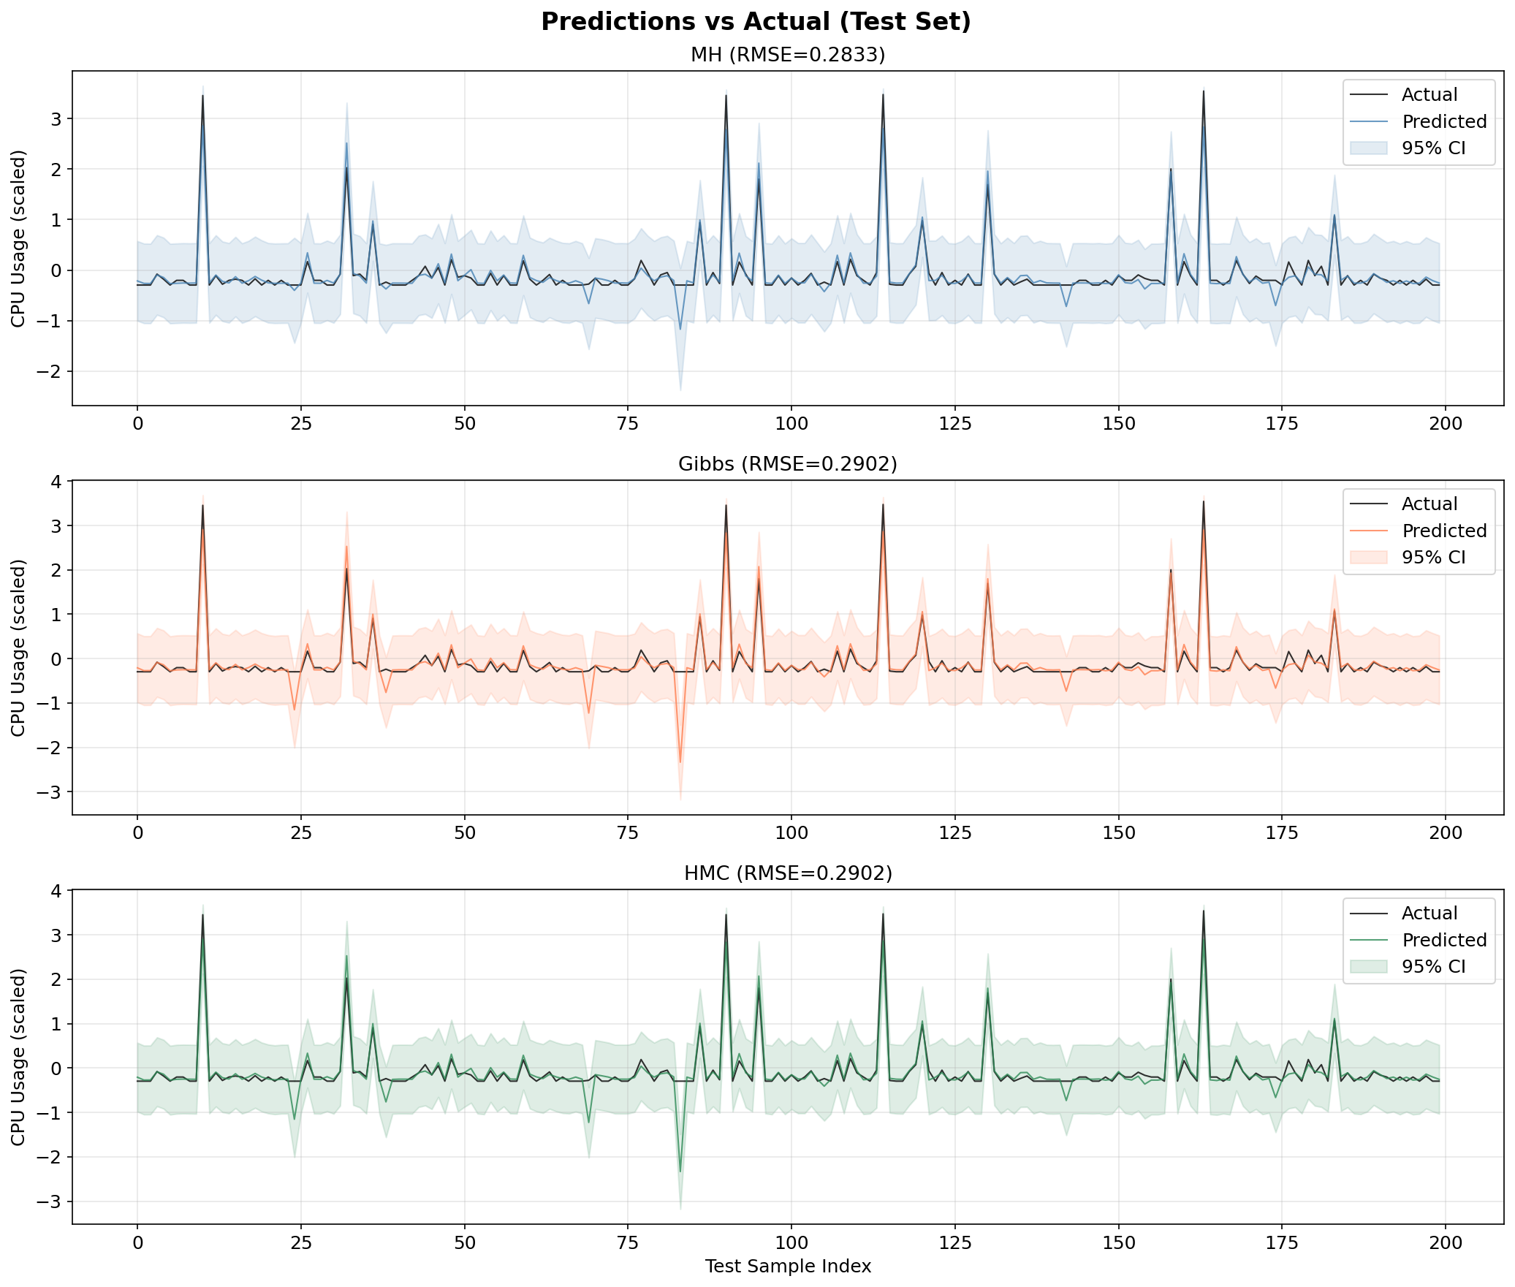
Figure 10: Predicted against actual CPU usage on the test set with 95% credible intervals.

5.6 Calibration: Diagnosis and Repair
Calibration asks whether the stated uncertainty is honest: an X% credible interval should contain the truth about X% of the time. The first round of experiments found 95% intervals covering 98.7% of test points and 50% intervals covering 94.3%, and explained this as a consequence of weakly informative priors. That explanation is wrong, and the correct one is more interesting.
A 50% interval that covers 94% of the data is roughly four times too wide, which is far beyond anything a weak prior can cause on 3,500 training points, where the likelihood overwhelms the prior. To locate the real cause we examined the residual distribution directly.
Property of the test residuals | Value | Gaussian expectation
Standard deviation | 0.2902 | —
Median absolute deviation | 0.0462 | —
Ratio sd / (1.4826 × MAD) | 4.24 | 1.00
Excess kurtosis | 108.9 | 0.0
Fraction beyond three standard deviations | 0.0073 | 0.0027

The verdict is unambiguous. An excess kurtosis of 109 and a ratio of standard deviation to robust standard deviation of 4.24 describe a distribution in which almost all residuals are tiny and a handful are enormous, which is exactly what a CPU trace of idle periods and sudden spikes produces. The Gaussian likelihood has only one parameter with which to describe both regimes, so it sets σ² large enough to accommodate the spikes. Every interval is then sized for a spike that usually does not occur.
A decisive check confirms the mechanism has nothing to do with MCMC or with the priors: building intervals from a plain least-squares fit and its residual standard deviation, with no Bayesian machinery at all, reproduces the same over-coverage. The problem is the likelihood, not the sampler and not the prior.
Replacing the Gaussian likelihood with the Student-t scale mixture of Section 2.7 addresses the cause directly. The results below compare the two likelihoods, both sampled with a tuning-free Gibbs sampler.
Interval | Nominal | Gaussian likelihood | Student-t likelihood | Mean width (Gaussian) | Mean width (Student-t)
50% | 50.0% | 94.5% | 73.7% | 0.534 | 0.068
95% | 95.0% | 98.7% | 96.3% | 1.549 | 0.252

The 50% interval, which is the sharper test of calibration, moves from 94.5% to 73.7% against a nominal 50%, and its mean width shrinks from 0.534 to 0.068. The 95% interval moves from 98.7% to 96.3%. The remaining deviation is expected: a Student-t with ν = 4 is a better description of the tails than a Gaussian, but a real CPU trace is not exactly Student-t either.
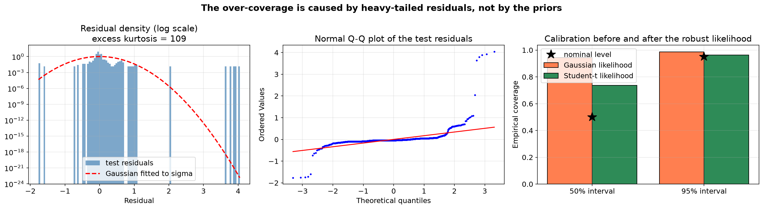
Figure 11: Left: the test residual density on a logarithmic scale against the fitted Gaussian, showing the excess mass in both the centre and the tails. Centre: the normal Q-Q plot, whose S-shape is the signature of heavy tails. Right: empirical coverage under each likelihood against the nominal levels.

5.7 Sensitivity to Hyperparameters
Metropolis-Hastings and HMC both require tuning; Gibbs Sampling does not. The tables below report acceptance rates measured over the tuning grid.
MH proposal scale for β | Acceptance rate
0.001 | 44.2%
0.005 | 16.2%
0.010 | 3.2%
0.020 | 0.4%
0.050 | 0.3%

HMC leapfrog steps L | Acceptance rate
5 | 95.8%
10 | 94.9%
15 | 95.2%
20 | 97.6%
25 | 97.0%

The MH grid shows the step-size trade-off sharply: acceptance falls from 44.2% at a scale of 0.001 to 0.3% at 0.05. It is worth reading this together with Section 5.1. The reason no scalar step size performs well is that there is no single good choice when the posterior is anisotropic; the grid is searching a one-dimensional family for a solution that requires a matrix. HMC acceptance stays high and flat across L, which indicates stable integration and suggests the step size is conservative enough that L could be reduced to save gradient evaluations.
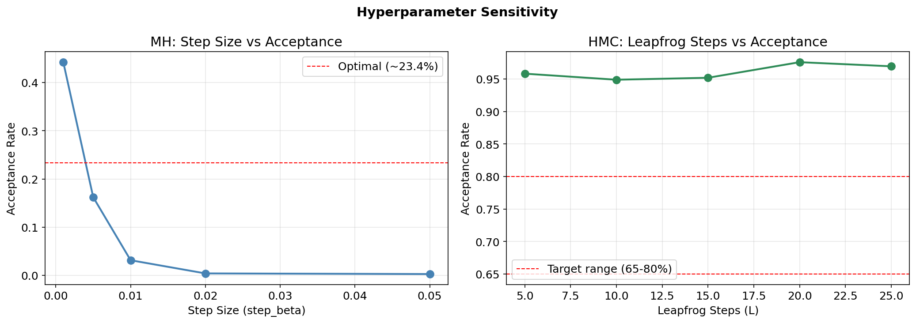
Figure 12: Acceptance rate against MH proposal step size (left) and against the number of HMC leapfrog steps (right).

5.8 Sensitivity to the Starting Point
MCMC theory guarantees convergence from any starting point, but says nothing about how long it takes. We ran each sampler from four deliberately different starting points, including one far outside the posterior bulk, and recorded how many iterations were needed for the log posterior to reach its stationary level.
Sampler | zeros (default) | least squares fit | dispersed (all +3) | extreme variance
Preconditioned MH | 294 | 0 | 958 | 311
Gibbs | 0 | 0 | 1 | 1
HMC | 6 | 0 | 40 | 13

Two patterns stand out. Gibbs Sampling is essentially insensitive to the starting point, because its first draw of β comes from the exact conditional given σ² and therefore lands in the posterior bulk immediately, regardless of where it started. The samplers that move by local proposals take measurably longer from the dispersed starting points, and the extreme variance start is the hardest case for all of them. This is the practical justification for discarding burn-in and for running multiple chains from different starting points rather than one long chain.
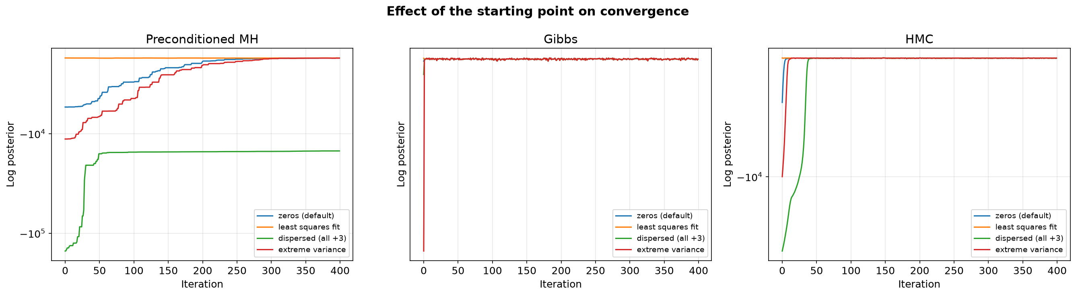
Figure 13: Log posterior over the first iterations from four starting points. Curves that meet quickly indicate that the choice of starting point has been forgotten.

6. Discussion
Strengths and weaknesses of each sampler, as measured on this problem:
Metropolis-Hastings.
- Strengths: needs only pointwise evaluation of an unnormalised density; simplest to implement; cheapest iteration, at 4.07 s for three chains.
- Weaknesses: an isotropic proposal cannot cope with a posterior of condition number 273, giving an average ESS of only 9.3. On this problem that is not merely inefficient but incorrect: after 10,000 draws the chains had not converged (worst split R-hat 1.47) and the posterior means were wrong by 0.315. Also requires tuning, and degrades as dimension grows.
Adaptive Metropolis-Hastings, estimating the covariance from the chain.
- Strengths: none observed on this problem. The method is sound in general and is standard practice, but it did not work here.
- Weaknesses: it needs the chain to explore well enough to estimate its own proposal covariance, which is precisely what the unpreconditioned chain cannot do. Acceptance collapsed to 1.2% and the worst split R-hat reached 9.7, leaving posterior means wrong by 0.489. The lesson is that adaptation cannot bootstrap itself out of a badly conditioned start.
Preconditioned Metropolis-Hastings, using the observed Fisher information.
- Strengths: keeps the generality of MH while removing its main weakness, raising ESS by a factor of 23 for negligible extra cost per iteration, and reaching acceptance of 27.5% against the theoretical optimum of 23.4 percent. The preconditioner comes from one least-squares fit, so it needs no conjugacy.
- Weaknesses: still a random walk, so at 217 effective draws it remains an order of magnitude behind Gibbs and HMC; adaptation must be confined to burn-in to keep the retained chain a homogeneous Markov chain; the Fisher information is only a good metric when the posterior is approximately Gaussian.
Gibbs Sampling.
- Strengths: no tuning parameters at all; every draw comes from an exact conditional; highest ESS per second here at 1,002; insensitive to the starting point.
- Weaknesses: requires closed-form full conditionals, which exist here only because we chose conjugate priors; updates blocks one at a time, so it can mix slowly under strong correlation; not applicable to most realistic models.
Hamiltonian Monte Carlo.
- Strengths: gradient-informed proposals largely eliminate random-walk behaviour, giving an ESS of 7,997 with 95.1% acceptance; the method of choice for high-dimensional non-conjugate models.
- Weaknesses: requires a differentiable log-posterior; each iteration costs L gradient evaluations, making it the slowest per sample here at 34.62 s; two hyperparameters to tune, which NUTS addresses.
A note on comparing acceptance rates.
Acceptance rate is a tuning diagnostic for MH and HMC, which have an explicit accept/reject step. For Gibbs Sampling it is identically 1 by construction and carries no information. Comparing samplers on acceptance rate alone would rank Gibbs first for a reason that has nothing to do with sampling quality, which is why the comparison here rests on split R-hat, ESS, ESS per second and Monte Carlo standard error.
What this study found beyond the sampler comparison.
The most useful results came from investigating anomalies rather than from the headline comparison. A diagnostic that saturated at the chain length was hiding real differences between samplers; an efficiency gap that had been described as generic random-walk behaviour turned out to have a specific, measurable and fixable cause; and an over-coverage that had been attributed to the priors was in fact a statement about the data, and pointed to a change of likelihood that improved both calibration and typical-case accuracy.
Limitations.
- The model is linear, so it cannot capture non-linear workload dynamics; a Bayesian neural network or a Gaussian process would be the natural next step.
- We use 5,000 observations from 50 virtual machines taken from the start of the trace, so weekly cycles and end-of-month effects are outside the sample.
- The degrees of freedom ν of the Student-t likelihood is fixed rather than inferred; placing a prior on ν and sampling it would let the data decide how heavy the tails are.
- Conclusions are drawn from a single dataset, and the relative ranking of samplers depends on posterior geometry, which is dataset-specific.

7. Conclusions and Extensions
The main findings of this extended study are:
- Plain Metropolis-Hastings had not converged after 10,000 draws, so the first round of experiments reached a conclusion that does not survive a stricter diagnostic: its claim that all three samplers approximate the same posterior is not supported. Its worst split R-hat is 1.47 and its posterior means are wrong by up to 0.315, which exceeds the 0.044 standard deviation of the widest posterior direction. The plain Gelman-Rubin statistic reported 1.03 and missed this entirely.
- Three independently constructed samplers, Gibbs, HMC and preconditioned MH, agree on the posterior means to within 0.00061, and an external library implementing an unrelated algorithm reproduces the same posterior to within 0.00080. Agreement across implementations, rather than any single sampler considered alone, is the strongest evidence of correctness in this study.
- Diagnostics must be validated before they are trusted, though the correction did not change every number. The threshold-truncated ESS estimator returns exactly the chain length for 10,000 genuinely independent draws, so it could not distinguish an excellent sampler from a perfect one. Under the Geyer estimator HMC moves from 6,183.5 to 7,997.3, while Gibbs stays at 10,000 because its draws really are near-independent here.
- The poor efficiency of plain Metropolis-Hastings is caused by posterior anisotropy (condition number 273, maximum coefficient correlation 0.77) induced by the correlated lag features, not by random-walk behaviour in the abstract.
- Estimating the proposal covariance from the chain history, the textbook adaptive-Metropolis recipe, fails on this posterior: acceptance collapses to 1.2% because the chain mixes too slowly during burn-in to estimate anything. Supplying the metric externally, from the observed Fisher information, raises the average ESS from 9.3 to 217.2 and brings the posterior means into agreement with Gibbs.
- The over-wide credible intervals are caused by heavy-tailed residuals (excess kurtosis 109), not by weakly informative priors. A Student-t likelihood sampled as a normal scale mixture moves 50% interval coverage from 94.5% to 73.7% and cuts the median absolute error by 60%.
- Gibbs Sampling reaches stationarity almost immediately from every starting point tested, while local-proposal samplers need measurably longer from dispersed starts, which justifies burn-in and multiple chains.
Directions for further work:
- Infer the degrees of freedom ν rather than fixing it, by placing a prior on ν and adding a Metropolis-within-Gibbs step for it.
- Implement NUTS ourselves rather than only using it as a reference, which would remove the need to tune L and complete the from-scratch comparison.
- Model the spike regime explicitly, for example with a mixture or a hidden Markov model over load states, instead of absorbing it into heavy tails.
- Extend to hierarchical models with per-virtual-machine coefficients, where Gibbs and HMC differ far more sharply than in this flat model and where conjugacy alone no longer suffices.
- Replace the fixed adaptation schedule with a diminishing-adaptation scheme that remains valid after burn-in.

8. References
[1] Beskos, A., Pillai, N., Roberts, G., Sanz-Serna, J. M., & Stuart, A. (2013). Optimal tuning of the hybrid Monte Carlo algorithm. Bernoulli, 19(5A), 1501-1534.
[2] Bishop, C. M. (2006). Pattern Recognition and Machine Learning. Springer.
[3] Brooks, S., Gelman, A., Jones, G., & Meng, X. L. (2011). Handbook of Markov Chain Monte Carlo. CRC Press.
[4] Gelman, A., Carlin, J. B., Stern, H. S., Dunson, D. B., Vehtari, A., & Rubin, D. B. (2013). Bayesian Data Analysis (3rd ed.). CRC Press.
[5] Geman, S., & Geman, D. (1984). Stochastic relaxation, Gibbs distributions, and the Bayesian restoration of images. IEEE Transactions on Pattern Analysis and Machine Intelligence, 6(6), 721-741.
[6] Geyer, C. J. (1992). Practical Markov Chain Monte Carlo. Statistical Science, 7(4), 473-483.
[7] Haario, H., Saksman, E., & Tamminen, J. (2001). An adaptive Metropolis algorithm. Bernoulli, 7(2), 223-242.
[8] Hastings, W. K. (1970). Monte Carlo sampling methods using Markov chains and their applications. Biometrika, 57(1), 97-109.
[9] Hoffman, M. D., & Gelman, A. (2014). The No-U-Turn Sampler: adaptively setting path lengths in Hamiltonian Monte Carlo. Journal of Machine Learning Research, 15(1), 1593-1623.
[10] Lange, K. L., Little, R. J. A., & Taylor, J. M. G. (1989). Robust statistical modeling using the t distribution. Journal of the American Statistical Association, 84(408), 881-896.
[11] Metropolis, N., Rosenbluth, A. W., Rosenbluth, M. N., Teller, A. H., & Teller, E. (1953). Equation of state calculations by fast computing machines. The Journal of Chemical Physics, 21(6), 1087-1092.
[12] Neal, R. M. (2011). MCMC using Hamiltonian dynamics. In Handbook of Markov Chain Monte Carlo (pp. 113-162). CRC Press.
[13] Roberts, G. O., Gelman, A., & Gilks, W. R. (1997). Weak convergence and optimal scaling of random walk Metropolis algorithms. The Annals of Applied Probability, 7(1), 110-120.
[14] Salvatier, J., Wiecki, T. V., & Fonnesbeck, C. (2016). Probabilistic programming in Python using PyMC3. PeerJ Computer Science, 2, e55.
[15] Shen, S., van Beek, V., & Iosup, A. (2015). Statistical Characterization of Business-Critical Workloads Hosted in Cloud Datacenters. In Proceedings of CCGrid 2015.
[16] Vehtari, A., Gelman, A., Simpson, D., Carpenter, B., & Burkner, P. C. (2021). Rank-normalization, folding, and localization: an improved R-hat for assessing convergence of MCMC. Bayesian Analysis, 16(2), 667-718.
[17] West, M. (1984). Outlier models and prior distributions in Bayesian linear regression. Journal of the Royal Statistical Society: Series B, 46(3), 431-439.

9. Code
The complete source code for this project is available at:
https://github.com/eladagmi24/mcmc-sampling-project
The repository contains:
Path | Contents
src/run_experiment_v2.py | Current experiment script. All five samplers, the corrected diagnostics, residual and posterior-geometry analysis, the Student-t sampler, the initialisation study and every figure.
src/create_report_v2.py | Generator for this document
src/run_experiment.py | First-round script, retained for provenance. Produces MH, Gibbs and HMC only, with the superseded diagnostics.
src/create_report.py | First-round report generator, retained for provenance
results/experiment_results_v2.json | Numerical results reported in this document
results/experiment_results.json | First-round results, cited here only where this document compares against them
results/figures/ | Every figure embedded in this document
notebooks/Sampling_Project.ipynb | Annotated notebook covering the first round of experiments
docs/ | This report, the proposal deck and its script, and PROJECT_STATUS_AND_FINDINGS.md summarising what changed between the two rounds
data/fastStorage/ | Input traces. Not included in the repository: the fastStorage directory is 1.19 GB across 1,250 files. See the README for the download link.

Every number and every figure in this report is produced by run_experiment_v2.py and read from experiment_results_v2.json by create_report_v2.py, so the document can be regenerated end to end from the raw traces with two commands and contains no hand-copied values:
python src/run_experiment_v2.py # writes results/ JSON and figures
python src/create_report_v2.py # writes this document into docs/
The first-round scripts are kept so that the comparisons drawn throughout Section 5 can be reproduced rather than taken on trust. Running run_experiment_v2.py with the --skip-nuts flag omits only the PyMC run, which is unnecessary because the external validation of Section 5.4 uses emcee; with that flag the whole pipeline completes in about one minute.
The Bitbrains traces are not committed to the repository. The fastStorage directory is 1.19 GB across 1,250 files, which is beyond what a source repository should carry, and the data is already published by its authors. The README gives the download link and the directory layout the scripts expect.

