Load & Stress

SLI:

* Handle 100 requests simultaneously within 1 second
* 1,000 stores each with average of 1,000 products, 10,000 users and 1 MIL purchases
* 1,000 users simultaneously

To estimate our systems expected traffic, we referenced products similar to *Tarefet* (our Trading System App). Following are some relevant numbers for Amazon and Ebay:

Ebay user statistics 2021:

* 19 MIL sellers
* 185 MIL active users
* 515 MIL downloads

Amazon user statistic 2021:

* 9.7 MIL sellers
* 200 MIL prime members.

Our system is slightly different so some translation in the terms/user types need to be made.

* Ebay’s active users and Amazons prime members would be considered subscribers in *Tarefet*
* A download of Ebay’s app without being an active user or seller would be considered a guest user in *Tarefet*
* A seller on Amazon or Ebay would be considered a store manager or owner in *Tarefet*
* Smaller stores generally have less non-owner employees and managers, whereas larger stores and corporations have few owners compared to their workforce. Larger stores carry significantly more weight in averaging the manager-owner ratio, since their hold most of the employees.
* In *Tarefet* we expect a system manager to be able to serve 1,000 users during an 8 hour shift. We need to support 1,000 users simultaneously.

The following breakdown should be a ballpark figure of our apps usage:

* 60% guest users
* 35% subscribers
* 4% store managers
* 1% store owners
* 3 System Managers (total, Not percent)

**SLI #1**:

100 users begin performing the following within one second: enter -> register -> login -> open store.

Results:

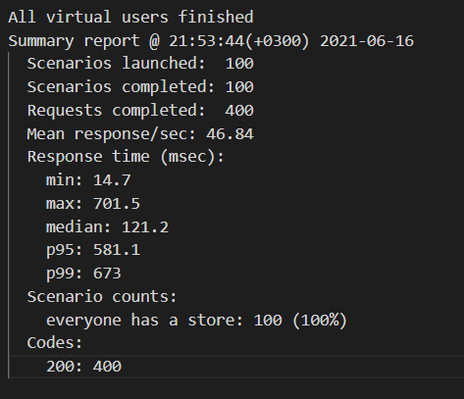

All requests were handled within 1 second, satisfying SLI #1.

**SLI #2**:

10,000 users (6,000 guests, 3,000 subscribers, 1,000 store owners and 3 system managers).

Each store owner has 1 store with 1000 products.

Each guest and subscriber buys an items from a store (12 times).

Results:

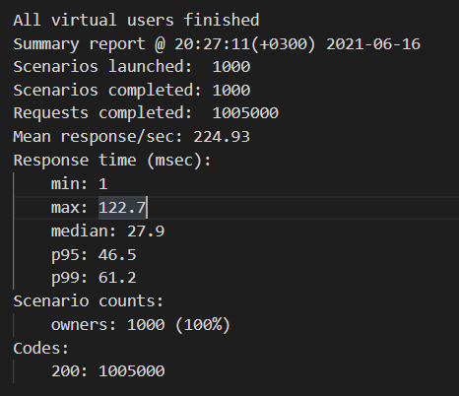 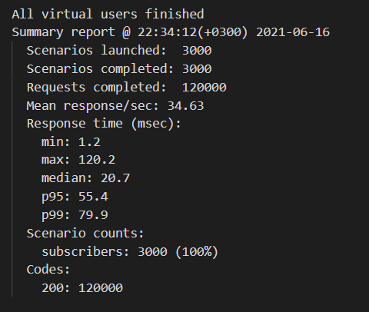

All requests were successful, satisfying SLI #2.

**SLI #3**:

1000 users perform: enter -> register -> login -> open store.

Results:

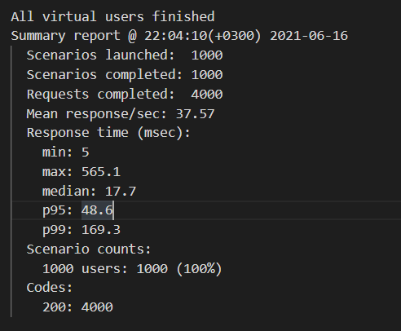

All requests returned status 200, satisfying SLI #3.

**Stress**:

We started with 1 user per second and over the span of 5 minutes ramped it up to 1000. Each user performing: enter -> register -> login -> logout.

Results:

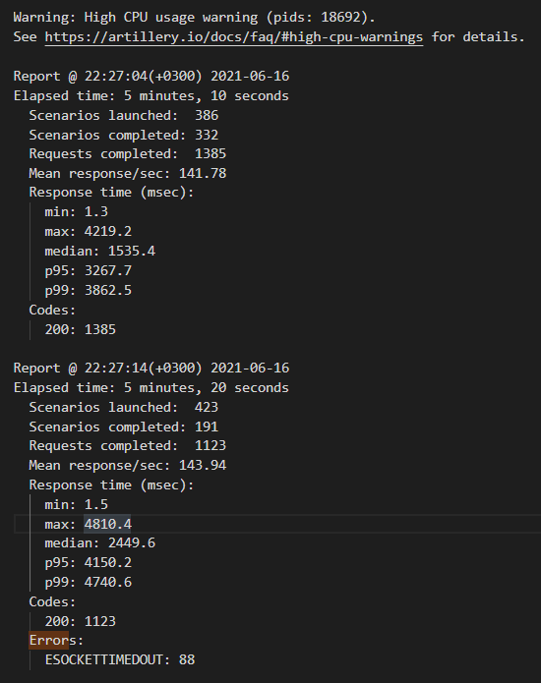

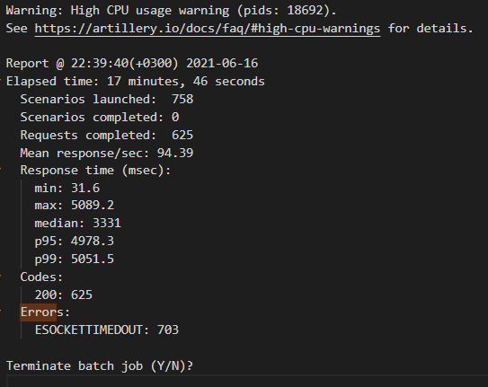

We fail to respond to all http requests within 1 second after 00:04:20 (around 1000 requests/second).

We fail to respond to all http requests within 5 seconds (timeout) after 00:05:10 (around 1500 – 5000 requests/second).

All requests either succeeded or timed out. No requests returned failure. No requests collapsed the system.