**מגישים:  
איתמר קראוס - 318304763**

**חי פדידה - 318302783**

**אייל כהן - 316148063**

**עידן אייזנברג - 316194315**

**אלעד גולדנברג - 315040519**

# **User Manual-** ZEBRA

**Version 1.0**

**10/08/2024**

**Table of Contents:**

**1. Introduction: 1**

**2. Overview: 1**

**3. Getting Started: 2**

Step 1: Accessing the Application 2

Step 2: Preparing Your JSON File 2

Step 3: Uploading Your JSON File 2

Step 4: Exploring Your Data 2

Step 5: Analysing and Interpreting Data 2

Step 6: Saving and Exporting Results 3

**4. Using The System: 4**

1. Uploading a JSON File 4

2. Searching Specific Lines in the Data File 4

3. Analysing Data with Visual Tools 4

4. Interacting with the Chatbot for Assistance 4

5. Saving and Exporting Data 4

6. Managing Multiple Files 5

7. Additional Features and Tips 5

**Appendix A: Navigate Between Screens 6**

# Introduction:

Welcome to the User Manual for our Web Application designed for seamless integration with Onshape. This tool allows you to easily upload and analyze JSON files, providing valuable insights into how Onshape is utilized within your organization.

Our application is built with a user-friendly interface where you can drag and drop your JSON files into a designated area. Once the file is uploaded, the app processes the data and generates detailed statistics, offering a comprehensive view of user activity, preferences, and trends within Onshape.

This manual will guide you through each step, from uploading your JSON files to interpreting the statistics generated by the app, ensuring you can maximize its potential in analyzing and improving your usage of Onshape. Whether you are an admin, manager, or power user, this tool will provide you with the data you need to make informed decisions and optimize your Onshape experience.

# Overview:

This web application is designed to simplify the process of analyzing and extracting valuable insights from JSON files related to Onshape usage. The application provides several key features to enhance your experience:

1. Upload by Dragging: A straightforward interface where users can upload their JSON files by simply dragging and dropping them into the designated area. This page is the starting point for processing your data.
2. Search Specific Lines in Data Files: This feature allows users to search through the uploaded JSON files to find specific lines or entries. It's a powerful tool for pinpointing exact pieces of data within large files, ensuring that you can quickly locate the information you need.
3. Analytics: A dynamic page that visually displays the data extracted from your JSON files. The analytics page provides charts, graphs, and other visualizations to help you interpret and understand the data, making it easier to identify patterns and trends in your Onshape usage.
4. Chatbot Assistance: A built-in chatbot that is available to assist with any questions or tasks related to manipulating the data from your JSON files. Whether you need help understanding the data, performing specific operations, or navigating the application, the chatbot is there to provide support.

# 3. Getting Started:

This guide will walk you through the initial steps to begin using the application and start analyzing your Onshape JSON files.

## Step 1: Accessing the Application

To access the web application, simply open your preferred web browser and navigate to the provided URL. Ensure that you have a stable internet connection to fully utilize all features of the app.

## Step 2: Preparing Your JSON File

Before you begin, ensure that your JSON file is formatted correctly and contains the relevant data from Onshape.

## Step 3: Uploading Your JSON File

* Navigate to the **Upload Page**.
* Drag your JSON file from your file explorer and drop it into the designated area on the page.
* The application will automatically start processing the file. You will be notified once the upload is complete, and the data is ready for analysis.

## Step 4: Exploring Your Data

Once the file is uploaded, you can start exploring your data through various features:

* **Search Specific Lines**: Use this page to search for particular entries or lines in your JSON file.
* **Analytics Page**: Visit this page to view visual representations of your data. Here, you can see charts and graphs that provide insights into your Onshape usage.
* **Chatbot Assistance**: If you need help with any functionality or have questions about your data, interact with the Chatbot for real-time support and guidance.

## Step 5: Analysing and Interpreting Data

Take your time to explore the analytics and search tools provided. Use the visualizations to gain a deeper understanding of your data. If you need further analysis or customized data manipulation, the Chatbot is there to assist you.

### 

### 

## Step 6: Saving and Exporting Results

After analysing your data, you can save or export the results for further use or sharing. The application provides options to download the analysed data in .csv format compatible with most needs.

This section provides a detailed walkthrough of how to use the key features of the web application to analyse and interpret your Onshape JSON data effectively.

### 

# 4. Using The System:

## 1. Uploading a JSON File

To begin analyzing your data:

1. Navigate to the **Upload Page**.
2. Drag and drop your JSON file into the designated area.
3. The system will automatically upload and process your file. You'll receive a confirmation message once the file is ready for analysis.

## 2. Searching Specific Lines in the Data File

If you need to locate specific information within your JSON file:

1. Go to the **Search** page.
2. Enter keywords, line numbers, or specific criteria in the search bar.
3. The system will display matching lines or entries from your file, making it easy to pinpoint the data you need.

## 3. Analysing Data with Visual Tools

For a visual representation of your data:

1. Access the **Analytics Page**.
2. Here, you'll find various charts, graphs, and other visual tools that break down your JSON data into easily digestible insights.
3. You can interact with these visuals to focus on specific data points or trends.

## 4. Interacting with the Chatbot for Assistance

If you need help or want to perform advanced operations:

1. Click on the **Chatbot Page**.
2. The chatbot is designed to assist with questions, guide you through the app's features, and help manipulate your JSON data.
3. Simply type your query or request, and the chatbot will provide the relevant information or perform the requested action.

## 5. Saving and Exporting Data

Once you've completed your analysis:

1. The system offers options to save or export your results.
2. Depending on your needs, you can download the data in CSV, or as visual reports.
3. Ensure that you save your work regularly, especially if you are conducting extensive analysis.

## 6. Managing Multiple Files

If you need to analyze multiple JSON files:

1. Repeat the upload process for each file.
2. Use the search and analytics tools on each file as needed.

## 7. Additional Features and Tips

* Make use of the chatbot to learn about hidden features or shortcuts that can enhance your workflow.
* Regularly check for updates or new features that may be added to the application to improve functionality.

# Appendix A: Navigate Between Screens

Navigating between the different screens of the web application is designed to be intuitive and user-friendly. Once logged into the application, you will find a navigation menu, typically located at the top or side of the interface, allowing you to quickly switch between the various features.

* **Upload by Dragging Page**: Start here to upload your JSON file. You can return to this page at any time by selecting the "Upload" option from the menu.

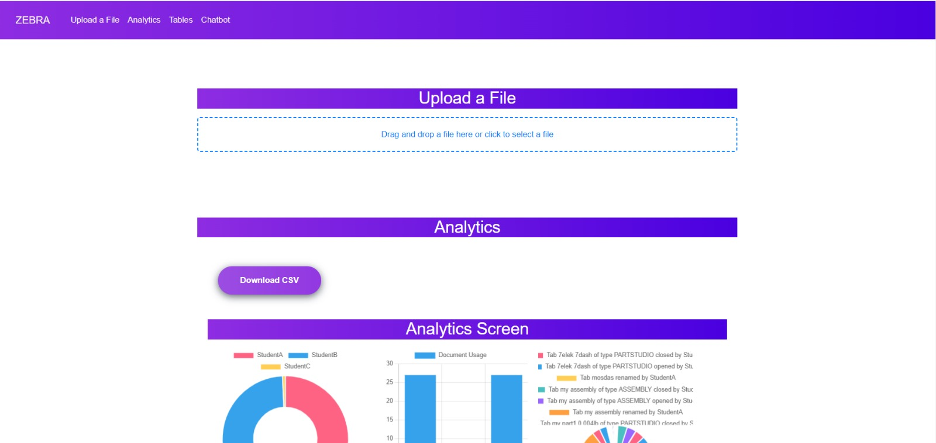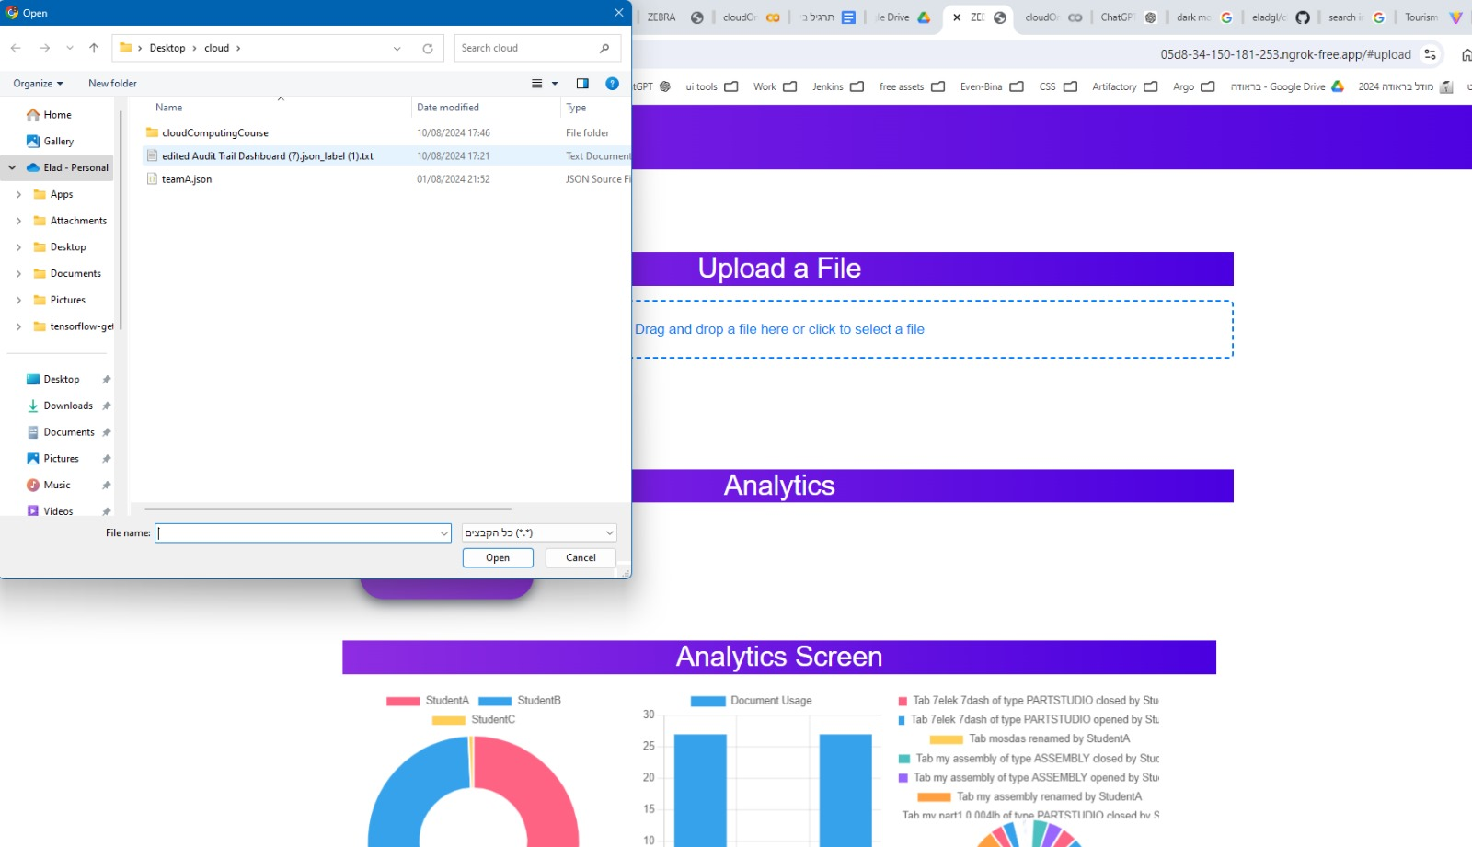

* **Search Specific Lines Page**: Access this page to search for specific data within your JSON files. Use the "Search" option in the navigation menu to switch to this screen.

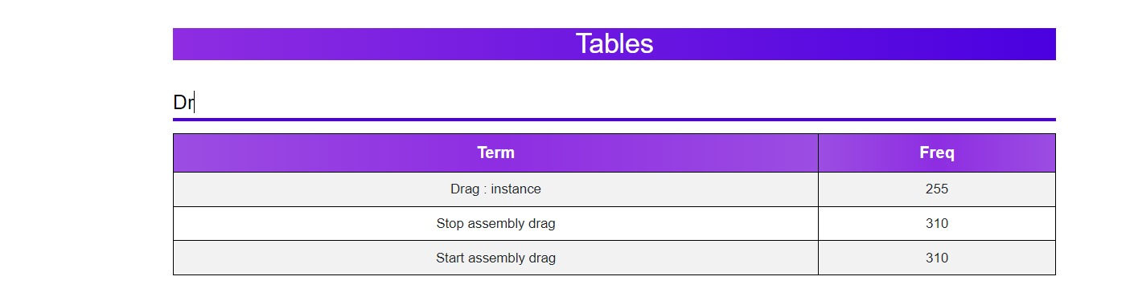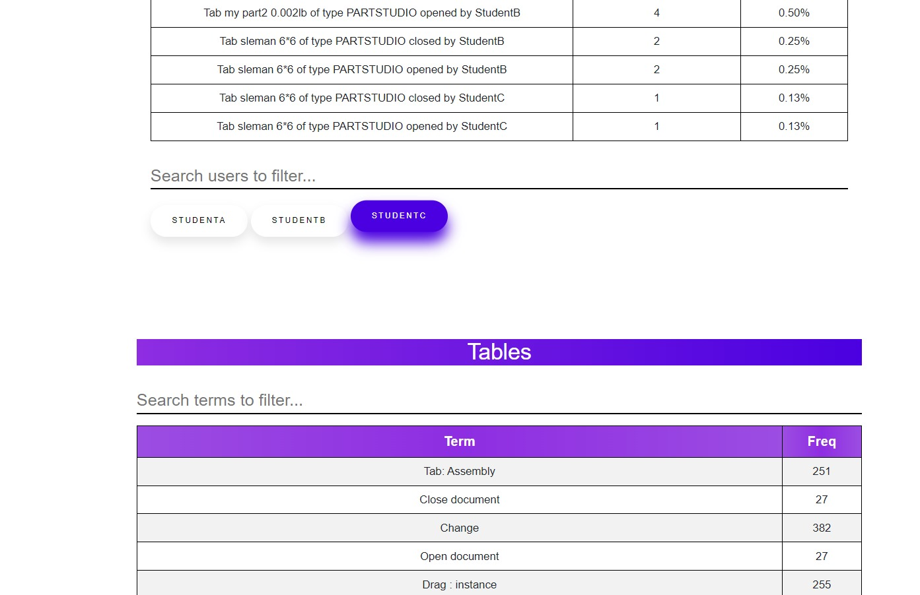

* **Analytics Page**: To view visual representations of your data, select the "Analytics" option. This will take you to a page where you can explore graphs, charts, and other visual tools.

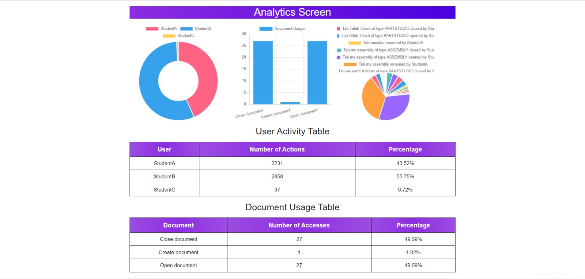

* **Chatbot Page**: click on the "Chatbot" option. The chatbot page is always accessible from the main navigation, ensuring you have support available whenever needed.

