**Algorithms in Logic – Final Project – Summary**

Elad Kapuza

Adam Goldbraikh

**Puzzle Problem**

**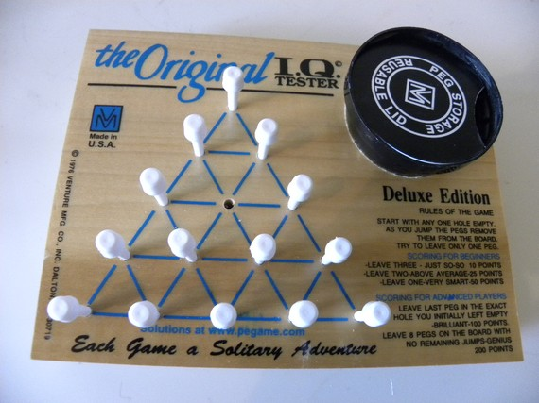**

Classic Game:

* Given a triangle board.
* Start with any one hole empty.
* As you jump the pegs remove them from the board as in "Damka" game.
* The goal: Remain with only one peg anywhere in the board.

Advanced Game:

* Given initial board and final board.
* Rules of movements remain the same.
* The goal: Reach to the final board.

**Logic Modeling**

Sets definitions

$A=\left\{\left(i,j,k\right): i,j,k are aligned neighbors\right\}$

Aligned neighbors, for example, the green vertices:

$U_{init}=\{v: v contains checker in the initial state\}$

$U_{final}=\{v: v contains checker in the final state\}$

$T={|U}_{init}{|-|U}_{final}|$

T - Number of steps from initial state to final state

Variables definitions

* $X_{i,j,k,p}$*-* True if in phase p, vertices i, j, k are aligned neighbors, and k can be reached from I via j.
* $Y_{i,p}$*-* True if vertex i has checker in phase p.

**Constraints –Boolean Logic**

1. **Initial state:** In the 1st phase (phase 1) we require all vertices in $U_{init}$ to have checker.
$$φ_{init}=\bigwedge_{i∈U_{init}}{Y_{i,1}˄\bigwedge_{i{∉U}_{init}}{¬Y_{i,1}}}$$

2. **One step:** In each phase p, we perform only one step.
$$φ_{one_step}=\bigwedge_{p=1}^{T}{\left[\bigvee_{(i,j,k)∈A}{\left(X_{i,j,k,p} ˄\bigwedge_{\begin{aligned}\left(r,s,t\right)∈A \\ (r,s,t)≠(i,j,k)\end{aligned}}{{¬X}_{r,s,t,p}}\right)}\right]}$$

3. **Legal step:** In each phase p there is at least one legal step
$$φ_{legal}=\bigwedge_{p=1}^{T}{\left[\bigvee_{(i,j,k)∈A}{\left(Y_{i,p}˄Y_{j,p}{˄¬Y}_{k,p}˄X_{i,j,k,p}\right)}\right]}$$

4. **Advancement**: In each phase p:

If there is a legal step from i to k via j, then in the next state, vertex i and j are empty and vertex k has checker.

All other vertices remain the same as in the previous state.

$$φ_{steps}=\bigwedge_{p=1}^{T}{\left[\bigvee_{(i,j,k)∈A}{\left(\begin{aligned}X_{i,j,k,p}{˄¬Y}_{i,p+1}{˄¬Y}_{j,p+1}{˄Y}_{k,p+1}˄ \\ \bigwedge_{a≠i,j,k}{Y_{a,p}{↔Y}_{a,p+1}}\end{aligned}\right)}\right]}$$

1. **Final state:** There is only one vertex among the n ones that has checker, all other vertices are empty, and we are in the last phase (T+1).

$$φ_{final}=\bigvee_{i=1}^{n}{\left(Y_{i,T+1}˄\bigwedge_{j≠i}{{¬Y}_{j,T+1}}\right)}$$

**Final formula:** We would like to check the satisfiability of the formula:

$$ψ=φ_{init}{ ˄ φ}_{one_step}{ ˄ φ}_{legal}{ ˄ φ}_{steps}{ ˄ φ}_{final}$$

**Advanced Game Small Modification:**

* We allow the player to set both the initial board and the final board.
* All first 4 formulas remain the same.
* We change only the 5th formula:

$${φ'}_{final}=\bigwedge_{i∈U_{final}}{Y_{i,T+1}˄\bigwedge_{i{∉U}_{final}}{{¬Y}_{i,T+1}}}$$

**Algorithm – Flow Diagram**

MainForm

**Path**

**"UNSAT"**

**board**

GameLogic

SolutionForm

FormulaGenerator

Boolean Logic Formula

**Result**

CnfConverter

CNF Formula

SAT Solver

1. The user enters initial board and final board (if mode="advanced") in the main screen.
2. The game logic object gets the board as input, derives from it the graph, variables and so on. Then it uses the Formula generator to generate Boolean logic formulas according the 5 constraints demonstrated earlier.
3. The CNF converter takes the formulas and converts them to CNF format using Tsietin algorithm.
4. The SAT solver takes the CNF formula, solves the whole CNF Boolean formula, and return the result back to the game logic object.
5. If result="UNSAT" a message is retrieved to the user accordingly.
6. Else: the solution form shows up and gets the solution path.

**Implementation - Blocks Diagram**

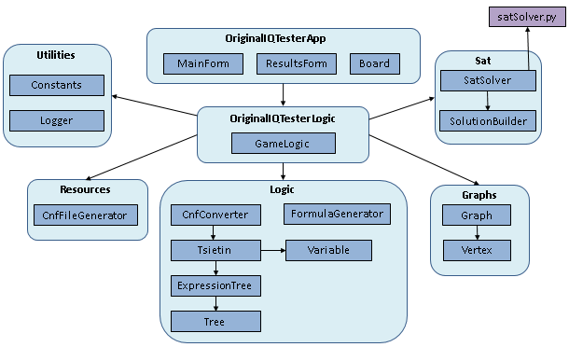

**OriginalIQTesterApp – C# WinForms Application**

* **MainForm** – main screen contains input objects – mode (classic or advanced), initial and final boards.
* **ResultsForm** (**SolutionForm**) – contains solution and steps towards the goal board.
* **Board** – Graphic object represents the board

**OriginalIQTesterLogic**

* **GameLogic** – Top level object the manages all the logic components of the application.

**Logic**

* **Tree** – General binary tree holding string nodes
* **ExpressionTree** – Uses Tree to implement logic expressions as trees.
* **Tseitin** – implements "Tseitin algorithm" to convert general Boolean formulas to CNF formulas using expression trees.
* **Variable** – represents a variable (regular or artificial in Tseitin algo).
* **CnfConverter** – uses Tseitin to convert general Boolean formulas to CNF.
* **FormulaGenerator** – Generate the game constraints as Boolean formulas.

**Graphs**

* **Graph** – represents the board as graph
* **Vertex** – represent vertex in the board.

**Sat**

* **SatSolver** – Runs python script "SatSolver.py" to run the solver and return a result – SAT or UNSAT.
* **SolutionBuilder** – Gets the solution and converts the satisfied variables list to steps list (path) that represents the game solution.

**Resources**

* **CnfFileGenerator** – Get the cnf formula and Generate from it CNF file in "cnf" format as input for the satSolver.py script.

**Utilities**

* Constants – Contains constants attributes for all the application components
* Logger – contains logs from the SAT solver.

**satSolver.py** – python script that uses Pycosat to run SAT solver. It gets as input a cnf file and returns a list of satisfied variable identifiers.

**Application**

**Main Screen**

**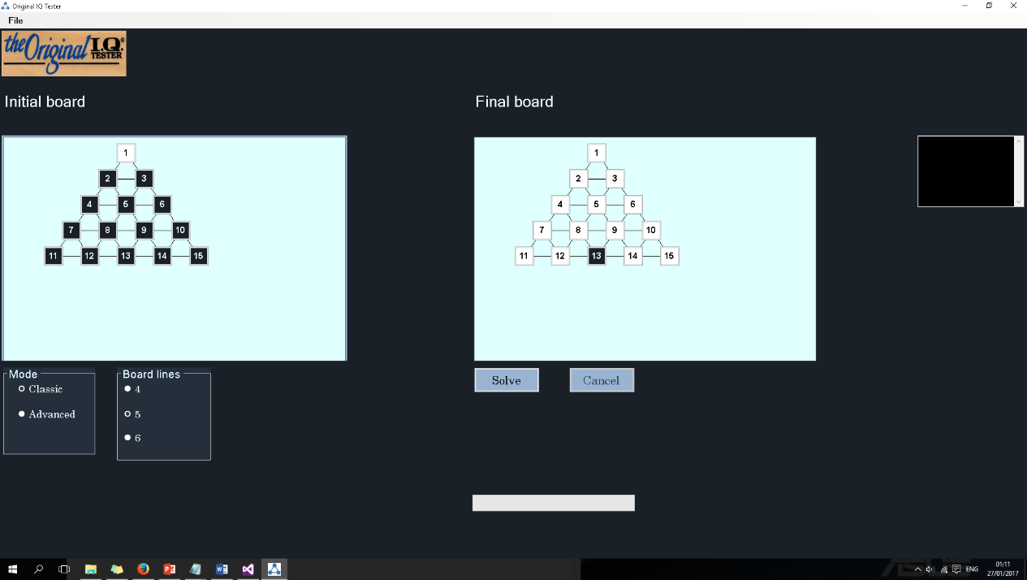**

Logger

Progress bar

1. C:\Users\elad\AppData\Local\Microsoft\Windows\INetCacheContent.Word\solve_btn.pngSet initial and final boards.
2. Press to start the solver.
3. C:\Users\elad\AppData\Local\Microsoft\Windows\INetCacheContent.Word\cancel_btn.pngPress to cancel operation.

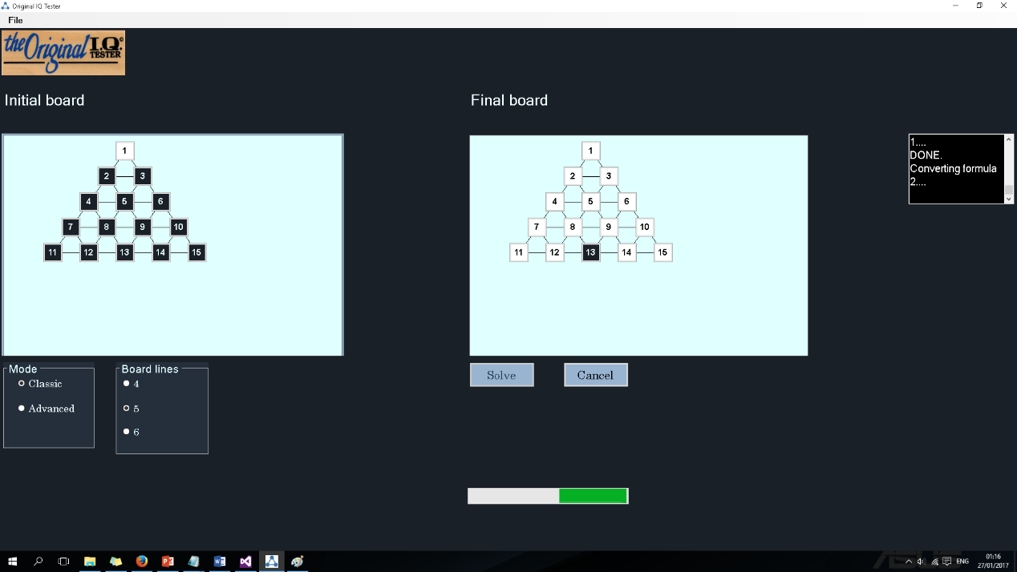

Solving in progress

**Solution Screen**

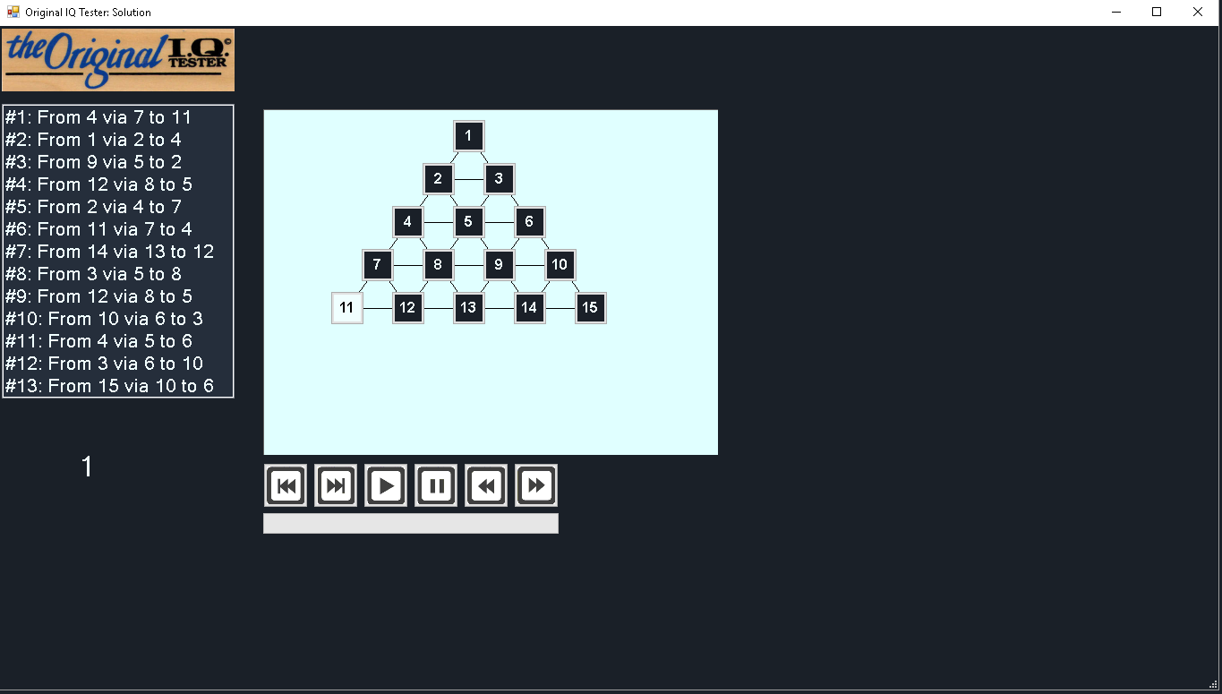

Steps list

Steps progress

Current phase

This how it looks while stepping into the solution.

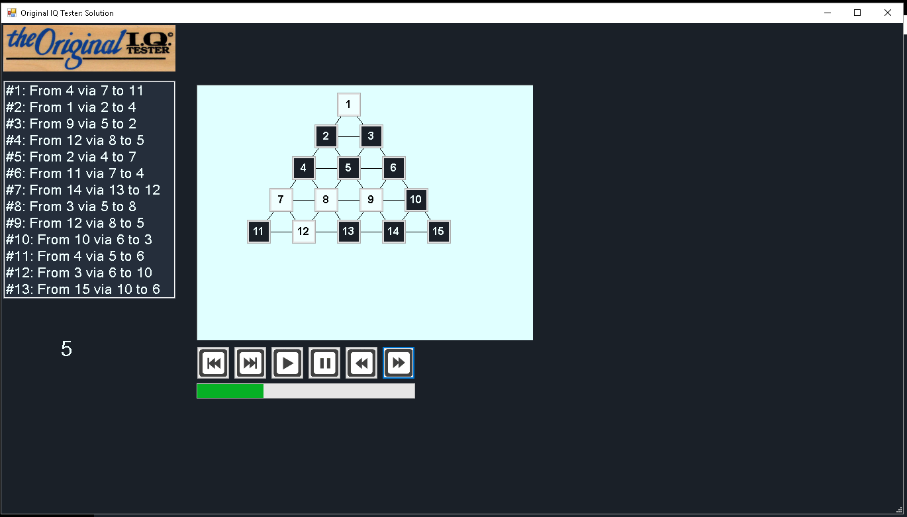

**Steps controls:**

* C:\Users\elad\AppData\Local\Microsoft\Windows\INetCacheContent.Word\first_btn.png Go to the first phase.
* Go to the last phaseC:\Users\elad\AppData\Local\Microsoft\Windows\INetCacheContent.Word\last_btn.png.
* C:\Users\elad\AppData\Local\Microsoft\Windows\INetCacheContent.Word\play_btn.png Auto-play solution steps.
* C:\Users\elad\AppData\Local\Microsoft\Windows\INetCacheContent.Word\pause_btn.png Pause the auto-playing.

C:\Users\elad\AppData\Local\Microsoft\Windows\INetCacheContent.Word\prev_btn.png

* Go to the previous phase.
* C:\Users\elad\AppData\Local\Microsoft\Windows\INetCacheContent.Word\next_btn.png Go to the next phase.