You Don't Need an Expensive
GPU Cluster to Start with Private AI
A practical path to private AI using standard enterprise servers, open-weight models, load balancing, and multi-agent inference.

Elad Kurzweil
Technical paper | September 2026
Lab example: Qwen3.8-Flash-Next - 125B total language-model parameters with 6B activated per token - deployed across multiple standard servers behind a load balancer and used by multiple Hermes agents.

Executive summary
Private AI does not have to begin with a purpose-built GPU cluster. Many organizations can validate useful inference workloads on infrastructure they already own, then scale only after measurements reveal the real bottleneck. This paper explains that approach and documents a lab design using Qwen3.8-Flash-Next with horizontally scaled inference nodes and Hermes multi-agent workloads.

1. Start with the workload, not the GPU
When organizations begin discussing private AI, the conversation often jumps immediately to high-end GPU servers, high-density racks, specialized networking, and liquid cooling. Those technologies are important at scale, but they are not a prerequisite for every private-AI project.
The first architectural question should be what the system must do. Training a foundation model, fine-tuning an existing model, serving interactive inference, building a RAG assistant, and operating autonomous agents are different workloads with very different infrastructure requirements.
- Foundation-model training: very high compute, fast GPU interconnects, large datasets, and specialized storage.
- Fine-tuning: can range from modest adapter tuning to substantial multi-GPU workloads.
- Inference: often much easier to start with because an already-trained model can be served from one or more conventional systems.
- RAG and internal assistants: depend heavily on data access, permissions, retrieval quality, and context management.
- Agent workloads: create repeated model calls, tool use, long-running sessions, and concurrency that can stress an inference service differently from a chatbot.
The goal is not to build the largest AI environment possible. The goal is to build the smallest environment that reliably supports the required business use case.

2. What makes private AI practical?

Open-weight models
Organizations can choose from capable open-weight models in many sizes and architectures. A model should be selected for the real task rather than by parameter count alone. For enterprise use, quality, latency, context size, tool use, multimodality, license terms, and operational support all matter.

Quantization
Quantization reduces the precision used to store model weights. This lowers RAM or VRAM requirements and can make a model practical on infrastructure that could not host the full-precision version. The trade-off is that quality and performance must be validated for the target workload.

Hybrid CPU and GPU inference
A model does not always need to reside entirely in GPU memory. Depending on the runtime, some weights or layers can be kept in system RAM while acceleration is provided by one or more GPUs. This is slower than keeping the full working set in high-bandwidth accelerator memory, but it can be a cost-effective way to validate a private-AI use case.

3. What can run on a regular enterprise server?
A modern dual-socket server with substantial system RAM, local NVMe storage, and an optional GPU can support meaningful AI workloads. The result depends on the model architecture, quantization format, memory bandwidth, NUMA placement, context size, and concurrency.
Design area | Practical guidance
CPU and RAM | Large system memory can make quantized and offloaded models possible, but memory bandwidth often matters as much as CPU core count.
GPU | A 24 GB or larger GPU can accelerate many models; partial offload can help when the model exceeds VRAM.
Storage | Local NVMe is useful for model files, caches, indexes, and fast startup. RAG data may live on shared or object storage.
Networking | Standard Ethernet is enough for independent inference nodes. High-speed fabrics become more important for tightly coupled distributed compute.
Virtualization | VMs can be useful for isolation and operations, though GPU passthrough, NUMA placement, and memory overhead must be considered.

4. Why Qwen3.8-Flash-Next is interesting for this approach
For my lab test I used Qwen3.8-Flash-Next, an experimental open-weight model from the Qwen team. Its architecture is relevant to private AI because it combines very large total capacity with sparse activation and design choices intended to improve long-context and agentic efficiency. [1]
Qwen3.8-Flash-Next | Official model-card specification
Model type | Causal language model with a vision encoder
Language-model parameters | 125B total, with 6B activated
Additional parameters | 51B n-gram embedding and 4B multi-token-prediction component
MoE layout | 512 experts; 10 routed experts plus 1 shared expert activated
Native context | 262,144 tokens
Extended context | Up to 1,000,000 tokens
Serving support | Transformers, vLLM, SGLang, TokenSpeed and other compatible runtimes

Sparse activation is not the same as small memory footprint
The “6B activated” figure describes the subset of language-model parameters used for token computation; it does not mean the complete model occupies only the memory of a 6B model. The full model weights and supporting components still need to be stored somewhere - accelerator memory, system RAM, or an offloading hierarchy. Sparse activation mainly changes how much compute participates in each token step.

Architecture choices that matter
- Qwen Sparse Attention (QSA): operates at the micro-block level and is intended to reduce long-context latency.
- Gated DeltaNet + QSA hybrid attention: combines linear-attention-style processing with sparse attention.
- Gated Residual: uses data-dependent gating in the residual path while keeping inference overhead low.
- N-gram embedding: adds parameter capacity in a form the model card describes as requiring less computation and being more amenable to offloading than MoE.
- Vision support: the model is multimodal, enabling image-plus-text workflows as well as language tasks.
The official model card recommends dedicated serving engines such as SGLang, KTransformers, or vLLM for production or high-throughput scenarios and provides OpenAI-compatible serving examples for vLLM and SGLang. [1]

5. My lab example: multiple inference nodes with Hermes
I tested the approach by running Qwen3.8-Flash-Next across multiple standard enterprise servers. Each server operated as an independent inference node with its own model instance. A load balancer exposed the group as one shared endpoint to Hermes, which was used to run multiple AI agents concurrently.
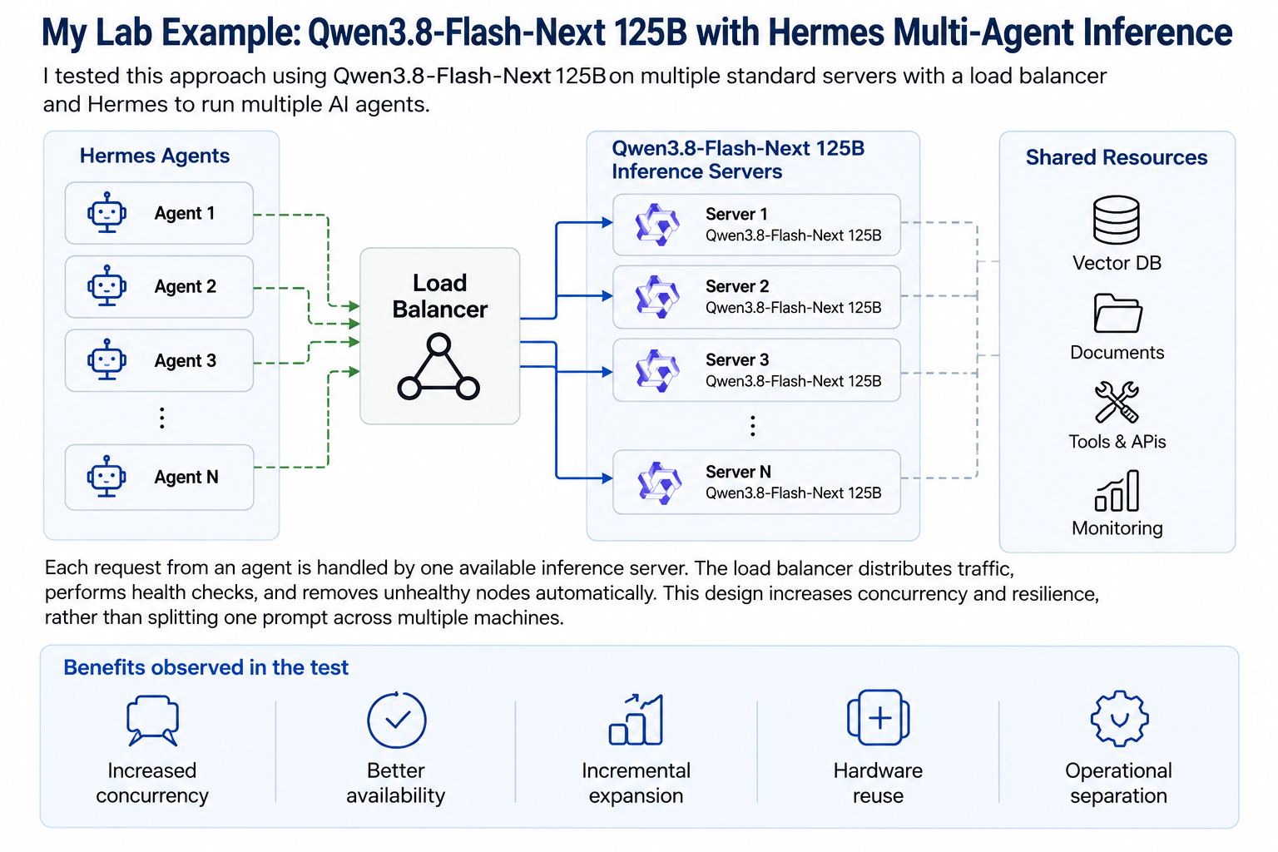
Figure 1 - Lab architecture: Hermes agents use a load-balanced pool of independent Qwen3.8-Flash-Next 125B inference servers.
The servers were not combining their memory to execute one prompt. One request was routed to one available inference node. The objective was horizontal inference scaling: increasing aggregate capacity, concurrency, resilience, and maintenance flexibility.

Why this is useful for agents
Agent workloads can generate far more model traffic than a normal chat session. An agent may analyze an objective, build a plan, call tools, inspect the result, correct errors, generate code or files, and continue through multiple iterations. Several agents running in parallel can therefore create queues quickly on a single inference server.
- One shared API endpoint hides the physical nodes from the agent framework.
- Health checks allow failed or unavailable nodes to be removed from rotation.
- Capacity can be added incrementally by adding more inference nodes.
- Maintenance can be performed on one node without stopping the complete service.
- The design reuses standard servers instead of requiring a monolithic accelerator platform on day one.

Load-balancer considerations for LLM traffic
- Use long enough HTTP and idle timeouts for streamed responses and multi-step agent tasks.
- Use model-aware readiness checks rather than checking only whether a TCP port is open.
- Keep model version, quantization, context settings, prompt templates, and API behavior consistent across nodes in the same pool.
- Measure active requests, queue depth, response time, and node utilization; simple round-robin may be inefficient when request lengths vary widely.
- Do not assume a node is healthy merely because the host is reachable - the model may still be loading, out of memory, or unable to generate tokens.

6. Understanding memory requirements
A simple first estimate for dense model-weight memory is parameter count multiplied by bytes per parameter. For example, a 7B model requires roughly 14 GB for 16-bit weights, 7 GB for 8-bit weights, and 3.5 GB for 4-bit weights before runtime overhead. Real usage is higher because inference also needs KV cache, temporary buffers, metadata, runtime memory, and space for concurrent requests.
For sparse or hybrid architectures such as Qwen3.8-Flash-Next, a single “parameter count × bytes” estimate is not sufficient to describe runtime behavior. Total stored weights, activated parameters, n-gram embeddings, expert routing, attention state, cache size, and the serving framework all affect the real memory footprint and throughput.

7. What performance should you expect?
Standard servers can be useful for proof-of-concept work, background processing, internal assistants, coding help, RAG, security-log analysis, and agent automation. They will not necessarily deliver the latency of a high-end accelerator system. The right question is whether the measured service level is acceptable for the intended users and workflow.
- Time to first token
- Prompt-processing speed
- Output tokens per second
- RAM and VRAM usage
- CPU and GPU utilization
- Queue depth
- Maximum sustainable concurrent users or agents
- Context-window impact
- Power consumption
- Failure rate and recovery behavior
Do not benchmark only one short prompt. Test real documents, real context lengths, realistic output sizes, multiple users or agents, and the actual sequence of tool calls your application will generate.

8. A practical starting architecture
A small private-AI platform can be organized into five layers: inference servers, a model runtime, a load balancer/API layer, enterprise data and RAG services, and monitoring/governance. The following sections describe the role of each layer and the operational decisions that matter most.

Inference servers
Start with one physical or virtual node, measure it, and add nodes only when utilization, queues, latency, or availability justify more capacity.

Model runtime
Choose a runtime based on the model format, available accelerators, API compatibility, concurrency, operational support, and production requirements. For Qwen3.8-Flash-Next, the official model card lists Transformers, vLLM, SGLang, TokenSpeed and compatible runtimes. [1]

API and load-balancing layer
Applications and agents should use a stable service endpoint rather than connecting directly to a physical model server. This layer can provide TLS, authentication, rate limiting, request logging, health checks, traffic distribution, and failure handling.

RAG and enterprise data
A private model becomes much more useful when it can retrieve approved company knowledge. The AI layer must preserve the permissions of the source systems. A user or agent should not gain access to a document simply because the model can retrieve it.

Monitoring and governance
Monitor both infrastructure and AI service behavior: CPU, RAM, GPU, storage, networking, model version, queue depth, latency, tokens per second, error rate, prompt size, and user or agent activity.

9. When is an expensive GPU cluster justified?
Standard servers are a useful starting point, not a universal replacement for specialized AI infrastructure. A dedicated accelerator cluster becomes reasonable when measured workload requirements show that conventional nodes cannot meet the required model size, latency, concurrency, training, or throughput targets.
- Large-scale model training
- Substantial fine-tuning workloads
- Very large models that cannot be hosted effectively on one node
- Strict low-latency service-level requirements
- High-volume concurrency
- Large multimodal workloads
- Predictable throughput at enterprise scale
- Tightly coupled distributed inference or training that needs high-speed accelerator interconnects

10. Common mistakes
- Buying hardware before defining the use case.
- Selecting a model based only on parameter count.
- Ignoring concurrent users and agent-generated request amplification.
- Focusing only on tokens per second while ignoring time to first token, queueing, reliability, and quality.
- Connecting applications directly to one physical model server.
- Using short web-service timeouts that are inappropriate for streaming LLM responses.
- Using weak health checks that do not verify model readiness.
- Ignoring document permissions in RAG systems.
- Treating a proof of concept as a production service without authentication, monitoring, lifecycle management, backup, and recovery.

11. Where should you begin?
1. Select one business problem - Choose a narrow, measurable use case such as internal documentation search, support-case summarization, configuration assistance, report generation, security-event review, or a specialized agent.
2. Define measurable success criteria - Specify response time, answer quality, privacy constraints, target users or agents, acceptable cost, and failure thresholds.
3. Test several models - Compare quality, memory use, tool-use reliability, context handling, and performance on a controlled set of real tasks.
4. Use existing infrastructure first - Start with an available server, enough RAM, NVMe storage, a supported runtime, and acceleration only where it is needed.
5. Measure the real bottleneck - Determine whether the limitation is model quality, memory capacity, memory bandwidth, GPU VRAM, context size, concurrency, storage, networking, load balancing, or application behavior.
6. Scale according to evidence - Add GPUs, servers, faster networking, or a dedicated cluster only when measurements show exactly what is required.
Start small. Measure the real bottleneck. Scale only when the workload justifies it.

Final thoughts
Private AI does not need to begin with a multimillion-dollar GPU environment. It can begin with one clearly defined business problem, one server, one carefully selected model, one controlled group of users or agents, and one measurable test.
In my lab, I used Qwen3.8-Flash-Next across multiple standard enterprise servers behind a load balancer and used Hermes to run multiple AI agents through a shared private-AI endpoint. The experiment was designed to test horizontal inference scaling rather than distributed execution of a single prompt.
The key lesson is not that standard servers replace GPU clusters. The key lesson is that infrastructure should follow measured requirements. Reuse what you already have, validate the workload, identify the bottleneck, and then invest in the next layer of infrastructure with evidence.
For many organizations, the first private AI platform may already be sitting in the datacenter.

References
[1] Qwen Team. “Qwen3.8-Flash-Next” model card, Hugging Face. https://huggingface.co/Qwen/Qwen3.8-Flash-Next
Model-card facts cited in this paper include the 125B / 6B-activated language-model specification, 51B n-gram embedding, 4B MTP component, MoE expert counts, 262,144-token native context, extension to 1,000,000 tokens, multimodal model type, and supported serving frameworks. Accessed September 2026.

