Kingdom of Saudi Arabia
Ministry of Education
University of Hail
College of Computer Science and Engineering
Cooperative Training Office

FINAL COOPERATIVE TRAINING REPORT
Project Title
Nadee Smart Assistant
An Internal Intelligent Support System for the Data Management Office
at Hail Region Municipality
Field | Details
Trainee Name | Elaf Abdulaziz Alkowair
Training Organization | Hail Region Municipality
Training Department | Data Management Office
Faculty Advisor | Omar Salem AL-Mostah
Academic College | College of Computer Science and Engineering
Report Type | Final Academic Coop Report
Academic Year | 1446–1447 AH / 2025–2026

Submitted in partial fulfillment of the Cooperative Training Program requirements.

Abstract

This final report presents the cooperative training experience of Elaf Abdulaziz Alkowair at the Data Management Office of Hail Region Municipality, and documents the applied project “Nadee Smart Assistant.” The project addresses a practical organizational challenge: employees frequently spend time searching for information related to the National Data Index (Nadee) and repeatedly ask similar questions about guides, procedures, maturity criteria, and supporting documents. The proposed solution is an internal web-based intelligent assistant that answers Nadee-related questions from a trusted knowledge base derived from SDAIA guidance, and provides an analytics module to monitor data-management maturity across fourteen domains. The system was implemented using Python, Django, and SQLite, with an Arabic RTL interface and a GitHub-based project repository for academic demonstration.

Table of Contents
Abstract 2
Table of Contents 3
1. Introduction 4
2. Training Organization Overview 4
2.1 Host Organization 4
2.2 Organizational Context 4
3. Main Tasks and Responsibilities 4
4. Problem Statement 5
5. Project Idea 5
6. Proposed Solution 6
6.1 Solution Overview 6
6.2 Core Modules 6
6.3 Knowledge Scope 6
7. Technologies and Programming Languages 6
7.1 Programming Languages 6
7.2 Frameworks, Tools, and Platforms 7
7.3 Workplace-Related Technologies and Learning 7
8. System Maps and Diagrams 7
8.1 Architecture Diagram 7
8.2 Sitemap 8
8.3 Chatbot Processing Flow 9
8.4 Conceptual Data Map 9
9. Use Cases 9
9.1 Use Case Diagram 9
9.2 Use Case Catalog 10
9.3 Detailed Scenario (UC-02) 10
10. System Features and Functional Description 11
11. Results and Benefits 11
12. Challenges and Lessons Learned 12
13. Conclusion and Recommendations 12
14. References 12
Appendices 13
Appendix A: Demo Credentials 13
Appendix B: Project Links 13
Appendix C: Nadee Domains and Criteria Count 13
Appendix D: Report Content Distribution 13

1. Introduction
Cooperative training is a critical bridge between academic learning and professional practice. During the internship at Hail Region Municipality, the trainee was immersed in real data-management operations, including coordination with the IT Department, participation in inter-agency meetings, and support for reporting activities related to the National Data Index (Nadee).
This final report consolidates the training experience—especially insights reflected in monthly reports five and six—and presents the applied project developed to respond to an operational need inside the Data Management Office. The report follows an academic structure covering the organization context, tasks, problem, idea, solution, technologies, maps, and use cases.

2. Training Organization Overview

2.1 Host Organization
The training was conducted at Hail Region Municipality, within the Data Management Office. The office contributes to data governance, data quality, institutional reporting, and alignment with national data controls and measurement frameworks under SDAIA.

2.2 Organizational Context
The workplace environment requires continuous coordination between business/data teams and technical teams. During the internship, the trainee supported communication between the Data Management Office and the IT Department, attended meetings with digital transformation and statistics stakeholders, and contributed to preparing materials for discussions involving SDAIA. These activities highlighted both the importance of accurate information and the cost of fragmented knowledge sources.

3. Main Tasks and Responsibilities
Key responsibilities performed during the cooperative training period include:
- Acting as a communication focal point between the Data Management Office and the IT Department.
- Participating in meetings with external entities (e.g., Digital Transformation Agency and Statistics Agency), documenting feedback, and preparing required materials.
- Supporting Data Quality activities: reviewing, updating, and following up on requirements and reports.
- Supporting Data Governance activities by reviewing related files and platform outputs.
- Contributing to Nadee-related reporting and organizational data-management follow-up.
- Mentoring new trainees by explaining workflows, communication practices, and report preparation.
- Self-development through Python learning and professional programs (e.g., IBM AI ELL and Data Science pathways).

4. Problem Statement
Employees in the Data Management Office frequently need reliable answers about the National Data Index (Nadee), including domains, criteria, maturity levels, supporting documents, and training materials. In practice, information is distributed across documents and discussions, which leads to:
- Difficulty accessing official Nadee guides and procedures quickly.
- Repeated similar inquiries that consume staff time.
- Delayed preparation for measurement cycles due to fragmented references.
- Limited visibility of maturity performance across data-management domains.
Therefore, the core problem is the absence of a unified, trusted, and easy-to-use internal assistant that can provide accurate Nadee knowledge on demand and support maturity follow-up.

5. Project Idea
The project idea is to build an internal platform named “Nadee Smart Assistant” dedicated to municipality employees in the Data Management Office. The platform provides:
- An intelligent chatbot that answers Nadee-related questions from a trusted knowledge base.
- A structured knowledge section for guides, procedures, FAQs, and training content.
- An analytics section that tracks maturity across the fourteen Nadee domains and generates practical alerts.
The idea directly links internship observations to a practical software solution that improves information access, reduces repeated questions, and supports readiness for Nadee measurement cycles.

6. Proposed Solution

6.1 Solution Overview
The implemented solution is a Django-based internal web system with authentication, chatbot interaction, knowledge browsing, and analytics dashboards. The chatbot uses a lightweight Arabic-aware matching engine to retrieve the most relevant knowledge article and returns the answer with its official source reference.

6.2 Core Modules
Module | Purpose | Main Output
Accounts | Secure employee access | Login / logout / registration
Chatbot | Answer Nadee questions | Conversational responses with sources
Knowledge Base | Organize official content | Guides, FAQs, procedures, training
Analytics | Monitor maturity performance | Domain scores, alerts, forecasts
Admin Panel | Manage content and metrics | CRUD operations for system data

6.3 Knowledge Scope
The knowledge base covers the three Nadee measurement elements (practice maturity, compliance, and operational excellence), fourteen data-management domains totaling forty-two criteria, six maturity levels, supporting documents (attachments), and readiness guidance for the third measurement cycle.

7. Technologies and Programming Languages

7.1 Programming Languages
Language | Usage in the Project
Python | Backend logic, chatbot engine, analytics services, management commands
HTML | Page structure and semantic content layout
CSS | Visual design, Nadee-inspired theme, responsive RTL interface
JavaScript | Chat interaction and front-end behavior
SQL (via ORM) | Data persistence through Django models on SQLite

7.2 Frameworks, Tools, and Platforms
Technology | Role | Justification
Django | Web framework | Structured MVC-like architecture, security, admin panel
SQLite | Database | Lightweight and suitable for internal/academic deployment
Git / GitHub | Version control & demo hosting | Collaboration, documentation, Pages preview
SDAIA Nadee Guide | Knowledge source | Official and trusted content foundation
WhiteNoise / Gunicorn | Production readiness options | Static serving and WSGI deployment support

7.3 Workplace-Related Technologies and Learning
In addition to the project stack, the training exposed the trainee to organizational data platforms and digital initiatives (including Beam-related awareness sessions mentioned in monthly report five), Nadee reporting practices, and self-development programs in AI and Data Science. These experiences informed the problem definition and the design of the assistant.

8. System Maps and Diagrams

8.1 Architecture Diagram
Figure 1 illustrates the logical architecture of the system layers and data flow.
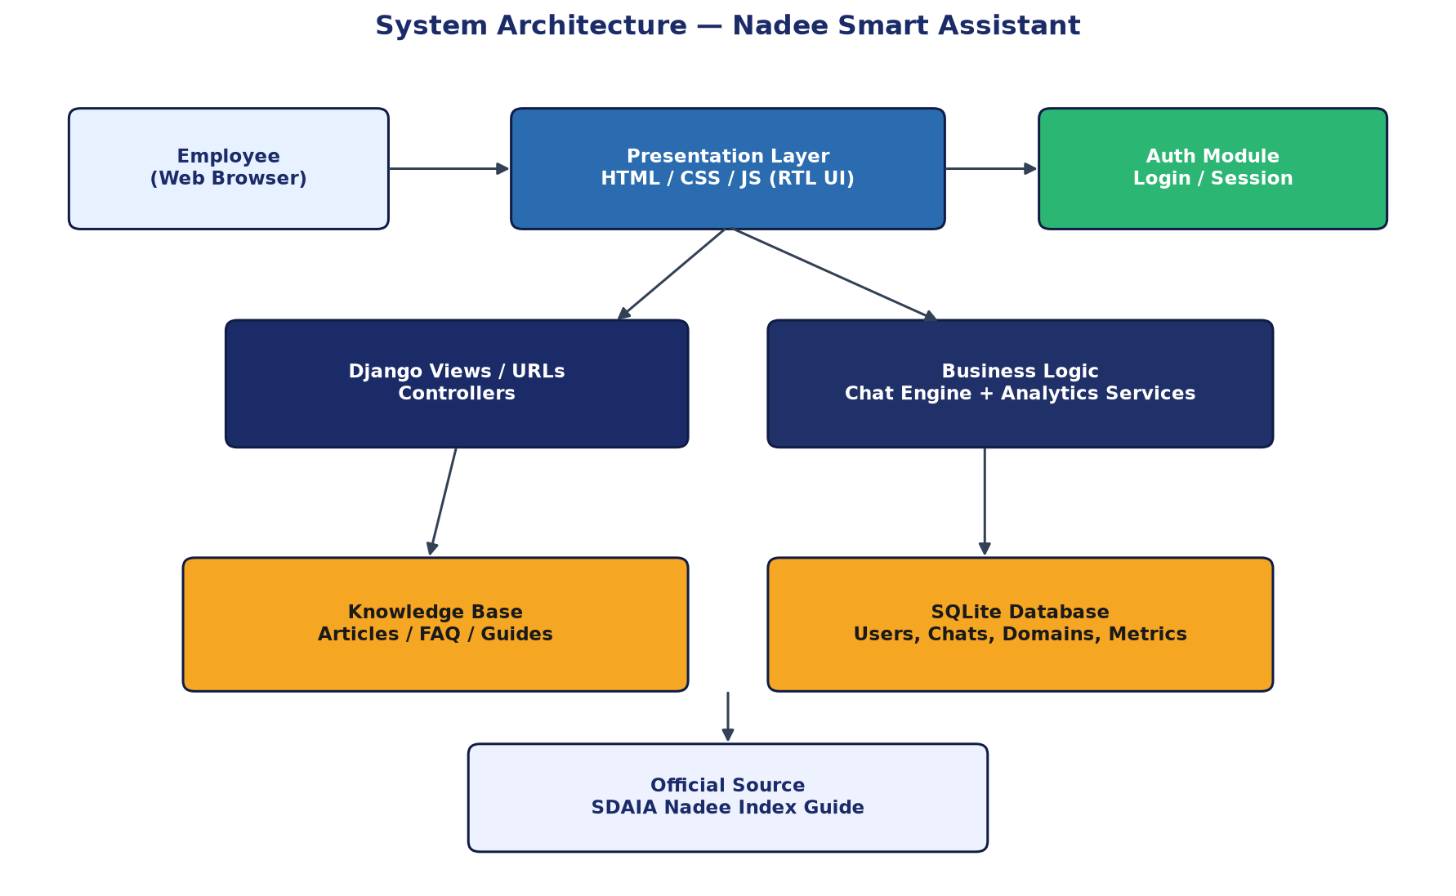
Figure 1. System architecture of Nadee Smart Assistant.

8.2 Sitemap
Figure 2 presents the main navigation structure of the application.
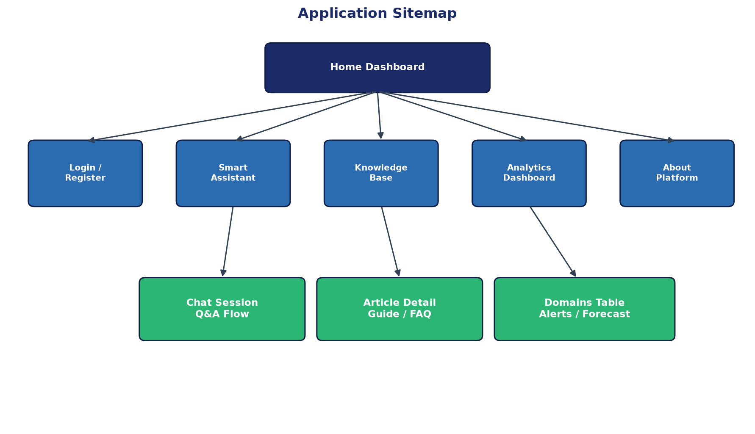
Figure 2. Application sitemap.

8.3 Chatbot Processing Flow
Figure 3 summarizes how a user question is transformed into a sourced answer.
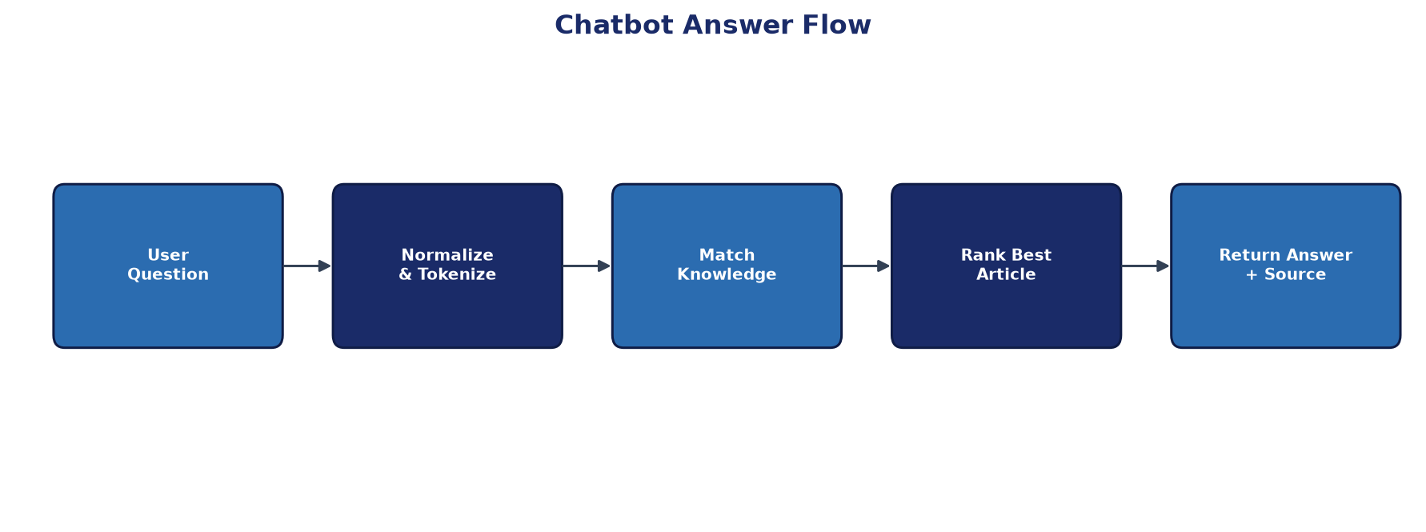
Figure 3. Chatbot answer-processing flow.

8.4 Conceptual Data Map
The main data entities and relationships can be summarized as follows:
- User → owns → ChatSession → contains → ChatMessage
- KnowledgeArticle ← referenced by → ChatMessage (optional)
- DataDomain stores maturity score, pillar, and criteria count
- PerformanceRecord / MaturityFactor / PerformanceAlert support analytics

9. Use Cases

9.1 Use Case Diagram
Figure 4 shows the primary actors and system use cases.
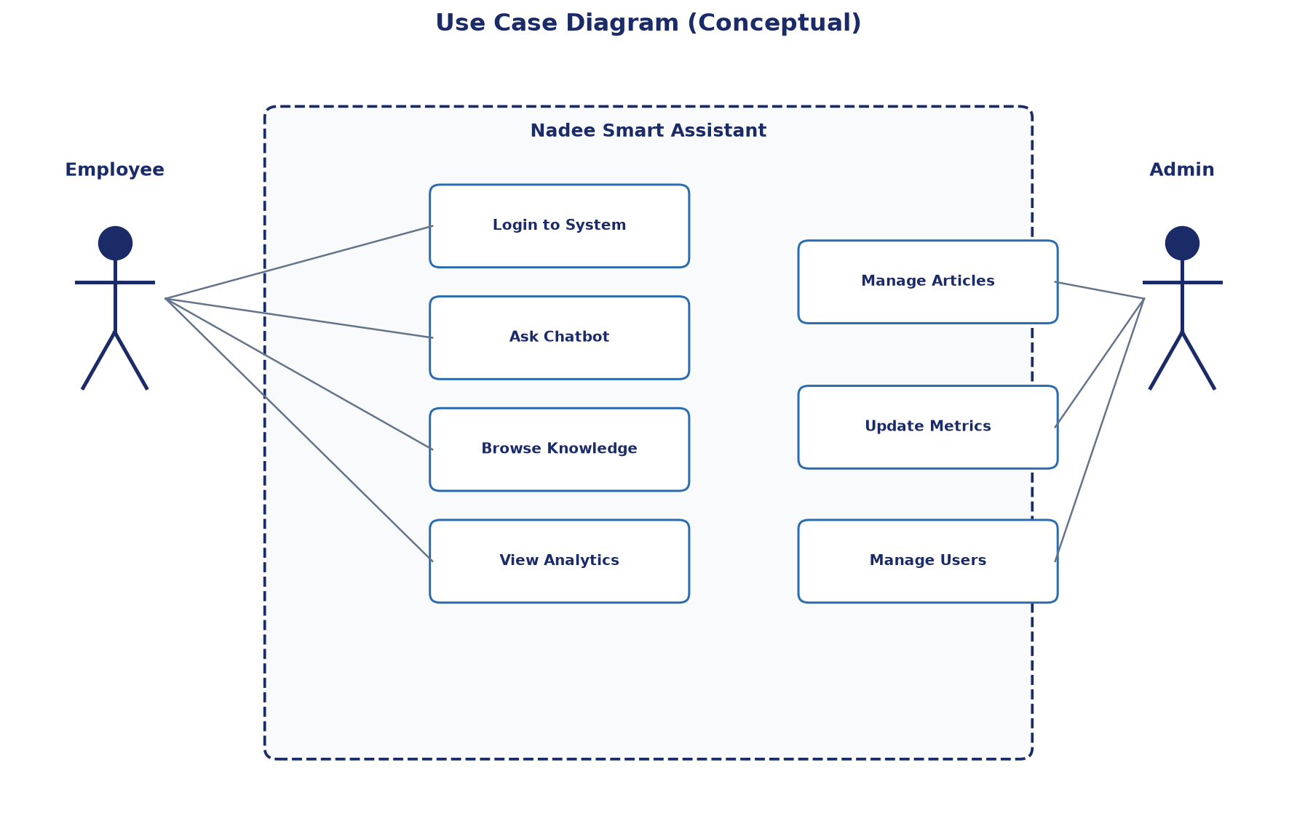
Figure 4. Conceptual use-case diagram.

9.2 Use Case Catalog
ID | Use Case | Actor | Description
UC-01 | Authenticate | Employee | Log in to access internal modules
UC-02 | Ask Assistant | Employee | Submit a Nadee-related question and receive an answer
UC-03 | Browse Knowledge | Employee | Search and open guides/procedures/FAQs
UC-04 | View Domain Maturity | Employee / Supervisor | Review 14-domain maturity analytics
UC-05 | Review Alerts | Employee / Supervisor | Read warnings and improvement suggestions
UC-06 | Manage Knowledge | Admin | Create/update knowledge articles
UC-07 | Manage Metrics | Admin | Update domain scores, factors, and alerts

9.3 Detailed Scenario (UC-02)
Actor: Data Management Office employee.
Goal: Understand maturity requirements for the Data Quality domain.
Main flow:
- Employee logs into the system.
- Employee opens the Smart Assistant page.
- Employee asks: “What is the Data Quality domain in Nadee?”
- System normalizes the question and matches it against the knowledge base.
- System returns the best article with source reference (SDAIA / Nadee guide).
- Employee may open Analytics to compare the domain maturity score with other domains.

10. System Features and Functional Description
- Secure internal access for municipality employees.
- Interactive chatbot specialized in Nadee content.
- Trusted knowledge base with categorized articles and keywords.
- Analytics dashboard for fourteen domains and forty-two criteria.
- Alerts and practical recommendations for maturity improvement.
- Admin interface for continuous content and metric updates.
- Academic preview via GitHub Pages plus full Django runtime locally.

11. Results and Benefits
The project delivers tangible benefits aligned with training-office needs:
- Faster access to official Nadee information.
- Reduction of repetitive inquiries through a shared assistant.
- Better readiness for measurement cycles via structured knowledge.
- Improved visibility of domain maturity and delay factors.
- A complete applied outcome that connects coop experience with software engineering practice.

12. Challenges and Lessons Learned
Major challenges included balancing daily office responsibilities with mentoring new trainees, handling detailed governance/quality follow-up, and consolidating scattered knowledge into one usable system. Another constraint was that GitHub Pages cannot host full Django applications; therefore, a static preview was prepared for demonstration while the complete system remains available for local execution. Key lessons include the value of clear requirements, documentation discipline, knowledge transfer, and designing solutions around real operational pain points.

13. Conclusion and Recommendations
The cooperative training experience at Hail Region Municipality provided practical exposure to data management, governance, quality, and inter-departmental coordination. The Nadee Smart Assistant project translates that experience into an applied internal system that answers trusted questions, organizes knowledge, and supports maturity monitoring. Future enhancements may include integrating advanced language models with source validation, connecting analytics to live operational data, and expanding the knowledge base as new Nadee guidance is released.

14. References
[1] Saudi Data and AI Authority (SDAIA). National Data Index (Nadee) — Third Measurement Cycle Guide.
[2] University of Hail, College of Computer Science and Engineering, Cooperative Training Office. Monthly Report Forms (S4).
[3] Alkowair, E. A. Monthly Coop Report No. 5 — Hail Region Municipality, Data Management Office.
[4] Alkowair, E. A. Monthly Coop Report No. 6 — Hail Region Municipality, Data Management Office.
[5] Django Software Foundation. Django Documentation. https://docs.djangoproject.com/
[6] Python Software Foundation. Python Documentation. https://docs.python.org/
[7] GitHub. Nadee Smart Assistant Repository. https://github.com/moneerafahaid-collab/nadee-smart-assistant

Appendices

Appendix A: Demo Credentials
- Employee: employee / Nadee@123
- Admin: admin / Admin@123

Appendix B: Project Links
- Repository: https://github.com/moneerafahaid-collab/nadee-smart-assistant
- GitHub Pages preview: https://moneerafahaid-collab.github.io/nadee-smart-assistant/

Appendix C: Nadee Domains and Criteria Count
# | Domain | Criteria
1 | Data Governance | 4
2 | Metadata and Data Directory | 3
3 | Data Quality | 4
4 | Data Storage | 3
5 | Content and Document Management | 3
6 | Data Modeling and Architecture | 2
7 | Reference and Master Data Management | 3
8 | Business Intelligence and Analytics | 4
9 | Data Integration and Sharing | 4
10 | Realizing Value from Data | 2
11 | Open Data | 3
12 | Freedom of Information | 2
13 | Data Classification | 3
14 | Personal Data Protection | 2
 | Total | 42

Appendix D: Report Content Distribution
Section Group | Content Focus | Approx. Weight
Introduction & Organization | Training context and workplace overview | 15%
Tasks & Problem | Responsibilities and operational pain points | 15%
Idea & Solution | Concept and system design | 25%
Technologies & Maps | Languages, tools, diagrams | 20%
Use Cases & Features | Functional modeling | 15%
Results & Conclusion | Outcomes, lessons, recommendations | 10%

Prepared by:
Elaf Abdulaziz Alkowair
Data Management Office — Hail Region Municipality

