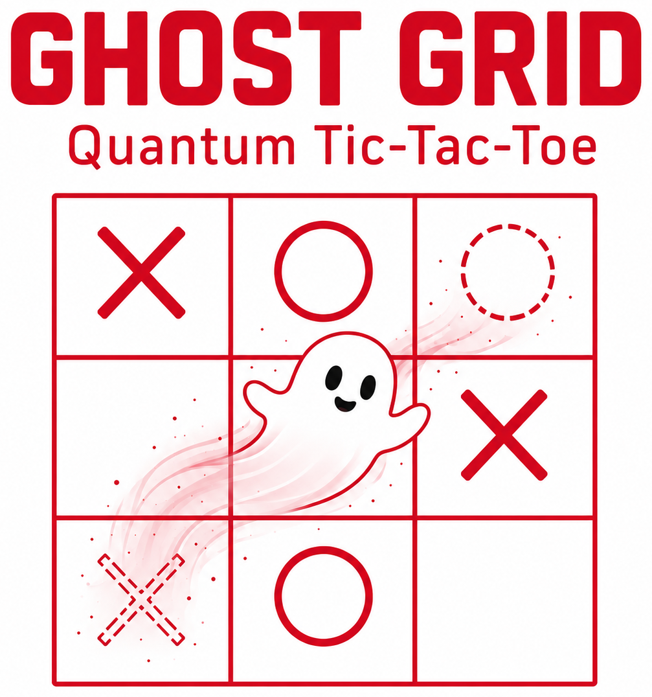 | SUPERPOSITION + ENTANGLEMENT  Goff’s full game • Two players • Pencils and erasers  Superposition: a spooky pair is one move in two places at once.  Entanglement: pairs that share a square are linked, so they affect each other.  Collapse: a measurement turns a spooky pair into one real mark.
1. Spooky pairs (superposition). X goes first. On each move, write your letter in two different squares. Label both with the move number: X₁ and X₁, then O₂ and O₂, then X₃ and X₃.
2. Shared squares (entanglement). Marks from different moves may share a square, so write small. Two moves that share a square cannot both end up there. Do not write in a square with a real mark.
3. Loops. A move closes a loop if a chain of pairs already joins its two squares. Example: X₁ is in squares 1 and 2. O₂ is in 2 and 5. X₃ in 1 and 5 closes a loop. Underline the linked marks.
4. Collapse (measurement). The player who did NOT close the loop chooses which square the newest move keeps. No dice are used. In the example, O picks square 1 or square 5 for X₃.
5. Chain reaction. Write the chosen mark large. It is real now. Cross out its twin. Cross out other spooky marks in that square and make their twins real. Repeat for each new real mark. Pairs not linked to the loop stay spooky. If O picks square 1, X₃ is real in 1, X₁ in 2, and O₂ in 5.
6. Win or keep going. Three real marks in a row wins: across, down, or diagonal. Spooky marks do not count. Check for a win after each collapse. If no one has won, the chooser makes the next move.
7. Several rows at once. Each row’s finish number is its largest move number. Rows with the lowest finish number score 1 point each. Later rows score ½ point each. The higher total wins.
8. Game end. The game ends after move 9 and any collapse. With no real winning row, it is a tie. If only one square is open at move 9, X writes both marks there. They make one real X.

1 | 2 | 3
4 | 5 | 6
7 | 8 | 9

