I Hate You: Hate Speech Detection and Lexical Explanations with TF–IDF Models
Text Mining and Sentiment Analysis
University of Milan
Student: Elaheh Zohdi | Matricola: 13731A
Academic year: 2023–2024
elaheh.zohdi@studenti.unimi.it

Abstract
Hate speech detection is an important component of content moderation and online safety, but it is still difficult in practice because hate, general profanity, and non-offensive language overlap at the lexical level. In this project I study hate speech classification on a widely used Twitter dataset labeled into three classes (hate, offensive, neither). I propose a lightweight pipeline based on text normalization, tokenization, stopword removal and stemming, followed by TF–IDF vectorization. I compare a linear classifier (Logistic Regression) and a non-linear model (XGBoost), and I evaluate them with accuracy and macro-F1 to account for strong class imbalance. Finally, I provide a lexical explanation of model decisions: (i) by inspecting the top TF–IDF features from the linear model coefficients and (ii) by computing SHAP explanations for the tree-based model. Results show that macro-F1 is similar across models, while the minority ‘hate’ class remains the main source of errors: many hate instances are predicted as ‘offensive’. Using class-balanced sample weights improves hate recall without sacrificing too much overall performance, and annotation agreement is clearly higher for correctly classified tweets than for mistakes.

1. Introduction
The spread of abusive language on social platforms affects users and communities, and it has pushed the development of automatic tools for detecting hate speech and offensive content. A recurring difficulty is that “hate” and “offensive” are not only rare compared to neutral language, but also close in meaning and often share the same surface vocabulary. As a consequence, high overall accuracy can hide poor detection of the most harmful class.
In this project I focus on the following research question:
How well can classical TF–IDF-based models distinguish hate speech from general offensive language, and which terms drive their decisions?
The main contributions are:
- a reproducible preprocessing and TF–IDF pipeline for hate/offensive/neither classification;
- an experimental comparison between Logistic Regression and XGBoost, including a cost-sensitive variant via sample weights;
- a lexical analysis of the learned decision rules using model coefficients and SHAP.

2. Related work
Hate speech detection has been approached with linear models on sparse features (e.g., bag-of-words or TF–IDF) as strong baselines, and with deep neural models that exploit contextual word representations. A key observation in the literature is that performance can be overestimated if datasets contain annotation artifacts or if validation is not carefully designed. Surveys summarize the variety of definitions and annotation guidelines across datasets, which makes comparisons difficult.
Besides detection, explainability has become important for trust and debugging. Feature weights of linear models provide a simple lexical explanation, while post-hoc methods such as SHAP can highlight which words contribute most to a decision in more complex models.

3. Dataset
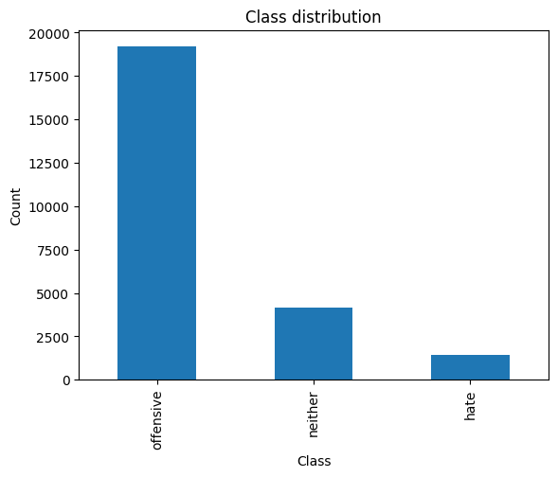
I use a public Twitter dataset originally annotated by multiple raters with three categories: hate speech, offensive language, and neither. Each tweet is associated with vote counts (how many annotators chose each class), and with the final label given by majority vote.
The dataset contains 24,783 tweets. There are no missing tweets and no duplicates in the provided file. Class distribution is strongly imbalanced: 19,190 offensive tweets, 4,163 neither tweets, and 1,430 hate tweets.
Table 1: Dataset statistics
Figure 1 - Class distribution in the dataset
Statistic | Value
Total tweets | 24,783
Missing tweets | 0
Duplicate tweets | 0
Offensive | 19,190 (77.4%)
Neither | 4,163 (16.8%)
Hate | 1,430 (5.8%)

3.1 Annotation agreement
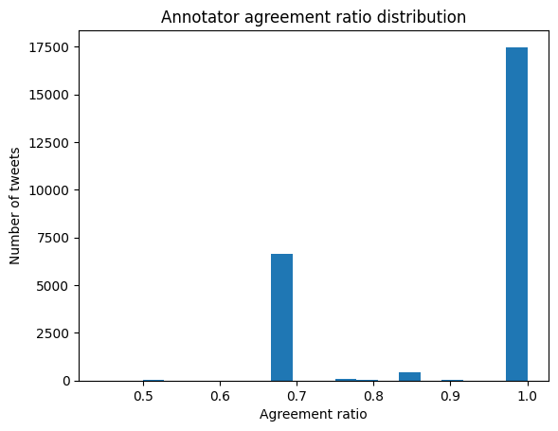
Since vote counts are available, I compute a simple agreement ratio to estimate how strongly annotators agreed on the final label. For each tweet I take the maximum number of votes for any class and divide it by the total number of votes (count). The resulting agreement ratio ranges between 0.44 and 1.00.
Agreement statistics are mean 0.905, median 1.00, and 25th percentile 0.667. Only 71 tweets have agreement ≤ 0.6, while 17,482 tweets have agreement ≥ 0.9. This suggests that most items are clear cut, but a small fraction is genuinely ambiguous.

4. Methodology
Figure 2 - Distribution of annotation agreement ratio
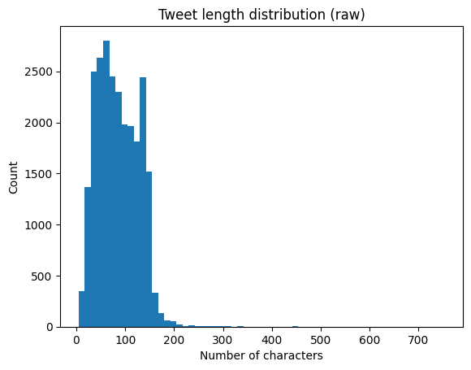
The overall methodology follows a standard text classification workflow: (i) exploratory data analysis, (ii) preprocessing and normalization, (iii) train/test split, (iv) feature extraction via TF–IDF, (v) model training, (vi) evaluation and error analysis, and (vii) lexical explanation.
Because the dataset is imbalanced, I report macro-F1 (average of per-class F1) in addition to accuracy, and I pay special attention to the F1 score for the hate class.

4.1 Exploratory analysis
Tweets are short texts: the average tweet length in the raw dataset is 85.4 characters (median 81), and 95% of tweets are shorter than 146 characters. The class distribution (Figure 1) confirms a strong imbalance toward ‘offensive’.

4.2 Text preprocessing
Figure 3 - tweet length distribution
I normalize the tweets to reduce noise while keeping the information useful for classification. The preprocessing pipeline is applied to each tweet and includes:
- Lowercasing
- Removing hashtags (keeping the word without ‘#’ when useful)
- Removing URLs
- Replacing @mentions with a dedicated token (MENTIONTOKEN) and removing the “RT” marker
- Converting digits into words
- Removing punctuation and line breaks
- Reducing repeated characters (for examples: ‘soooo’ → ‘soo’)
- Expanding English contractions (for example: don’t → do not)
- Tokenization, stopword removal, and Snowball stemming.
After preprocessing, empty token lists are removed (in this run, none were produced). The average tweet length becomes 8.07 tokens (median 8), with the most common token length equal to 5.
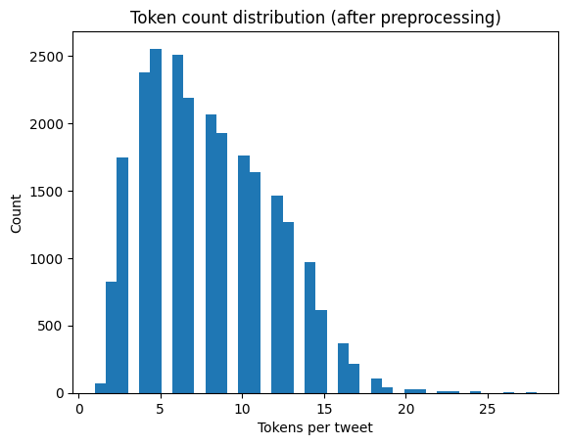
Figure 5 - Token count distribution after preprocessing

4.3 Train/test split
I split the dataset into training and test sets with an 80/20 ratio, using stratification to preserve the original class proportions. This results in 19,826 training tweets and 4,957 test tweets.
Training labels: 15,352 offensive, 3,330 neither, 1,144 hate.
Test labels: 3,838 offensive, 833 neither, 286 hate.

5. Feature representation
I represent each tweet with TF–IDF features over word n-grams. TF–IDF down-weights very frequent words and highlights more discriminative terms. Because tweets are short, I include both unigrams and bigrams.
The TF–IDF vectorizer is fitted on the training set only to avoid information leakage. Parameters: ngram_range=(1,2), min_df=3, max_df=0.9, sublinear_tf=True. The resulting vocabulary size is 10,813 features, producing sparse matrices of shape 19,826×10,813 (train) and 4,957×10,813 (test).

6. Models
I compare three classifiers:
1) Logistic Regression (balanced): a linear model trained on TF–IDF features with class_weight='balanced' to compensate for imbalance.
2) XGBoost: a gradient-boosted decision tree model trained on the same TF–IDF features.
3) XGBoost + sample weights: the same model but trained with per-sample weights computed from class frequencies (balanced), giving higher weight to minority classes.
For XGBoost I use a multi-class softprob objective, depth 6 trees, subsampling, and L2 regularization. Hyperparameters are kept moderate to avoid overfitting.

7. Experimental results
Table 2 summarizes the main results. Overall accuracy is above 0.87 for all models, but macro-F1 provides a clearer picture of performance on minority classes. Logistic Regression achieves the best hate F1 (0.44), while XGBoost attains the highest accuracy (0.91) but the lowest hate F1 (0.34), suggesting that it is more conservative on the hate class and often predicts ‘offensive’ instead. Introducing sample weights improves hate detection for XGBoost (hate F1 rises to 0.42) and yields the best macro-F1 (0.74) among the XGBoost variants.
A persistent error pattern is hate being predicted as offensive. many hate tweets contain profanity and slurs that also appear in the offensive class, and the dataset itself reflects annotator uncertainty for borderline cases.
Table 2: Model performance on the test set.
Model | Accuracy | Macro-F1 | F1 (hate) | F1 (offensive) | F1 (neither)
LogReg (balanced) | 0.87 | 0.74 | 0.44 | 0.91 | 0.86
XGBoost | 0.91 | 0.72 | 0.34 | 0.94 | 0.89
XGBoost + sample weights | 0.87 | 0.74 | 0.42 | 0.92 | 0.88

7.1 Confusion matrices
Figure 5 shows the confusion matrix for the baseline XGBoost model. Out of 286 hate tweets, only 72 are correctly classified as hate, while 185 are predicted as offensive.
Figure 6 shows the confusion matrix for XGBoost trained with sample weights. Hate recall improves substantially (169/286 hate tweets are correctly detected), at the cost of a larger number of offensive tweets being predicted as hate.

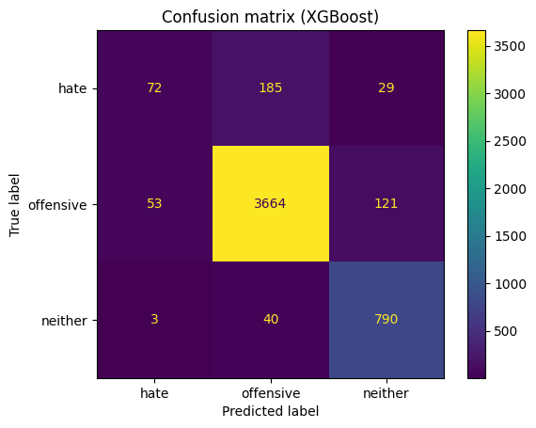
Figure 6 - confusion matrix (XGBoost)
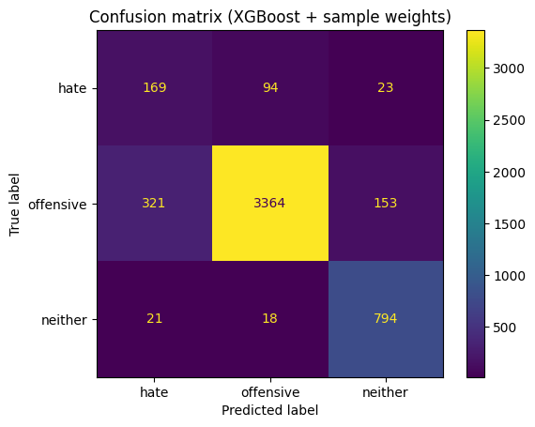
Figure 7 - Confusion matrix (XGBoost + sample weights)

8. Lexical explanations
Beyond performance, I aim to identify which words most influence the models. I use two complementary approaches:
- Logistic Regression coefficients: since the model is linear in TF–IDF space, high positive weights indicate terms that push predictions toward a class.
- SHAP for XGBoost: SHAP values estimate feature contributions for the tree-based model. For global importance I use mean absolute SHAP values, which measure the magnitude of influence regardless of sign.
Across methods, terms associated with identity-based slurs emerge as strong predictors for the hate class, while general profanity is often shared between hate and offensive, supporting the observed confusion between these labels.

8.1 Top tokens from Logistic Regression
For the hate class, the top-weighted tokens include explicit slurs and group identifiers. For example, the highest-weight tokens include “f*ggot”, “n*gger”, “n*gga”, “f*g”, and other highly specific terms. This is expected for a TF–IDF linear model: rare and class-specific words receive high weights.
A potential drawback is that the model can over-rely on lexical cues and may fail on implicit hate or creative spellings.

8.2 SHAP explanations for XGBoost
Figure 7–9 report the top features by mean absolute SHAP for each class. One of the most influential tokens is mentiontoken, which is not part of the original tweets: it is a placeholder introduced during preprocessing when replacing @username mentions. Its high importance suggests that directly addressed replies (tweets containing mentions) are common in this dataset and often co-occur with abusive language. At the same time, this is a reminder that the model can exploit conversational markers in addition to the actual hateful terms, so the interpretation should focus primarily on the content-related tokens (slurs/profanity) rather than on mentiontoken alone.
The SHAP plots also show that several profane terms contribute across multiple classes, reinforcing that the boundary between hate and offensive is fuzzy. This supports the idea that improving hate detection may require richer context beyond surface vocabulary.

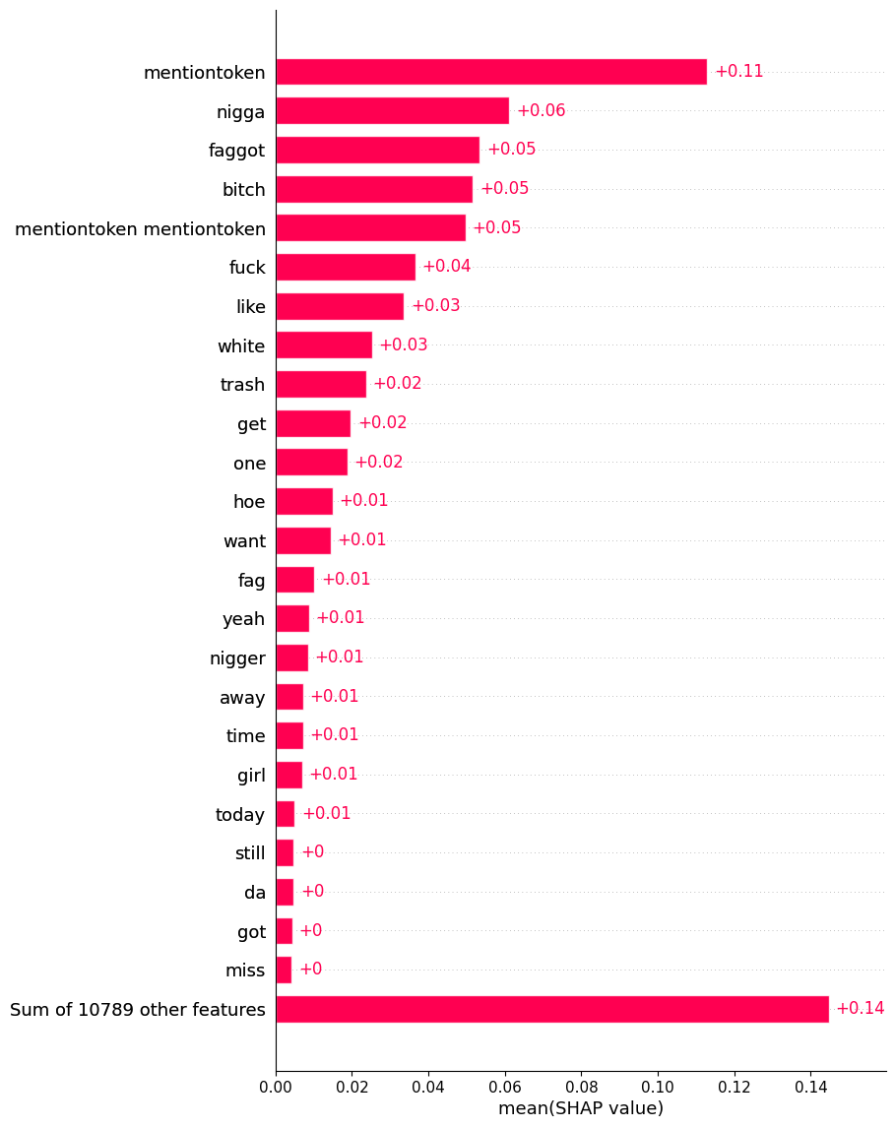
Figure 8 - SHAP bar plot (mean |SHAP|) for the hate class
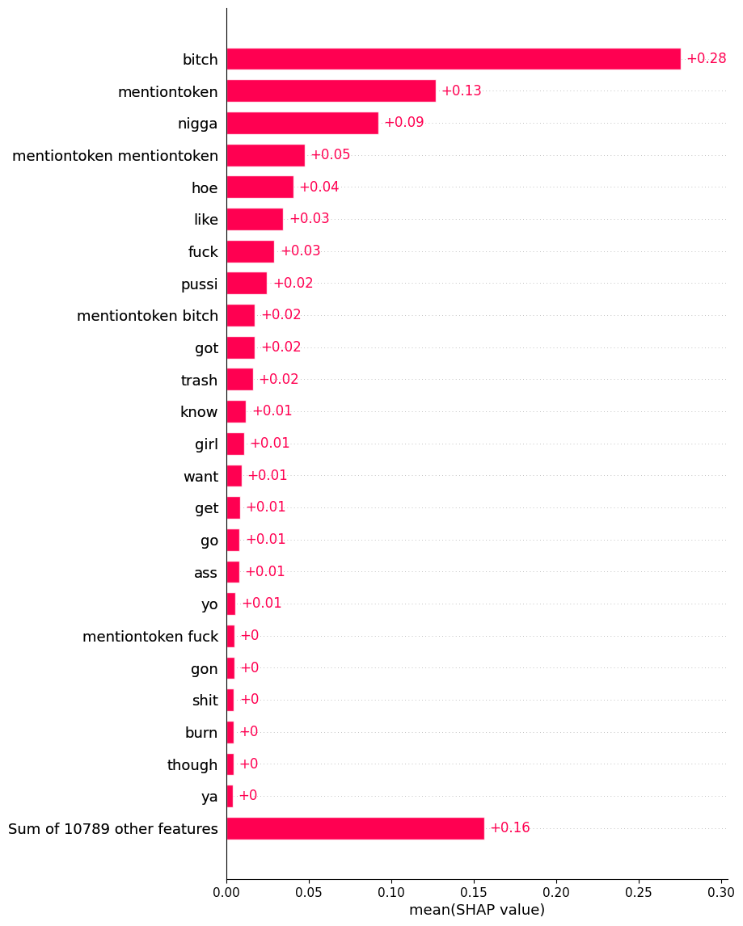
Figure 9 - SHAP bar plot (mean |SHAP|) for the offensive class.

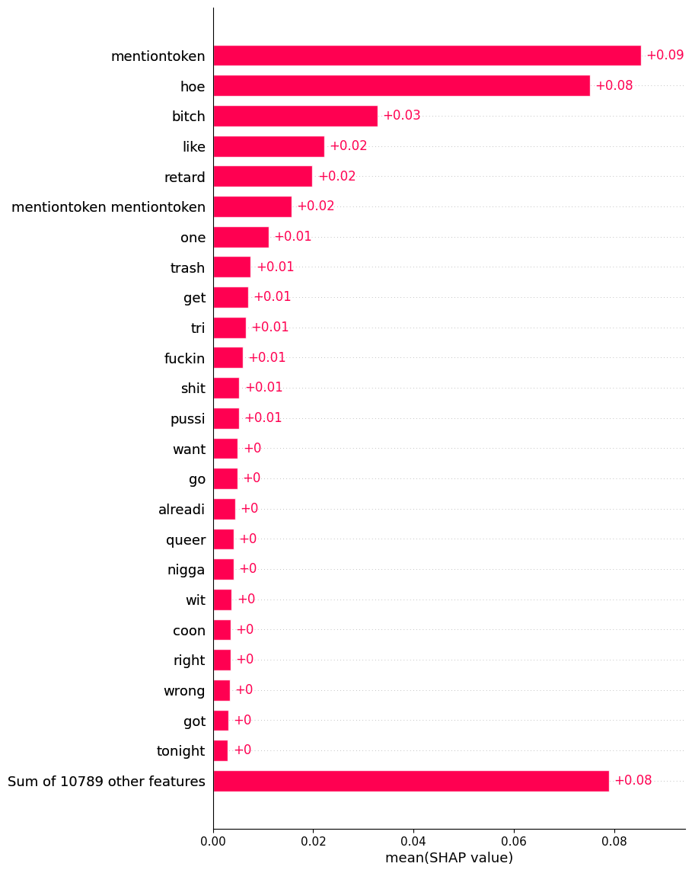
Figure 10 - SHAP bar plot (mean |SHAP|) for the neither class

9. Error analysis
To better understand mistakes, I connect model errors with annotation agreement. If annotators disagreed on an item, the label is less reliable, and we expect higher error rates. This is exactly what appears in the results: mean agreement is 0.925 for correctly classified tweets but drops to 0.776 for misclassified tweets.
For the weighted XGBoost model, row-normalized confusion rates show that 59.1% of hate tweets are correctly classified as hate, 32.9% are predicted as offensive, and 8.0% as neither. The largest residual error is hate to offensive (94 cases), which aligns with the lexical overlap between the two classes.
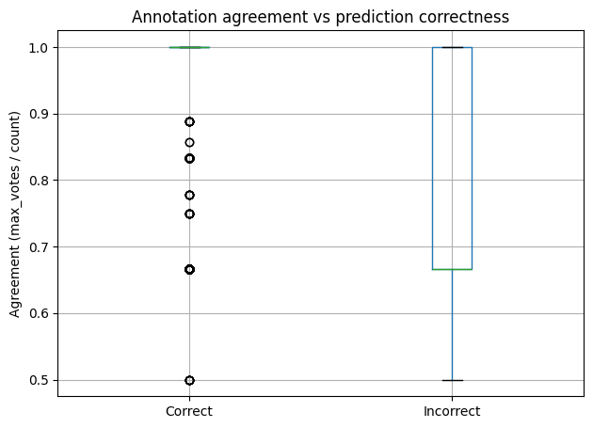
Figure 11 - Annotation agreement vs prediction correctness (weighted XGBoost)

10. Concluding remarks
This project confirms that TF–IDF models remain strong baselines for hate speech detection on Twitter, but distinguishing hate speech from general offensive language is still challenging. Logistic Regression yields a good balance and the strongest performance on the hate class, while XGBoost improves accuracy but can lose recall on hate unless class imbalance is explicitly addressed. Sample weighting helps recover hate recall and improves macro-F1.
From an interpretability perspective, both coefficient inspection and SHAP reveal coherent lexical patterns: hate is driven by identity-related slurs, while profanity appears across hate and offensive. Future work could test contextual embeddings (e.g., BERT-like models), explore data augmentation for minority classes, and evaluate robustness on newer datasets where language and slang evolve over time.

References
- Arango, A., Pérez, J., & Poblete, B. (2019). Hate speech detection is not as easy as you may think: A closer look at model validation. SIGIR.
- Chen, T., & Guestrin, C. (2016). XGBoost: A scalable tree boosting system. KDD.
- Davidson, T., Warmsley, D., Macy, M., & Weber, I. (2017). Automated hate speech detection and the problem of offensive language. ICWSM.
- Fortuna, P., & Nunes, S. (2018). A survey on automatic detection of hate speech in text. ACM Computing Surveys, 51(4).
- Lundberg, S. M., & Lee, S.-I. (2017). A unified approach to interpreting model predictions. NeurIPS.
- Mathew, B., Saha, P., Yimam, S. M., Biemann, C., Goyal, P., & Mukherjee, A. (2021). HateXplain: A benchmark dataset for explainable hate speech detection. AAAI.

